Name: Ranjit Chavan
PRN: 123B1B103
Assignment No 4
Screenshots Documentation
IPFS Integration

1. File Selection Interface
This screenshot shows the web interface where the user selects a file to upload. The interface includes a file input field and an upload button. This step is the starting point of the IPFS upload process.
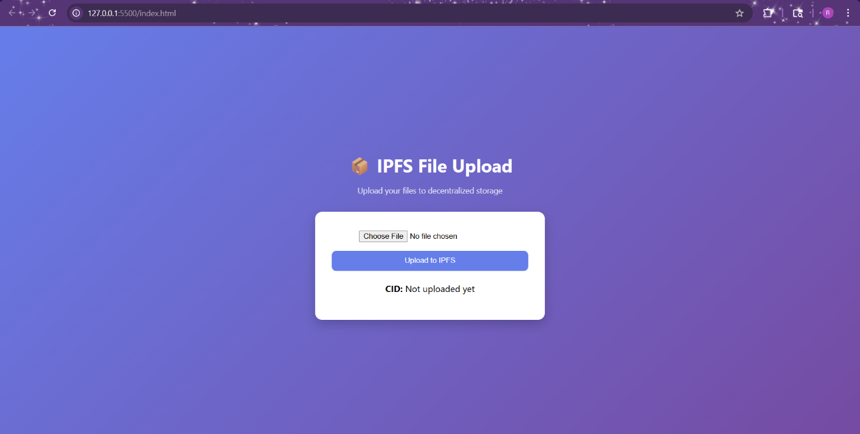
2. File Upload Initiation
This screenshot shows the user clicking the “Upload” button after selecting a file. The frontend sends the file to the backend server, which processes the request and prepares it for uploading to IPFS via Pinata.
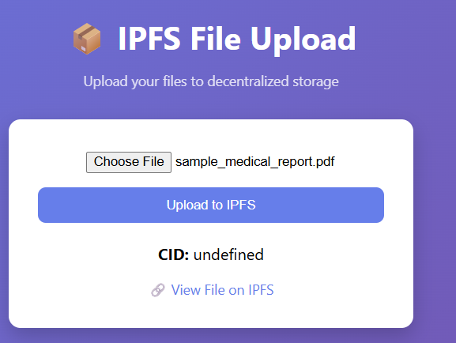
3. File Upload Success
This screenshot shows the successful upload of the file to IPFS. After uploading, a unique CID (Content Identifier) is generated and displayed on the screen. This CID uniquely identifies the file on the IPFS network.
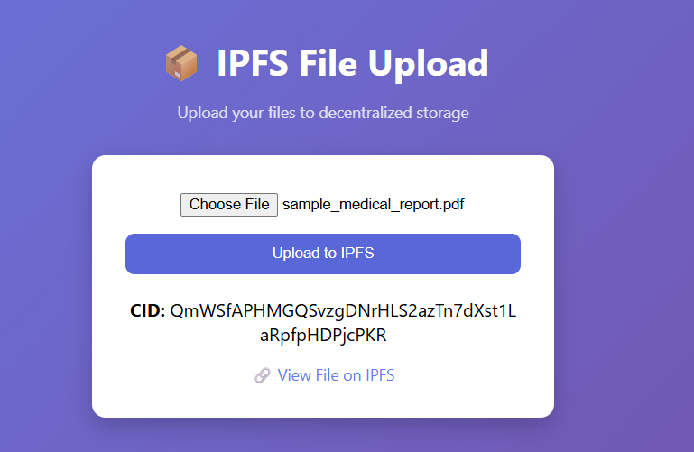
4. CID Display
This screenshot highlights the generated CID displayed in the application. The CID acts as a permanent reference to the uploaded file and is used for retrieving the file from IPFS.
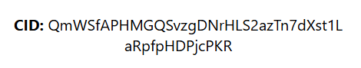
5. File Retrieval via IPFS Link
This screenshot shows the file being accessed using the IPFS gateway link. By clicking the generated link, the file is retrieved from the decentralized IPFS network and displayed in the browser.
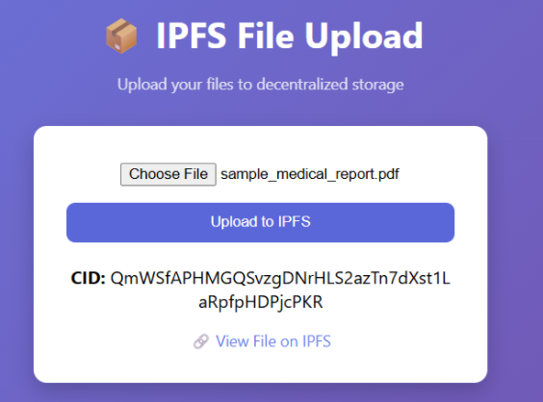
6. Transaction Link (Event Page Only)
This screenshot shows the transaction details if the project is integrated with blockchain. It includes the transaction hash and its details on a blockchain explorer such as Etherscan. This confirms that the event (such as storing CID) is recorded on the blockchain.
