CRICKET FIELDING ANALYSIS DATA COLLECTION

1.INTRODUCTION:
Fielding is a critical component in cricket, often determining the outcome of close matches. While batting and bowling statistics are frequently analyzed, detailed fielding analysis remains underutilized despite its strategic importance.
Fielding performance includes actions such as catching, throwing, stopping runs, run-outs, and stumpings. Each of these actions contributes to the overall team success and can significantly influence the match outcome.
The aim of fielding analysis is to quantify these actions, identify individual strengths and weaknesses, and provide actionable insights to improve fielding strategy and player efficiency.

2. Objective
To collect detailed fielding data for selected players in a T20 match.
To analyze performance metrics for catches, run-outs, stumpings, and direct hits.
To identify strengths and areas for improvement for individual players.
To support strategic decision-making for field placements and team performance.

3. Importance of Fielding Analysis
- Run Prevention: Efficient fielding saves crucial runs.
- Wicket Creation: Accurate throws, run-outs, and catches can change the match dynamics.
- Player Development: Identifying skill gaps allows targeted coaching.
- Strategic Advantage: Data-driven insights help in positioning players optimally.

4. Data Collection Process
1. Match Selection: Choose a T20 match innings for observation.
2. Player Selection: Select 3–5 key fielders for detailed tracking.
3. Event Recording: For every ball bowled, record:
- Catch (successful or dropped)
- Stumping (successful or missed)
- Run-out (direct hit, missed)
- Throw (clean, good, or poor)
- Runs saved/conceded
4. Contextual Information: Record the ball number, over, and match situation.
5. Data Logging: Maintain a spreadsheet or database for organized analysis.

5. Data Preparation & Metrics
Once data is collected:
Categorize Actions: Assign codes or weights to different fielding actions. Example:
- Catch: 15 points
- Clean Pick: 2 points
- Good Throw: 3 points
- Dropped Catch: -10 points
- Stumping: 12 points
- Run Out: 20 points
- Missed Run Out: -5 points
- Direct Hit: 10 points
Performance Score: Sum weighted actions to calculate Player Performance Score (PS).
Skill Contribution: Track individual contributions for specific skills to understand strengths and weaknesses

6. Data Visualization Techniques
- Bar Charts: Compare overall performance scores among players.
- Pie Charts: Show percentage contribution of top performers.

7. Deliverables
- Fielding Data Spreadsheet: Organized dataset of all recorded actions.
- Performance Scores: Calculated PS for each player.
- Charts & Graphs: Visual representation of player performance and skill distribution.
- Insights Report: Recommendations for improving fielding strategy and training focus.

8. Applications
- Player performance assessment and development
- Strategic planning for field placements
- Coaching & training module design
- Match preparation and opponent analysis

9. Tools & Software for Analysis
- Microsoft Excel / Google Sheets: For data recording and basic analysis
- Python (pandas, matplotlib, seaborn): For advanced data analysis and visualization
- PowerPoint / Canva: For creating presentations
- Database Systems (optional): For storing large match datasets

10. Code Implementation
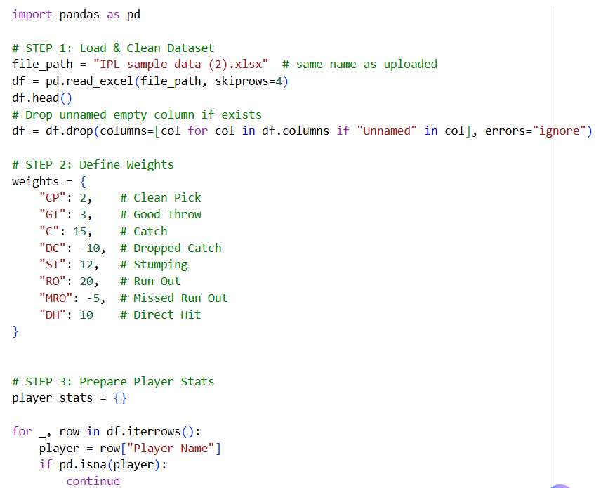

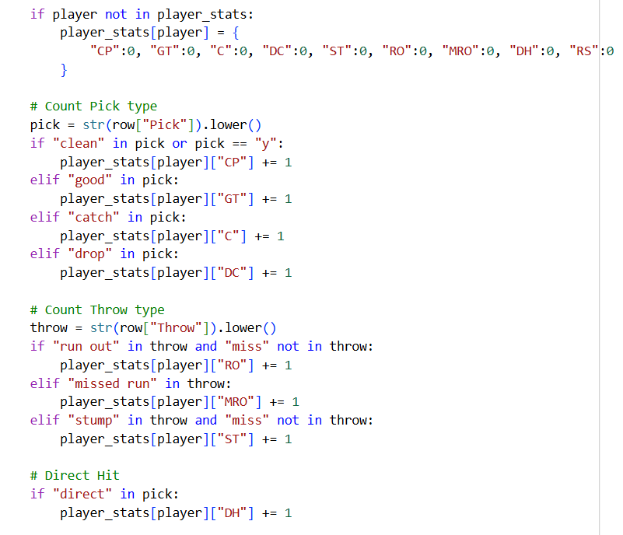

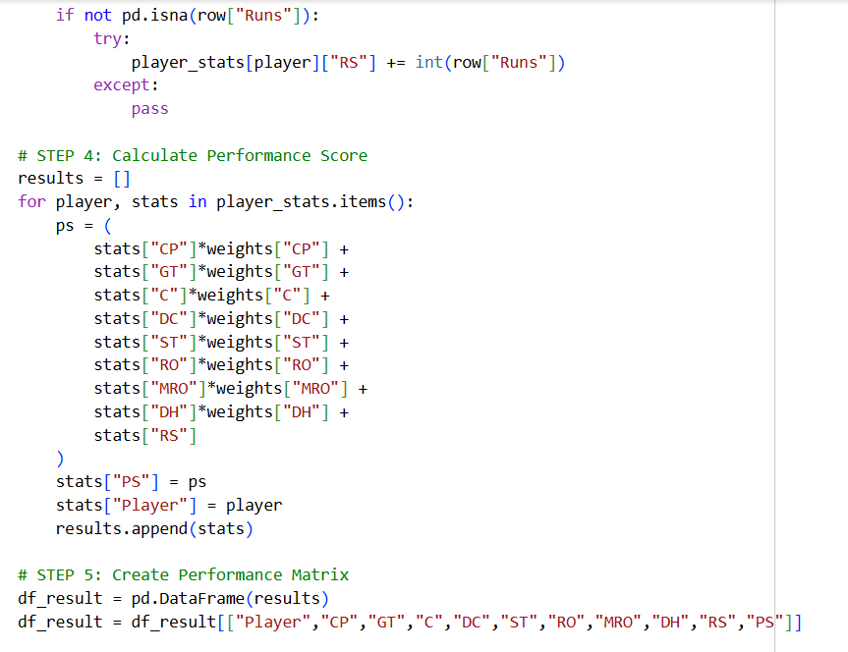
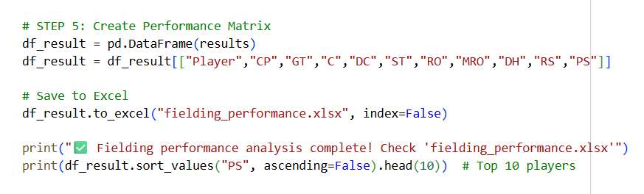
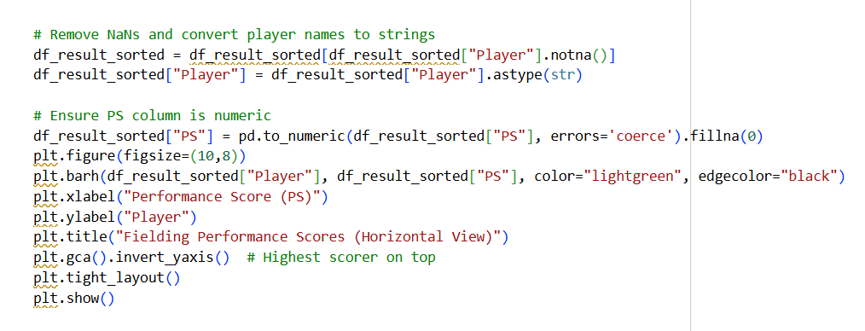
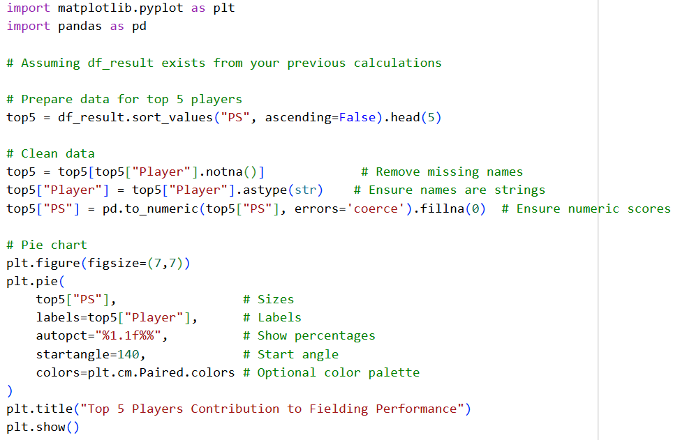

OUTPUT:

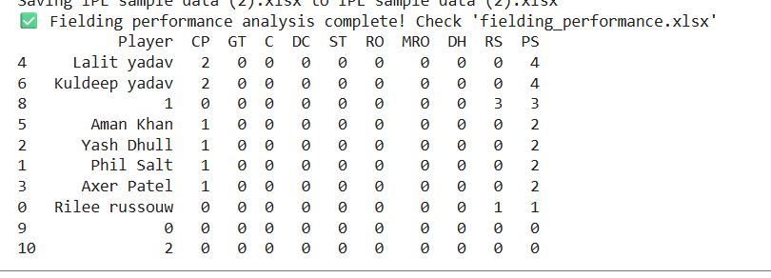

BAR CHART:
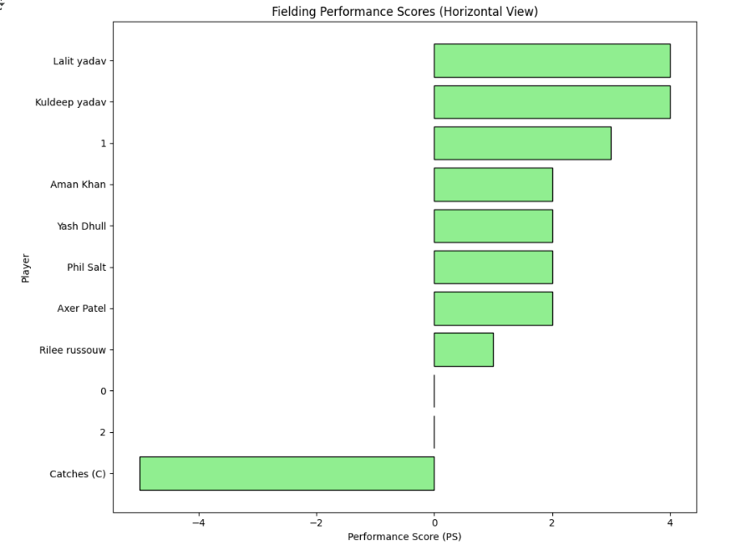

PIE CHART:
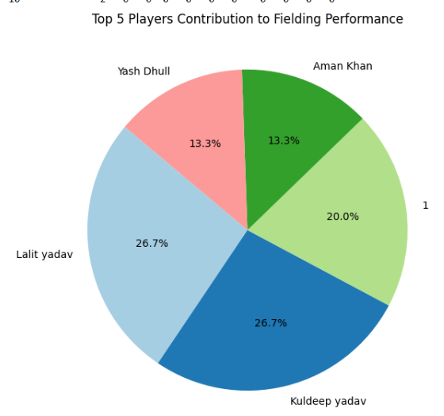

10. Conclusion
Fielding performance analysis is a data-driven approach to improving cricket strategies. By systematically collecting, analyzing, and visualizing fielding data, teams can:
- Optimize player positions
- Improve fielding efficiency
- Reduce runs conceded
- Increase chances of winning matches

