Transforming Hand Gesture into Words: A Novel Approach for Assistive Communications using ML Techniques
In propose project we are employing Machine & Deep Learning algorithms to convert human gesture into words. Each algorithm performance is evaluated in terms of accuracy, precision, recall and FSCORE. As Machine Learning we have utilized Random Forest algorithm and as deep learning we have utilized CNN algorithm. Among both algorithms CNN is getting highest accuracy.
To train above algorithms we have utilized Hand Gesture dataset which consists of 10 different Hand Signs which is showing below
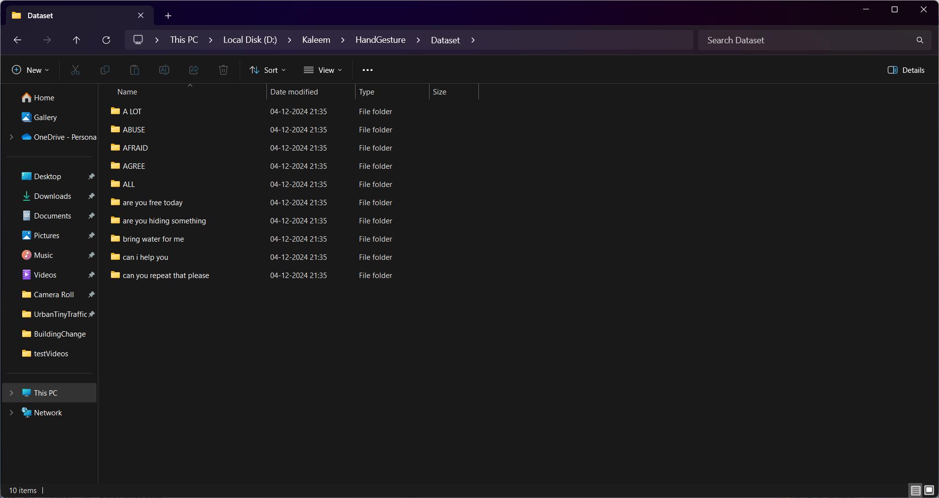
In above screen each folder contains different Hand Signs and its names can be seen as folder name. Several Hand Signs are available but on internet we manage to get this many words hand signs and just go inside any folder to view sign images.
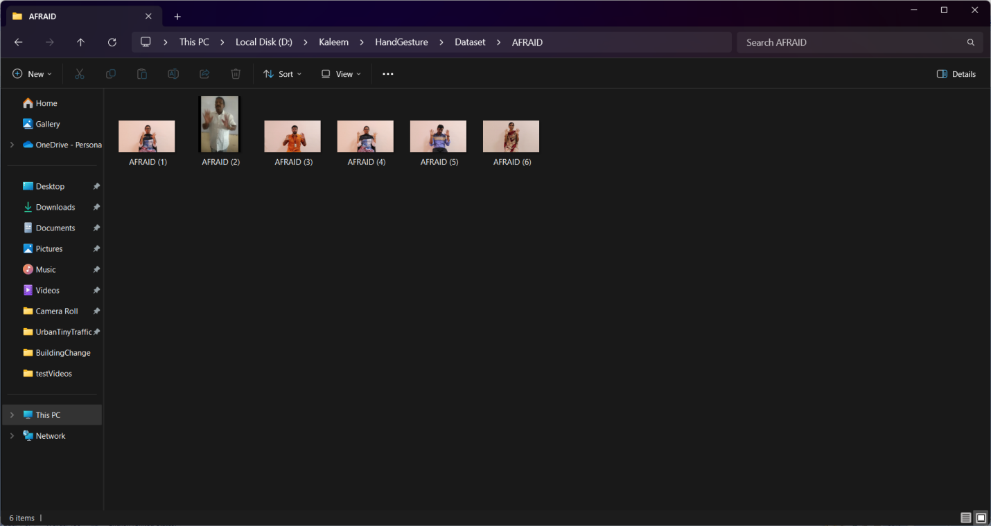
In above screen can see Hand Gesture signs for ‘Afraid’ word. To extract features from above signs we have utilize Media-pipe algorithm to identify hand signs and to obtain features.
To implement this project we have designed following modules
- Upload Hand Gesture Dataset: using this module user can upload ‘Dataset’ folder with different hand signs. This module will apply Media-Pipe algorithm to detect hand positions and then extract features
- Preprocess Dataset: this module will apply processing techniques such as normalization and shuffling on extracted features
- Train & Test Split: this module will split processed features into train and test where application using 80% dataset features for training and 20% for testing
- Train Machine Learning Random Forest Algorithm: 80% training features will be input to Random Forest ML algorithm to train a model and this model will be applied on 20% test data to calculate prediction accuracy
- Train Deep Learning CNN Algorithm: 80% training features will be input to CNN algorithm to train a model and this model will be applied on 20% test data to calculate prediction accuracy
- Hand Gesture to words from Video: using this module we can upload test video with different hand gestures and then CNN will predict type of gesture and converts into words
- Hand Gesture to words from Webcam: using this module we can open webcam video where user can show different hand signs on webcam and then CNN will predict type of gesture and converts into words
- Comparison Graph: this module will plot comparison graph between all algorithms.
SCREEN SHOTS
To run project double click on ‘run.bat’ file to get below screen
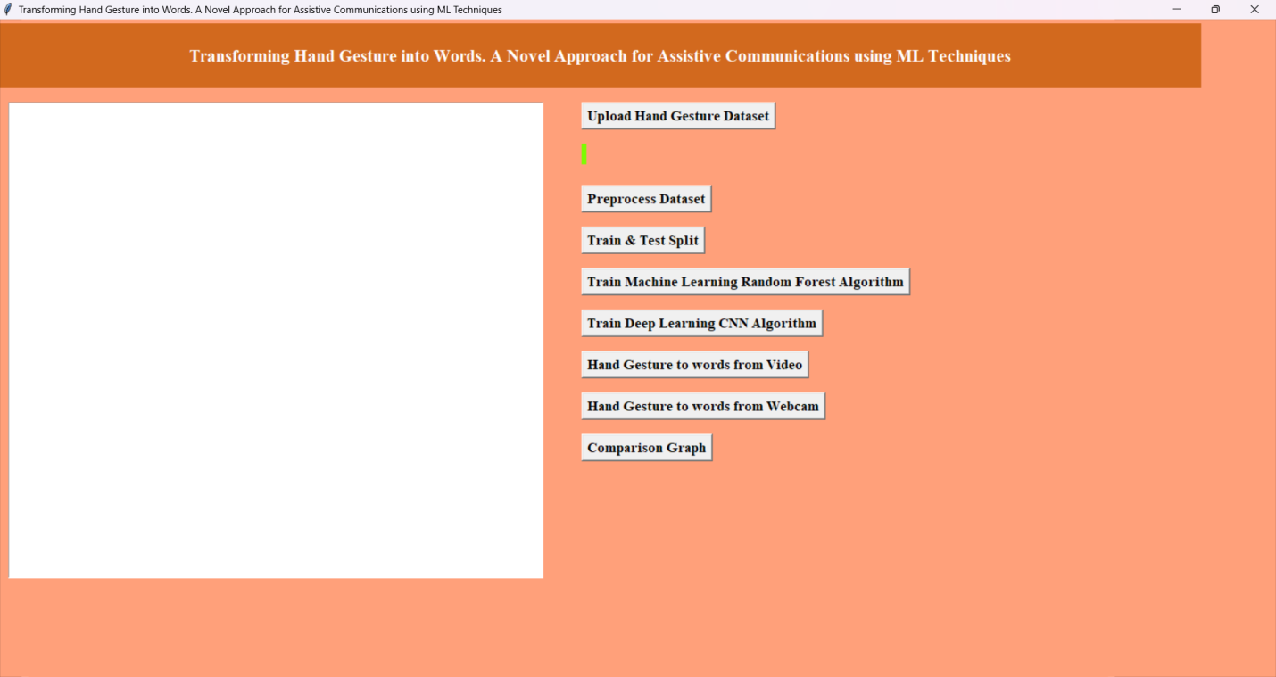
In above screen click on ‘Upload Hand Gesture Dataset’ button to upload dataset and get below page
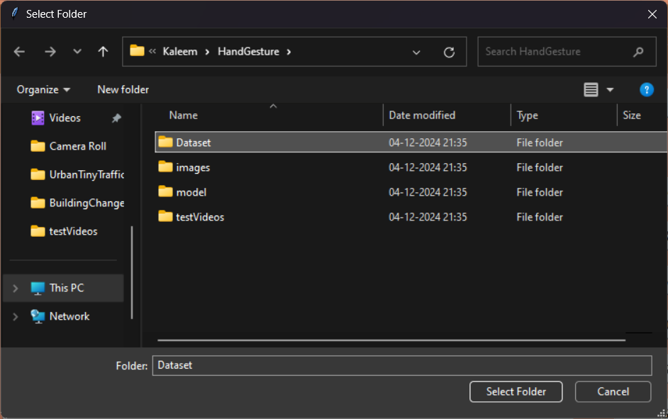
In above screen selecting and uploading entire ‘Dataset’ folder and then click on ‘Select Folder’ button to load dataset and get below page
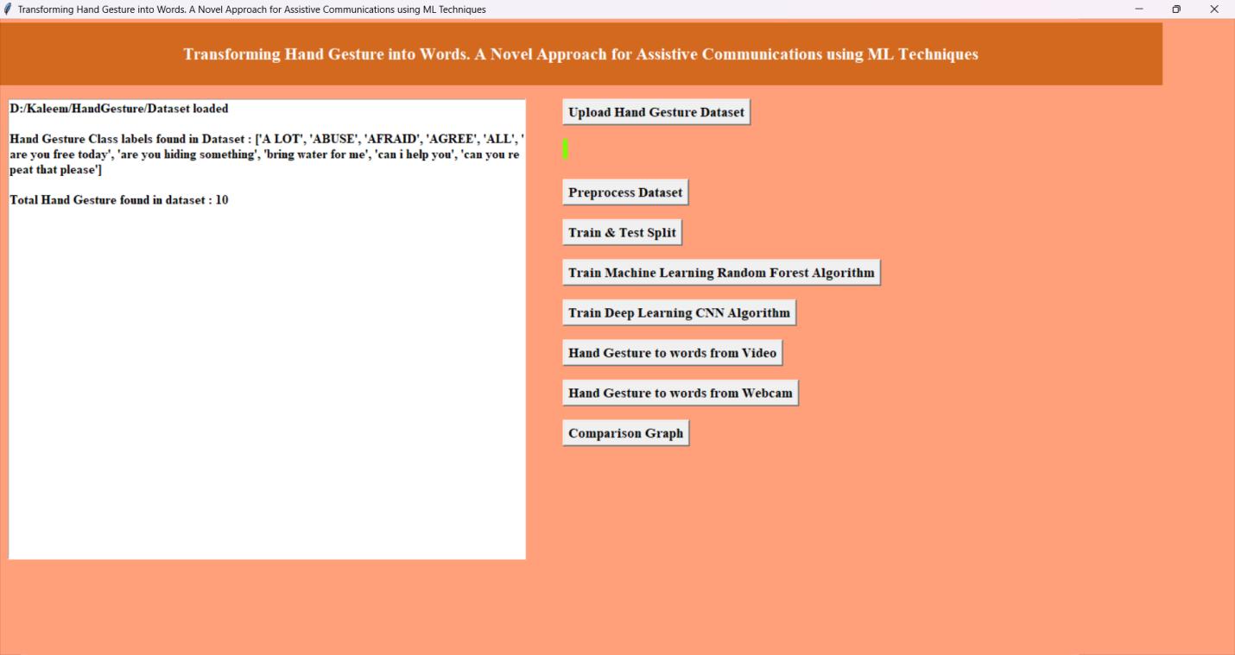
In above screen can see different hand gesture images loaded to application and can see number of loaded different hand gestures and now click on ‘Pre-process Dataset’ button to normalize features and get below page
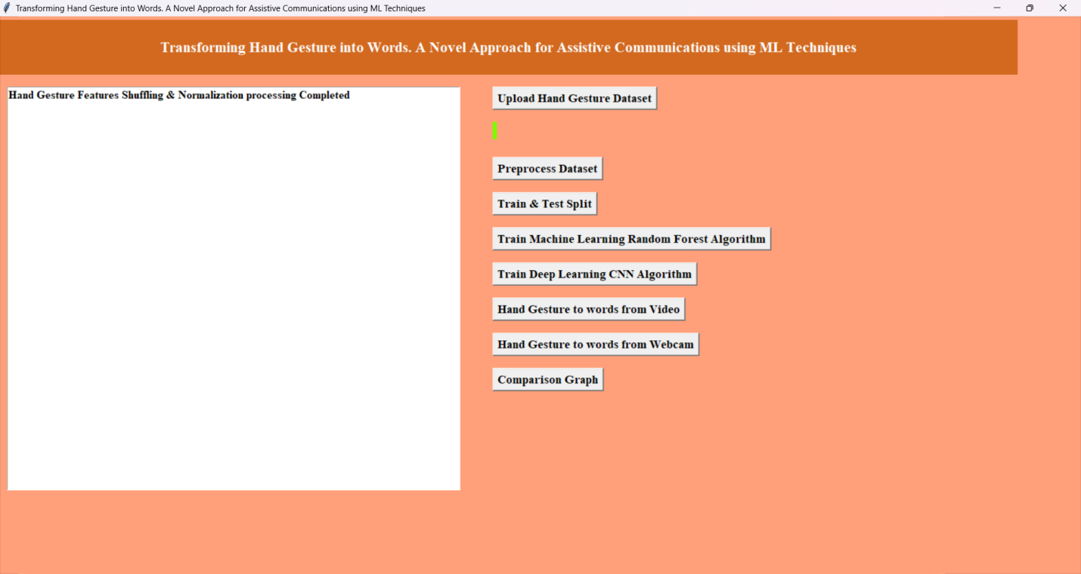
In above screen dataset features processing completed and now clicks on ‘Train & Test Split’ button to split dataset and to get below page
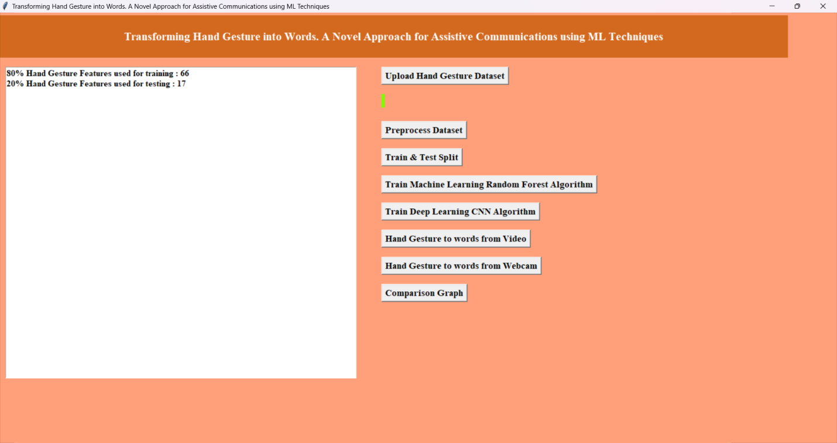
In above screen can see dataset train and test size and now click on ‘Train Machine Learning Random Forest Algorithm’ button to train Random Forest and get below page
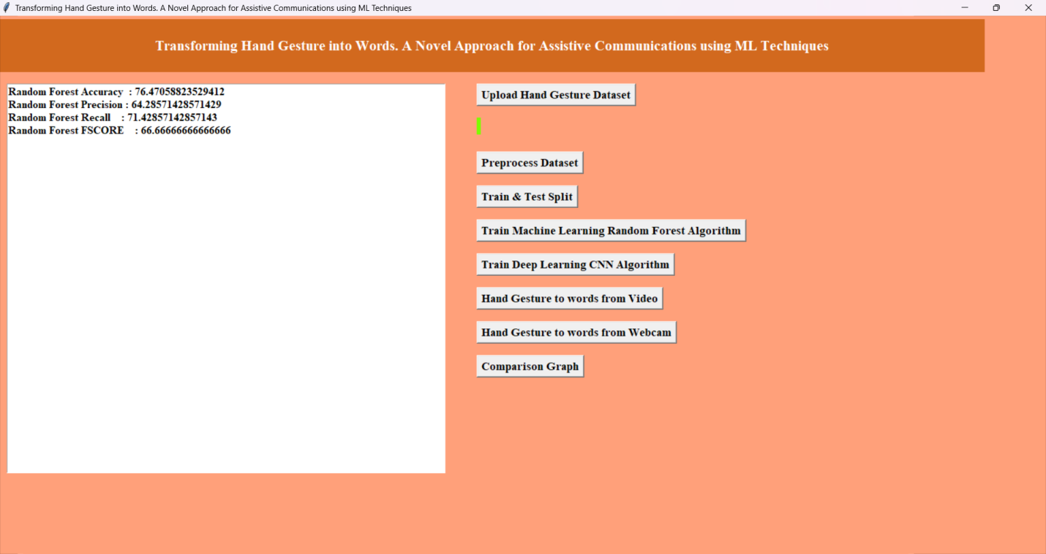
In above screen Random Forest got 76% accuracy and can see other metrics like precision, recall and FSCORE. Now click on ‘Train Deep Learning CNN Algorithm’ button to train CNN algorithm and get below page
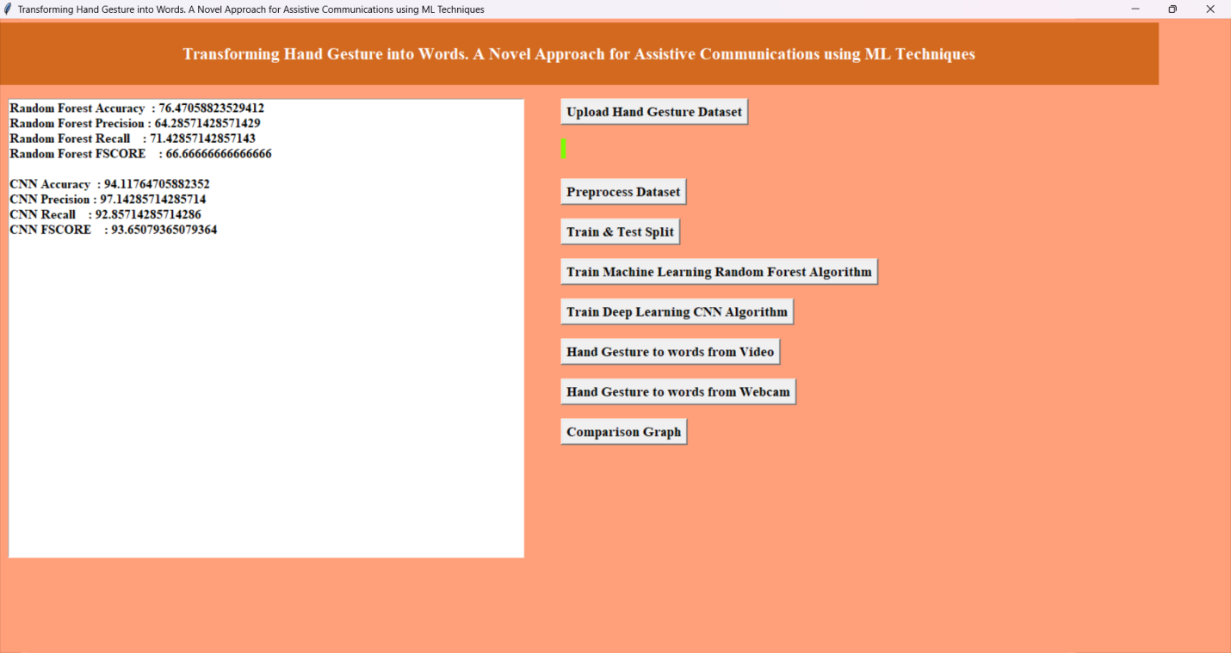
In above screen Deep learning CNN algorithm got 94% accuracy and can see other metrics also. Now click on ‘Hand Gesture to words from Video’ button to upload video and get below output
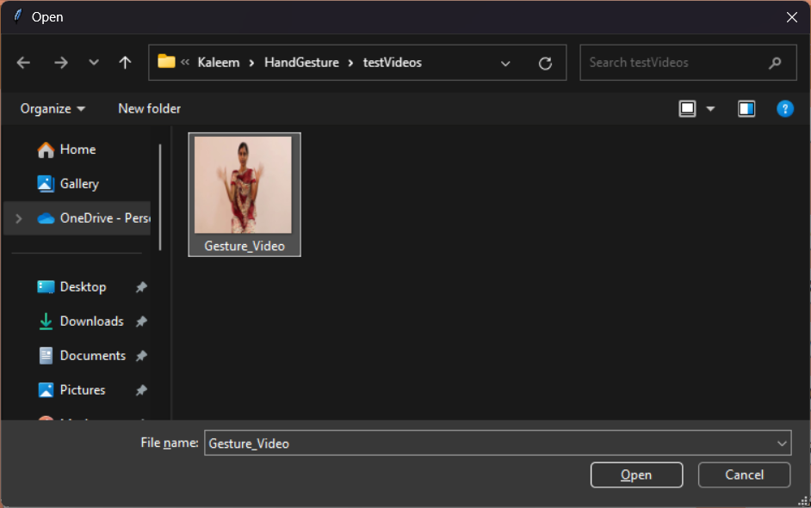
In above screen uploading video with different Hand Gesture and now click on ‘Open’ button to play video and then convert detected gesture into words
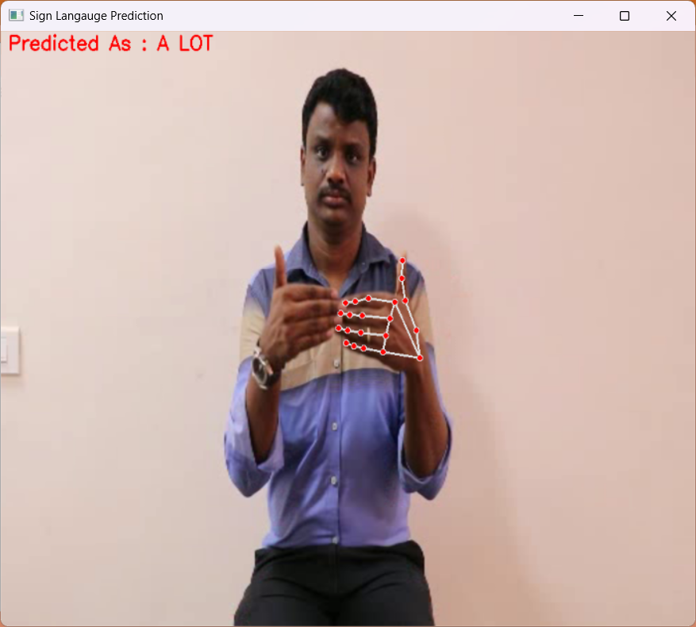
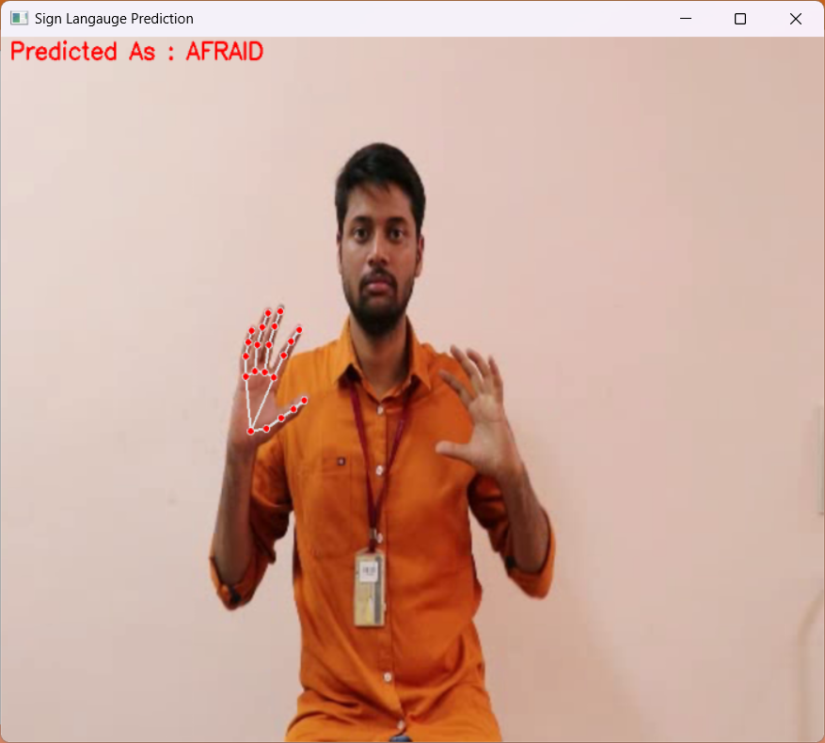
In above screen as video play then algorithm will identify hand gesture and then convert into words which are showing in red color text and after entire video playing completed then will get below generated ‘words’.
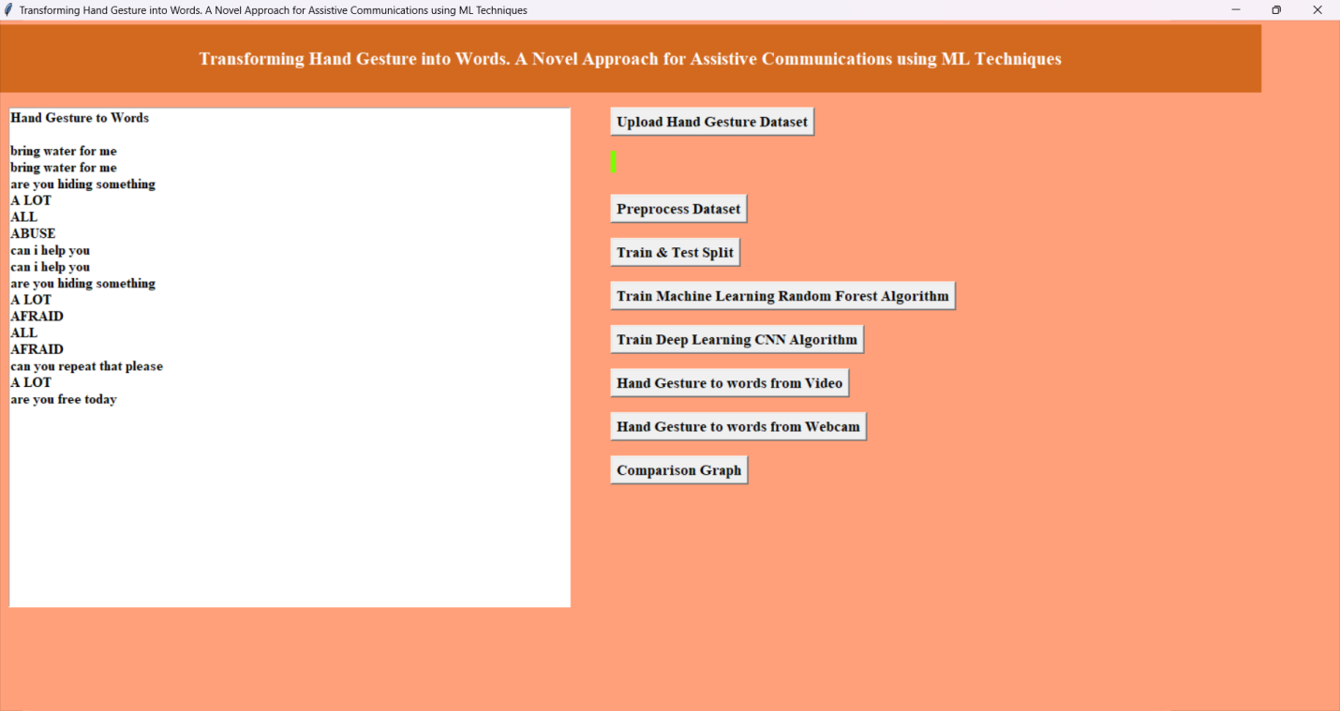
In above screen can see all converted hand gesture words and now click on ‘Hand Gesture to words from Webcam’ button to start webcam and generate words
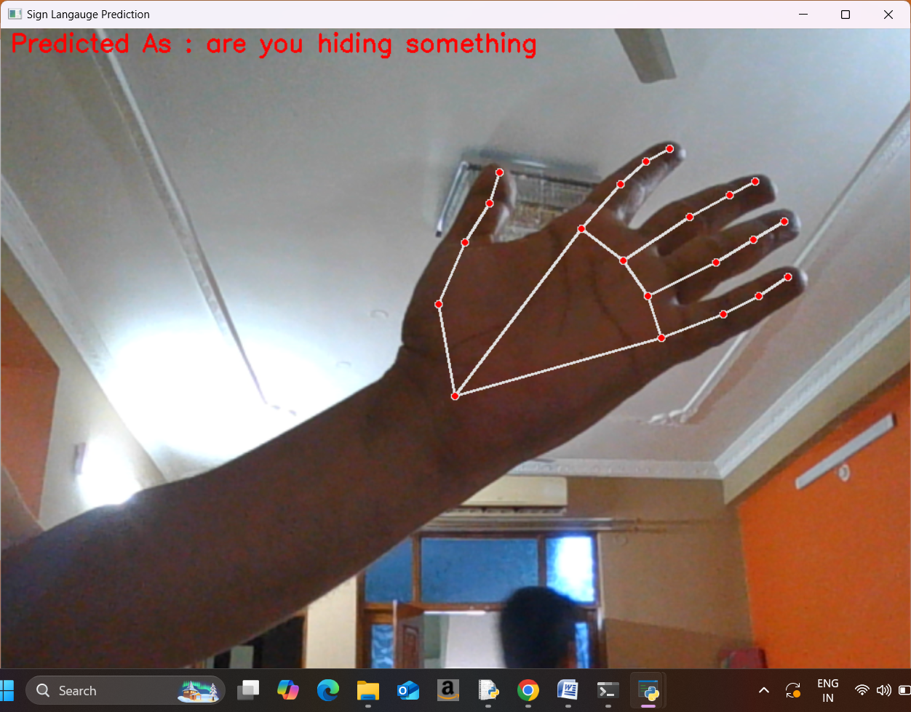
In above screen from webcam also hand gestures are identified and converted into words which can see in below screen.
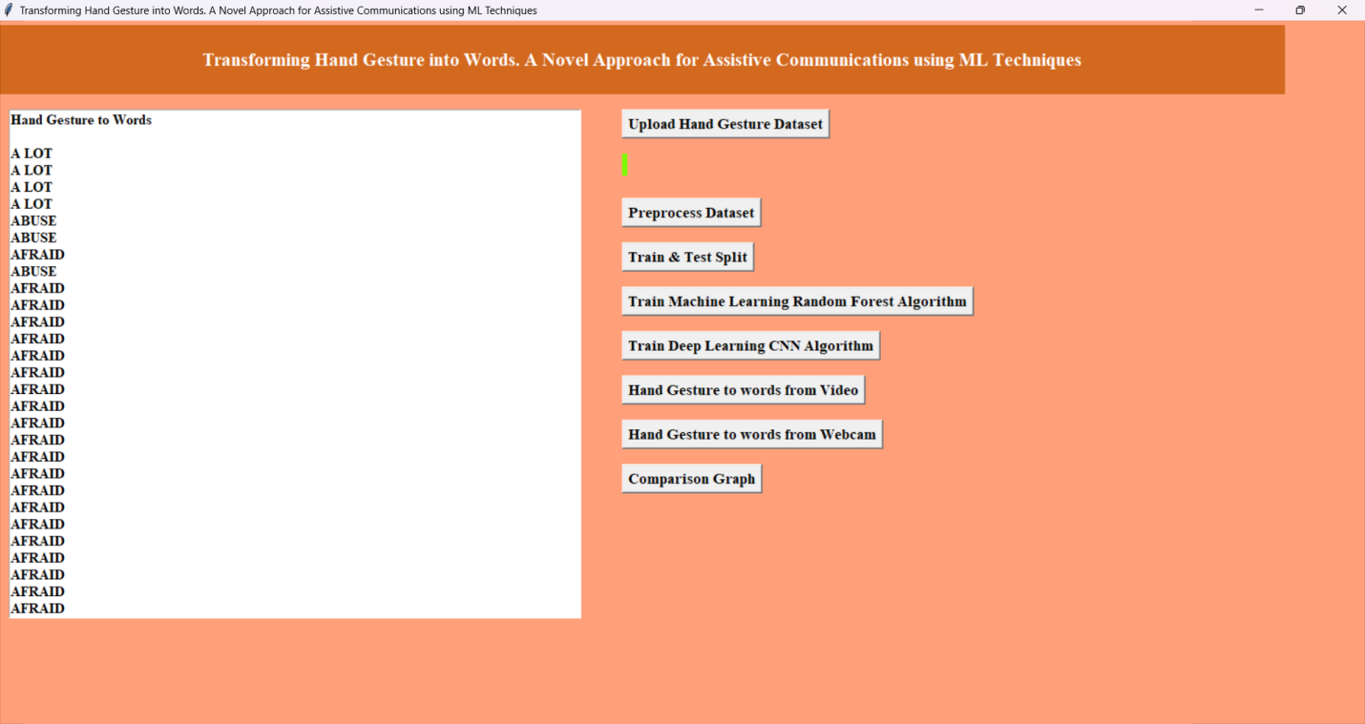
In above screen can see all converted words and now click on ‘Comparison Graph’ button to get below graph
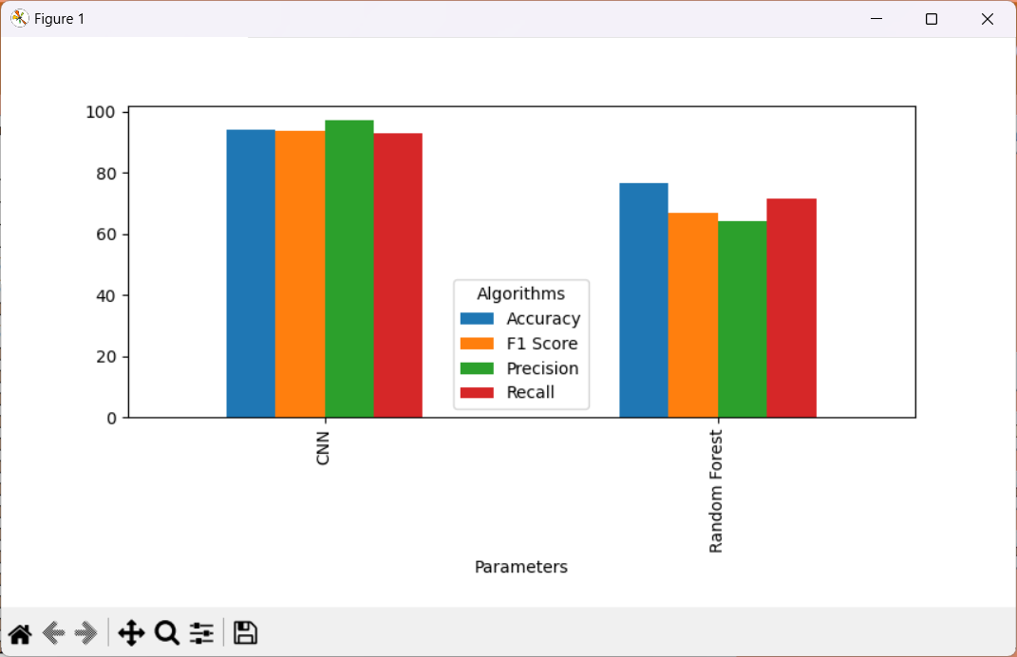
In above graph x-axis represents algorithm names and y-axis represents accuracy and other metrics in different color bars and in both algorithms CNN got high performance.

