Cognizant-Upgrad Training Program
Weekly Submission Document
Trainee Information
Name: Ranjita Linganagouda Patil
Email: ranjitapatil541@gmail.com
Batch_Name: B1_Python
Course: uGE_DotNet FSD(Python)
Training Duration: 16th Feb 2026-30th April 2026
Session Timings: 9:30AM-6:30PM
Faculty: Kunal
Week 7: Day 1: 30-03-2026
Q1) Extensible Notification System with Failure Handling
Controllers/NotificationController.cs
using Microsoft.AspNetCore.Mvc;

[ApiController]
[Route("api/notifications")]
public class NotificationController : ControllerBase
{
private readonly INotificationService _service;

public NotificationController(INotificationService service)
{
_service = service;
}

[HttpPost("bulk")]
public async Task<IActionResult> SendBulk(BulkNotificationRequest request)
{
await _service.SendBulkAsync(request.Notifications);
return Ok("Processed");
}
}

DTOs/BulkNotificationRequest.cs

public class BulkNotificationRequest
{
public List<NotificationRequest> Notifications { get; set; } = new List<NotificationRequest>();
}

Interfaces/INotificationService.cs

public interface INotificationService
{
Task SendBulkAsync(List<NotificationRequest> requests);
}

Interfaces/INotificationStrategy.cs

public interface INotificationStrategy
{
string Type { get; }
Task SendAsync(NotificationRequest request);
}

Logging/FailureLogger.cs

public class FailureLogger
{
public void Log(string message)
{
Console.WriteLine($"[FAILURE]: {message}");
}
}

Models/NotificationRequest.cs

public class NotificationRequest
{
public string Type { get; set; } = string.Empty;
public string Message { get; set; } = string.Empty;
public string Recipient { get; set; } = string.Empty;
}
Services/NotificationService.cs

public class NotificationService : INotificationService
{
private readonly IEnumerable<INotificationStrategy> _strategies;
private readonly FailureLogger _logger;

public NotificationService(IEnumerable<INotificationStrategy> strategies, FailureLogger logger)
{
_strategies = strategies;
_logger = logger;
}

public async Task SendBulkAsync(List<NotificationRequest> requests)
{
var tasks = requests.Select(request => ProcessNotification(request));
await Task.WhenAll(tasks);
}

private async Task ProcessNotification(NotificationRequest request)
{
var strategy = _strategies.FirstOrDefault(s => s.Type == request.Type);

if (strategy == null)
{
_logger.Log($"Invalid Type: {request.Type}");
return;
}

try
{
await strategy.SendAsync(request);
}
catch
{
try
{
await strategy.SendAsync(request);
}
catch (Exception ex)
{
_logger.Log($"Failed for {request.Type}: {ex.Message}");
}
}
}
}

Strategies/EmailNotificationStrategy.cs

public class EmailNotificationStrategy : INotificationStrategy
{
public string Type => "Email";

public async Task SendAsync(NotificationRequest request)
{
await Task.Delay(500);

if (new Random().Next(0, 3) == 0)
throw new Exception("SMTP Failure");

Console.WriteLine($"Email sent to {request.Recipient}");
}
}

Strategies/SmsNotificationStrategy.cs

public class SmsNotificationStrategy : INotificationStrategy
{
public string Type => "SMS";

public async Task SendAsync(NotificationRequest request)
{
await Task.Delay(300);

if (new Random().Next(0, 3) == 0)
throw new Exception("SMS Timeout");

Console.WriteLine($"SMS sent to {request.Recipient}");
}
}

Strategies/PushNotificationStrategy.cs

public class PushNotificationStrategy : INotificationStrategy
{
public string Type => "Push";

public async Task SendAsync(NotificationRequest request)
{
await Task.Delay(200);

Console.WriteLine($"Push sent to {request.Recipient}");
}
}

Program.cs

var builder = WebApplication.CreateBuilder(args);

builder.Services.AddControllers();

builder.Services.AddEndpointsApiExplorer();
builder.Services.AddSwaggerGen();
builder.Services.AddScoped<INotificationService, NotificationService>();
builder.Services.AddScoped<INotificationStrategy, EmailNotificationStrategy>();
builder.Services.AddScoped<INotificationStrategy, SmsNotificationStrategy>();
builder.Services.AddScoped<INotificationStrategy, PushNotificationStrategy>();
builder.Services.AddSingleton<FailureLogger>();

var app = builder.Build();

app.UseSwagger();
app.UseSwaggerUI();
app.MapGet("/", context =>
{
context.Response.Redirect("/swagger");
return Task.CompletedTask;
});

app.UseHttpsRedirection();

app.MapControllers();

app.Run();

Q2) Thread-Safe In-Memory Cache with Expiration Bug

Models/CacheItem.cs

namespace CacheSystem.Models
{
public class CacheItem
{
public object Value { get; }
public DateTime Expiry { get; }

public CacheItem(object value, TimeSpan expiry)
{
Value = value;
Expiry = DateTime.UtcNow.Add(expiry);
}

public bool IsExpired()
{
return DateTime.UtcNow > Expiry;
}
}
}

Interfaces/ICacheService.cs

using CacheSystem.Models;
namespace CacheSystem.Interfaces
{
public interface ICacheService
{
void Set(string key, object value, TimeSpan expiry);
object? Get(string key);
}
}

Services/InMemoryCacheService.cs

using System.Collections.Concurrent;
using CacheSystem.Interfaces;
using CacheSystem.Models;

namespace CacheSystem.Services
{
public class InMemoryCacheService : ICacheService
{
private readonly ConcurrentDictionary<string, CacheItem> _cache;

// Singleton instance
private static readonly Lazy<InMemoryCacheService> _instance =
new Lazy<InMemoryCacheService>(() => new InMemoryCacheService());

public static InMemoryCacheService Instance => _instance.Value;

private InMemoryCacheService()
{
_cache = new ConcurrentDictionary<string, CacheItem>();
StartCleanupTask();
}

public void Set(string key, object value, TimeSpan expiry)
{
var item = new CacheItem(value, expiry);
_cache[key] = item;
}

public object? Get(string key)
{
if (!_cache.TryGetValue(key, out var item))
return null;

if (item.IsExpired())
{
_cache.TryRemove(key, out _);
return null;
}

return item.Value;
}

// Background cleanup
private void StartCleanupTask()
{
Task.Run(async () =>
{
while (true)
{
try
{
foreach (var pair in _cache)
{
if (pair.Value.IsExpired())
{
_cache.TryRemove(pair.Key, out _);
}
}
}
catch
{

}

await Task.Delay(5000);
}
});
}
}
}

Controllers/CacheController.cs

using Microsoft.AspNetCore.Mvc;
using CacheSystem.Interfaces;

namespace CacheSystem.Controllers
{
[ApiController]
[Route("api/cache")]
public class CacheController : ControllerBase
{
private readonly ICacheService _cache;

public CacheController(ICacheService cache)
{
_cache = cache;
}

[HttpPost("set")]
public IActionResult Set(string key, string value, int seconds)
{
_cache.Set(key, value, TimeSpan.FromSeconds(seconds));
return Ok("Stored successfully");
}

[HttpGet("get")]
public IActionResult Get(string key)
{
var result = _cache.Get(key);

if (result == null)
return NotFound("Key not found or expired");

return Ok(result);
}
}
}

Program.cs

using CacheSystem.Interfaces;
using CacheSystem.Services;

var builder = WebApplication.CreateBuilder(args);

builder.Services.AddControllers();

builder.Services.AddSingleton<ICacheService>(sp => InMemoryCacheService.Instance);

builder.Services.AddEndpointsApiExplorer();
builder.Services.AddSwaggerGen();

var app = builder.Build();

app.UseSwagger();
app.UseSwaggerUI();
app.MapGet("/", context =>
{
context.Response.Redirect("/swagger");
return Task.CompletedTask;
});

app.UseHttpsRedirection();
app.MapControllers();

app.Run();

Q3) JWT Authentication System with Random Failures

Models/LoginRequest.cs

namespace AuthSystem.Models
{
public class LoginRequest
{
public string Username { get; set; } = string.Empty;
public string Password { get; set; } = string.Empty;
}
}

Models/TokenResponse.cs

namespace AuthSystem.Models
{
public class TokenResponse
{
public string AccessToken { get; set; } = string.Empty;
public string RefreshToken { get; set; } = string.Empty;
}
}

Models/RefreshToken.cs

namespace AuthSystem.Models
{
public class RefreshToken
{
public string Token { get; set; } = string.Empty;
public DateTime Expiry { get; set; }
public string UserId { get; set; } = string.Empty;
}
}

Interfaces/IAuthService.cs

using AuthSystem.Models;

namespace AuthSystem.Interfaces
{
public interface IAuthService
{
TokenResponse Login(LoginRequest request);
TokenResponse Refresh(string refreshToken);
}
}

Services/AuthService.cs

using System.IdentityModel.Tokens.Jwt;
using System.Security.Claims;
using System.Text;
using AuthSystem.Interfaces;
using AuthSystem.Models;
using Microsoft.IdentityModel.Tokens;

namespace AuthSystem.Services
{
public class AuthService : IAuthService
{
private readonly IConfiguration _config;

private static readonly Dictionary<string, RefreshToken> _refreshTokens = new();

public AuthService(IConfiguration config)
{
_config = config;
}

public TokenResponse Login(LoginRequest request)
{
if (request.Username != "admin" || request.Password != "123")
throw new Exception("Invalid credentials");

var userId = "1";
var role = "Admin";

var accessToken = GenerateJwtToken(userId, role);
var refreshToken = GenerateRefreshToken(userId);

_refreshTokens[refreshToken.Token] = refreshToken;

return new TokenResponse
{
AccessToken = accessToken,
RefreshToken = refreshToken.Token
};
}

public TokenResponse Refresh(string refreshToken)
{
if (!_refreshTokens.TryGetValue(refreshToken, out var stored))
throw new Exception("Invalid refresh token");

if (stored.Expiry < DateTime.UtcNow)
throw new Exception("Refresh token expired");

var newAccessToken = GenerateJwtToken(stored.UserId, "Admin");

return new TokenResponse
{
AccessToken = newAccessToken,
RefreshToken = refreshToken
};
}

private string GenerateJwtToken(string userId, string role)
{
var key = new SymmetricSecurityKey(
Encoding.UTF8.GetBytes(_config["Jwt:Key"]!)
);

var creds = new SigningCredentials(key, SecurityAlgorithms.HmacSha256);

var claims = new[]
{
new Claim("UserId", userId),
new Claim(ClaimTypes.Role, role)
};

var token = new JwtSecurityToken(
issuer: _config["Jwt:Issuer"],
audience: _config["Jwt:Audience"],
claims: claims,
expires: DateTime.UtcNow.AddMinutes(15),
signingCredentials: creds
);

return new JwtSecurityTokenHandler().WriteToken(token);
}

private RefreshToken GenerateRefreshToken(string userId)
{
return new RefreshToken
{
Token = Guid.NewGuid().ToString(),
Expiry = DateTime.UtcNow.AddDays(1),
UserId = userId
};
}
}
}

Controllers/AuthController.cs

using AuthSystem.Interfaces;
using AuthSystem.Models;
using Microsoft.AspNetCore.Authorization;
using Microsoft.AspNetCore.Mvc;

namespace AuthSystem.Controllers
{
[ApiController]
[Route("api/auth")]
public class AuthController : ControllerBase
{
private readonly IAuthService _service;

public AuthController(IAuthService service)
{
_service = service;
}

[HttpPost("login")]
public IActionResult Login(LoginRequest request)
{
try
{
var result = _service.Login(request);
return Ok(result);
}
catch (Exception ex)
{
return Unauthorized(ex.Message);
}
}

[HttpPost("refresh")]
public IActionResult Refresh(string refreshToken)
{
try
{
var result = _service.Refresh(refreshToken);
return Ok(result);
}
catch (Exception ex)
{
return Unauthorized(ex.Message);
}
}

[Authorize]
[HttpGet("protected")]
public IActionResult Protected()
{
return Ok("You are authorized!");
}
}
}

appsettings.json
{
"Jwt": {
"Key": "THIS_IS_SUPER_SECRET_KEY_123456789",
"Issuer": "AuthSystem",
"Audience": "AuthSystemUsers"
}
}

Program.cs

using System.Text;
using AuthSystem.Interfaces;
using AuthSystem.Services;
using Microsoft.AspNetCore.Authentication.JwtBearer;
using Microsoft.IdentityModel.Tokens;

var builder = WebApplication.CreateBuilder(args);
builder.Services.AddControllers();
builder.Services.AddScoped<IAuthService, AuthService>();

builder.Services.AddEndpointsApiExplorer();
builder.Services.AddSwaggerGen();

builder.Services.AddAuthentication(JwtBearerDefaults.AuthenticationScheme)
.AddJwtBearer(options =>
{
options.RequireHttpsMetadata = false;
options.SaveToken = true;

options.TokenValidationParameters = new TokenValidationParameters
{
ValidateIssuer = true,
ValidateAudience = true,
ValidateLifetime = true,
ValidateIssuerSigningKey = true,

ValidIssuer = builder.Configuration["Jwt:Issuer"],
ValidAudience = builder.Configuration["Jwt:Audience"],

IssuerSigningKey = new SymmetricSecurityKey(
Encoding.UTF8.GetBytes(builder.Configuration["Jwt:Key"]!)
),

ClockSkew = TimeSpan.Zero
};
});

builder.Services.AddAuthorization();

var app = builder.Build();

app.UseSwagger();
app.UseSwaggerUI();

app.UseAuthentication();
app.UseAuthorization();
app.MapGet("/", ctx =>
{
ctx.Response.Redirect("/swagger");
return Task.CompletedTask;
});

app.MapControllers();

app.Run();

Q4)API Rate Limiting System (Scalable Design)

Models/ClientRequestInfo.cs

namespace RateLimiterSystem.Models
{
public class ClientRequestInfo
{
public Queue<DateTime> Requests { get; } = new Queue<DateTime>();
}
}

Services/RateLimiterService.cs

using System.Collections.Concurrent;
using RateLimiterSystem.Models;

namespace RateLimiterSystem.Services
{
public class RateLimiterService
{
private readonly ConcurrentDictionary<string, ClientRequestInfo> _clients
= new ConcurrentDictionary<string, ClientRequestInfo>();

private readonly int _limit = 5;
private readonly TimeSpan _window = TimeSpan.FromSeconds(10);

public bool IsAllowed(string clientId)
{
var now = DateTime.UtcNow;

var client = _clients.GetOrAdd(clientId, _ => new ClientRequestInfo());

lock (client)
{
while (client.Requests.Count > 0 &&
now - client.Requests.Peek() > _window)
{
client.Requests.Dequeue();
}
if (client.Requests.Count >= _limit)
return false;
client.Requests.Enqueue(now);
return true;
}
}
}
}

Middleware/RateLimitingMiddleware.cs

using RateLimiterSystem.Services;

namespace RateLimiterSystem.Middleware
{
public class RateLimitingMiddleware
{
private readonly RequestDelegate _next;

public RateLimitingMiddleware(RequestDelegate next)
{
_next = next;
}

public async Task InvokeAsync(HttpContext context, RateLimiterService limiter)
{
var clientId = context.Connection.RemoteIpAddress?.ToString() ?? "unknown";

if (!limiter.IsAllowed(clientId))
{
context.Response.StatusCode = 429;
context.Response.ContentType = "text/plain";

await context.Response.WriteAsync("Too Many Requests - Rate limit exceeded");
return;
}

await _next(context);
}
}
}

Controllers/TestController.cs

using Microsoft.AspNetCore.Mvc;

namespace RateLimiterSystem.Controllers
{
[ApiController]
[Route("api/test")]
public class TestController : ControllerBase
{
[HttpGet]
public IActionResult Get()
{
return Ok("Request successful");
}
}
}

Program.cs

using RateLimiterSystem.Middleware;
using RateLimiterSystem.Services;

var builder = WebApplication.CreateBuilder(args);

builder.Services.AddControllers();
builder.Services.AddSingleton<RateLimiterService>();

builder.Services.AddEndpointsApiExplorer();
builder.Services.AddSwaggerGen();

var app = builder.Build();

app.UseSwagger();
app.UseSwaggerUI();
app.UseMiddleware<RateLimitingMiddleware>();

app.MapGet("/", ctx =>
{
ctx.Response.Redirect("/swagger");
return Task.CompletedTask;
});

app.MapControllers();

app.Run();

Q5) Deadlock Creation and Resolution

Services/DeadlockDemoService.cs

namespace DeadlockSystem.Services
{
public class DeadlockDemoService
{
private readonly object _lockA = new object();
private readonly object _lockB = new object();

public void CreateDeadlock()
{
var t1 = new Thread(() =>
{
lock (_lockA)
{
Console.WriteLine("Thread 1 acquired LockA");
Thread.Sleep(1000);

lock (_lockB)
{
Console.WriteLine("Thread 1 acquired LockB");
}
}
});

var t2 = new Thread(() =>
{
lock (_lockB)
{
Console.WriteLine("Thread 2 acquired LockB");
Thread.Sleep(1000);

lock (_lockA)
{
Console.WriteLine("Thread 2 acquired LockA");
}
}
});

t1.Start();
t2.Start();
}
}
}

Services/DeadlockFixedService.cs

namespace DeadlockSystem.Services
{
public class DeadlockFixedService
{
private readonly object _lockA = new object();
private readonly object _lockB = new object();

public void FixWithLockOrdering()
{
var t1 = new Thread(() => AcquireLocks());
var t2 = new Thread(() => AcquireLocks());

t1.Start();
t2.Start();
}

private void AcquireLocks()
{
lock (_lockA)
{
Console.WriteLine($"{Thread.CurrentThread.ManagedThreadId} got LockA");

lock (_lockB)
{
Console.WriteLine($"{Thread.CurrentThread.ManagedThreadId} got LockB");
}
}
}
}
}

Services/DeadlockDetectionService.cs

namespace DeadlockSystem.Services
{
public class DeadlockDetectionService
{
private readonly object _lockA = new object();
private readonly object _lockB = new object();

public void RunWithDetection()
{
var t1 = new Thread(() => Work(_lockA, _lockB));
var t2 = new Thread(() => Work(_lockB, _lockA));

t1.Start();
t2.Start();
}

private void Work(object first, object second)
{
bool lockTaken1 = false;
bool lockTaken2 = false;

try
{
Monitor.TryEnter(first, TimeSpan.FromSeconds(2), ref lockTaken1);

if (!lockTaken1)
{
Console.WriteLine("Deadlock detected at first lock");
return;
}

Console.WriteLine($"{Thread.CurrentThread.ManagedThreadId} got first lock");

Thread.Sleep(500);

Monitor.TryEnter(second, TimeSpan.FromSeconds(2), ref lockTaken2);

if (!lockTaken2)
{
Console.WriteLine("Deadlock detected at second lock, releasing...");
return;
}

Console.WriteLine($"{Thread.CurrentThread.ManagedThreadId} got second lock");
}
finally
{
if (lockTaken2) Monitor.Exit(second);
if (lockTaken1) Monitor.Exit(first);
}
}
}
}

Controllers/DeadlockController.cs

using DeadlockSystem.Services;
using Microsoft.AspNetCore.Mvc;

namespace DeadlockSystem.Controllers
{
[ApiController]
[Route("api/deadlock")]
public class DeadlockController : ControllerBase
{
private readonly DeadlockDemoService _demo;
private readonly DeadlockFixedService _fixed;
private readonly DeadlockDetectionService _detect;

public DeadlockController(
DeadlockDemoService demo,
DeadlockFixedService fixedService,
DeadlockDetectionService detect)
{
_demo = demo;
_fixed = fixedService;
_detect = detect;
}

[HttpGet("create")]
public IActionResult CreateDeadlock()
{
_demo.CreateDeadlock();
return Ok("Deadlock triggered");
}

[HttpGet("fix")]
public IActionResult FixDeadlock()
{
_fixed.FixWithLockOrdering();
return Ok("Deadlock fixed using lock ordering");
}

[HttpGet("detect")]
public IActionResult DetectDeadlock()
{
_detect.RunWithDetection();
return Ok("Deadlock detection with timeout started");
}
}
}

Program.cs

using DeadlockSystem.Services;

var builder = WebApplication.CreateBuilder(args);

builder.Services.AddControllers();

builder.Services.AddSingleton<DeadlockDemoService>();
builder.Services.AddSingleton<DeadlockFixedService>();
builder.Services.AddSingleton<DeadlockDetectionService>();

builder.Services.AddEndpointsApiExplorer();
builder.Services.AddSwaggerGen();

var app = builder.Build();

app.UseSwagger();
app.UseSwaggerUI();

app.MapGet("/", ctx =>
{
ctx.Response.Redirect("/swagger");
return Task.CompletedTask;
});

app.MapControllers();

app.Run();

Q6) Custom HashMap with Performance Degradation

Models/HashNode.cs

namespace CustomHashMap.Models
{
public class HashNode<TKey, TValue>
{
public TKey Key { get; set; }
public TValue Value { get; set; }
public HashNode<TKey, TValue>? Next { get; set; }

public HashNode(TKey key, TValue value)
{
Key = key;
Value = value;
Next = null;
}
}
}

Services/MyHashMap.cs

using System.Collections.Concurrent;
using CustomHashMap.Models;

namespace CustomHashMap.Services
{
public class MyHashMap<TKey, TValue>
{
private HashNode<TKey, TValue>?[] _buckets;
private int _capacity;
private int _count;

private const double LoadFactorThreshold = 0.75;
private readonly object _resizeLock = new();

public MyHashMap(int capacity = 16)
{
_capacity = capacity;
_buckets = new HashNode<TKey, TValue>[capacity];
_count = 0;
}

private int GetIndex(TKey key, int capacity)
{
int hash = key!.GetHashCode();
hash ^= (hash >> 16);
hash &= 0x7fffffff;
return hash % capacity;
}

public void Add(TKey key, TValue value)
{
lock (_resizeLock)
{
Insert(key, value, _buckets);

if ((double)_count / _capacity > LoadFactorThreshold)
{
Resize();
}
}
}

private void Insert(TKey key, TValue value, HashNode<TKey, TValue>?[] buckets)
{
int index = GetIndex(key, buckets.Length);
var head = buckets[index];

while (head != null)
{
if (head.Key!.Equals(key))
{
head.Value = value;
return;
}
head = head.Next;
}

var newNode = new HashNode<TKey, TValue>(key, value)
{
Next = buckets[index]
};

buckets[index] = newNode;
_count++;
}
public TValue? Get(TKey key)
{
int index = GetIndex(key, _capacity);
var head = _buckets[index];

while (head != null)
{
if (head.Key!.Equals(key))
return head.Value;

head = head.Next;
}

return default;
}

public bool Remove(TKey key)
{
lock (_resizeLock)
{
int index = GetIndex(key, _capacity);
var head = _buckets[index];
HashNode<TKey, TValue>? prev = null;

while (head != null)
{
if (head.Key!.Equals(key))
{
if (prev == null)
_buckets[index] = head.Next;
else
prev.Next = head.Next;

_count--;
return true;
}

prev = head;
head = head.Next;
}

return false;
}
}

private void Resize()
{
int newCapacity = _capacity * 2;
var newBuckets = new HashNode<TKey, TValue>[newCapacity];

foreach (var bucket in _buckets)
{
var current = bucket;

while (current != null)
{
var next = current.Next;

int newIndex = GetIndex(current.Key, newCapacity);

current.Next = newBuckets[newIndex];
newBuckets[newIndex] = current;

current = next;
}
}

_buckets = newBuckets;
_capacity = newCapacity;
}
}
}

Controllers/HashMapController.cs

using CustomHashMap.Services;
using Microsoft.AspNetCore.Mvc;

namespace CustomHashMap.Controllers
{
[ApiController]
[Route("api/hashmap")]
public class HashMapController : ControllerBase
{
private static readonly MyHashMap<string, string> _map = new();

[HttpPost("add")]
public IActionResult Add(string key, string value)
{
_map.Add(key, value);
return Ok("Added successfully");
}

[HttpGet("get")]
public IActionResult Get(string key)
{
var result = _map.Get(key);

if (result == null)
return NotFound("Key not found");

return Ok(result);
}

[HttpDelete("remove")]
public IActionResult Remove(string key)
{
bool removed = _map.Remove(key);

if (!removed)
return NotFound("Key not found");

return Ok("Removed successfully");
}
}
}

Program.cs

var builder = WebApplication.CreateBuilder(args);

builder.Services.AddControllers();

builder.Services.AddEndpointsApiExplorer();
builder.Services.AddSwaggerGen();

var app = builder.Build();

app.UseSwagger();
app.UseSwaggerUI();

app.MapGet("/", ctx =>
{
ctx.Response.Redirect("/swagger");
return Task.CompletedTask;
});

app.MapControllers();

app.Run();

Q7)High-Load Order Processing System

Models/Order.cs

namespace OrderSystem.Models;

public class Order
{
public string Id { get; set; } = Guid.NewGuid().ToString();
public string UserId { get; set; } = "";
public string Item { get; set; } = "";
public DateTime CreatedAt { get; set; } = DateTime.UtcNow;
}

Models/OrderRequest.cs

namespace OrderSystem.Models;

public class OrderRequest
{
public string Item { get; set; } = "";
}

Models/TokenResponse.cs

namespace OrderSystem.Models;

public class TokenResponse
{
public string AccessToken { get; set; } = "";
}

Models/CacheItem.cs

namespace OrderSystem.Models;

public class CacheItem
{
public object Value { get; set; }
public DateTime Expiry { get; set; }

public CacheItem(object value, TimeSpan ttl)
{
Value = value;
Expiry = DateTime.UtcNow.Add(ttl);
}

public bool IsExpired() => DateTime.UtcNow > Expiry;
}

Interfaces/IOrderRepository.cs

using OrderSystem.Models;

namespace OrderSystem.Interfaces;

public interface IOrderRepository
{
void Add(Order order);
Order? Get(string id);
}

Interfaces/IOrderService.cs

using OrderSystem.Models;

namespace OrderSystem.Interfaces;

public interface IOrderService
{
Order PlaceOrder(string userId, OrderRequest request);
Order? GetOrder(string id);
}

Interfaces/INotificationStrategy.cs

namespace OrderSystem.Interfaces;

public interface INotificationStrategy
{
string Type { get; }
Task SendAsync(string message);
}

Interfaces/IAuthService.cs

using OrderSystem.Models;

namespace OrderSystem.Interfaces;

public interface IAuthService
{
TokenResponse Login(string user);
}

Services/OrderRepository.cs

using System.Collections.Concurrent;
using OrderSystem.Interfaces;
using OrderSystem.Models;

namespace OrderSystem.Services;

public class OrderRepository : IOrderRepository
{
private readonly ConcurrentDictionary<string, Order> _orders = new();

public void Add(Order order)
{
_orders[order.Id] = order;
}

public Order? Get(string id)
{
_orders.TryGetValue(id, out var order);
return order;
}
}

Services/CacheService.cs

using System.Collections.Concurrent;
using OrderSystem.Models;

namespace OrderSystem.Services;

public class CacheService
{
private readonly ConcurrentDictionary<string, CacheItem> _cache = new();

public CacheService()
{
StartCleanup();
}

public void Set(string key, object value, TimeSpan ttl)
{
_cache[key] = new CacheItem(value, ttl);
}

public object? Get(string key)
{
if (_cache.TryGetValue(key, out var item))
{
if (item.IsExpired())
{
_cache.TryRemove(key, out _);
return null;
}
return item.Value;
}
return null;
}

private void StartCleanup()
{
Task.Run(async () =>
{
while (true)
{
foreach (var key in _cache.Keys)
{
if (_cache.TryGetValue(key, out var item) && item.IsExpired())
_cache.TryRemove(key, out _);
}
await Task.Delay(5000);
}
});
}
}

Services/AuthService.cs

using System.IdentityModel.Tokens.Jwt;
using System.Security.Claims;
using System.Text;
using Microsoft.IdentityModel.Tokens;
using OrderSystem.Interfaces;
using OrderSystem.Models;

namespace OrderSystem.Services;

public class AuthService : IAuthService
{
private readonly IConfiguration _config;

public AuthService(IConfiguration config)
{
_config = config;
}

public TokenResponse Login(string user)
{
var key = new SymmetricSecurityKey(
Encoding.UTF8.GetBytes(_config["Jwt:Key"]!)
);

var token = new JwtSecurityToken(
claims: new[] { new Claim("UserId", user) },
expires: DateTime.UtcNow.AddMinutes(15),
signingCredentials: new SigningCredentials(key, SecurityAlgorithms.HmacSha256)
);

return new TokenResponse
{
AccessToken = new JwtSecurityTokenHandler().WriteToken(token)
};
}
}

Services/OrderService.cs

using OrderSystem.Interfaces;
using OrderSystem.Models;

namespace OrderSystem.Services;

public class OrderService : IOrderService
{
private readonly IOrderRepository _repo;
private readonly CacheService _cache;
private readonly IEnumerable<INotificationStrategy> _strategies;

public OrderService(IOrderRepository repo, CacheService cache, IEnumerable<INotificationStrategy> strategies)
{
_repo = repo;
_cache = cache;
_strategies = strategies;
}

public Order PlaceOrder(string userId, OrderRequest request)
{
var order = new Order
{
UserId = userId,
Item = request.Item
};

_repo.Add(order);
_cache.Set(order.Id, order, TimeSpan.FromMinutes(5));

Task.Run(async () =>
{
foreach (var strategy in _strategies)
{
int retry = 2;
while (retry-- > 0)
{
try
{
await strategy.SendAsync($"Order {order.Id} confirmed");
break;
}
catch
{
await Task.Delay(200);
}
}
}
});

return order;
}

public Order? GetOrder(string id)
{
var cached = _cache.Get(id) as Order;
if (cached != null) return cached;

var order = _repo.Get(id);

if (order != null)
_cache.Set(id, order, TimeSpan.FromMinutes(5));

return order;
}
}

Strategies/EmailNotificationStrategy.cs

using OrderSystem.Interfaces;

namespace OrderSystem.Strategies;

public class EmailNotificationStrategy : INotificationStrategy
{
public string Type => "Email";

public async Task SendAsync(string message)
{
await Task.Delay(200);
Console.WriteLine("EMAIL: " + message);
}
}

Strategies/SmsNotificationStrategy.cs

using OrderSystem.Interfaces;

namespace OrderSystem.Strategies;

public class SmsNotificationStrategy : INotificationStrategy
{
public string Type => "SMS";

public async Task SendAsync(string message)
{
await Task.Delay(200);
Console.WriteLine("SMS: " + message);
}
}

Middleware/ExceptionMiddleware.cs

namespace OrderSystem.Middleware;

public class ExceptionMiddleware
{
private readonly RequestDelegate _next;

public ExceptionMiddleware(RequestDelegate next)
{
_next = next;
}

public async Task Invoke(HttpContext context)
{
try
{
await _next(context);
}
catch (Exception ex)
{
context.Response.StatusCode = 500;
await context.Response.WriteAsync($"Error: {ex.Message}");
}
}
}

Middleware/RateLimitingMiddleware.cs

using System.Collections.Concurrent;

namespace OrderSystem.Middleware;

public class RateLimitingMiddleware
{
private readonly RequestDelegate _next;
private static readonly ConcurrentDictionary<string, List<DateTime>> _requests = new();

public RateLimitingMiddleware(RequestDelegate next)
{
_next = next;
}

public async Task Invoke(HttpContext context)
{
var key = context.Connection.RemoteIpAddress?.ToString() ?? "unknown";
var now = DateTime.UtcNow;

var list = _requests.GetOrAdd(key, _ => new List<DateTime>());

lock (list)
{
list.RemoveAll(x => (now - x).TotalSeconds > 10);

if (list.Count >= 5)
{
context.Response.StatusCode = 429;
return;
}

list.Add(now);
}

await _next(context);
}
}

Middleware/IdempotencyMiddleware.cs

using System.Collections.Concurrent;

namespace OrderSystem.Middleware;

public class IdempotencyMiddleware
{
private readonly RequestDelegate _next;
private static readonly ConcurrentDictionary<string, string> _store = new();

public IdempotencyMiddleware(RequestDelegate next)
{
_next = next;
}

public async Task Invoke(HttpContext context)
{
if (context.Request.Headers.TryGetValue("Idempotency-Key", out var key))
{
if (_store.TryGetValue(key!, out var response))
{
await context.Response.WriteAsync(response);
return;
}
}

await _next(context);
}
}

Controllers/AuthController.cs

using Microsoft.AspNetCore.Mvc;
using OrderSystem.Interfaces;

namespace OrderSystem.Controllers;

[ApiController]
[Route("api/auth")]
public class AuthController : ControllerBase
{
private readonly IAuthService _auth;

public AuthController(IAuthService auth)
{
_auth = auth;
}

[HttpPost("login")]
public IActionResult Login(string user)
{
return Ok(_auth.Login(user));
}
}

Controllers/OrdersController.cs

using Microsoft.AspNetCore.Authorization;
using Microsoft.AspNetCore.Mvc;
using OrderSystem.Interfaces;
using OrderSystem.Models;

namespace OrderSystem.Controllers;

[ApiController]
[Route("api/orders")]
public class OrdersController : ControllerBase
{
private readonly IOrderService _service;

public OrdersController(IOrderService service)
{
_service = service;
}

[Authorize]
[HttpPost]
public IActionResult PlaceOrder(OrderRequest request)
{
var userId = User.FindFirst("UserId")?.Value ?? "user";
return Ok(_service.PlaceOrder(userId, request));
}

[Authorize]
[HttpGet("{id}")]
public IActionResult Get(string id)
{
var order = _service.GetOrder(id);
if (order == null) return NotFound();
return Ok(order);
}
}

Program.cs

using System.Text;
using Microsoft.AspNetCore.Authentication.JwtBearer;
using Microsoft.IdentityModel.Tokens;
using OrderSystem.Interfaces;
using OrderSystem.Middleware;
using OrderSystem.Services;
using OrderSystem.Strategies;

var builder = WebApplication.CreateBuilder(args);

builder.Services.AddControllers();

builder.Services.AddSingleton<IOrderRepository, OrderRepository>();
builder.Services.AddSingleton<IOrderService, OrderService>();
builder.Services.AddSingleton<CacheService>();
builder.Services.AddScoped<IAuthService, AuthService>();

builder.Services.AddScoped<INotificationStrategy, EmailNotificationStrategy>();
builder.Services.AddScoped<INotificationStrategy, SmsNotificationStrategy>();

builder.Services.AddAuthentication(JwtBearerDefaults.AuthenticationScheme)
.AddJwtBearer(options =>
{
options.TokenValidationParameters = new TokenValidationParameters
{
ValidateIssuerSigningKey = true,
IssuerSigningKey = new SymmetricSecurityKey(
Encoding.UTF8.GetBytes(builder.Configuration["Jwt:Key"]!)
),
ValidateLifetime = true,
ClockSkew = TimeSpan.Zero
};
});

builder.Services.AddAuthorization();
builder.Services.AddSwaggerGen();

var app = builder.Build();

app.UseSwagger();
app.UseSwaggerUI();

app.UseMiddleware<ExceptionMiddleware>();
app.UseMiddleware<IdempotencyMiddleware>();
app.UseMiddleware<RateLimitingMiddleware>();

app.UseAuthentication();
app.UseAuthorization();

app.MapGet("/", ctx =>
{
ctx.Response.Redirect("/swagger");
return Task.CompletedTask;
});

app.MapControllers();

app.Run();

appsettings.json

{
"Jwt": {
"Key": "THIS_IS_SUPER_SECRET_KEY_123456789"
}
}
Projects

- Personal Productivity Heatmap Dashboard(Frontend)
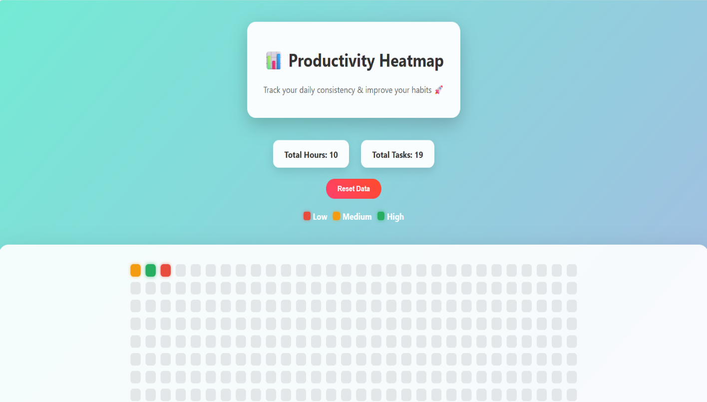

2) Full-Stack Healthcare Appointment System (ASP.NET Core + SQL)(Backend)

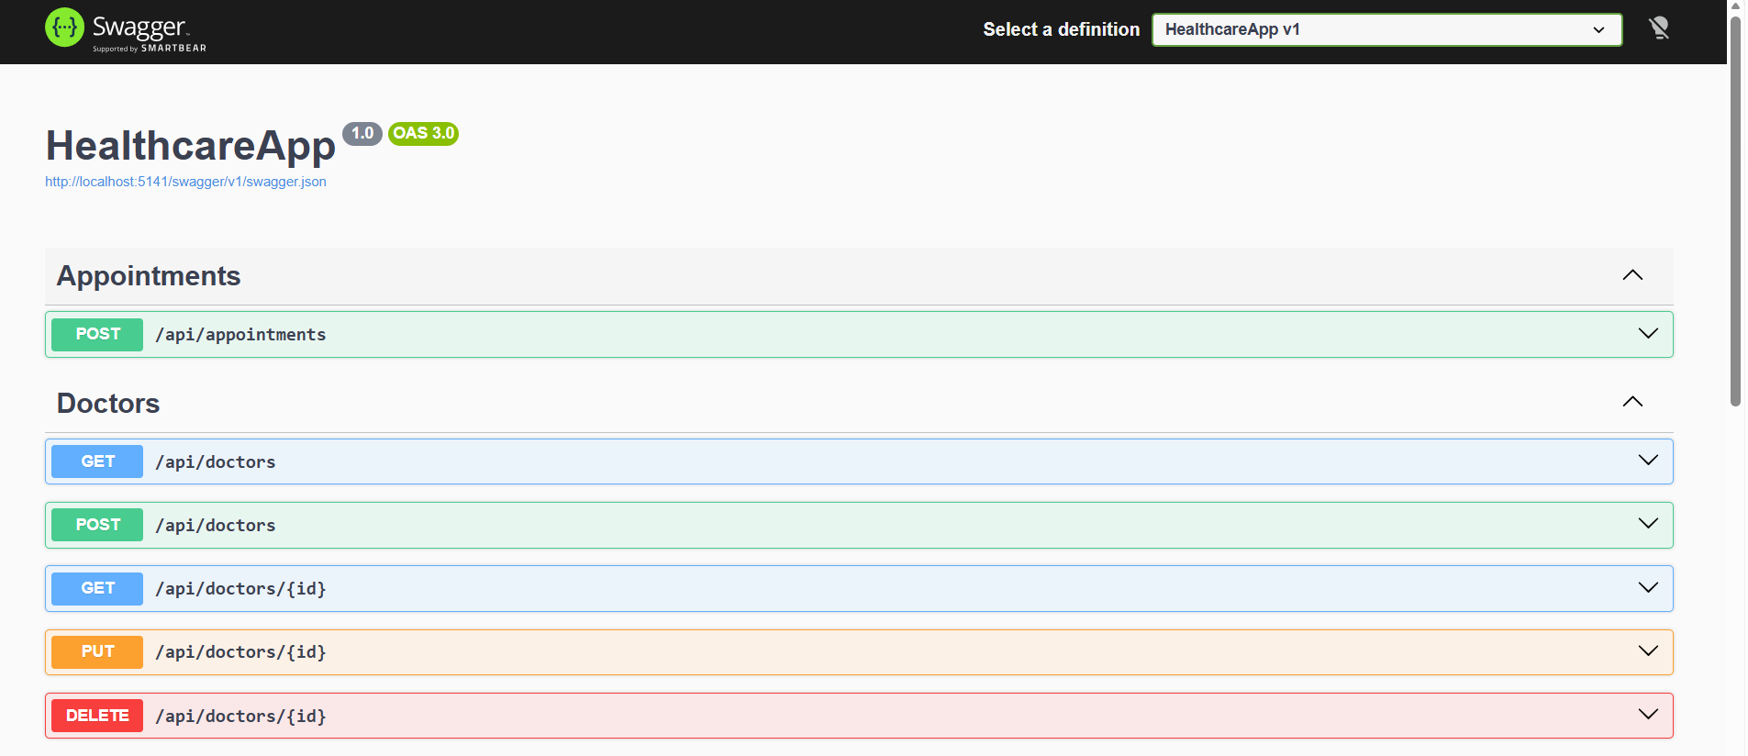

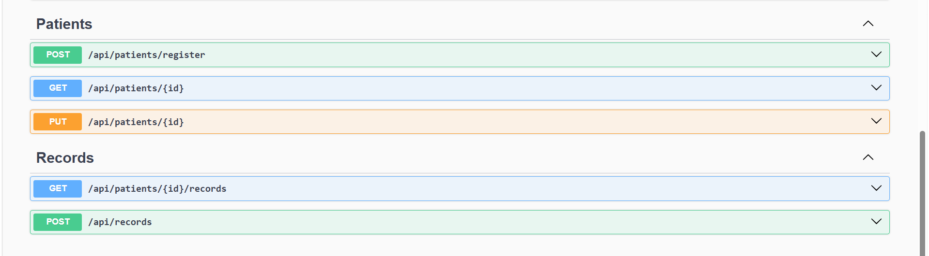

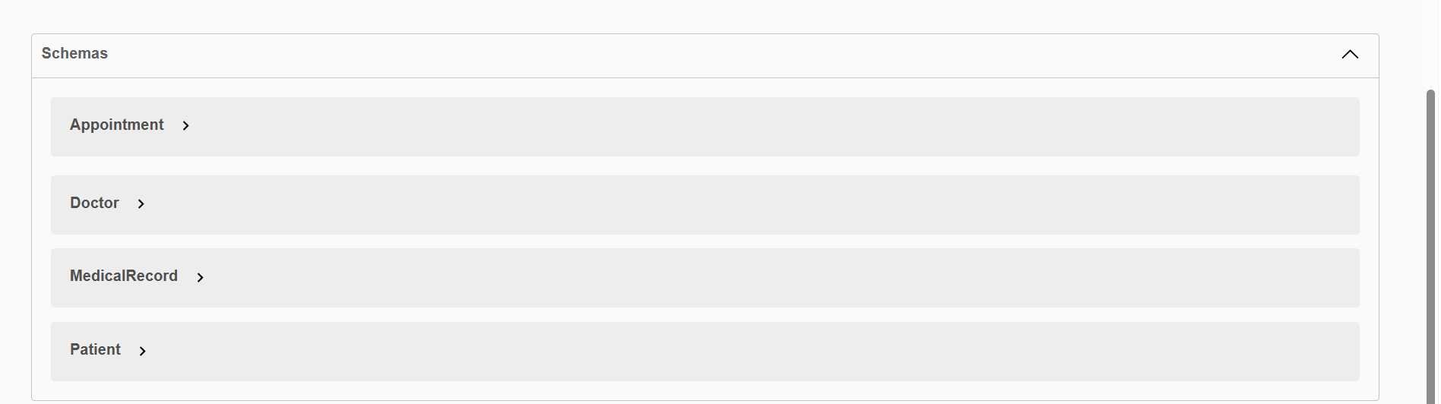

1: CREATE DOCTOR
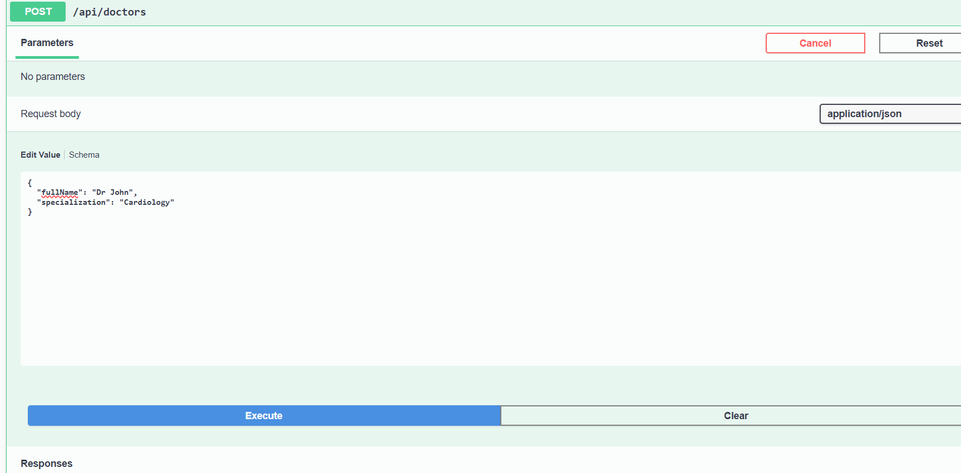

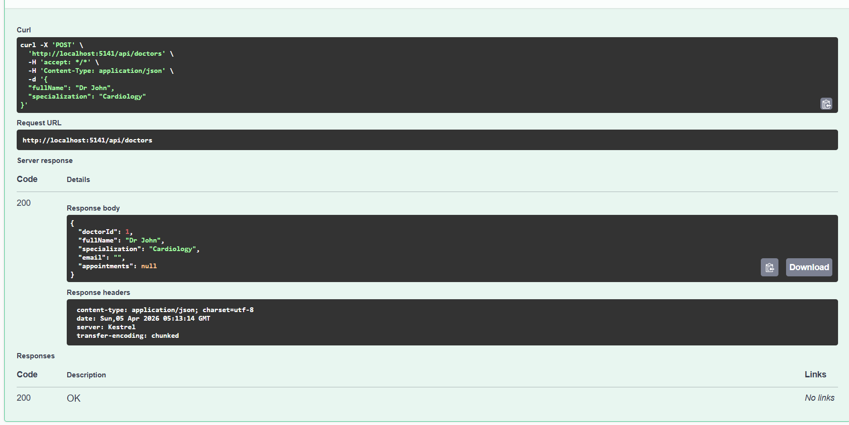

2: CREATE SECOND DOCTOR
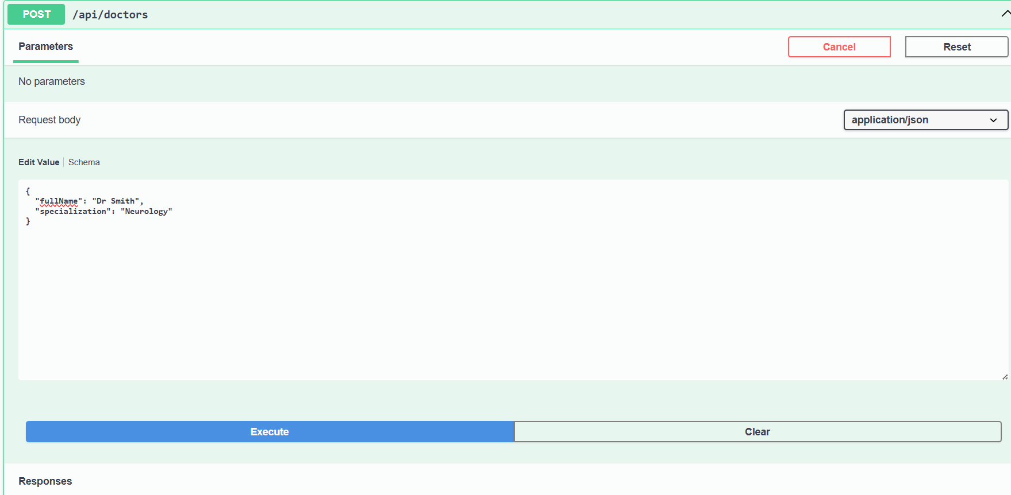

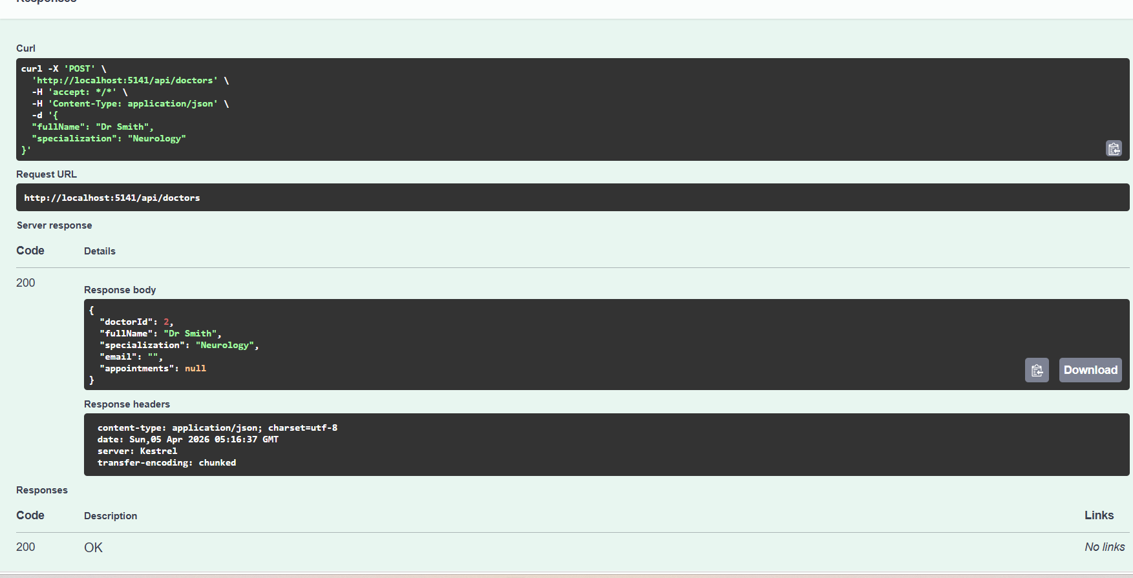
3: GET ALL DOCTORS
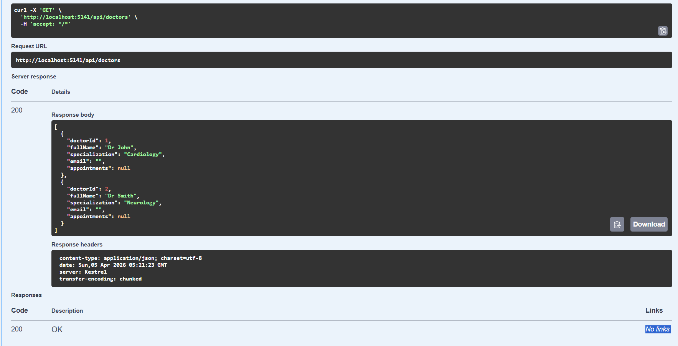

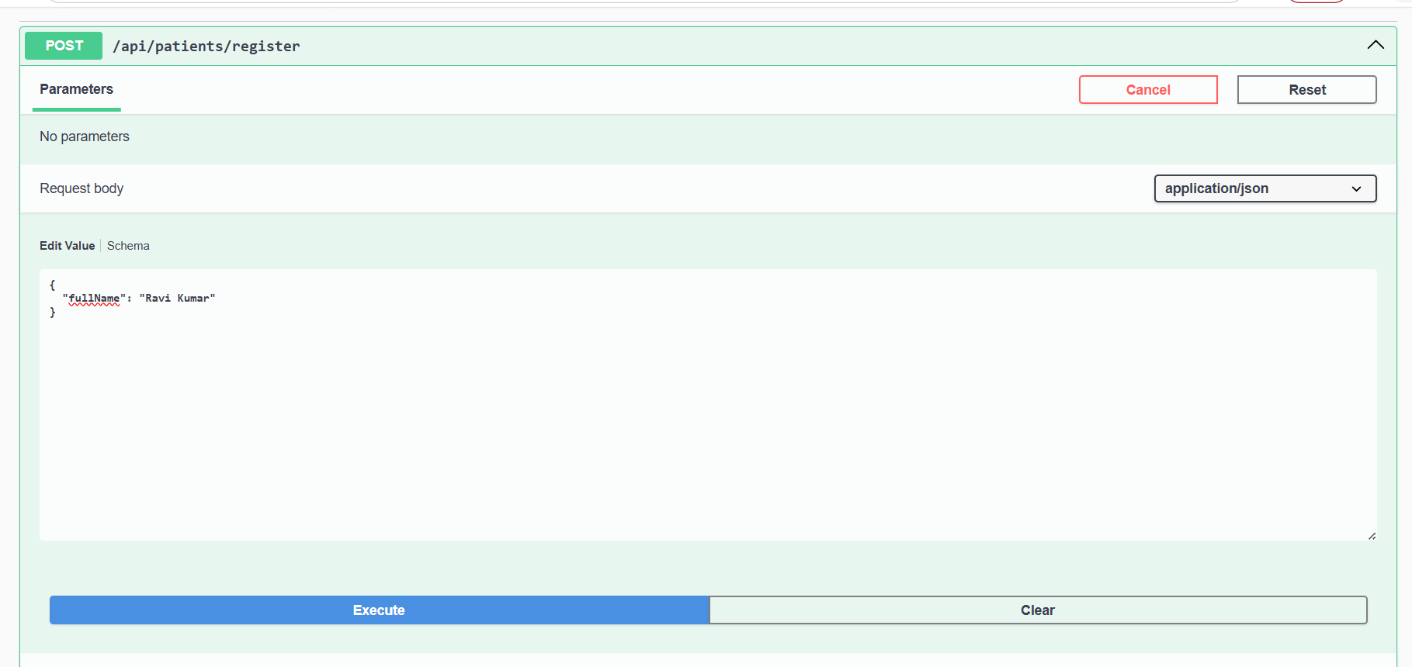
4: CREATE PATIENT

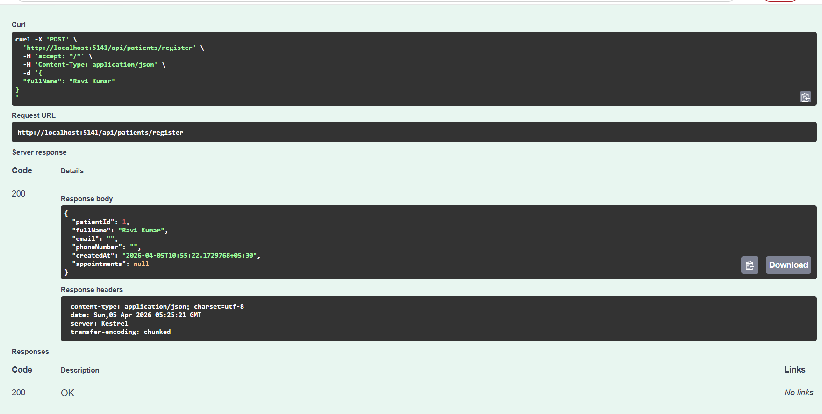

5: GET PATIENT BY ID
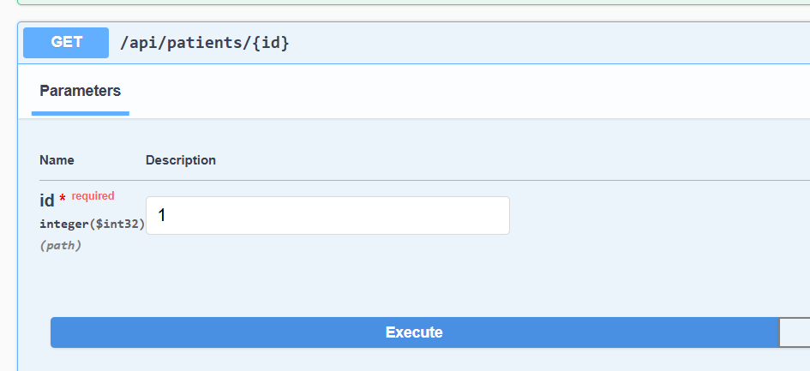

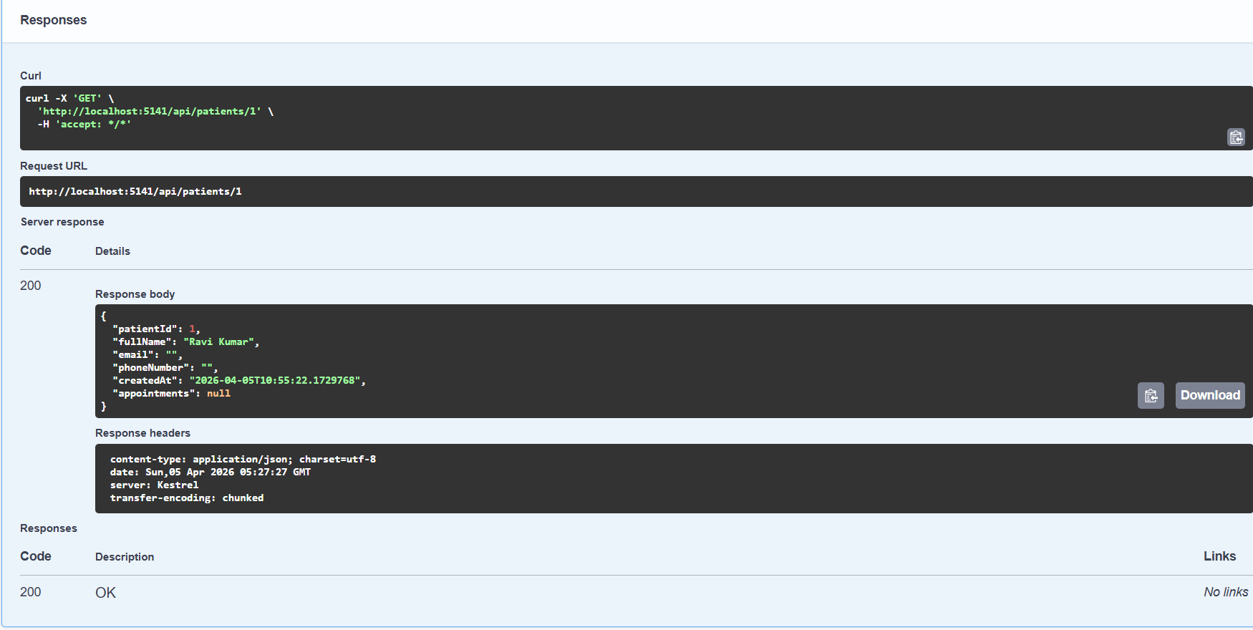

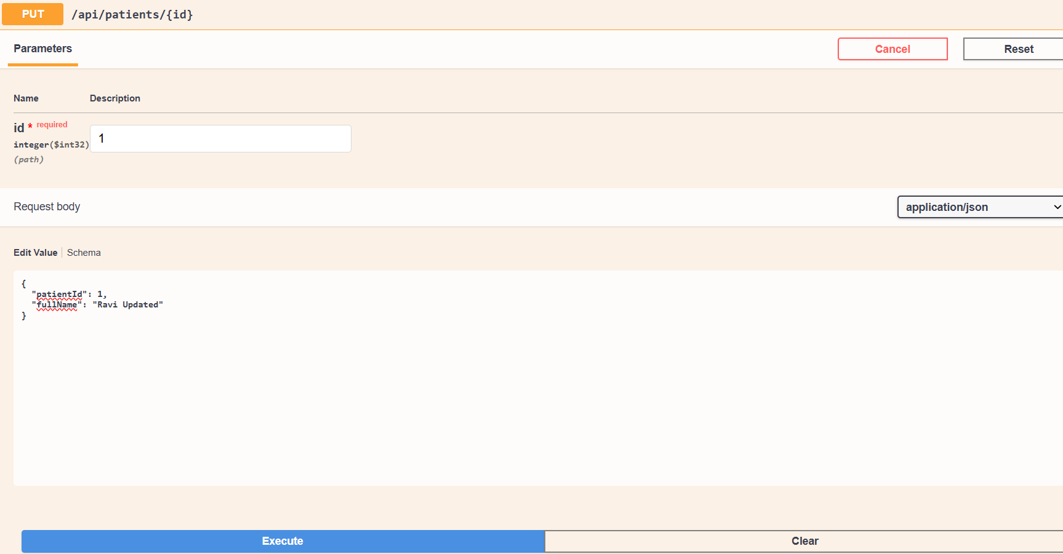
6: UPDATE PATIENT

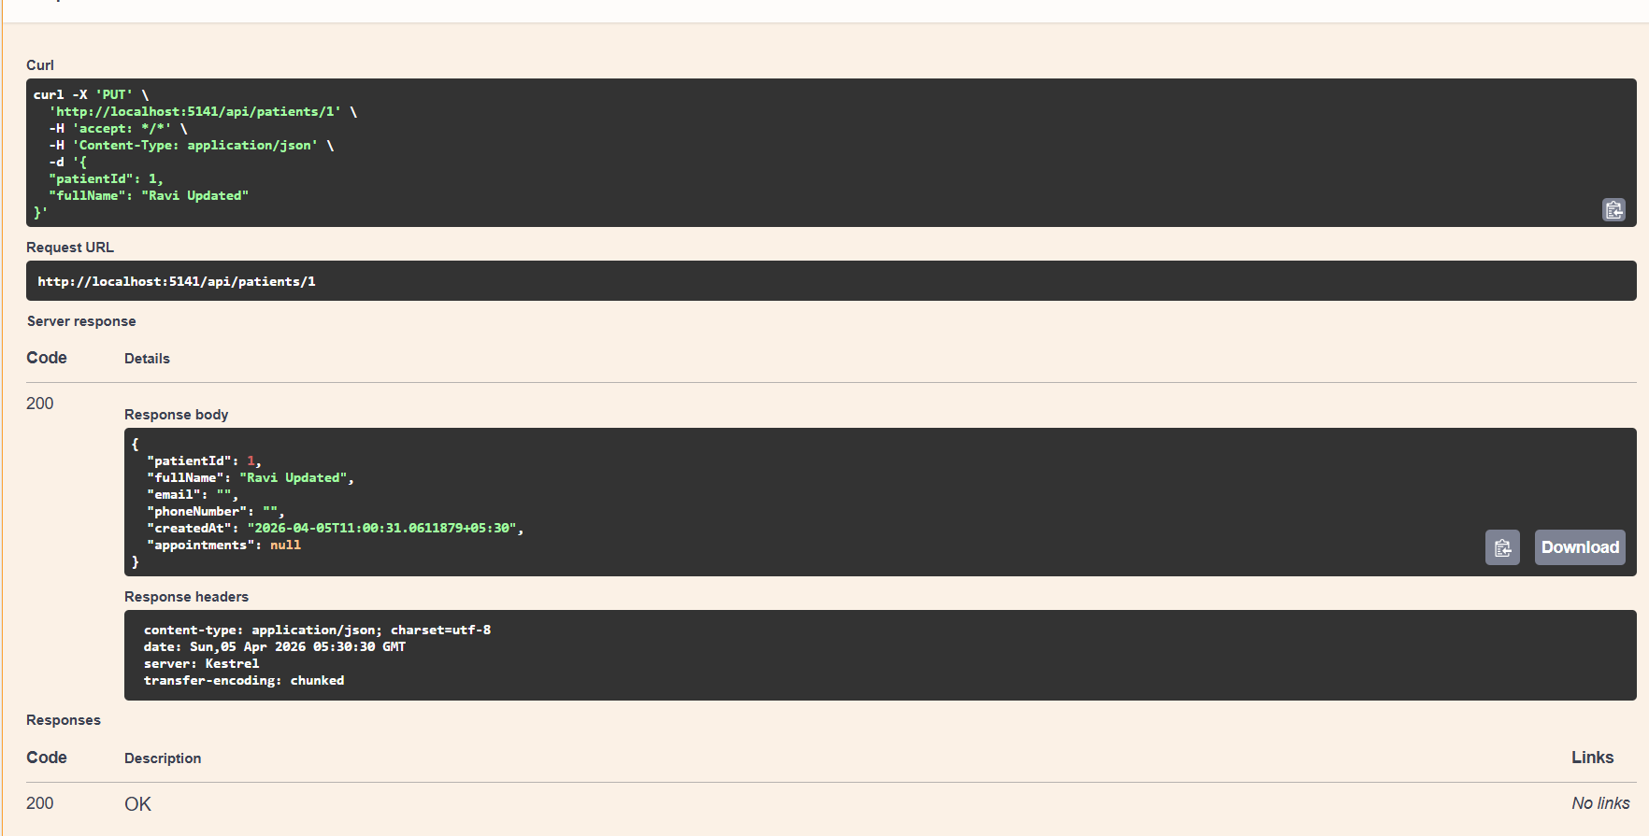

7: BOOK APPOINTMENT
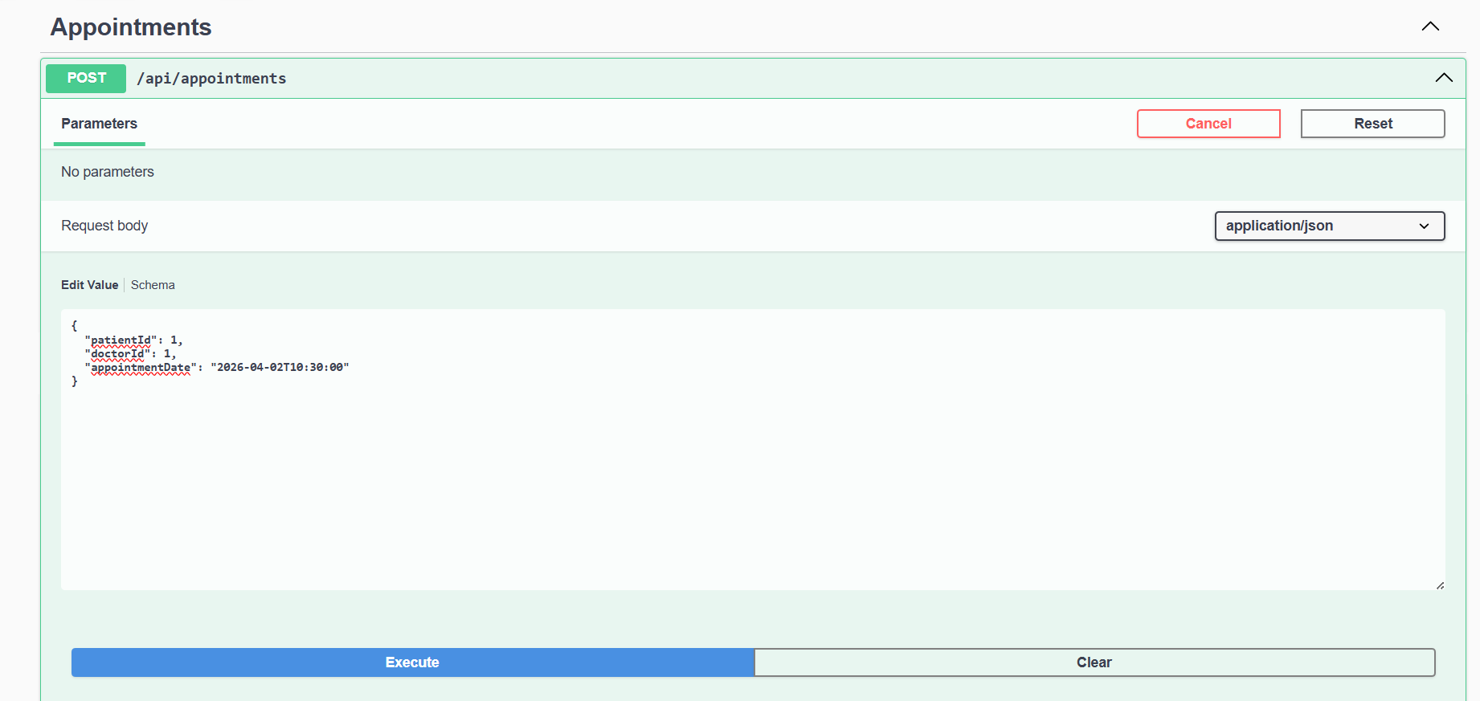

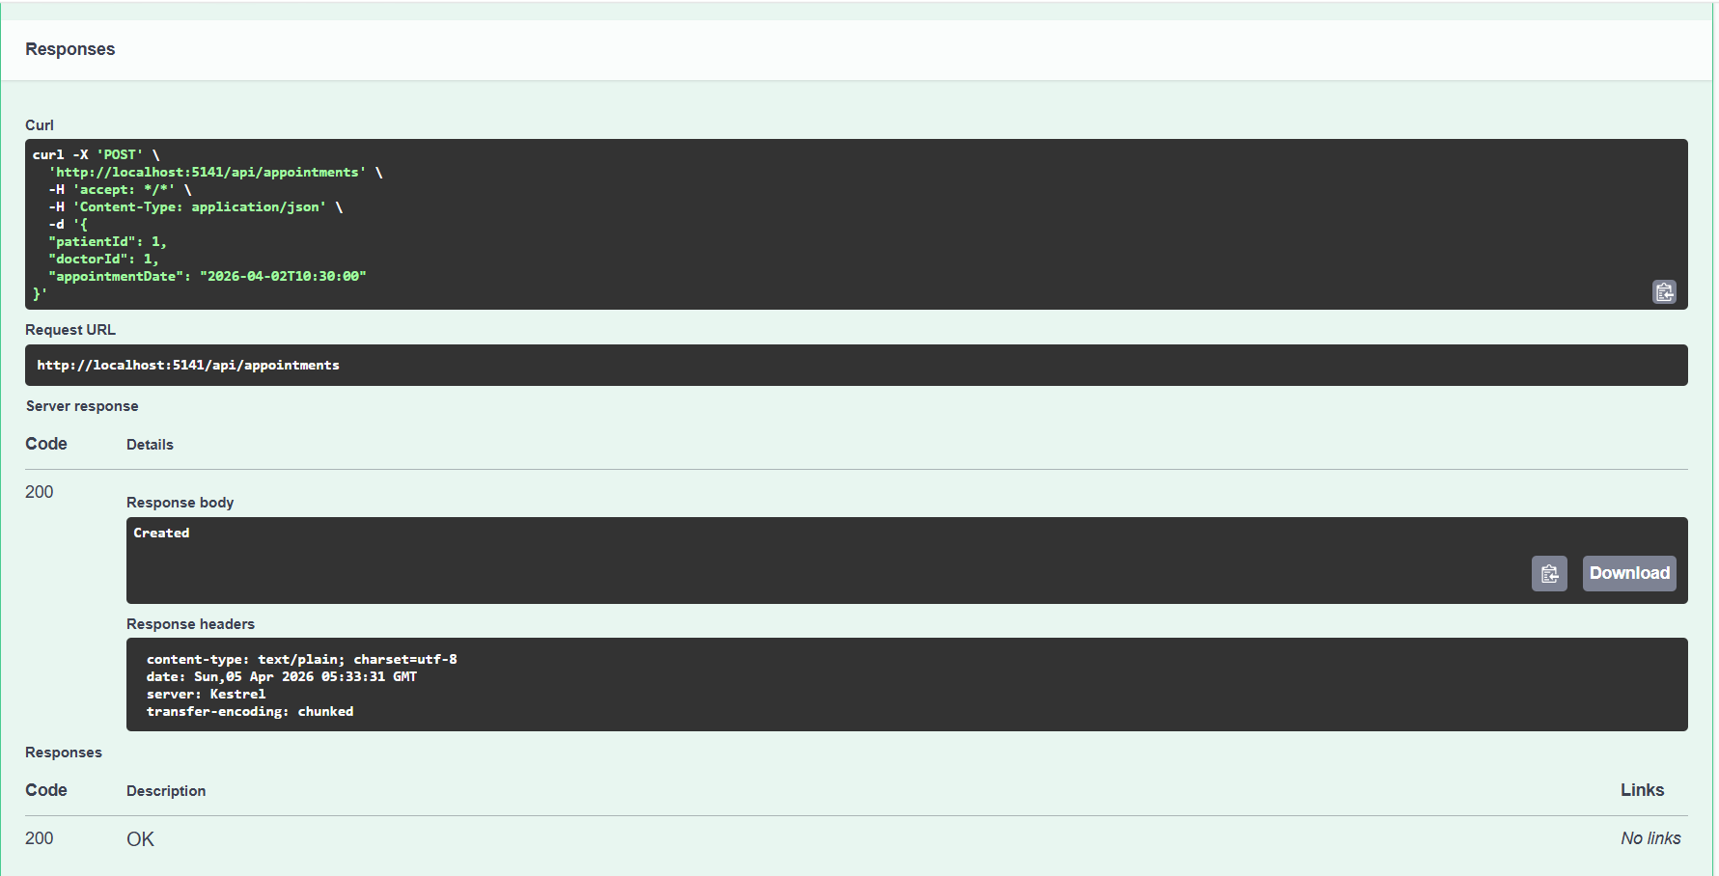

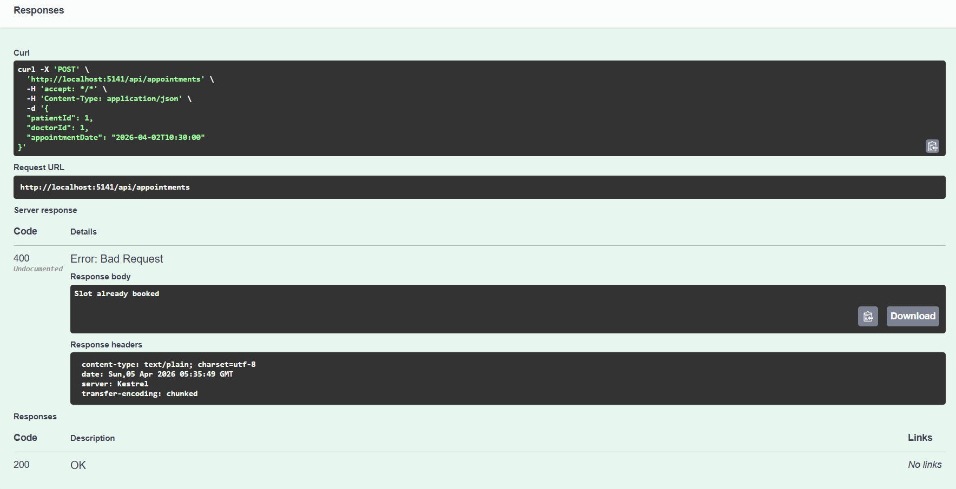
8: VALIDATION

9: CREATE MEDICAL RECORD
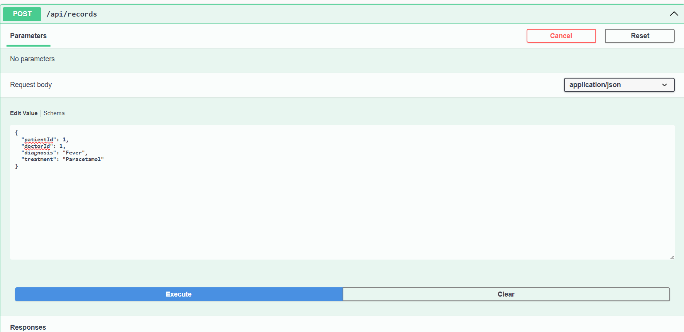

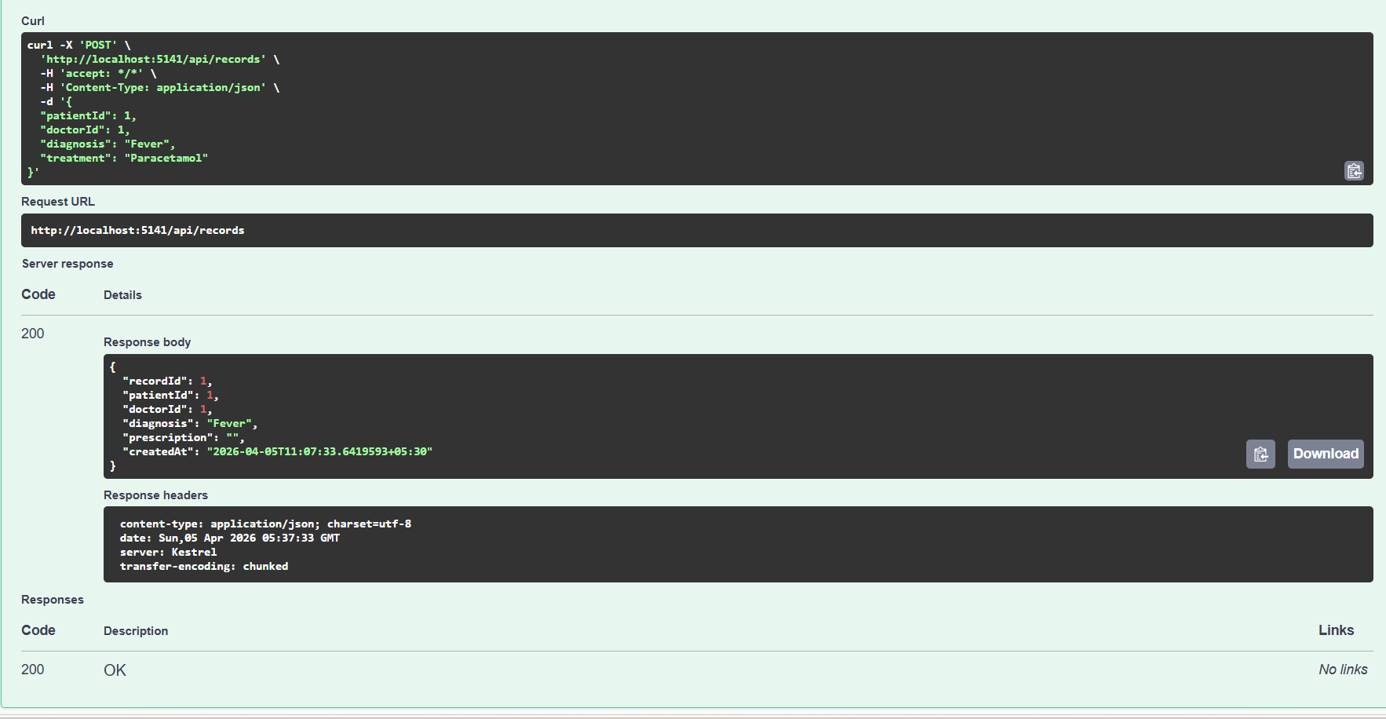

10: FETCH MEDICAL RECORD BY ID
