Cognizant-Upgrad Training Program
Weekly Submission Document
Trainee Information
Name: Ranjita Linganagouda Patil
Email: ranjitapatil541@gmail.com
Batch_Name: .Net with Python – B5_Net Standard
Course: uGE_DotNet FSD(Python)
Training Duration: 16th Feb 2026-30th April 2026
Session Timings: 9:30AM-6:30PM
Faculty: Kunal

Day 1: 08-04-20206
Q1) Food Delivery Platform using microservices.
OrderService.Tests
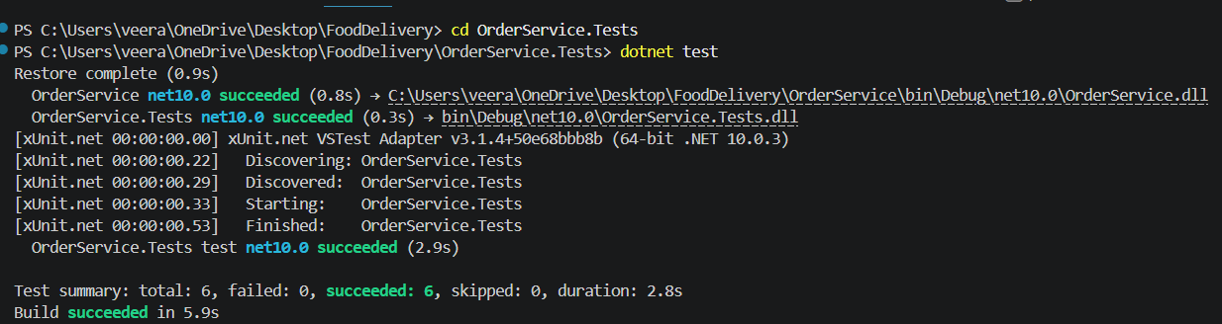

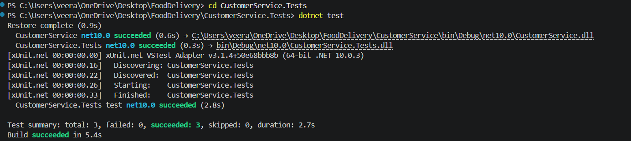
CustomerService.Tests

RestaurantService.Tests
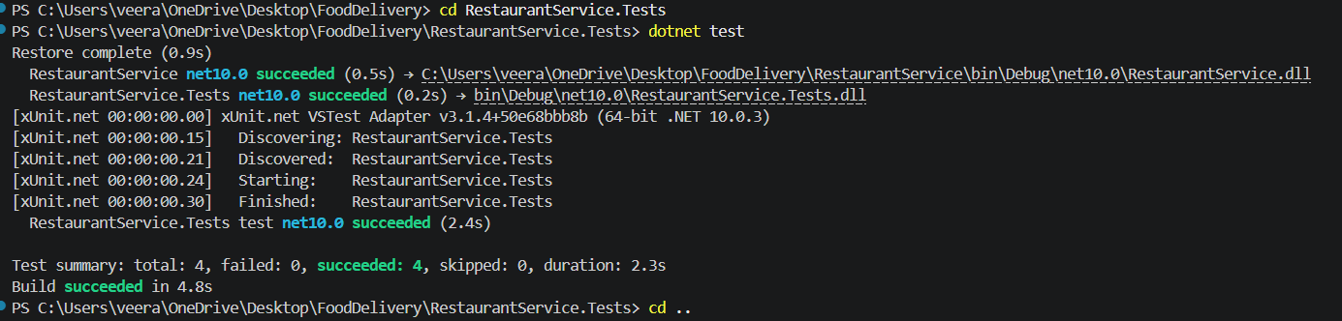

MenuService.Tests
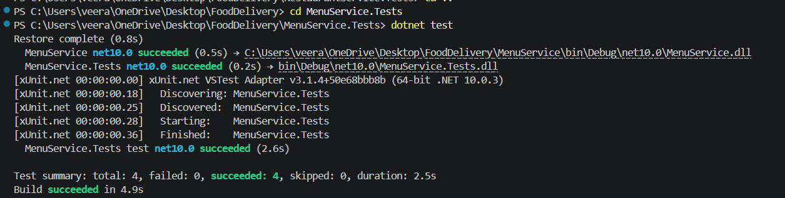

Day 2: 09-04-2026
1. Create & List
mkdir test1
cd test1
ls
2. Multiple Files
touch a.txt b.txt c.txt
ls
3. Add Content
echo "Linux Practice" > a.txt
4. View Content
cat a.txt
5. Copy File
cp a.txt copy_a.txt
ls
6. Rename File
mv b.txt new_b.txt
ls
7. Delete File
rm c.txt
ls
8. Move File
mkdir data
mv a.txt data/
9. Nested Directory
mkdir -p project/logs
10. List Recursively
ls -R
11. Check Permissions
ls -l
12. Change Permission
chmod +x copy_a.txt
13. Remove Write Permission
chmod -w copy_a.txt
14. Overwrite File
echo "Hello World" > file.txt
15. Append Data
echo "Second Line" >> file.txt
16. Use Pipe
cat file.txt | grep "Hello"
17. Combine Commands
cat file.txt | wc -l
18. Current User
whoami
19. System Date
date
20. Running Processes
ps
21. Simple Script
nano hello.sh
chmod +x hello.sh
./hello.sh
22. Username Script
nano user.sh
23. Date Script
nano date.sh
24. Variables
nano var.sh
25. Conditional
nano check.sh
26. Loop
nano loop.sh
27. Combine Script
nano final.sh
28. Final Challenge
touch x.txt y.txt z.txt
echo "File X" > x.txt
echo "File Y" > y.txt
echo "File Z" > z.txt
mkdir folder2
mv x.txt folder2/
cat y.txt

Day 3: 10-04-2026
Python
Q1) Take a number and print its square and cube
num = int(input("Enter a number: "))
square = num * num
cube = num * num * num
print("Square:", square)
print("Cube:", cube)

Q2) Take a string and print:
first character
last character
text = input("Enter a string: ")
if text:
print("First character:", text[0])
print("Last character:", text[-1])
else:
print("Empty string!")
Q3)Print all numbers between 1–20 that are divisible by 3
for i in range(1, 21):
if i % 3 == 0:
print(i)
Q4) Take 3 numbers and print the largest
a = int(input("Enter first number: "))
b = int(input("Enter second number: "))
c = int(input("Enter third number: "))
if a >= b and a >= c:
print("Largest:", a)
elif b >= a and b >= c:
print("Largest:", b)
else:
print("Largest:", c)

Q5)Create a function that returns True if number > 100, else False
def is_greater_than_100(num):
if num > 100:
return True
else:
return False
n = int(input("Enter a number: "))

result = is_greater_than_100(n)

print(result)

Q6) Take input and print:
" Welcome Admin" if name is "admin"
else "Welcome User"
name = input("Enter your name: ")
if name == "admin":
print("Welcome Admin")
else:
print("Welcome User")

Q7) Create a list and print its length without using len()
nums = [10, 20, 30, 40, 50]
count = 0
for item in nums:
count += 1
print("Length of list:", count)

Q8)Print multiplication table of a number

num = int(input("Enter a number: "))
for i in range(1, 11):
print(f"{num} x {i} = {num*i}")

Q9) Count how many numbers in list are greater than 10
nums = [5, 12, 8, 20, 3, 15]
count = 0
for num in nums:
if num > 10:
count += 1
print("Count:", count)

Q10) Take a word and print it 5 times using loop
word = input("Enter a word: ")
for i in range(5):
print(word)

Q11) Take a list and create a new list with only odd numbers
nums = [1, 2, 3, 4, 5, 6, 7]
odd_nums = []
for num in nums:
if num % 2 != 0:
odd_nums.append(num)
print("Odd numbers:", odd_nums)

Q12) Check if a number is prime
num = int(input("Enter a number: "))

if num <= 1:
print("Not a prime number")
else:
for i in range(2, int(num**0.5) + 1):
if num % i == 0:
print("Not a prime number")
break
else:
print("Prime number")

if num <= 1:
print("Not a prime number")
else:
for i in range(2, int(num**0.5) + 1):
if num % i == 0:
print("Not a prime number")
break
else:
print("Prime number")

Q13)Find second largest number in a list
nums = [10, 20, 5, 40, 30]

# Remove duplicates
nums = list(set(nums))
nums.sort()

print("Second largest:", nums[-2])

14.Take a sentence and count:
👉 vowels
👉 consonants

text = input("Enter a sentence: ")

vowels = 0
consonants = 0

vowel_set = "aeiouAEIOU"

for ch in text:
if ch.isalpha():
if ch in vowel_set:
vowels += 1
else:
consonants += 1

print("Vowels:", vowels)
print("Consonants:", consonants)

Q15)Create dictionary:
👉 keys = numbers (1–5)
👉 values = cube of numbers

cube_dict = {}
for i in range(1, 6):
cube_dict[i] = i ** 3
print(cube_dict)

Q16) Replace all spaces in string with _

text = input("Enter a sentence: ")
new_text = text.replace(" ", "_")

print(new_text)

Q17) Generate 5 random numbers and store in list

import random
nums = []

for i in range(5):
num = random.randint(1, 100)
nums.append(num)

print(nums)

Q18) Write a program:
👉 count how many times a number appears in list

nums = [1, 2, 3, 2, 4, 2, 5]

target = int(input("Enter number to count: "))

count = 0

for num in nums:
if num == target:
count += 1

print("Count:", count)

Q19) Read a file and print only lines that contain word "Python"

with open("test.txt", "r") as file:
for line in file:
if "Python" in line:
print(line.strip())

Q20) Handle exception:
👉 user enters string instead of number → print custom error

try:
num = int(input("Enter a number: "))
print("You entered:", num)

except ValueError:
print("Error: Invalid input! Enter numbers only.")

Q21).Check if two strings are anagrams
👉 ("listen", "silent")

str1 = input("Enter first string: ")
str2 = input("Enter second string: ")
if sorted(str1.lower()) == sorted(str2.lower()):
print("Anagram")
else:
print("Not Anagram")

Q22) Flatten a list:
[1, [2,3], [4,5]] → [1,2,3,4,5]

nums = [1, [2, 3], [4, 5]]

flat_list = []

# Loop
for item in nums:
if isinstance(item, list):
for i in item:
flat_list.append(i)
else:
flat_list.append(item)

print(flat_list)

Q23) Create dictionary from two lists:
keys = ["a","b","c"]
values = [1,2,3]

keys = ["a", "b", "c"]
values = [1, 2, 3]
result = {}

for i in range(len(keys)):
result[keys[i]] = values[i]
print(result)

Q24) Find all duplicate elements in a list
nums = [1, 2, 3, 2, 4, 1, 5]

seen = set()
duplicates = set()

for num in nums:
if num in seen:
duplicates.add(num)
else:
seen.add(num)

print(list(duplicates))

Q25) Sort a list without using sort()
nums = [5, 2, 9, 1, 7]

n = len(nums)

for i in range(n):
for j in range(0, n - i - 1):
if nums[j] > nums[j + 1]:
nums[j], nums[j + 1] = nums[j + 1], nums[j]

print(nums)

Q26) Create a program:
👉 reverse each word in a sentence
👉 "hello world" → "olleh dlrow"

text = input("Enter a sentence: ")

words = text.split()

result = []

for word in words:
result.append(word[::-1])

final = " ".join(result)

print(final)

Q27) Write a lambda function:
👉 check if number is even or odd
check = lambda x: "Even" if x % 2 == 0 else "Odd"

num = int(input("Enter a number: "))

print(check(num))

Q28) Read CSV and:
👉 print rows where age > 25

import csv

with open("data.csv", "r") as file:
reader = csv.DictReader(file)
for row in reader:
if int(row["age"]) > 25:
print(row)

Q29) Create nested dictionary and:
👉 print only values using loop

students = {
"s1": {"name": "Ranjita", "age": 22},
"s2": {"name": "Patil", "age": 26}
}

for student in students.values():
for value in student.values():
print(value)

Q30) Take list and:
👉 separate into 2 lists:
- even numbers
- odd numbers
nums = [1, 2, 3, 4, 5, 6, 7]
even = []
odd = []
for num in nums:
if num % 2 == 0:
even.append(num)
else:
odd.append(num)
print("Even numbers:", even)
print("Odd numbers:", odd)

Day 4: 11-04-2026
Q1) Create a class Vehicle with:
- attributes: brand, speed
- method: move() → returns "Vehicle is moving"
Create a subclass Car that:
- overrides move() → returns "Car is moving fast"
👉 Create object and call method.

class Vehicle:
def __init__(self, brand, speed):
self.brand = brand
self.speed = speed

def move(self):
return "Vehicle is moving"

class Car(Vehicle):
def move(self):
return "Car is moving fast"

car1 = Car("Toyota", 120)

print(car1.move())

Q2) Create a class Employee:
- attributes: name, salary
- method: display_details()
Create subclass Manager:
- add attribute: department
- override method to include department
class Employee:
def __init__(self, name, salary):
self.name = name
self.salary = salary

def display_details(self):
return f"Name: {self.name}, Salary: {self.salary}"
class Manager(Employee):
def __init__(self, name, salary, department):
# Call parent constructor
super().__init__(name, salary)
self.department = department

def display_details(self):
return f"Name: {self.name}, Salary: {self.salary}, Department: {self.department}"

m1 = Manager("Ranjita", 50000, "IT")

print(m1.display_details())

Q3) Create a class Shape:
- method area() → returns 0
Create:
- Rectangle (length, width)
- Circle (radius)
👉 Override area() in both.

import math

class Shape:
def area(self):
return 0

class Rectangle(Shape):
def __init__(self, length, width):
self.length = length
self.width = width

def area(self):
return self.length * self.width

class Circle(Shape):
def __init__(self, radius):
self.radius = radius

def area(self):
return math.pi * self.radius * self.radius
rect = Rectangle(5, 3)
circle = Circle(4)

print("Rectangle Area:", rect.area())
print("Circle Area:", circle.area())

Q4) Create a class BankAccount:
- attributes: account_number, balance
- method: deposit(), withdraw()
👉 Add validation:
- cannot withdraw more than balance

class BankAccount:
def __init__(self, acc_no, balance):
self.acc_no = acc_no
self.balance = balance

def deposit(self, amt):
self.balance += amt

def withdraw(self, amt):
if amt > self.balance:
print("Not enough balance")
else:
self.balance -= amt

acc = BankAccount("123", 1000)

acc.deposit(500)
acc.withdraw(200)
print(acc.balance)

Q5)Create a class Student:
- private attribute: __marks
- method: set_marks() (validation: 0–100)
- method: get_marks()

class Student:
def __init__(self):
self.__marks = 0 # private variable

def set_marks(self, marks):
if 0 <= marks <= 100:
self.__marks = marks
else:
print("Invalid marks")

def get_marks(self):
return self.__marks

s = Student()

s.set_marks(85)
print("Marks:", s.get_marks())

s.set_marks(150) # invalid
print("Marks:", s.get_marks())

Q6) Create a class Book:
- attributes: title, author
- override __str__() → "Title by Author"

class Book:
def __init__(self, title, author):
self.title = title
self.author = author

def __str__(self):
return f"{self.title} by {self.author}"

b1 = Book("Python Basics", "Ranjita")

print(b1)

Q7) Create a class CartItem:
- attributes: name, price, quantity
- override __repr__() to display full info
class CartItem:
def __init__(self, name, price, quantity):
self.name = name
self.price = price
self.quantity = quantity
def __repr__(self):
return f"CartItem(name='{self.name}', price={self.price}, quantity={self.quantity})"
item = CartItem("Laptop", 50000, 2)
print(item)

Q8)Create a generator that:
- yields squares of numbers from 1 to n
def square_generator(n):
for i in range(1, n + 1):
yield i * i

n = int(input("Enter a number: "))

for value in square_generator(n):
print(value)

Q9) Create a generator for:
- even numbers up to n
def even_generator(n):
for i in range(1, n + 1):
if i % 2 == 0:
yield i

n = int(input("Enter a number: "))

for num in even_generator(n):
print(num)

Q10).Create a custom iterator class:
- that iterates over a list in reverse order

class ReverseIterator:
def __init__(self, data):
self.data = data
self.index = len(data) - 1 # start from last

def __iter__(self):
return self

def __next__(self):
if self.index < 0:
raise StopIteration
value = self.data[self.index]
self.index -= 1
return value

nums = [1, 2, 3, 4, 5]

rev = ReverseIterator(nums)

for num in rev:
print(num)

Q11)Given a list of numbers:
👉 Use map() to:
- convert all numbers into their cubes

nums = [1, 2, 3, 4, 5]
cubes = list(map(lambda x: x**3, nums))
print(cubes)

Q12.)Given a list of names:
👉 Use filter() to:
- return only names with length > 5
names = ["Ranjita", "Ram", "Seeta", "Samantha", "Amit"]
result = list(filter(lambda name: len(name) > 5, names))
print(result)

Q13) Given a list:
👉 Use reduce() to:
- find product of all elements
from functools import reduce

nums = [1, 2, 3, 4]

product = reduce(lambda x, y: x * y, nums)

print(product)

Q14)Create a decorator:
- that prints execution time of a function
👉 Apply it to a function that runs a loop

import time

def time_decorator(func):
def wrapper():
start = time.time()

func() # call original function

end = time.time()
print("Execution Time:", end - start, "seconds")

return wrapper

@time_decorator
def run_loop():
for i in range(1000000):
pass

# Call function
run_loop()

Q15) Create a decorator:
- that checks if user is "admin"
- only then allows function execution
👉 Otherwise print "Access Denied"

def admin_required(func):
def wrapper(user):
if user == "admin":
return func(user)
else:
print("Access Denied")
return wrapper

@admin_required
def delete_data(user):
print("Data deleted successfully")

delete_data("admin") # allowed
delete_data("guest") # denied

Q16) Create a JSON file with:
- multiple users (name, email)
👉 Read file and:
- print only emails ending with "@gmail.com"

import json

with open("users.json", "r") as file:
data = json.load(file)
for user in data:
if user["email"].endswith("@gmail.com"):
print(user["email"])

Q17) Write a regex program to:
extract all email addresses from a string
import re
text = "Contact us at test@gmail.com or admin@yahoo.com and info@outlook.com"
# Regex pattern
emails = re.findall(r"[a-zA-Z0-9._%+-]+@[a-zA-Z0-9.-]+\.[a-zA-Z]+", text)
print(emails)

