Amazon sales data analysis

**Wireframe Documentation**

As per the problem statement, we have divided analysis into three sections: -

Yearly total sales amount

Monthly total sales amount

Year wise monthly sales amount

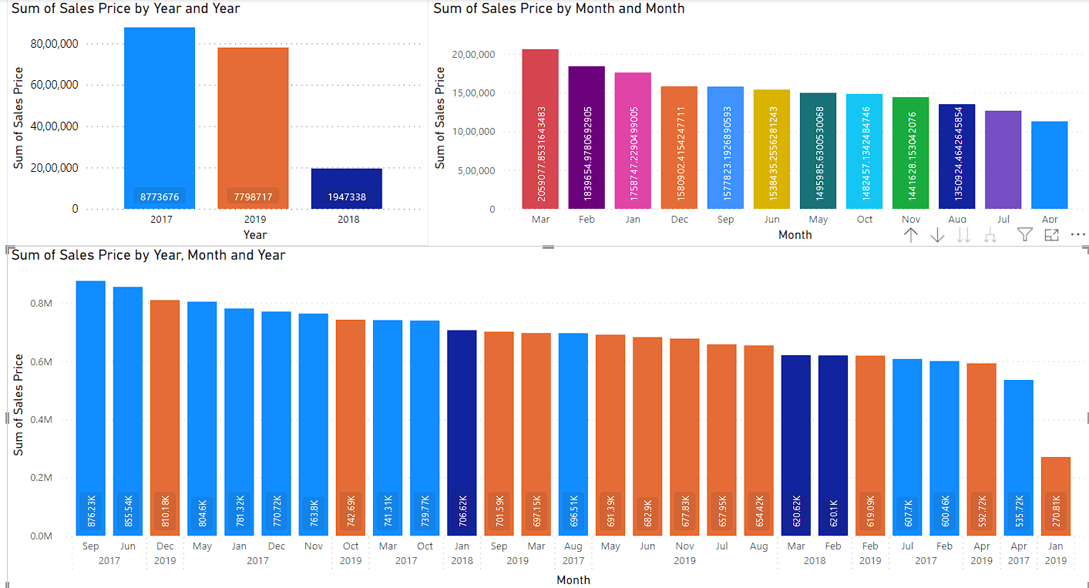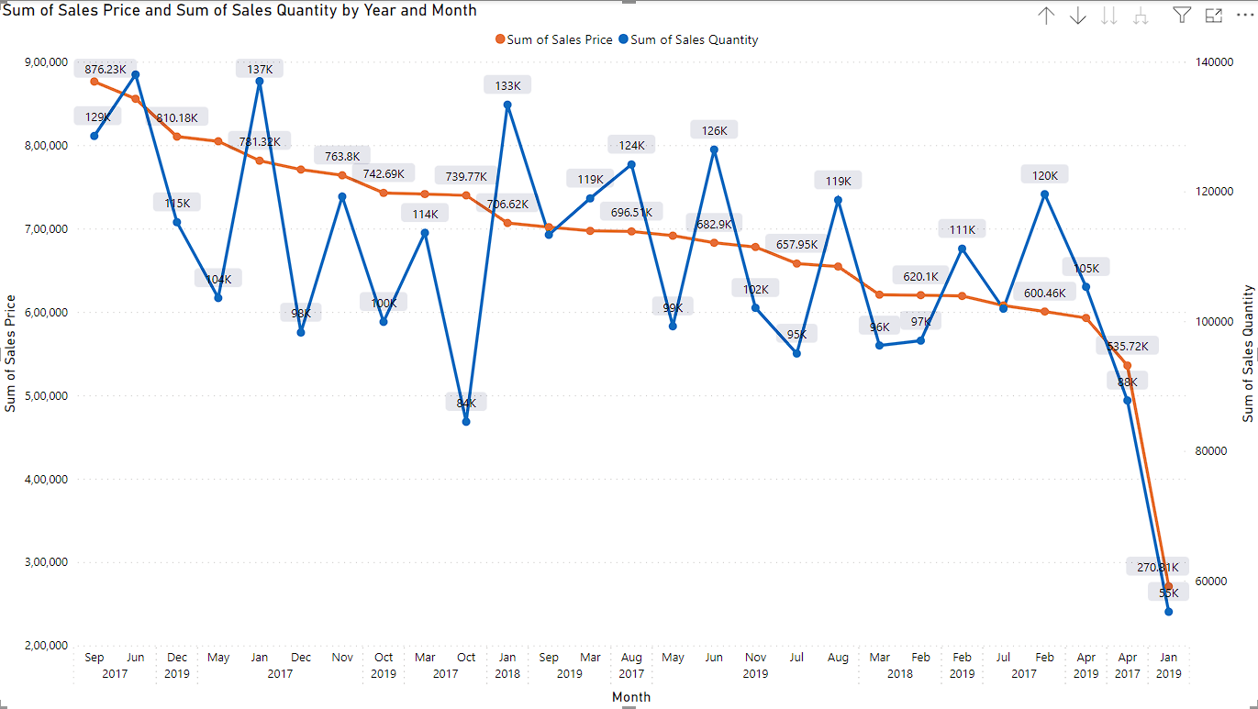year wise sales quantity and amount