**LETSUPGRADE LINUX ADMINSTRATION**

**DAY 3 : ASSIGNMENT 1**

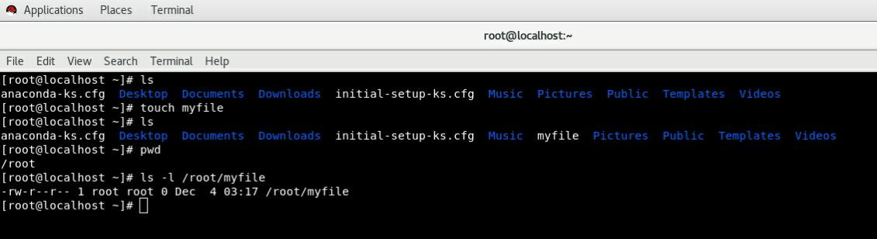**Ans1: Creating And Verifying** myfile **By Using touch command**

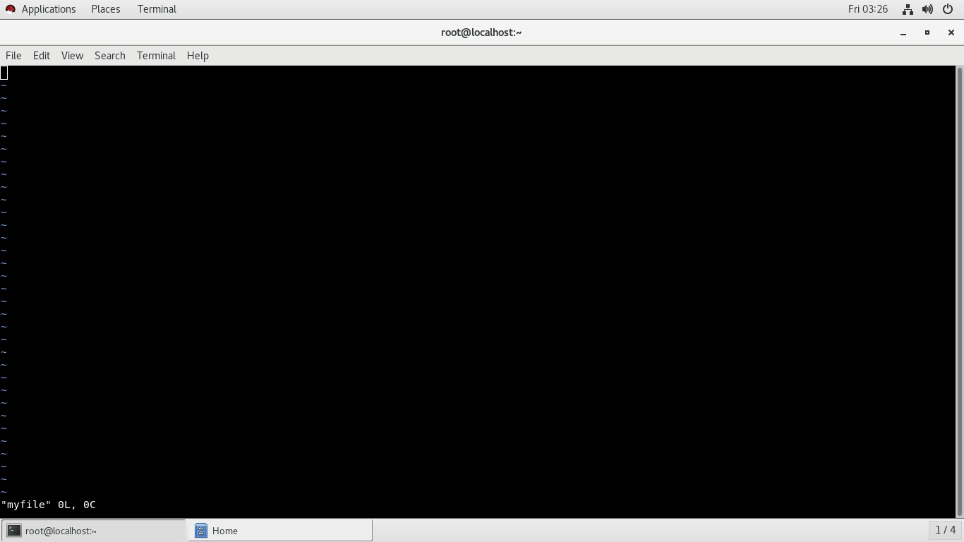**ANS 2.**

**Opening The File Using Vi Editor**

**ANS 3 .**

**Writing The Details And Saving It By Using :wq! Then Opening It By Using cat command**

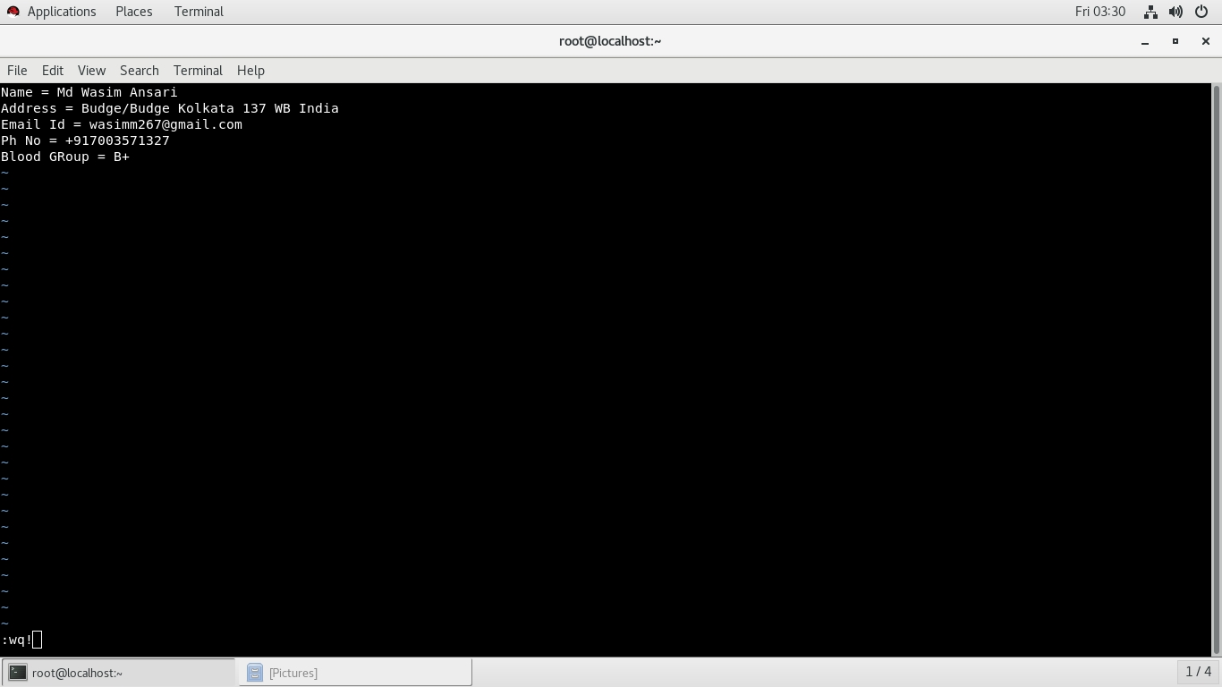

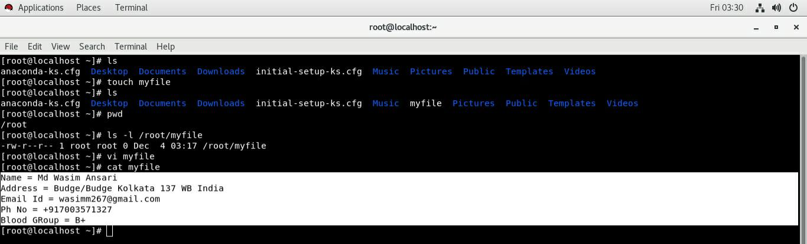

**ANS 4.**

**Creating one single expression to find the name and blood group line**

