**LINUX ADMINISTRATION ESSENTIAL**

**DAY 5 ASSIGNMENT 2**

**1. Add a 10GB disk to the CentOS.**

**Ans.** Verify That Disk Is Added Using **fdisk -l**

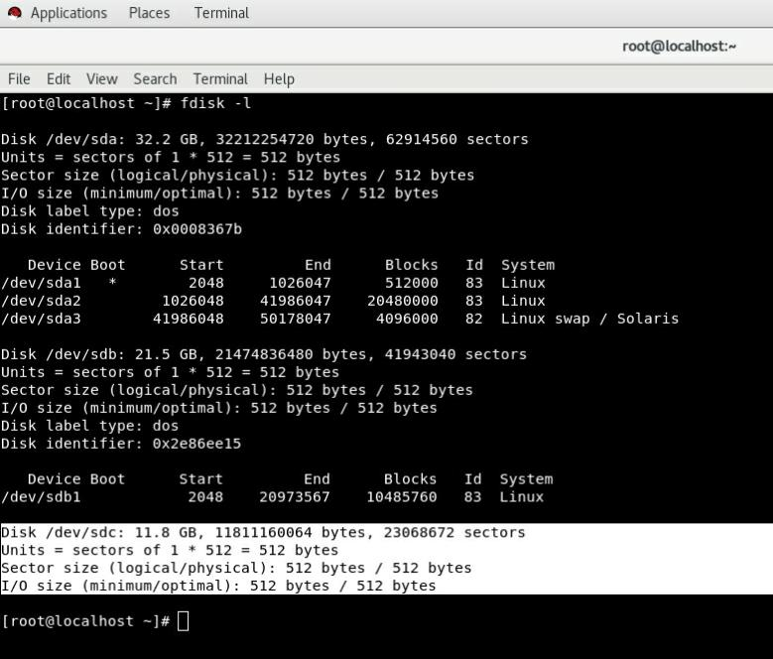

**#I Have Taken 11Gb To Avoid Any Kind Of Storage Issue.**

**2. Create 2 Partitions 4GB and 6GB of Space respectively.**

**Ans.** Creating 2 Partition

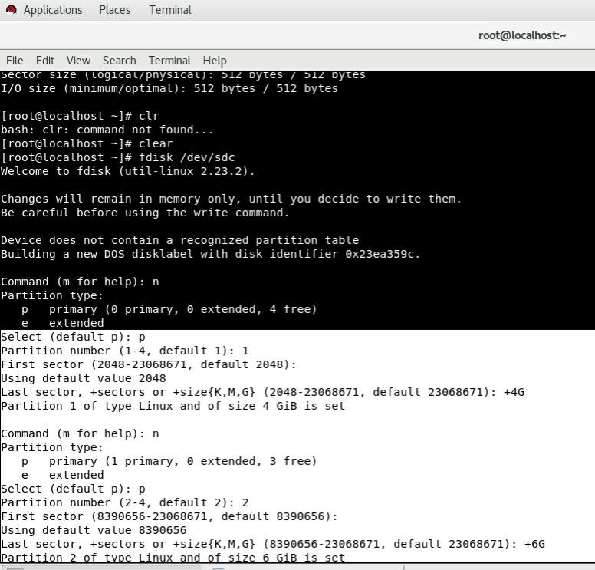

**3. Format 4GB with xfs and 6GB with ext4 file system.**

**Ans.**

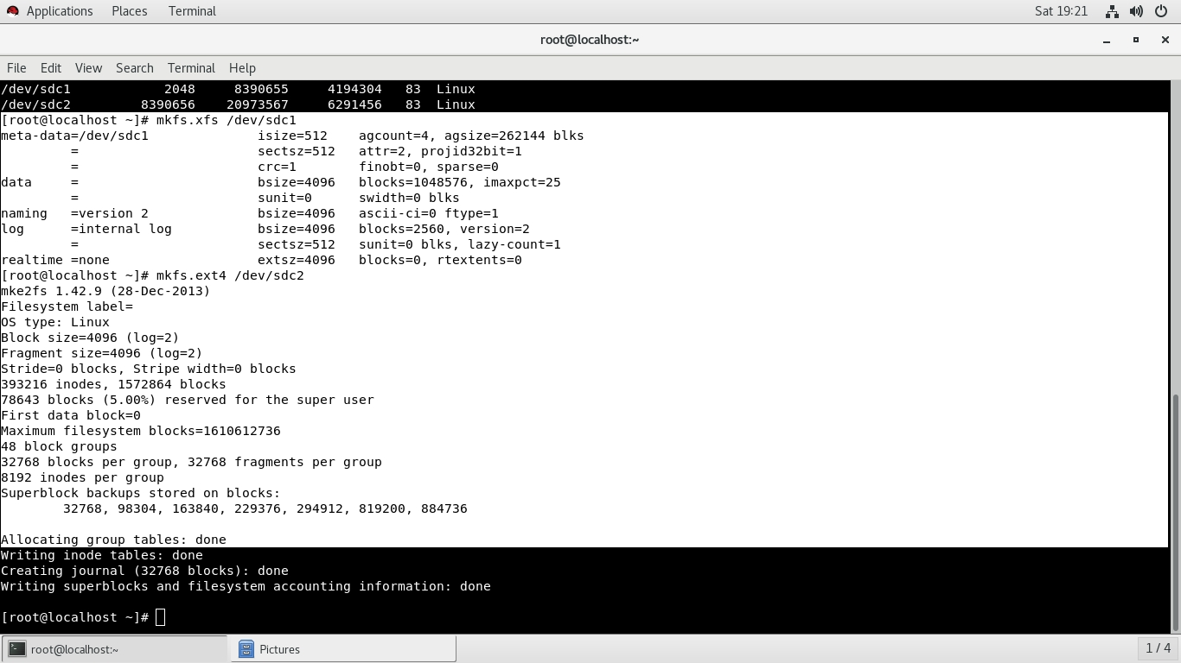Formating And Creating File System Using **mkfs** Command

**4. Mount 4GB and 6GB in /data and /music directory respectively.**

**Ans.**

Creating Mount Point Using **fstab** File

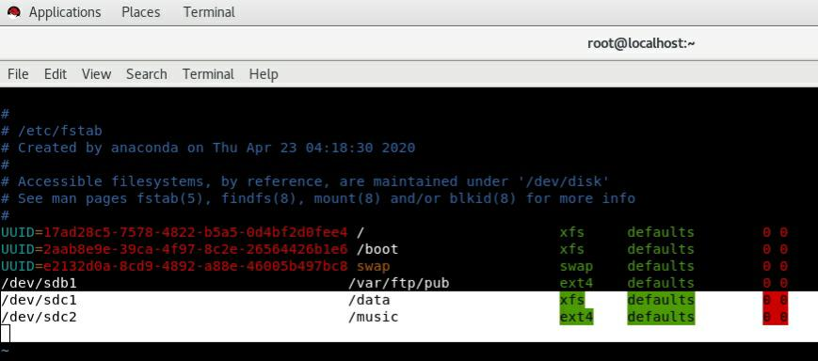

**Verifying Mount Point Is Created**

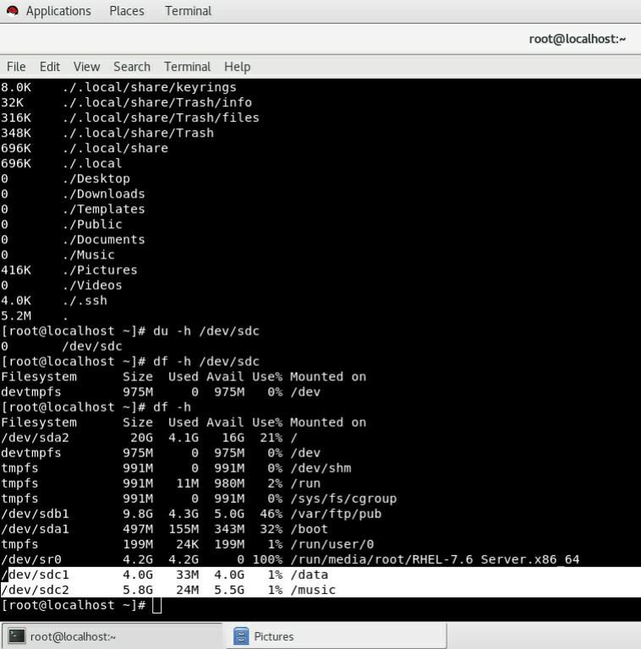

**5. Create one file of 1GB in each of the mount point created above.**

**Ans.** Creating 1Gb File Using **seq > 1000000** Command

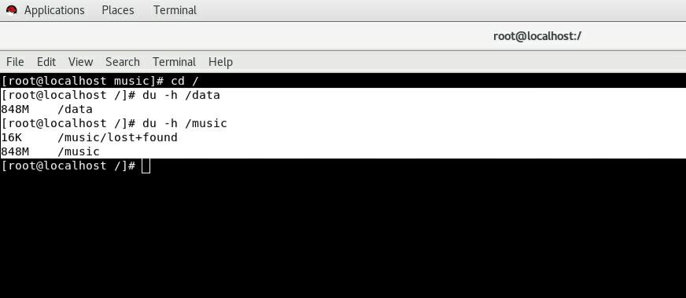

**#Here The File Created Is Having 848 Mb Which Is Closest To 1Gb**

**6. Verify the disk Consumption and disk space free in the mounted partitions.**

**Ans.** Verify Disk Usage Using **df -h** Command

