Step 1: Create EC2 Instance
Login to AWS Console.
Go to:
Amazon EC2 → Launch Instance
Configuration:
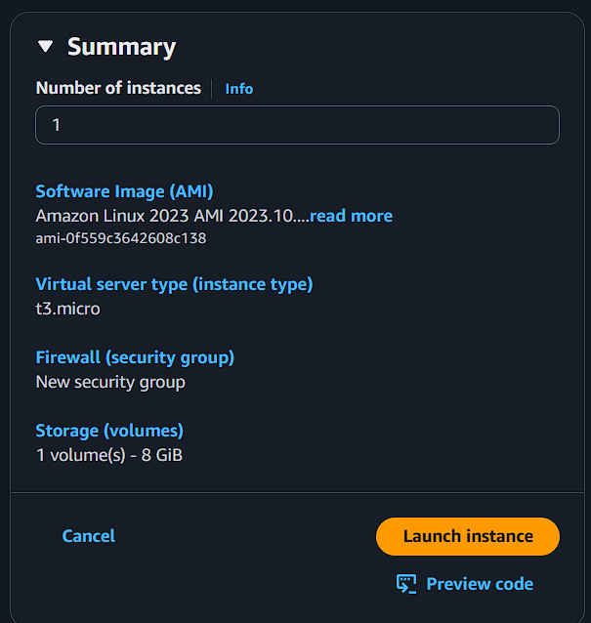
Click Launch Instance.

Step 2: Connect to EC2
ssh -i studentkey.pem ec2-user@<public-ip>

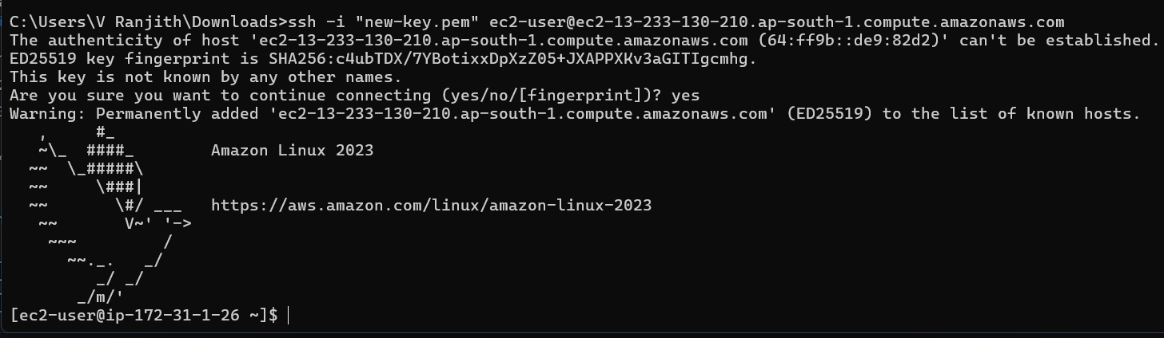

Step 3: Create Test Data
Create some files to simulate application data.
sudo mkdir /labdata
echo "EC2 snapshot recovery lab file" | sudo tee /labdata/file1.txt
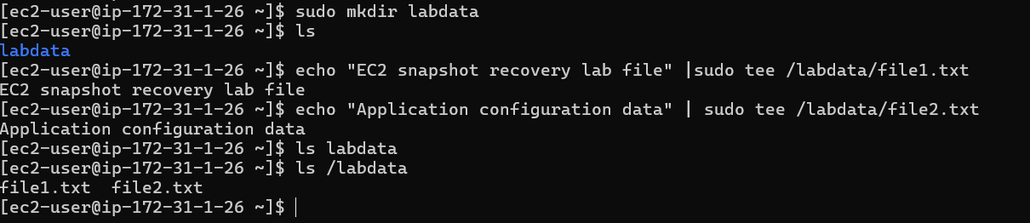
ls /labdata
Expected output:
file1.txt
file2.txt

Step 4: Create Snapshot of Root Disk
Go to EC2 Console → Instances
Select:
studentname-ec2
Open Storage tab.

Copy the Root Volume ID.
Navigate to:
EC2 → Volumes
Select the root volume.
Click:
Actions → Create Snapshot
Configuration:

Field | Value
Name | studentname-rootdisk-snapshot
Description | Backup before corruption
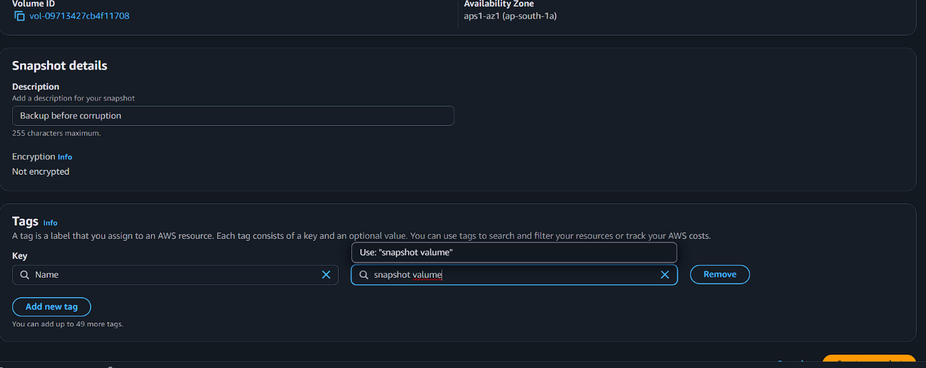
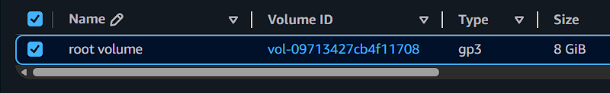
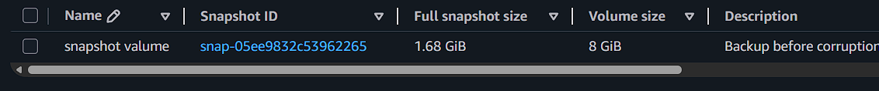
Wait until snapshot state = Completed.

Step 5: Simulate Root Disk Corruption
SSH into the instance.
⚠️ These commands intentionally break the system.
Delete system files:
sudo rm -rf /
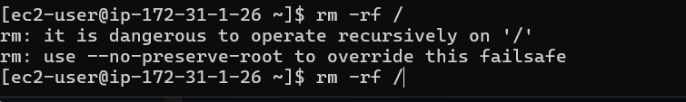
Delete boot files:
sudo rm -rf /boot/*
Reboot the system:
sudo shutdown -r now
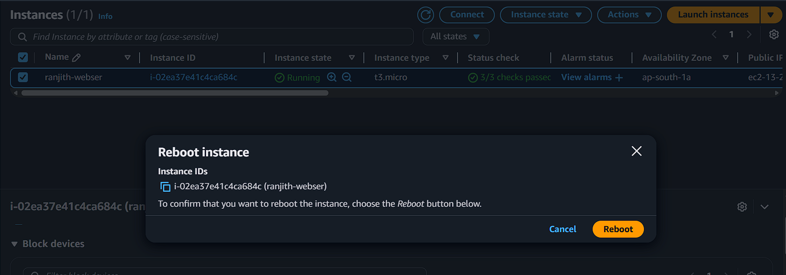

Step 6: Try to Access the Instance
Try SSH again:
ssh -i studentkey.pem ec2-user@<public-ip>
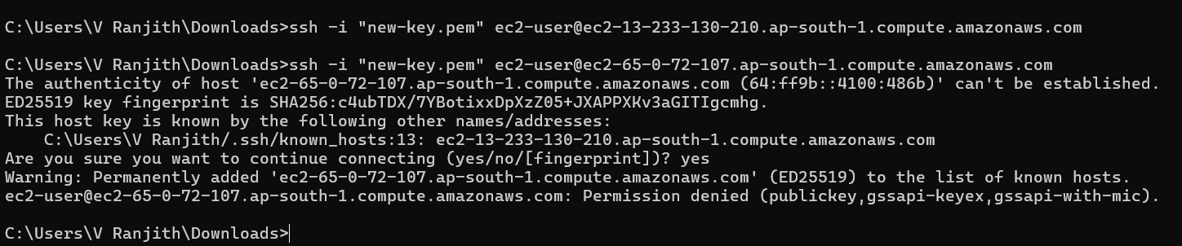

Expected result:
❌ Connection fails or instance fails health checks
This confirms OS disk corruption.

Step 7: Stop the Instance
Go to:
EC2 → Instances
Select:
studentname-ec2
Click:
Instance State → Stop
Wait until instance is stopped.

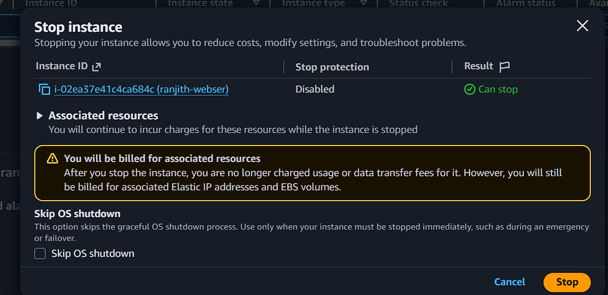
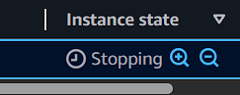

Step 8: Create New Volume from Snapshot
Navigate to:
EC2 → Snapshots
Select:
studentname-rootdisk-snapshot
Click:
Actions → Create Volume
Configuration:
Field | Value
Name | studentname-recovery-volume
Volume Type | gp3
Availability Zone | Same as EC2

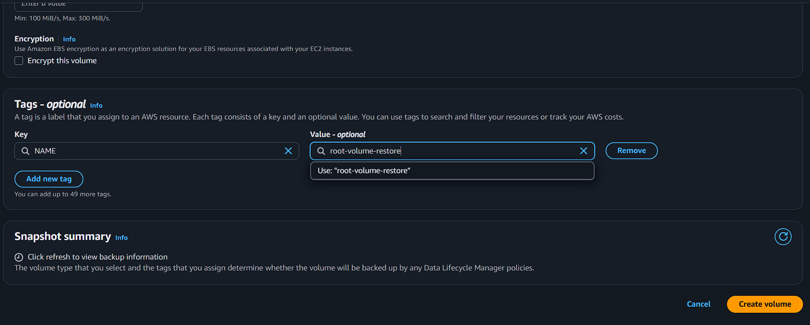

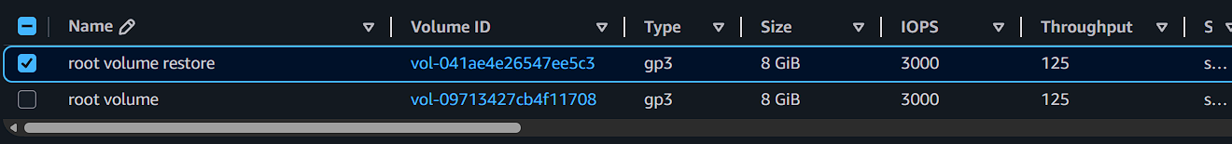
Create the volume.

Step 9: Detach Corrupted Root Disk
Go to:
EC2 → Volumes
Find the volume attached to:
studentname-ec2
Example device name:
/dev/xvda
Click:
Actions → Detach Volume
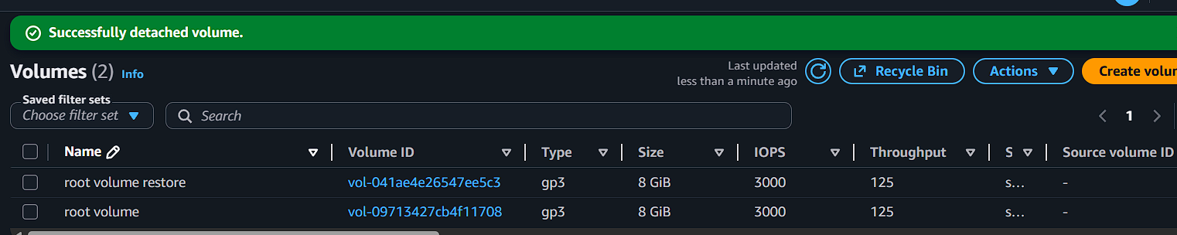

Step 10: Attach Recovery Volume as Root Disk
Select:
studentname-recovery-volume
Click:
Actions → Attach Volume
Configuration:
Field | Value
Instance | studentname-ec2
Device | /dev/xvda

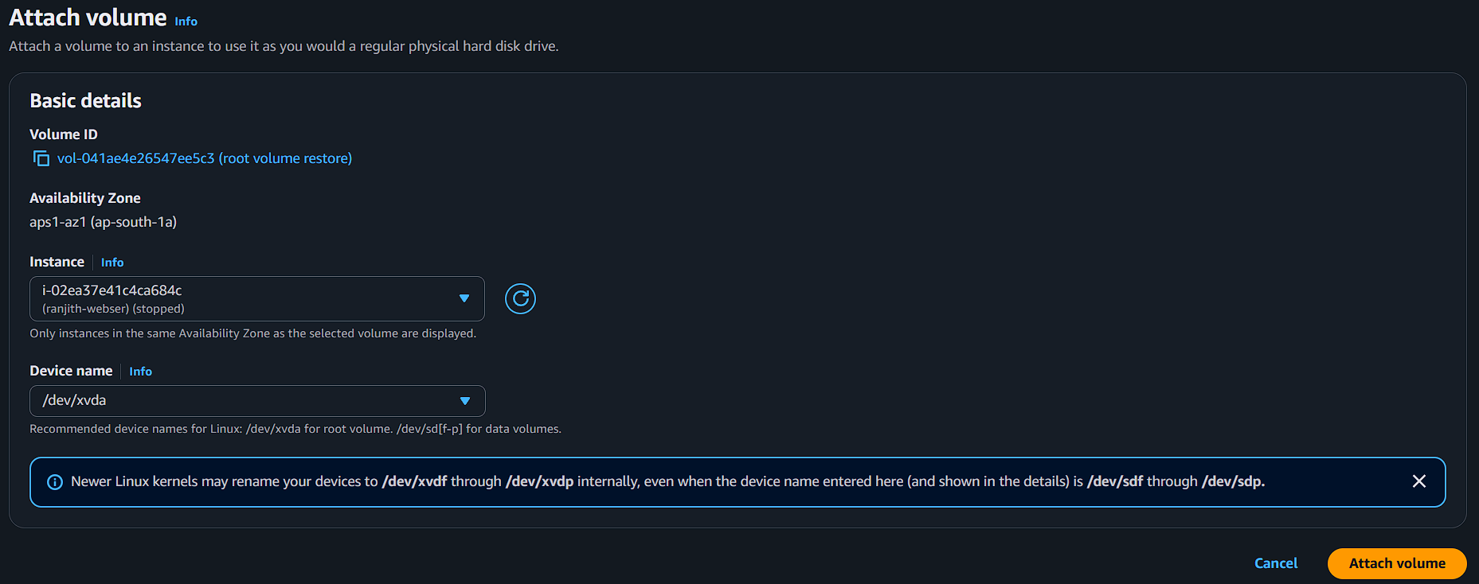
Attach the volume.
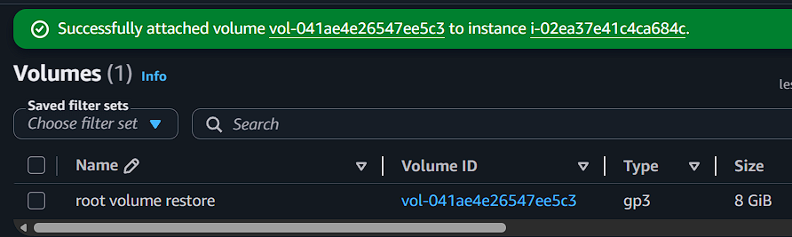

Step 11: Start the Instance
Go to:
EC2 → Instances
Select:
studentname-ec2
Click:
Instance State → Start
Wait until instance is running.
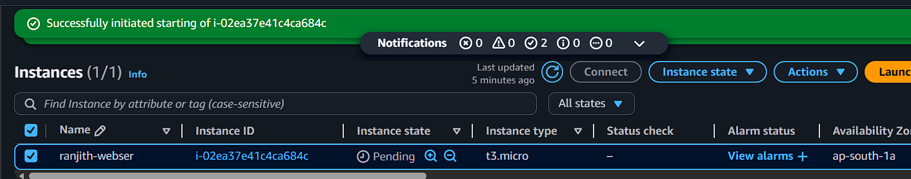
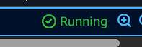

Step 12: Login and Validate
Connect again:
ssh -i studentkey.pem ec2-user@<public-ip>
Check data:
ls /labdata
cat /labdata/file1.txt
Expected output:
EC2 snapshot recovery lab file
This confirms the snapshot successfully restored the OS disk.

