RDS
STEP 1: LAUNCH INSTANCE
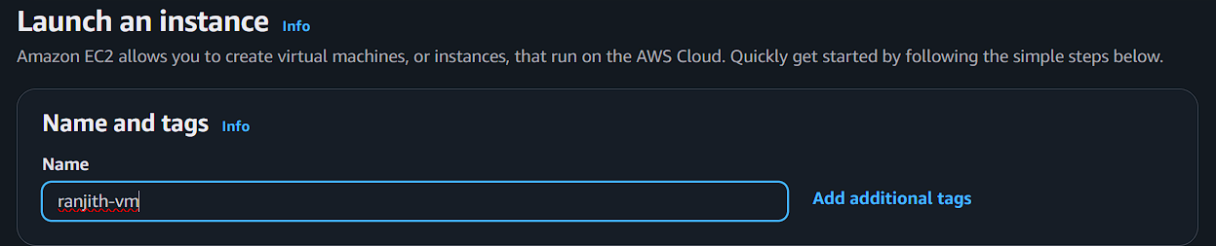
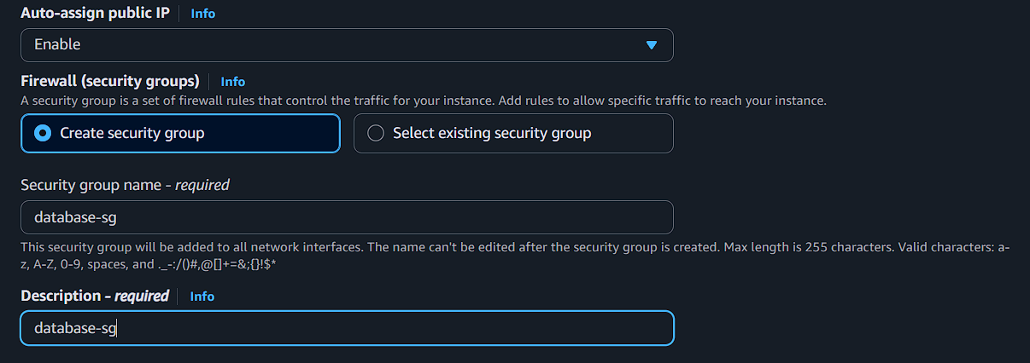
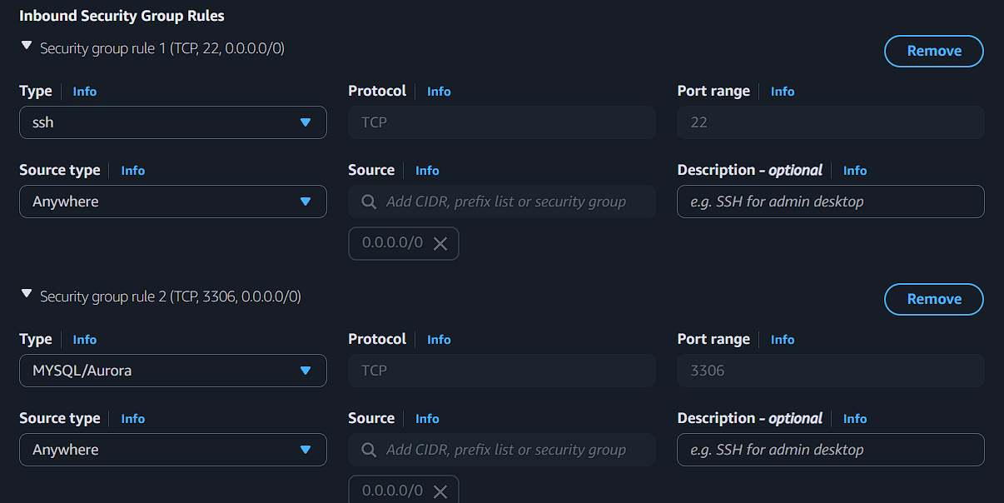

Now create RDS (database)
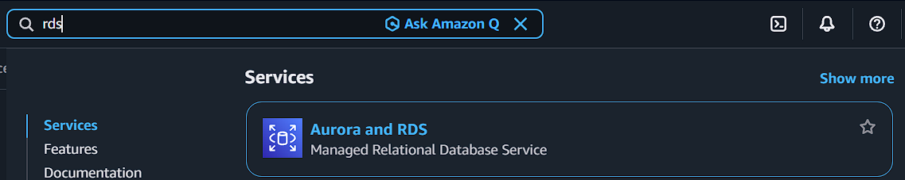
Click create database
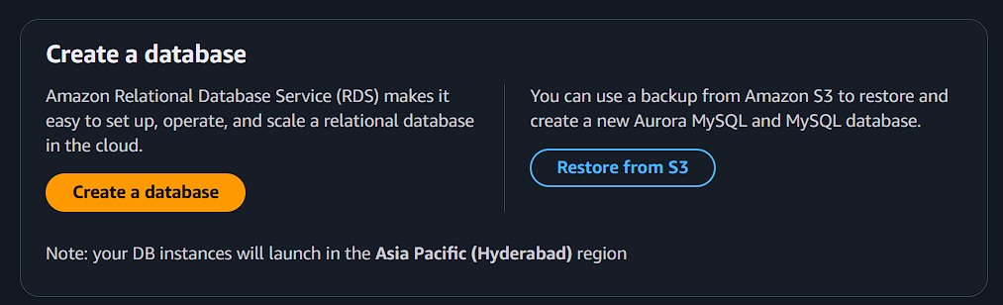
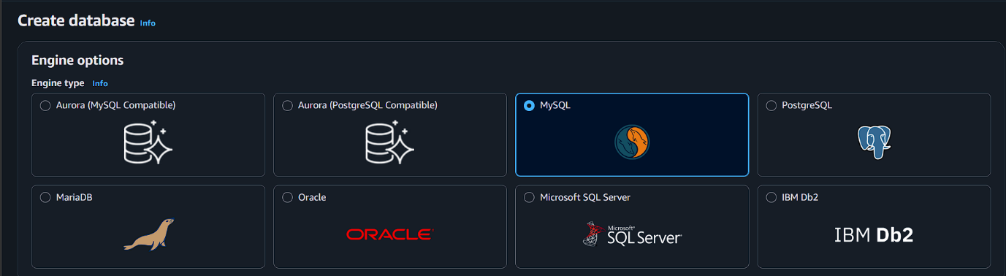
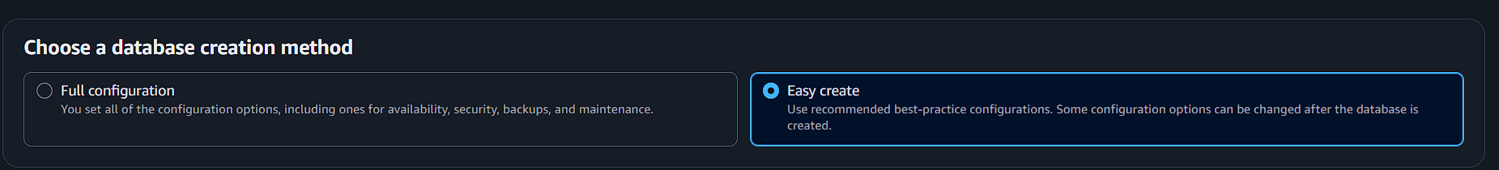
Practice purpose
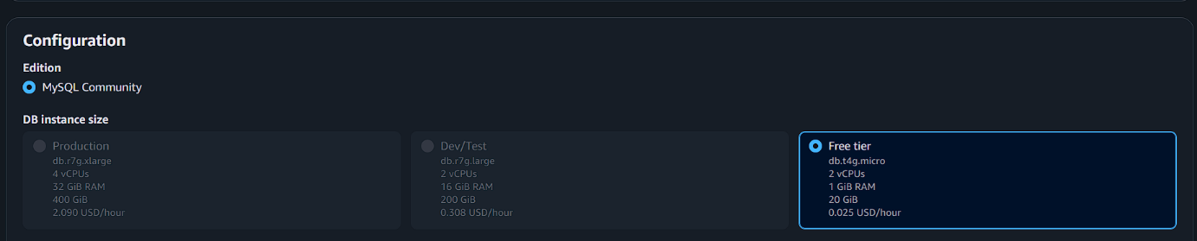
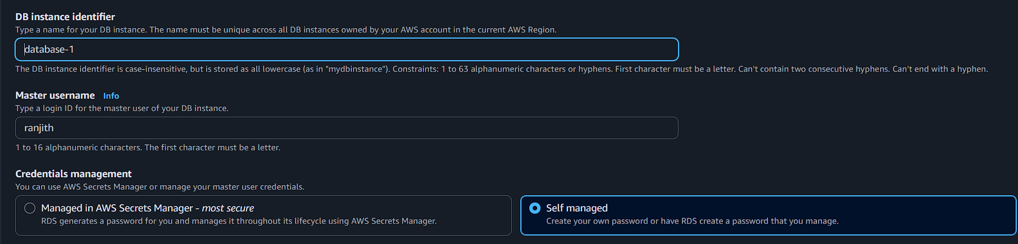
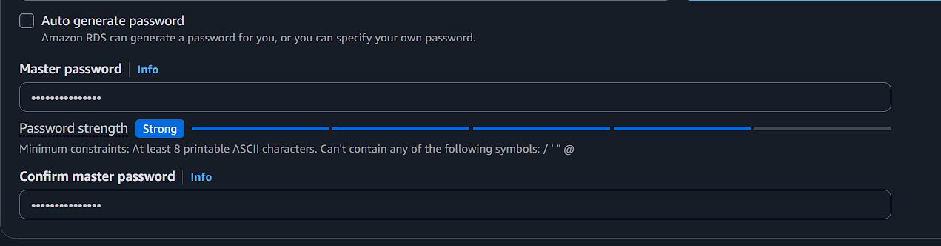
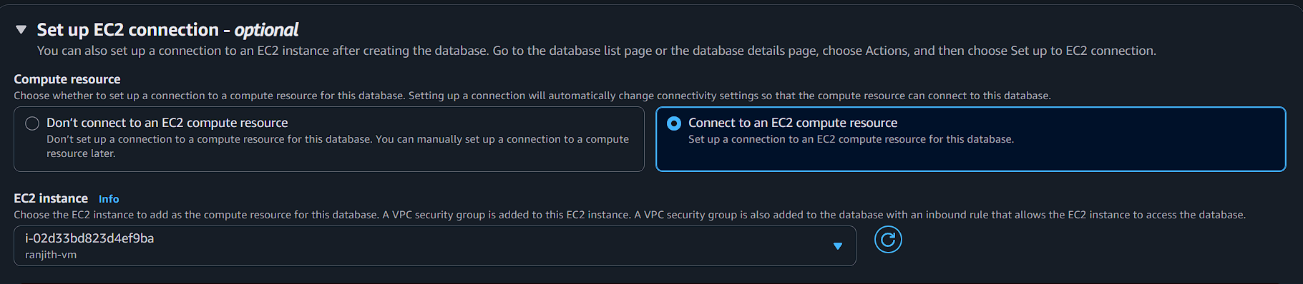
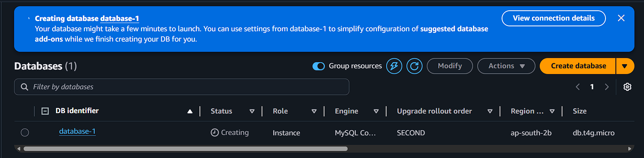
Creating take some time…please wait
Minimum takes 10 minutes

Now connect instance
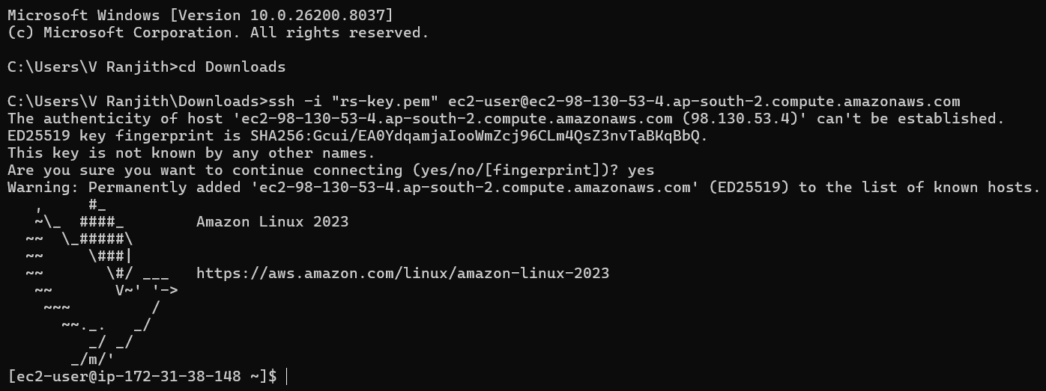
Install mysql packages
Checking available packages
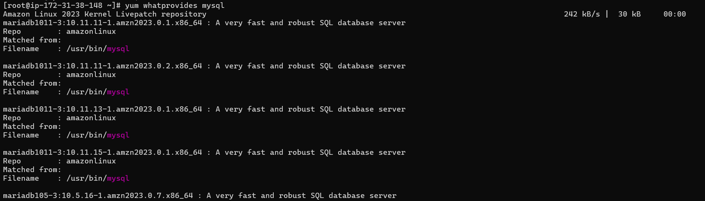
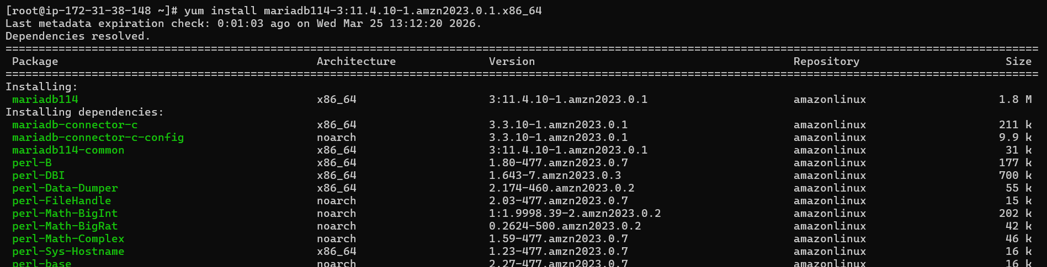
Now go to rds and click created database
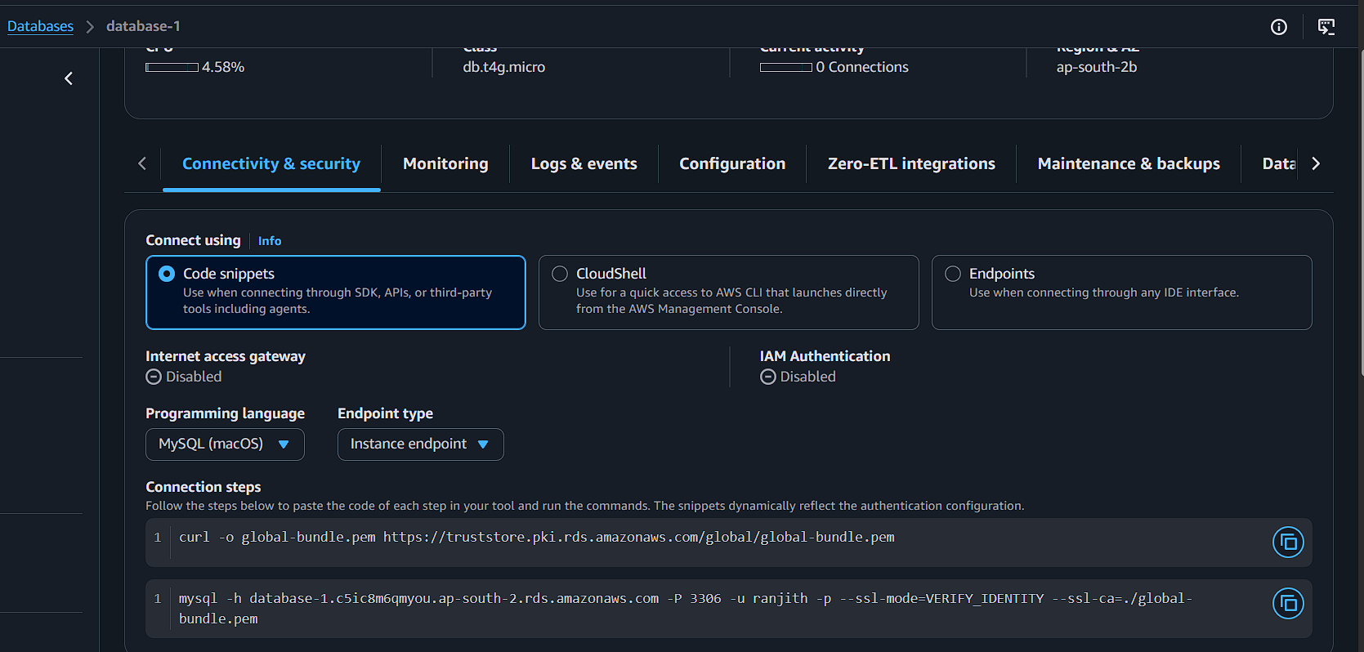
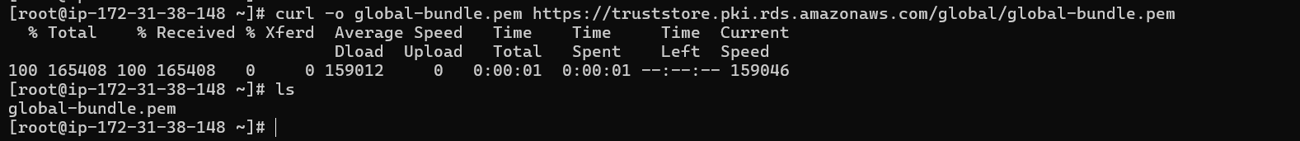
One key has been download then next command copy and paste the terminal
mysql -h database-1.c5ic8m6qmyou.ap-south-2.rds.amazonaws.com -P 3306 -u ranjith -p --ssl-mode=VERIFY_IDENTITY --ssl-ca=./global-bundle.pem-marked line can be remove
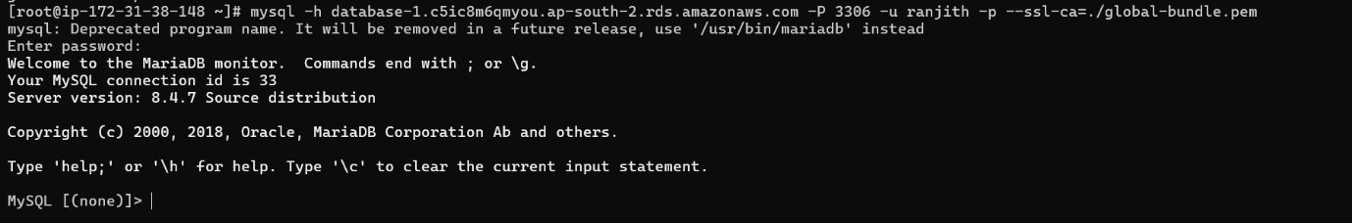
Now database can be connected
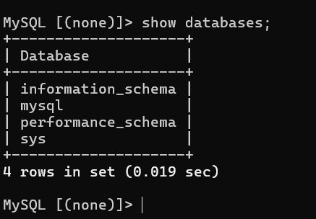
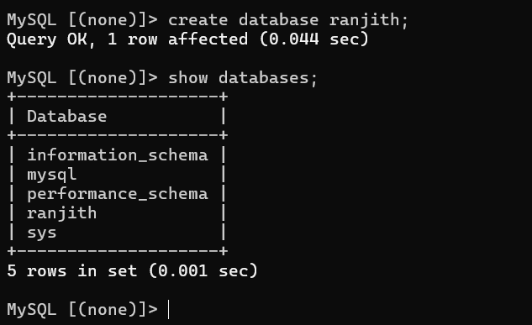
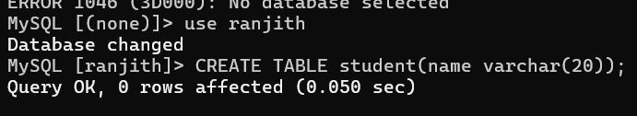
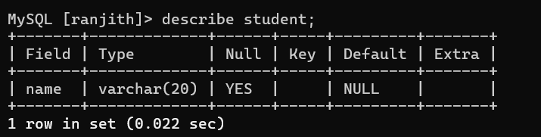
Finally delete the database
