What is YUM?

YUM (Yellowdog Updater Modified) is an open-source command-line as well as graphical-based package management tool for RPM (RedHat Package Manager) based Linux systems.

It allows users and system administrators to easily install, update, remove or search software packages on a system.

1. Install a Package with YUM

# yum install firefox
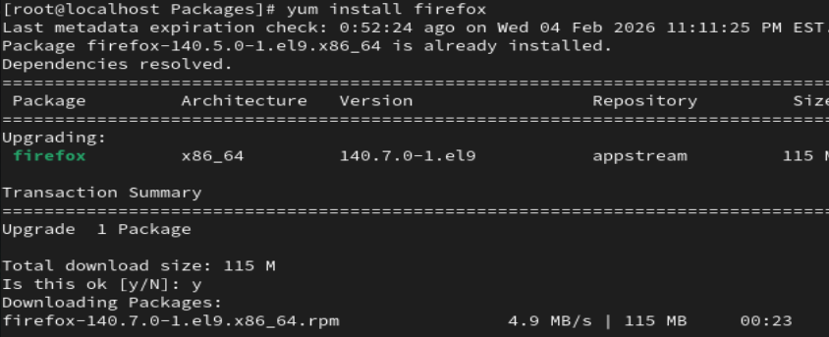
#dnf install firefox

# yum install firefox htttpd

2. Removing a Package with YUM

# yum remove firefox
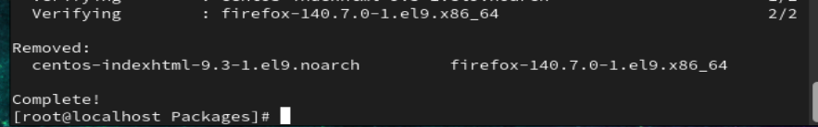
# yum remove firefox httpd
# dnf remove firefox httpd

3. Updating a Package using YUM

# yum update mysql
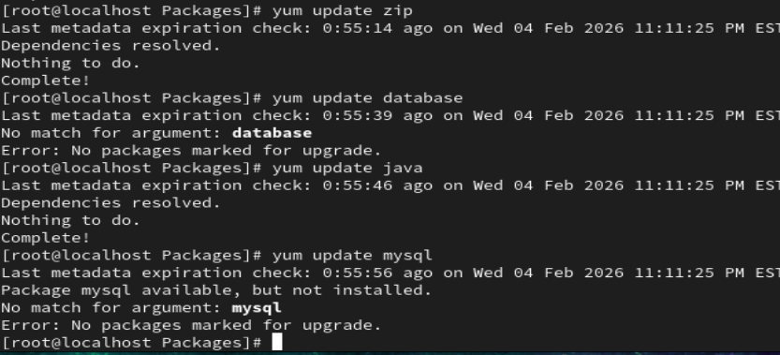
# dnf update mysql
4. List a Package using YUM
# yum list openssh
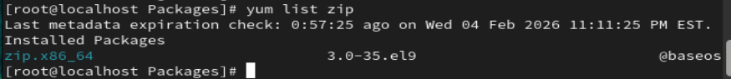
# dnf list openssh

5. Search for a Package using YUM
# yum search vsftpd
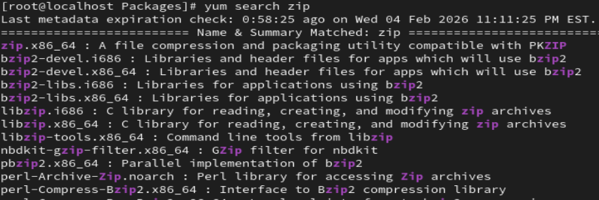
6. Get Information about a Package using YUM
# yum info firefox
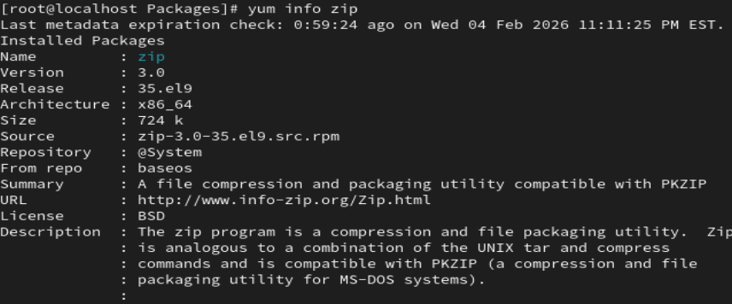
7. List all Available Packages using YUM
# yum list | less
8. List all Installed Packages using YUM

# yum list installed | less
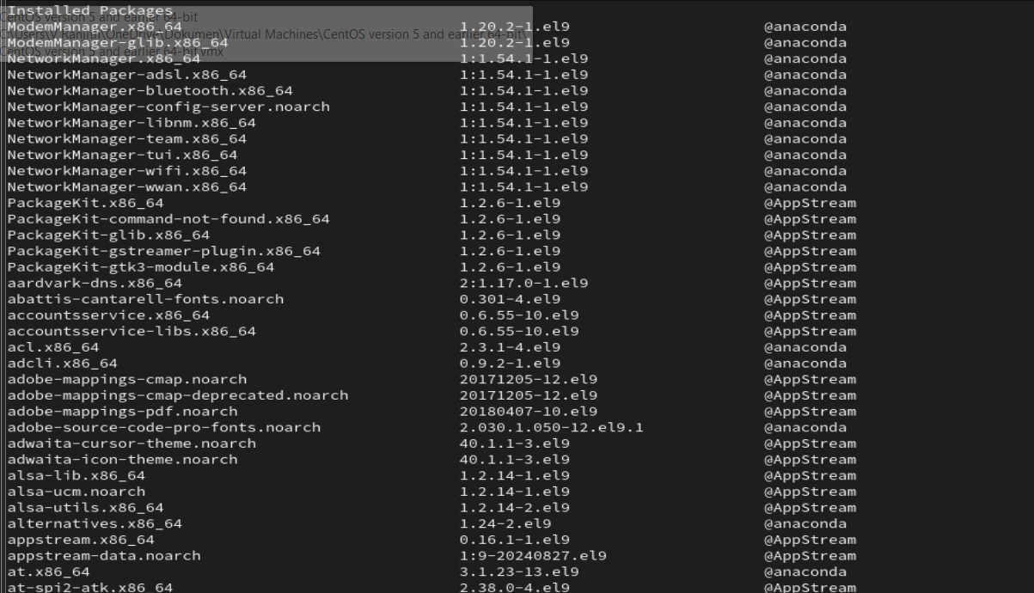

9. Yum Provides Function

# yum provides /etc/httpd/conf/httpd.conf
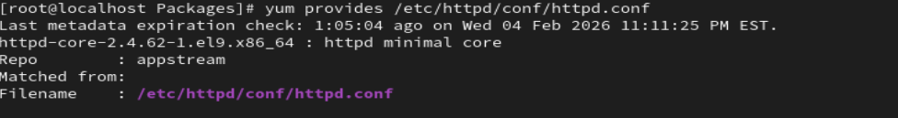
10. Check for Available Updates using Yum

# yum check-update
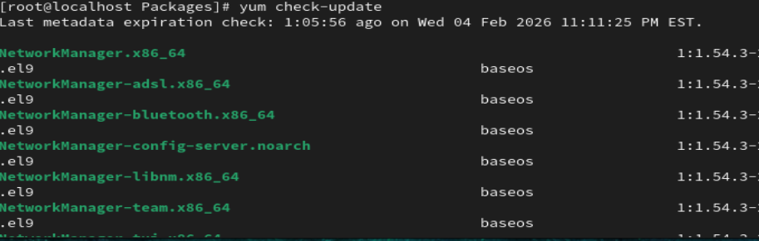
11. Update System using Yum

# yum update
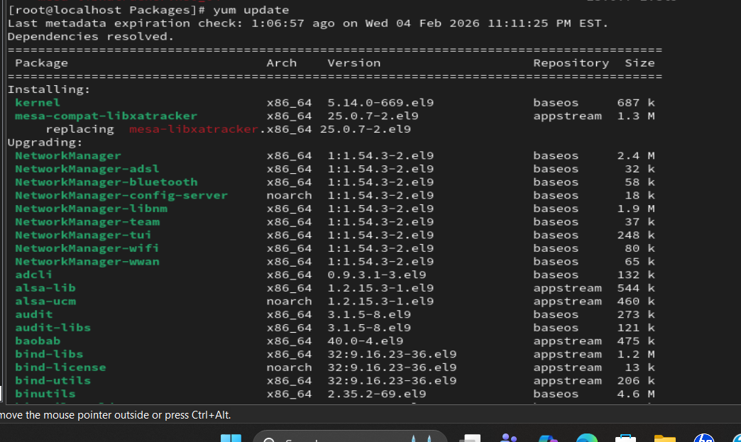
16. List Enabled Yum Repositories
# yum repolist
16. List all Enabled and Disabled Yum Repositories

# yum repolist all
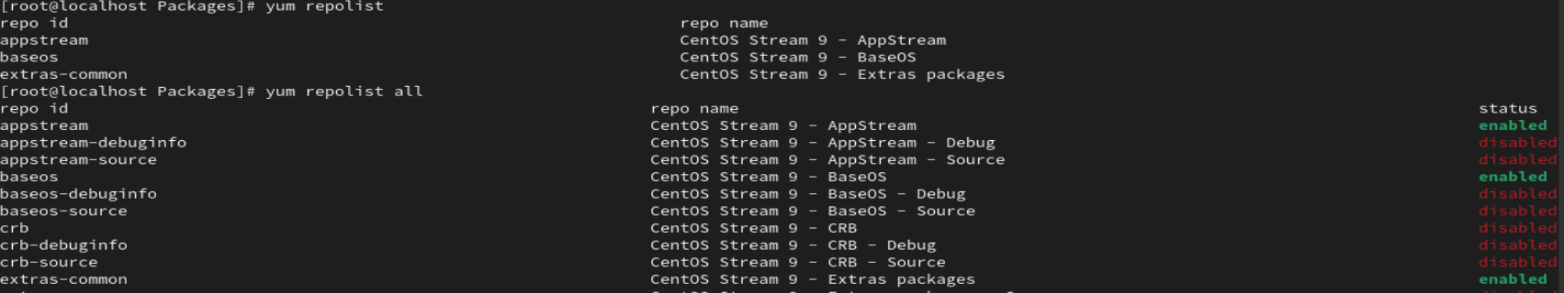
17. Install a Package from a Specific Repository

# yum --enablerepo=epel install phpmyadmin
19. Clean Yum Cache

# yum clean all
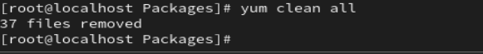
20. View History of Yum

# yum history
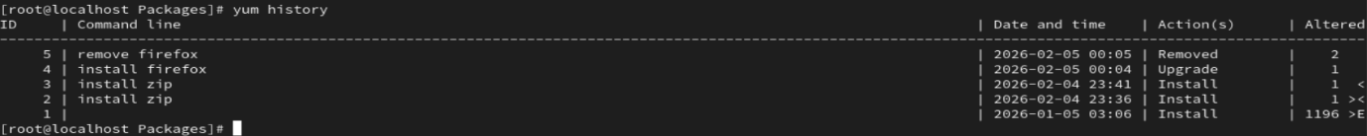
#yum history undo 21
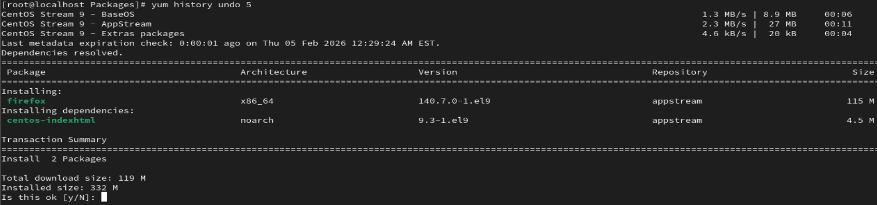
#yum history redo 30
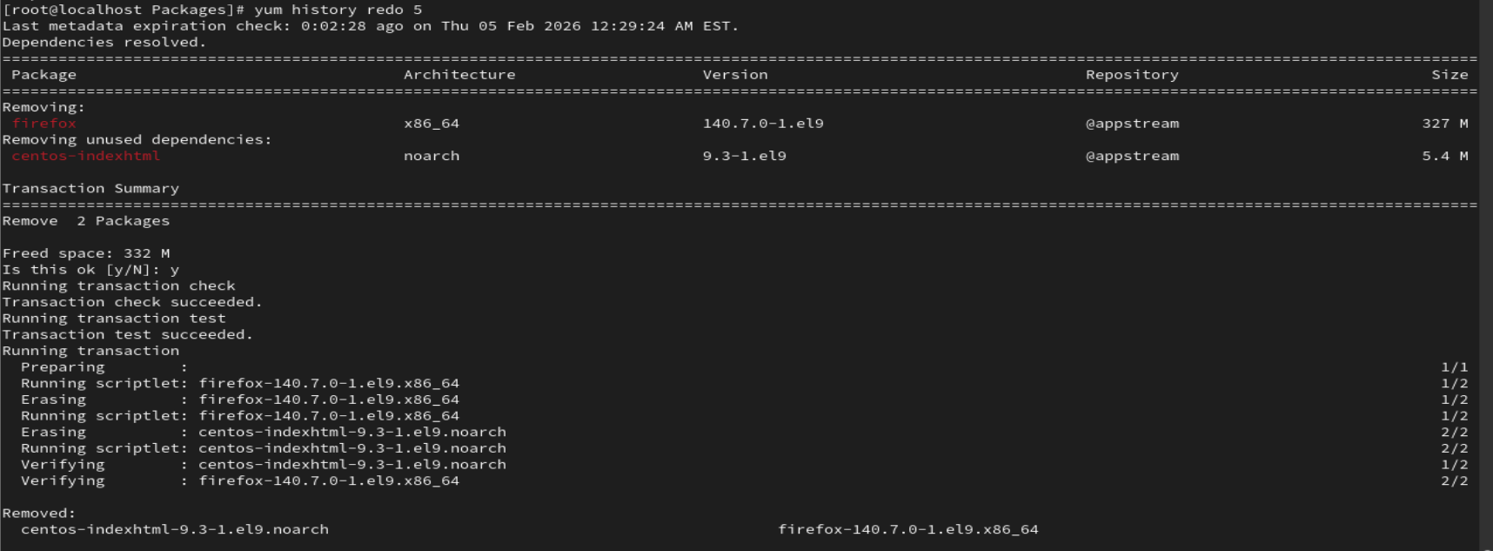

21.Enable and Disable repository
#yum-config-manager --disable Localrepo_BaseOS
#yum-config-manager --enable Localrepo_BaseOS
