**Playwright with TypeScript**

**Day1**

HTML: **Hyper text markup language**

* HTML is the structure of the page
* HTML consists of series of elements.

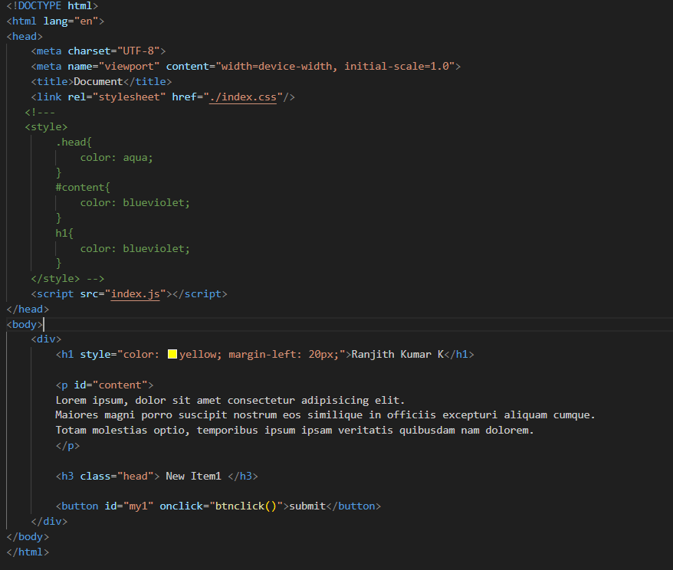

This HTML document is a simple webpage with the following key components:

* Standard HTML5 structure with DOCTYPE declaration and language attribute
* Head section containing:
  + Metadata for character encoding and responsive viewport
  + Page title
  + External CSS link to "index.css"
  + Commented-out internal CSS styles that would have applied different colors
  + JavaScript link to "index.js"
* Body content including:
  + A main div container
  + H1 heading with inline styling (yellow color and left margin)
  + Paragraph with Lorem ipsum placeholder text and ID "content"
  + H3 heading with class "head"
  + Button with ID "my1" that calls a JavaScript function "btnclick()" when clicked

**Java Script Basics:**

**Function Definition and Event Handling**

javascript

function btnclick(){

alert('Hi team click here')

}

This defines a function named btnclick that displays an alert dialog with the message "Hi team click here" when called. This function would typically be connected to a button's click event in HTML.

**Variable Declaration**

javascript

let a=10;

let b=5;

const c =90;

* let is used to declare variables that can be reassigned later
* const is used to declare constants that cannot be reassigned
* Three variables are created: a (value 10), b (value 5), and c (constant value 90) javascript

**How to print the Values different formats**

*/\**

*console.log("sum of ",a+b);*

*console.log("Sum of "+a+" and "+b+" is "+(a+b));*

*console.log(`Sum of ${a} and ${b} is ${a+b}`);*

*\*/*

These commented lines demonstrate three ways :

* Using comma separation
* Using string concatenation with +
* Using template literals with backticks and ${}

**Boolean Variable**

let val = true;

Declares a boolean variable val with the value true.

**Array Operations**

let arr = ["hello",48,true,3.0]

Creates an array with mixed data types (string, number, boolean, float).

**Array manipulation methods:**

javascript

arr.push("jira"); *// Adds "jira" to the end*

arr.push(50); *// Adds 50 to the end*

arr.pop(); *// Removes the last element (50)*

**Array Methods with Arrow Functions**

arr.filter((e)=> Number.isInteger(e))

.map((e)=> e*10)

.forEach((e) => console.log(e));

This chain of methods:

1. Filters the array to keep only integer elements
2. Multiplies each remaining element by 10
3. Prints each result to the console

**String Reversal Function**

javascript

function reverse(a) {

console.log(a.split('').reverse().join(''));

}

reverse("today"); *// Outputs: "yadot"*

**Recursive Function**

javascript

function rec(a){

if(a==10){

return;

}

console.log(a)

rec(a+1);

}

rec(1);

**Local Storage Form Handling Summary**

This code demonstrates a two-part process for handling form data using HTML, JavaScript, and localStorage:

**The store() Function**

This function handles form submission and data storage:

1. Gets a reference to a form with ID "registrationForm"
2. Adds a submit event listener to the form
3. Prevents the default form submission behavior
4. Creates an object containing form values (name, role, age)
5. Stores this data in the browser's localStorage after converting it to JSON
6. Redirects the user to "index1.html" after saving

**CODE:**

function store(){

const form = document.getElementById("registrationForm");

form.addEventListener("submit", function(event) {

event.preventDefault();

const formData = {

name: form.name.value,

role: form.role.value,

Age: form.age.value

};

localStorage.setItem("formData", JSON.stringify(formData));

window.location.href = "index1.html";

});

}

**The display() Function**

This function retrieves and displays previously stored form data:

1. Gets a reference to an element with ID "output"
2. Retrieves the stored form data from localStorage
3. If data exists:
   * Parses the JSON string back into an object
   * Displays the data in formatted HTML
4. If no data exists:
   * Shows a "No data found" message

function display(){

const output = document.getElementById("output");

const storedData = localStorage.getItem("formData");

if (storedData) {

const data = JSON.parse(storedData);

output.innerHTML = `

<p><strong>Name:</strong> ${data.name}</p>

<p><strong>Role:</strong> ${data.role}</p>

<p><strong>Age:</strong> ${data.Age}</p>

`;

} else {

output.textContent = "No data found.";

}

}

**Day2:**

**JS Events:**

In JavaScript, events are actions or occurrences that happen in the browser that the browser or the user can respond to, Events are essential for making web pages interactive like when a user clicks a button.

**Button Click Event:**

This provide if you click event display the current data and time.

<!---Button Clicked event-->

   <button

   onclick="this.innerHTML = Date()">

   The time is :</button>

**Mouse entered and leave event:**

<!--- Mouse enter / mouse leave event-->

   <button

   onmouseenter="this.innerHTML='Mouse Entered'"

   onmouseleave="this.innerHTML='Mouse Leave'">Mouse</button>

This event provide hover the mouse on the button is display the text.

**Key Pressing:**

This Event working based on enter the text into inside the text box it will show the alert.

<!--- Key pressing Event-->

   <input type="text" onkeydown="pressing()"/>

JS 🡪

function pressing(){

   alert("clicked");

}

**Set Timeout & Set Interval Event:**

* Timeout used for performing some action specific interval of time and you want to stop the time out action is possible.
* Interval Specific interval you can perform some action in the console or alert.

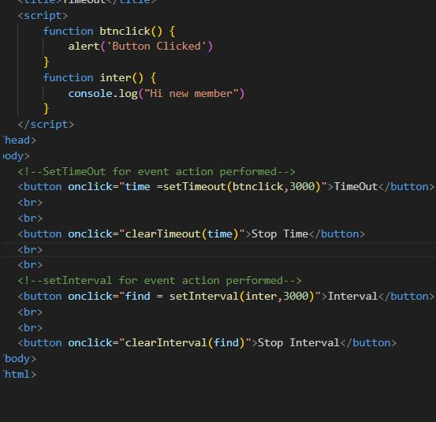

**Create the Form Add some Functionality:**

**Task 1 and Task 2:**

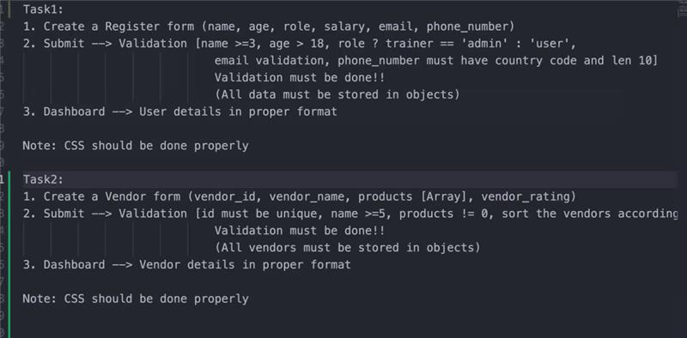

**Promises in JS:**

JavaScript is single-threaded and often needs to do async operations like:

* Fetching data from a server
* Reading a file
* Waiting for a timer

**Asynchronous Function:**

async function catdis(params) {

   const url = "[https://cataas.com/cat?width=200;height=200;json=true";](https://cataas.com/cat?width=200;height=200;json=true%22;)

   const cat = await fetch(url).then(res => res.json()).then(data => data.url);

   document.getElementById("catid").src =cat

}

**Day3:**

**TypeScript:**

Install typescript and run commands.

* npm -v
* npm init -y
* npm install typescript –save-dev
* npm tsc init
* npx tsc index.ts
* node index.js

**Define:**

TypeScript is the superset of java script and typescript add the syntax on top of JS.

**Basic Function Creation:**

function dis1() {

    let name: string = "Ranjith";

    console.log(name);

}

function dis2(){

    const age:number = 10000;

    console.log(age)

}

dis1()

dis2()

**Create the Interface and class store the data and displays:**

// Interface

interface emp{

    user_id: number;

    name: string;

    role? : any;

}

const user1:emp={

    user_id:2,

    name:"rash",

    role:"EC"

}

const user2:emp={

    user_id:2,

    name:"rash"

}

console.log(user1);

console.log(user2);

This code refers the add the Interface and add the data into the class based on the type.

**Task:**  
you need to create a vendor object with types and then display all the values by sorting on the basis of their id

**Sort the array and Optional Parameters:**

* In typescript how the object and type value are created and handle the functions using foreach loop, mention optional param, give the type (any).

interface emp{

    user_id: number;

    name: string;

    role? : any;

}

class compnay1 implements emp{

user_id: number;

name: string;

role?: any;

constructor(user_id:number, name:string, role:any){

this.user_id=user_id;

this.name=name;

this.role=this.role;

}

}

function showcompany1(){

const emp1:emp = new compnay1(1,"dhurv","trainer");

console.log(emp1);

}

function showcompany2(){

const emp2:emp = new compnay1(10,"karthik","employee");

console.log(emp2);

}

showcompany1()

showcompany2()

const database1:compnay1[] = [

new compnay1(2,"user1","dep1"),

new compnay1(2,"user1","dep1"),

new compnay1(2,"user1","dep1")

]

const sort1 = database1.sort((e1,e2)=>e1.user_id>e2.user_id ? -1: 0)

for (const vendor of sort1) {

console.log(`ID: ${vendor.user_id}, Name: ${vendor.name}, Role: ${vendor.role != undefined ? vendor.name + " " : vendor.name}`);

}

**Promise to Get the response from API:**

* Get the data from url in json format data and display the json data using Promise<Response>.

function getFacts(url: string): Promise<Response> {

    return fetch(url).then(res => res.json());

getFacts("https://cataas.com/cat?width=200;height=200;json=true").then(data => console.log(data));

**Day 4:**

1. B) Microsoft

The typescript developed by Microsoft, It's open source high level programming language and TypeScript used to develop JavaScript applications for both client-side and server-side.

2. C) Node

TypeScript can technically be used with other backend technologies that support JavaScript, TS is subset of Java script library.

3. C) Java Script

The primary purpose of the TypeScript compiler tsc is to transpile TypeScript code into plain JavaScript code that can be understood and executed by web browsers and Node.js.

4. C) extends

The keyword to inherit the class using extends keyword.

5. B) var x = "string";

This one is incorrect because the syntax is JS.

6. B) var x:number= 999;

This one is refer the type of x is number store the value 999 this syntax for TypeScript.

7. B) .ts

TypeScript source code files typically use the .ts file extension.

8. tsc filename.ts

This command used for run the typescript file using Typescript Compiler.

9. B) tsc filename -w

-w flag tells the TypeScript compiler to watch the specified file or the entire project if a tsconfig.json is present for changes and automatically recompile when a change is detected.

10. super()

The super() keyword is used within the constructor of the child class to invoke the constructor of the immediate parent class.

**Day 5:**

**Key of:**

Keyof is used to store the different type of value in same variable and return the values, get the data from type Point using generic function.

type Point = { name: string; age: number };

type a = keyof Point;

let x:a;

x = "name";

x = "age";

interface Person{

    name: string;

    age: number;

    address: string;

    phone: string;

}

const person: Person = {

    name: "John Doe",

    age: 30,

    address: "123 Main St",

    phone: "123-456-7890"

};

interface Employee{

    name: string;

    department: string;

    salary: number;

}

const newemp: Employee = {

    name: "Jane Smith",

    department: "Engineering",

    salary: 80000

}

//generic function to get data from object

function getData<T,K extends keyof T>(obj : T, key : K){

    return obj[key];

}

console.log(getData(person, "name"));

console.log(getData(person, "age"));

console.log(getData(person, "address"));

console.log(getData(newemp, "name"));

console.log(getData(newemp, "department"));

console.log(getData(newemp, "salary"));

**Reduce Function:**

This one is used for simplifying the code and easy to understand and reduce the code size.

//Reduce Function

function sum1(...numbers: number[]):number{

    return numbers.reduce((t, num)=>t+num,0);

}

function addstring(...names: string[]):string{

    return names.reduce((t, name)=>t+name, "");

}

const result = sum1(1,2,3,4,5);

console.log(result);

const result1 = addstring("John", "Doe", "Smith");

console.log(result1);

**Method overloading:**

In typescript overloaded method same as java and pass the different type of values into the same method, I want pass number or string same method can be used return the values.

interface employee{

    details:{

        (name : string):string;

        (age : number) :string;

    }

}

const emp: employee={

    details: (name: string | number): string => {

        if (typeof name === "string") {

            return `Name is ${name}`;

        } else {

            return `Age is ${name}`;

        }

    }

}

console.log(emp.details("John Doe"));

console.log(emp.details(30));

interface EcomApp {

    products: {

        (id: number): string;

        (name: string): string;

    };

}

const product1: EcomApp = {

    products: (idOrName: number | string): string => {

        if (typeof idOrName === "number") {

            return `ID of product is ${idOrName}`;

        } else {

            return `Product name is ${idOrName}`;

        }

    }

};

console.log(product1.products(101));

console.log(product1.products("Laptop"));

**Modules import & export Classes, Functions:**

Access the method and class level variables one class to another class using import/export keyword.

**Class1 File:**

In this Class1 getname() and getHomeDetails () two functions used in another class Class2 using import export keyword to access the method from another class this class have interface and Details list can add product.

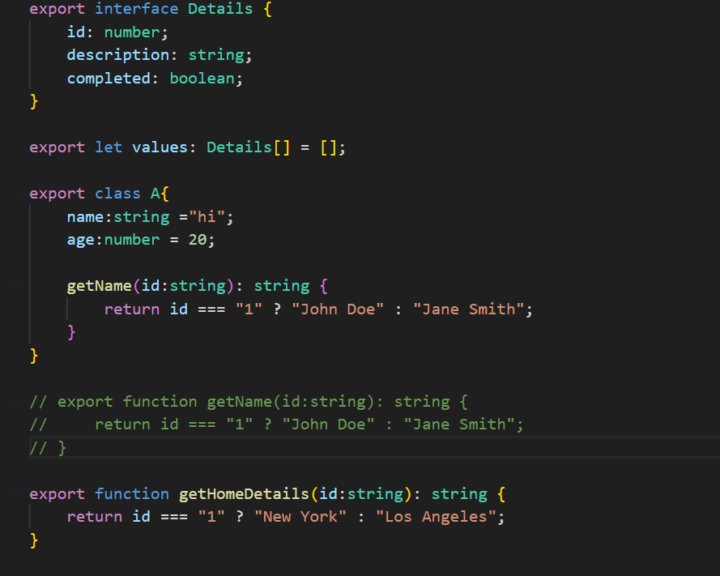

**Addproduct.ts File:**

This class have two function addproduct() and listTasks() two functions to access inside the class2 call this functions.

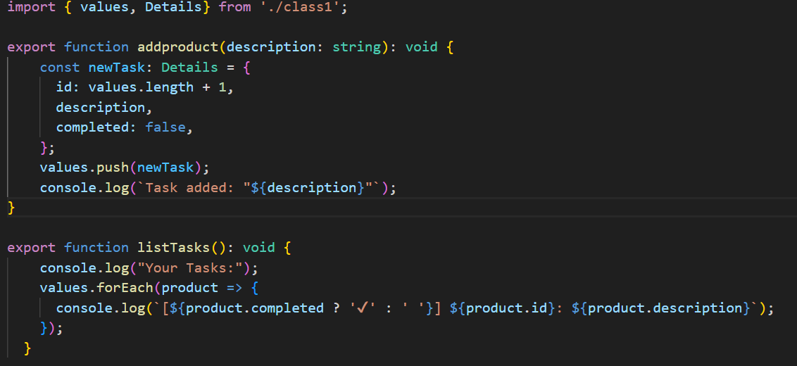

**Class 2 File:**

The Class2 main class to call all functionalities to import statement access the method from Class1 and use inside the Class2 we can create the obj for that class and to access the getName() function .

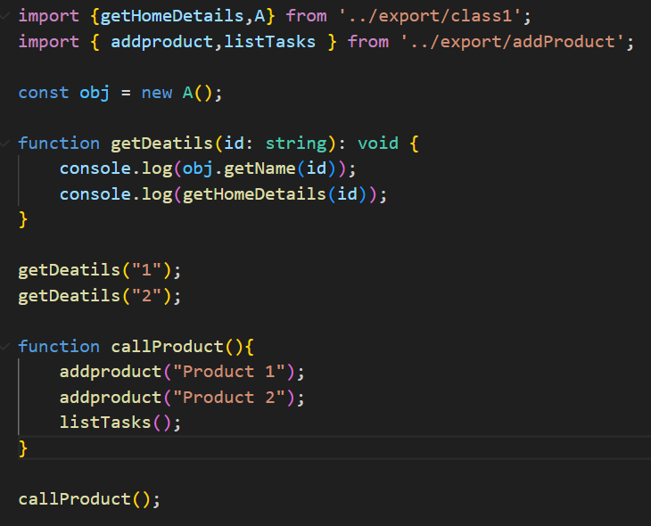

**Day 6:**

**Playwright:**

**Features:**

* Auto wait
* Cross browser Compatibility – Chrome, Firefox, Edge, Webkit.
* Multi-platform – Mac OS, Windows, Linux
* Multilingual Flexibility – Supports Java, Python, Java Script, C#, .NET

**Advance Feature:**

* Tracing and Debugging – take screenshot, video recording
* Network Interception
* Browser Context Management
* Codegen Tool
* Java Script – Asynchronous this one does not execute the order wise.
* **await – used to wait each action**

**Installation of Playwright:**

* npm install playwright@latest

**Run the test:**

* npx playwright test

**Run the test headed mode:**

* npx playwright test –headed

**Run the test UI mode:**

* npx playwright test –ui

**Get the report in html page:**

* npx playwright show-report
* **Test report generate in 9323 port**

**Import the playwright and expect in .ts file**

import {test, expect} from "@playwright/test";

**Assertion in Playwright:**

expect (locator).tobeVisible();