**Master of Science in Information Technology**

**JNTU Hyderabad**

**Assessment Test –I**

**Duration: 3½ Hrs. Date : 25-10-2016**

**Level-0**

1. We want make a package of goal kilos of chocolate. We have small bars (1 kilo each) and big bars (5 kilos each). Print the number of big and small bars to use, assuming we always use big bars before small bars.

**Test case 1:**

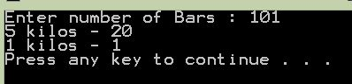

**Test case 2:**

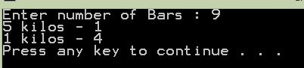

**Test case 3:**

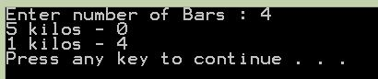

1. Calculate Body mass Index (BMI) for single user taking the following inputs.
2. Read weight from key board in Kgs (Decimal Value).
3. Read height in Feet’s and inches(Integer values). Write a separate method to convert height into meters (method should return the calculated height in mtrs) using the given formula.

Meters = ((Feet*12)+inches)*0.0254

1. Now create a method called calculate_bmi which takes weigtht(kgs) and height(meters) as parameters and should return the calculated bmi .

Bmi = weight/(height*height)

1. If bmi<18 it should print **Under weight**
2. If bmi lies between 18-22.9 it should print **Normal**
3. If bmi lies between 23-24.9 it should print **Over weight**
4. If bmi>25 it should print **Obesity**

**Sample Output:**

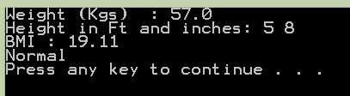

**Note: If you failed to follow the above instructions, you are program will not be evaluated**

**Level-1**

1. Calculate BMI for n number of users. Follow the above mentioned instructions to calculate BMI.

**Sample Output:**

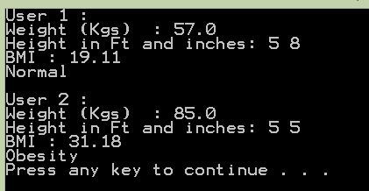

1. Write a program to find the common factors of a given 2 numbers.

**Test case 1:**

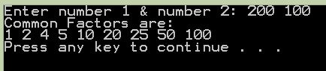

**Test case 2:**

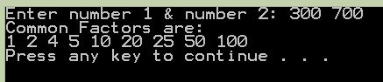

**Level-2**

1. Generate Pyramid For a Given Number.

**Test Case 1:**

Enter Number:

5

Enter X:

1

0

1 2

3 4 5

6 7 8 9

10 11 12 13 14

----------------------------------------------

**Test Case 2:**

Enter Number:

5

Enter X:

2

0

2 4

6 8 10

12 14 16 18

20 22 24 26 28

----------------------------------------------

**Test Case 3:**

Enter Number:

5

Enter X:

3

0

3 6

9 12 15

18 21 24 27

30 33 36 39 42

1. Write a Java Program to print all the Unicode (ASCII) values of characters.

**Level 3:**

We use the integers **a, b** and **n** to create the following series:

C:\Users\Ranjith\Pictures\l3.JPG

You are given **q** queries in the form of a, b and n. For each query, print the series corresponding to the given a, b and n values as a single line of n space-separated integers.

**Input Format**

The first line contains an integer, q, denoting the number of queries.   
Each line **i** of the q subsequent lines contains three space-separated integers describing the respective ai, bi, and ni values for that query.

**Constraints**

* 0 <= q <= 50
* 0 <= a, b <= 50
* 0 <= n <= 15

**Output Format**

For each query, print the corresponding series on a new line. Each series must be printed in order as a single line of n space-separated integers.

**Sample Input**

2

0 2 10

5 3 5

**Sample Output**

2 6 14 30 62 126 254 510 1022 2046

8 14 26 50 98

**Explanation**

We have two queries:

1. We use a=0, b=2, and n=10 to produce some series So, S1 …… Sn-1:
   * S0 = 0 + 1*2 = 2
   * S1 = 0 + 1*2 + 2*2 = 6
   * S2 = 0 + 1*2 + 2*2 + 4*2 = 14

... And so on.

Once we hit n=10, we print the first ten terms as a single line of space-separated integers.

1. We use a=5, b=3 , and n=5 to produce some series :
   * S0 = 5 + 1*3 = 8
   * S1 = 5 + 1*3 + 2*3 = 14
   * S2 = 5 + 1*3 + 2*3 + 4*3 = 26
   * S3 = 5 + 1*3 + 2*3 + 4*3 +8*3 = 50
   * S4 = 5 + 1*3 + 2*3 + 4*3 +8*3 +16*3= 98

We then print each element of our series as a single line of space-separated values.

**Note: Optimization of code (loop condition) and coding style (indentation, comments, and writing methods) will help to fetch high scores.**