Optimizing User, Group, and Role Management with Access Control and Workflows

**Team Id:NM2025TMID16397**

**Team Leader:RANJITH KUMAR.S**

**Team member : YUVARAJ.V**

**Team member : YUVANESH.A**

**Team member : NAVINKUMAR. T**

# Problem Statement:

In a small project management team consisting of a Project Manager (Alice) and a Team Member (Bob), there is a need to efficiently manage project tasks and ensure accountability throughout the project lifecycle. The current system lacks clear role definitions, access controls, and a structured workflow, leading to confusion regarding task assignments and progress tracking.

# Objective:

To establish a clear and efficient project management framework by defining distinct roles and responsibilities for the Project Manager and Team Member, implementing appropriate access controls, and introducing a structured workflow for task assignment and progress tracking to enhance accountability and reduce confusion throughout the project lifecycle.

# Skills:

Users, Groups, Roles, Tables, Access Control List, Flow Designer

# TASK INITIATION

## Milestone 1 : Users

## Activity 1: Create Users

1. Open service now
2. Click on All >> search for users
3. Select Users under system security
4. Click on new
5. Fill the following details to create a new user
6. Click on submit

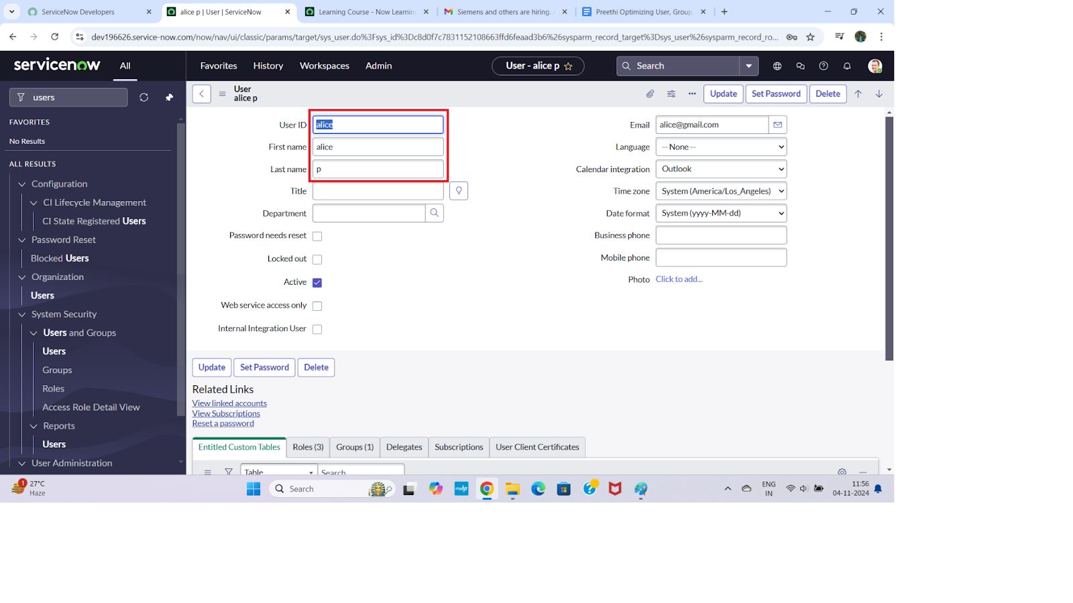

**Create one more user:**

1. Create another user with the following details
2. Click on submit

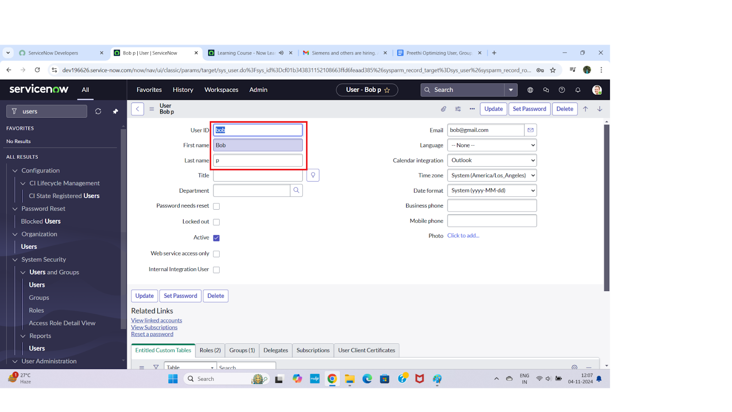

## Milestone 2 : Groups

## Activity 1: Create Groups

1. Open service now.
2. Click on All >> search for groups
3. Select groups under system security
4. Click on new
5. Fill the following details to create a new group
6. Click on submit

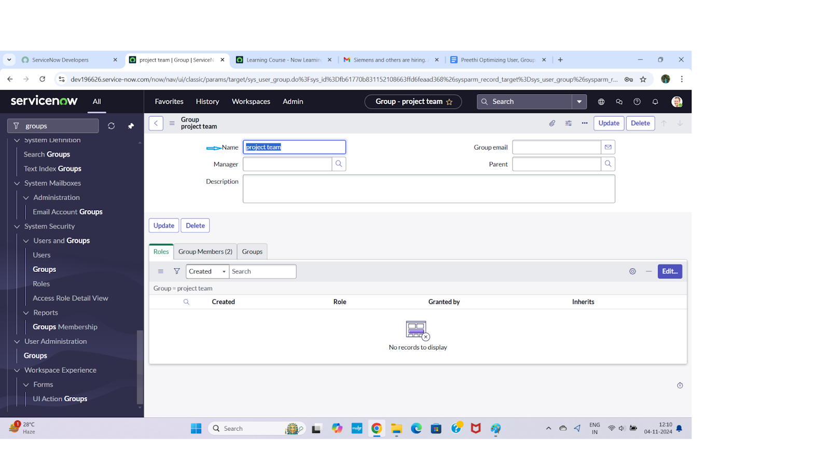

## Milestone 3 : Roles

## **Activity 1:** **Create roles**

1. Open service now.
2. Click on All >> search for roles
3. Select roles under system security
4. Click on new
5. Fill the following details to create a new role
6. Click on submit

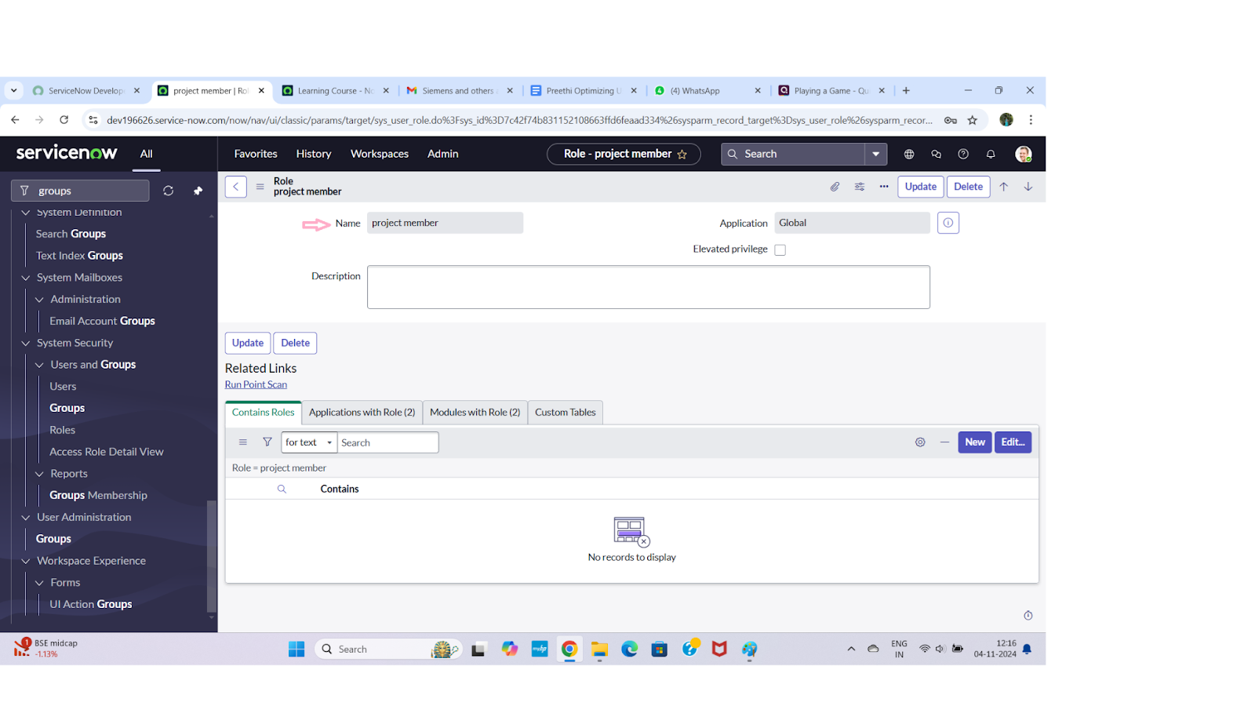

**Create one more role:**

7.Create another role with the following details

8.Click on submit

## Milestone 4 : Table

## **Activity 1:** **Create Table**

1. Open service now.
2. Click on All >> search for tables
3. Select tables under system definition
4. Click on new
5. Fill the following details to create a new table  
   Label : project table  
   Check the boxes Create module & Create mobile module
6. Under new menu name : project table
7. Under table columns give the columns

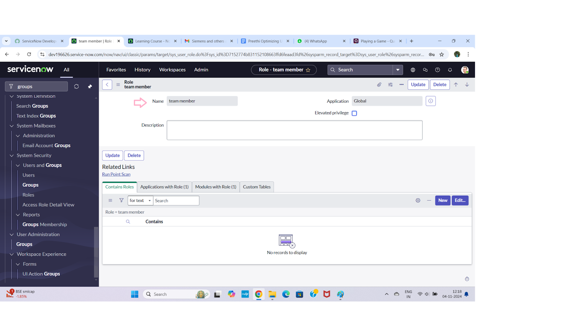

1. Click on submit

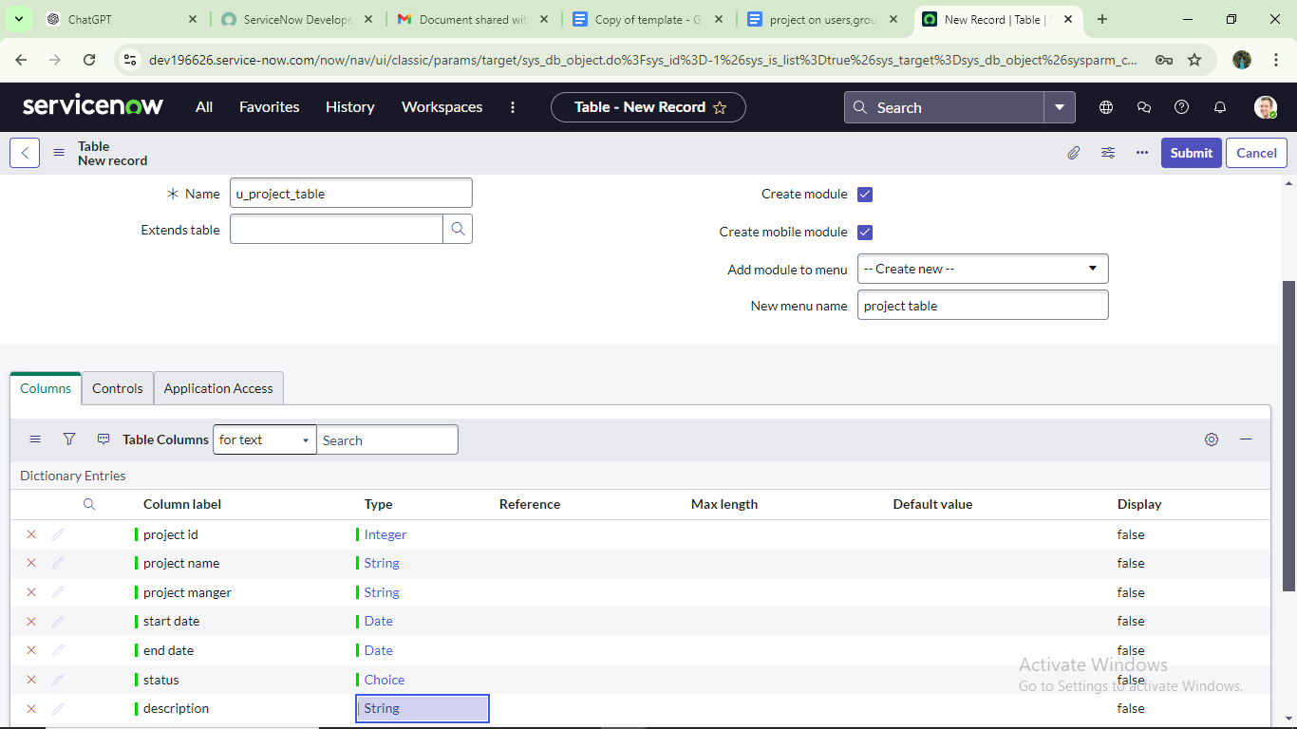

**Create one more table:**

9.Create another table as:task table 2 and fill with following details.

10. Click on submit.

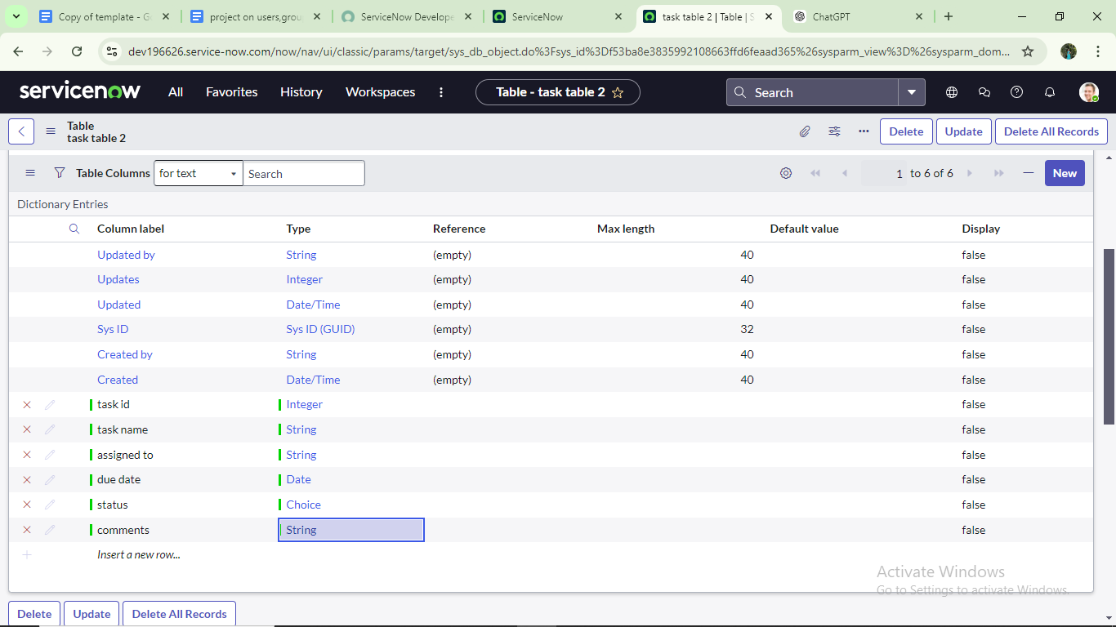

## Milestone 5 : Assign users to groups

## **Activity 1:** **Assign users to project team group**

1.Open service now.

2.Click on All >> search for groups

3.Select tables under system definition

4.Select the project team group

5.Under group members

6.Click on edit

7.Select alice p and bob p and save

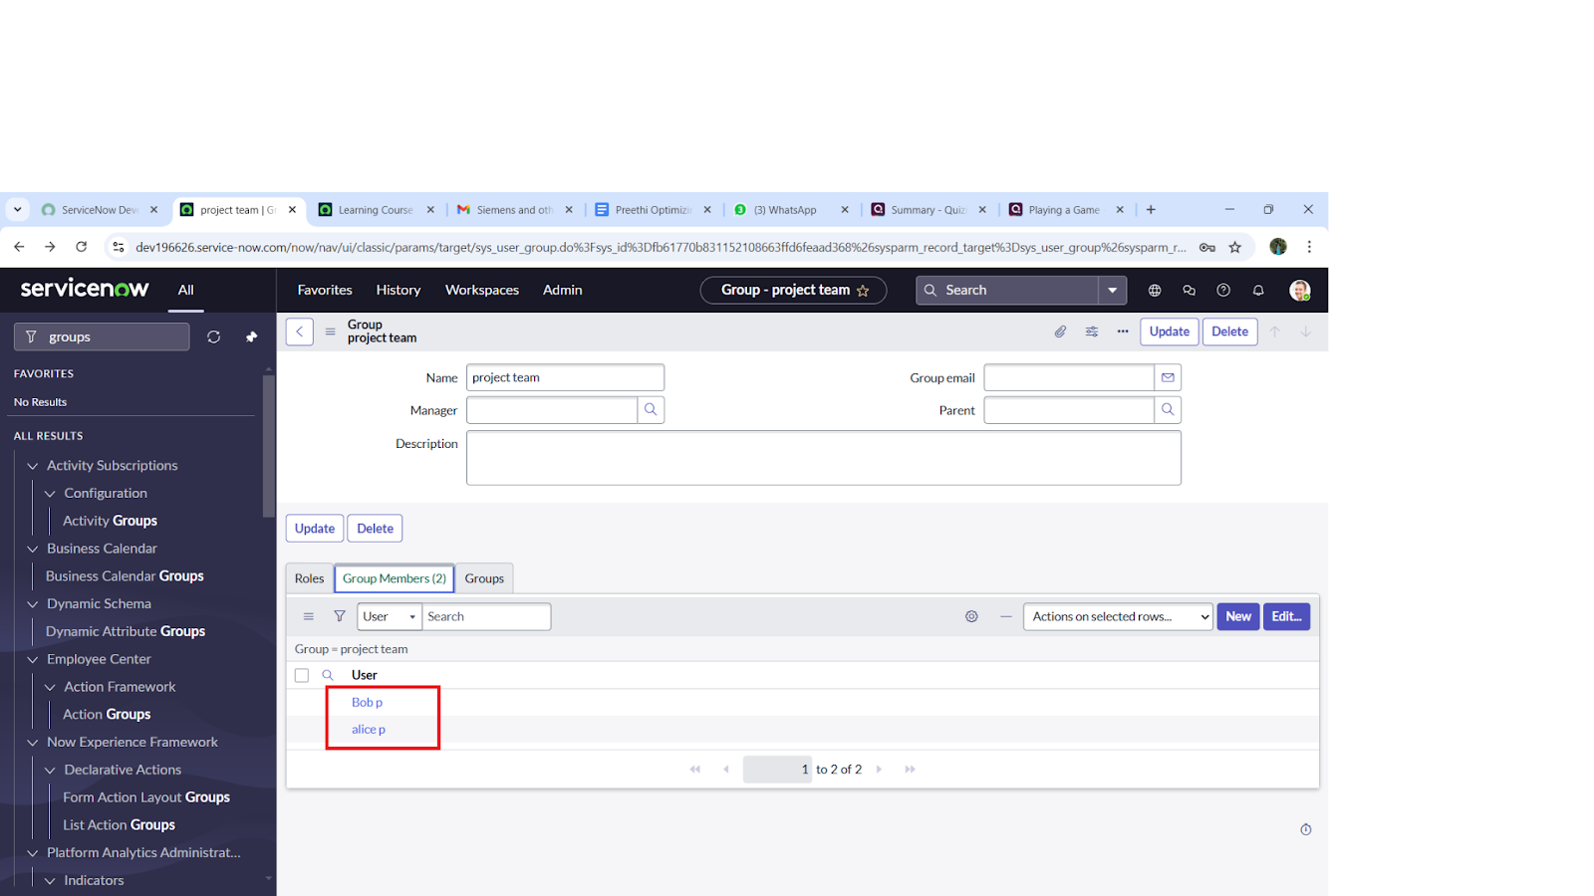

## **Milestone 6 : Assign roles to users**

## **Activity 1:** **Assign roles to alice user**

1.Open servicenow.Click on All >> search for user

2.Select tables under system definition

3.Select the project manager user

4.Under project manager

5.Click on edit

6.Select project member and save

7.click on edit add u_project_table role and u_task_table role

8.click on save and update the form.

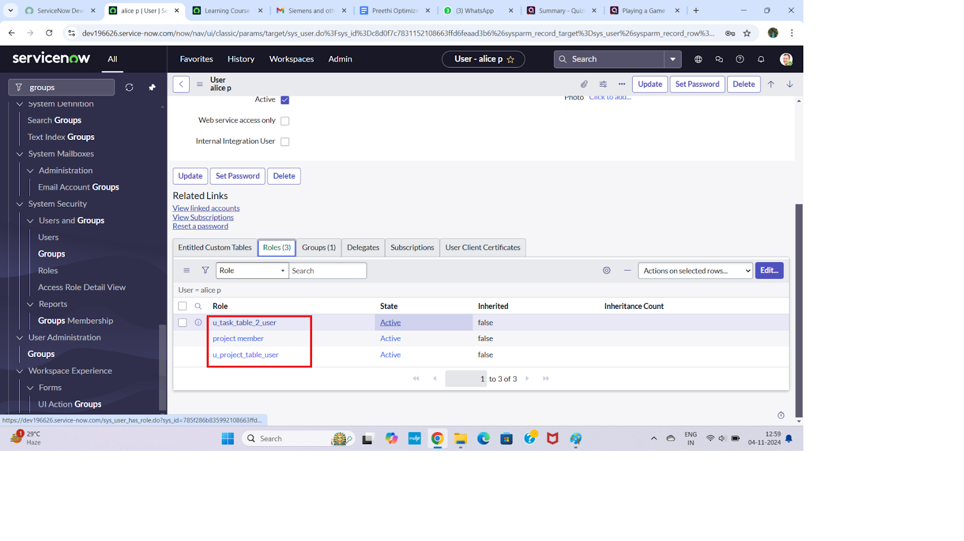

## **Activity 2:** **Assign roles to bob user**

1. Open service now Click on All >> search for user

2.Select tables under system definition

3.Select the bob p user

4.Under team member

5.Click on edit

6.Select team member and give table role and save

7. Click on profile icon Impersonate user to bob

8. We can see the task table2.

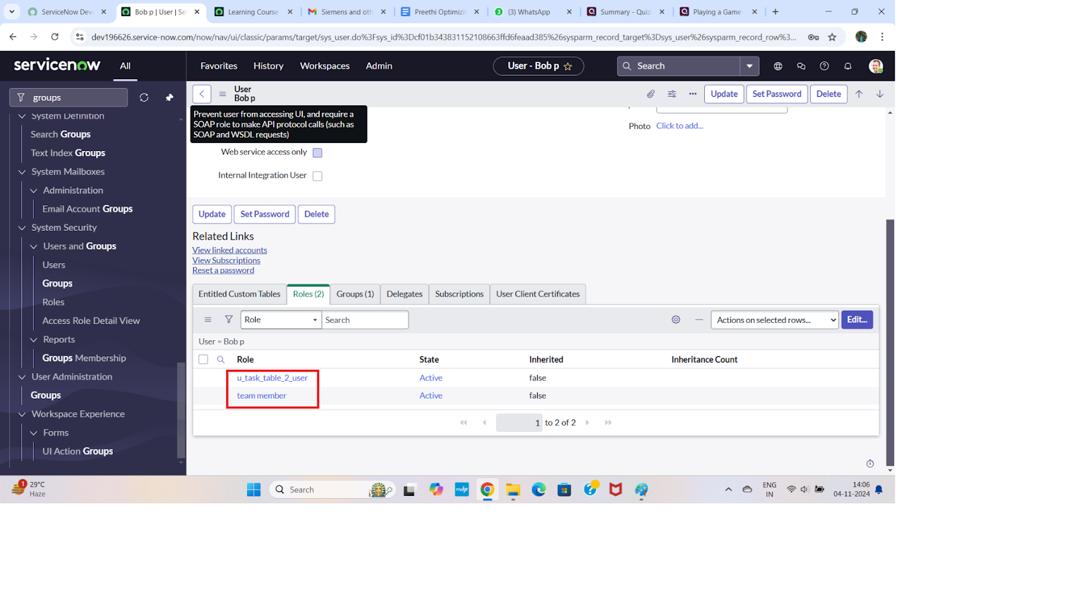

## **Milestone 7 : Application access**

## **Activity 1: Assign table access to application**

1. while creating a table it automatically create a application and module for that table
2. Go to application navigator search for search project table application
3. Click on edit module
4. Give project member roles to that application
5. Search for task table2 and click on edit application.
6. Give the project member and team member role for task table 2 application

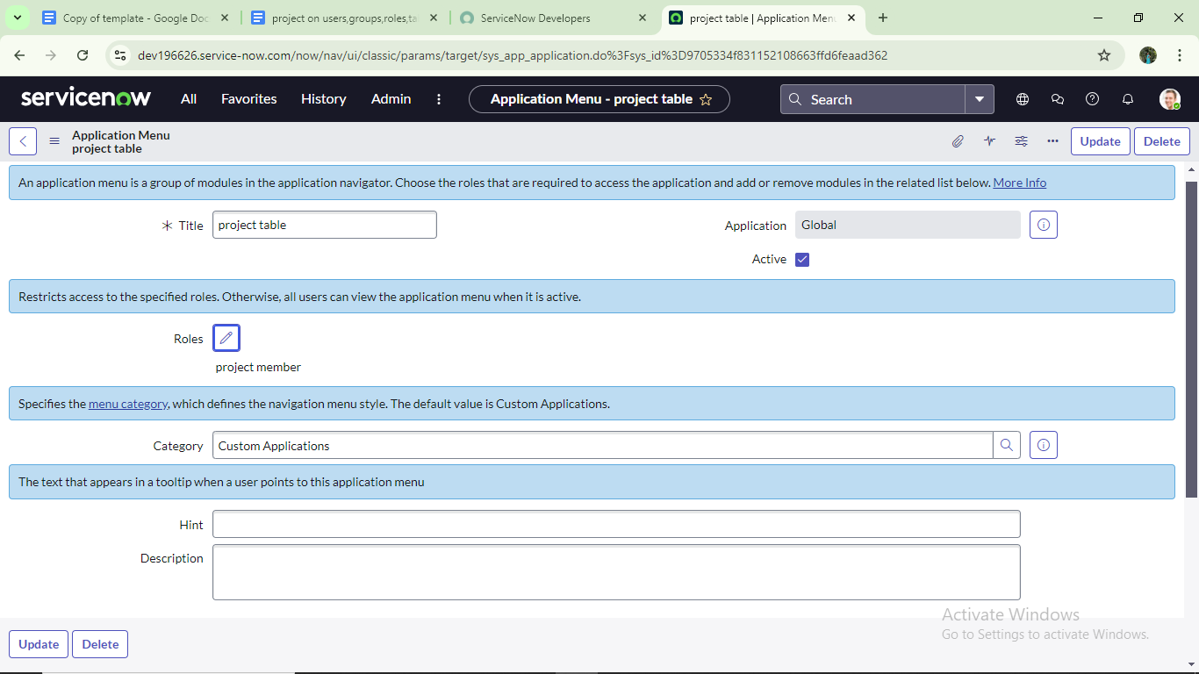

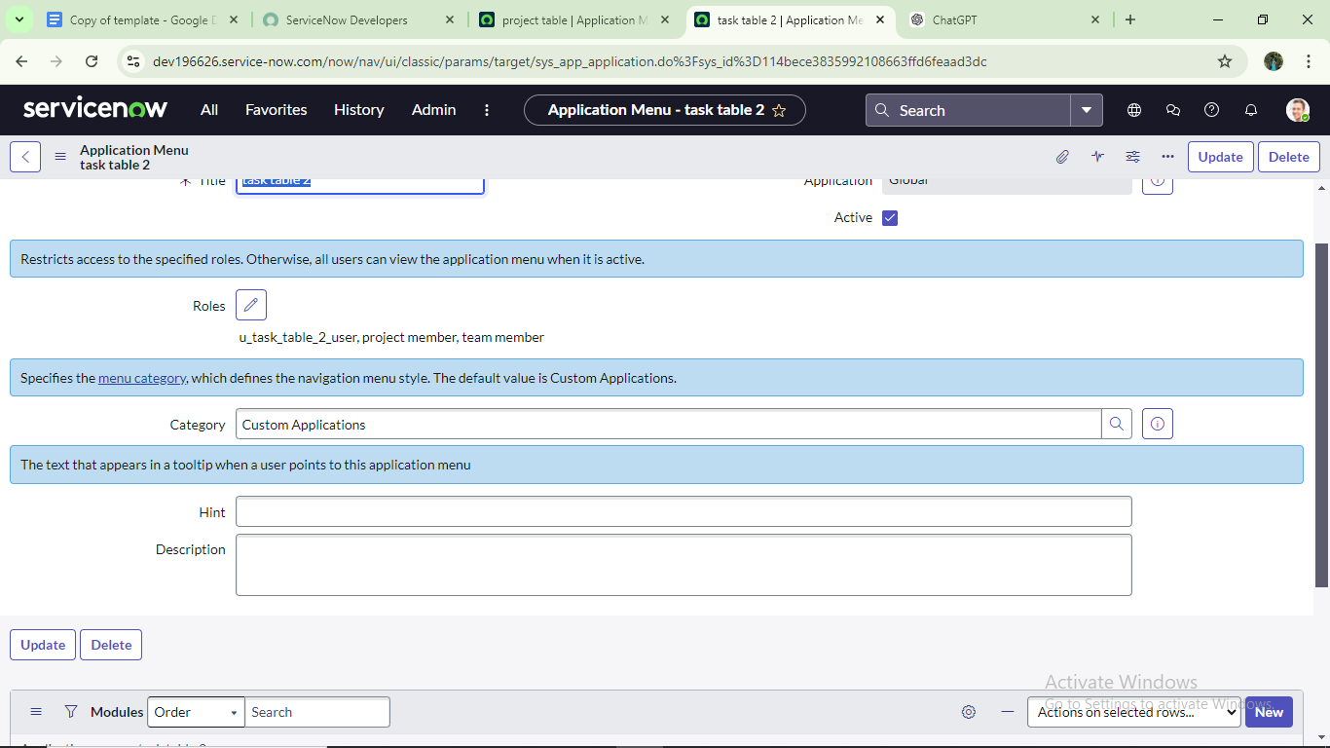

## Milestone 8 :Access control list

## Activity 1: Create ACL

1. Open service now.
2. Click on All >> search for ACL
3. Select Access Control(ACL) under system security
4. Click on elevate role
5. Click on new
6. Fill the following details to create a new ACL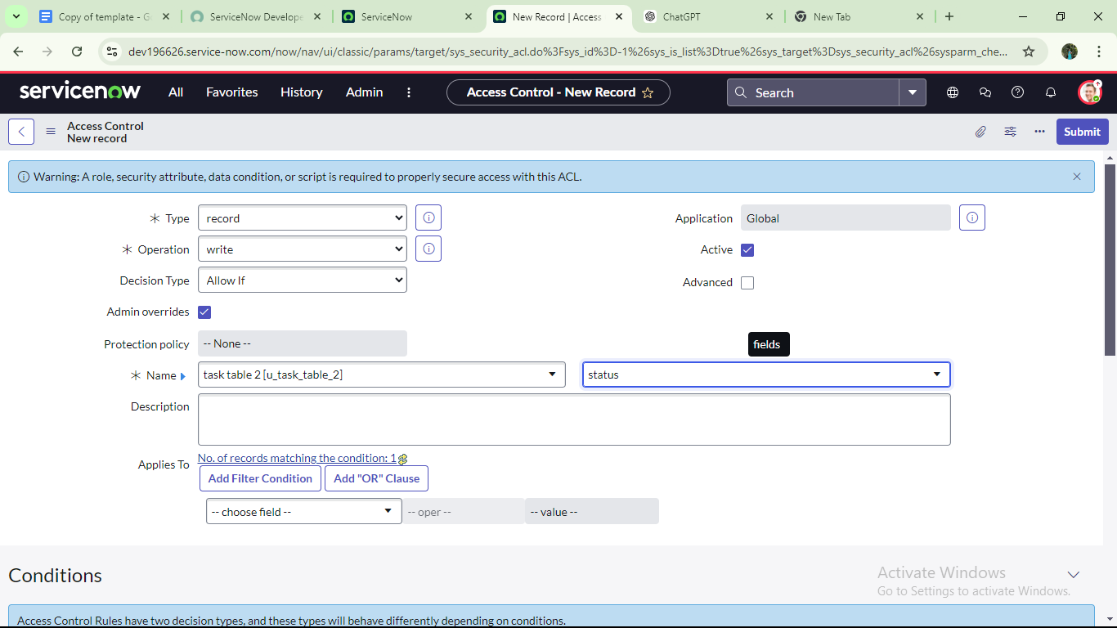
7. Scroll down under requires role
8. Double click on insert a new row
9. Give task table and team member role
10. Click on submit
11. Similarly create 4 acl for the following fields

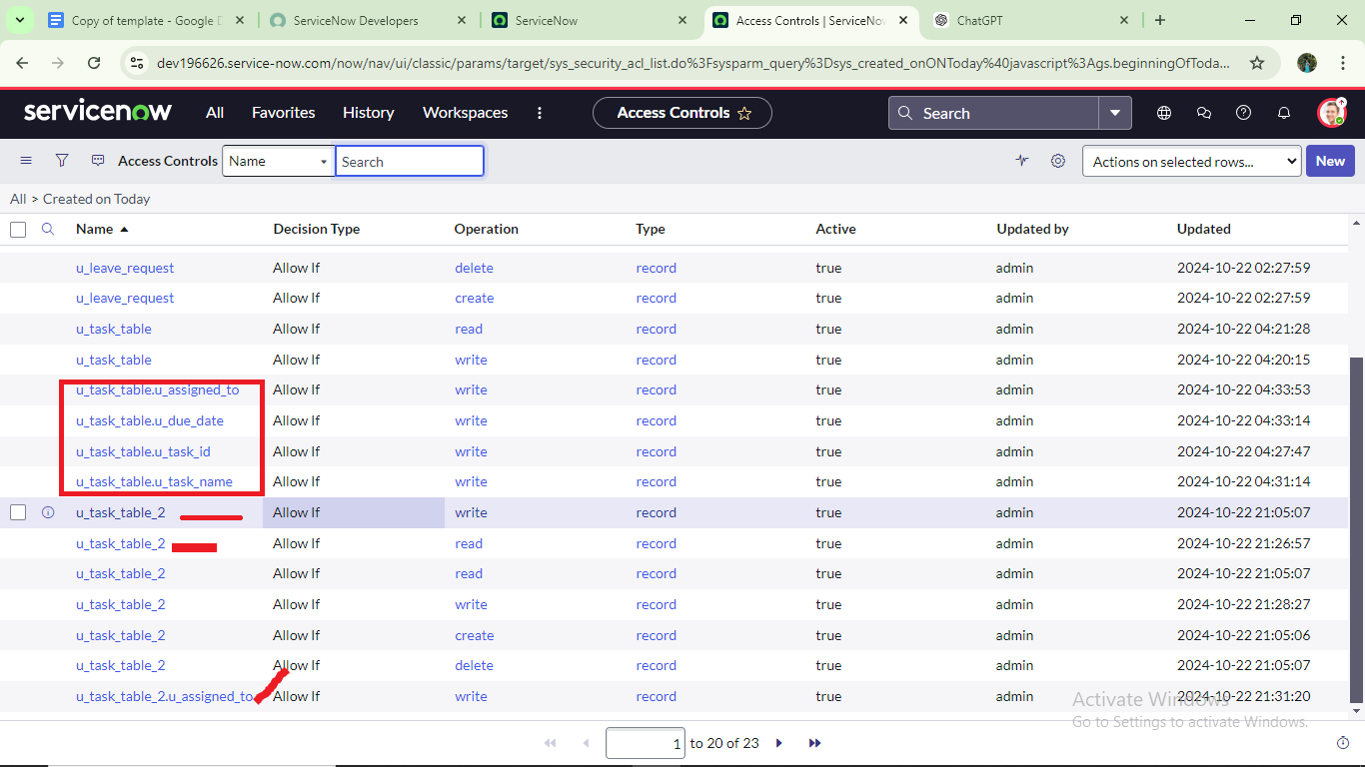

12.Click on profile on top right side

13.Click on impersonate user

14.Select bob user

15.Go to all and select task table2 in the application menu bar

16. Comment and status fields are have the edit access

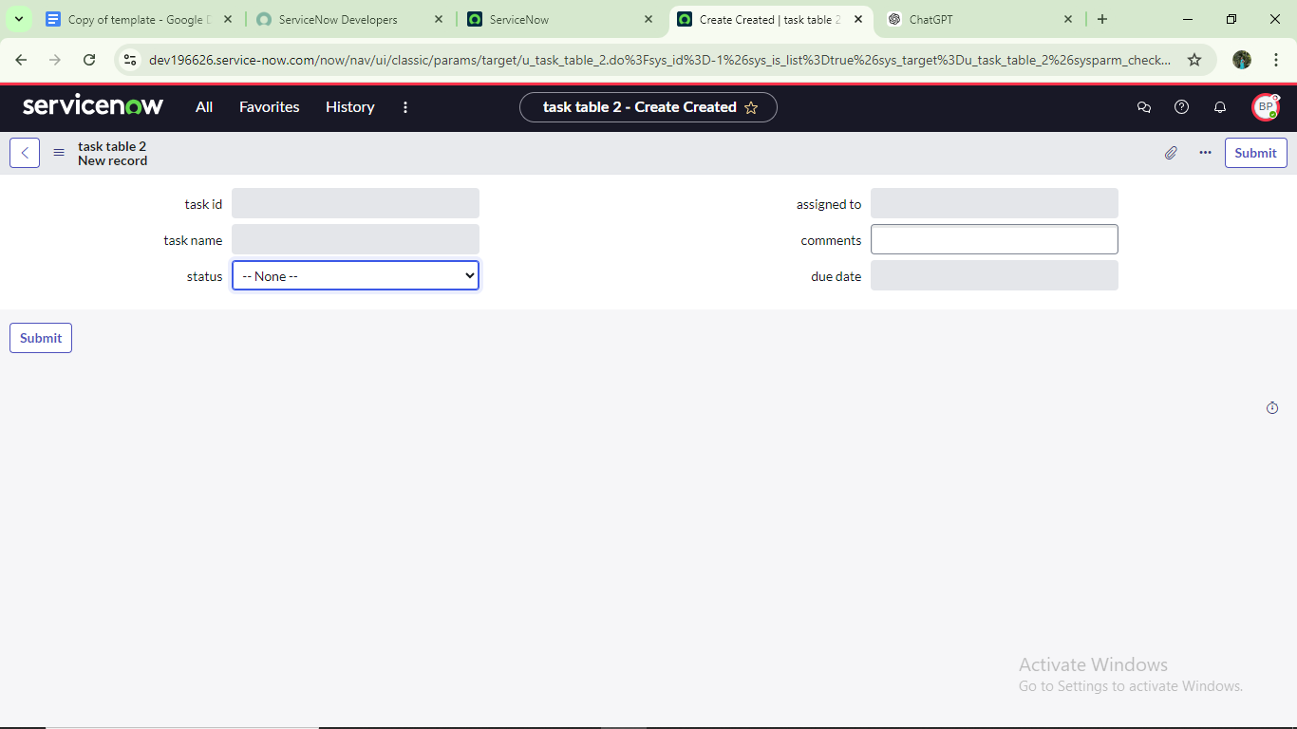

## **Milestone 9: Flow** **Activity 1:** **Create a Flow to Assign operations ticket to group**

1. Open service now.
2. Click on All >> search for Flow Designer
3. Click on Flow Designer under Process Automation.
4. After opening Flow Designer Click on new and select Flow.
5. Under Flow properties Give Flow Name as “ task table”.
6. Application should be Global.
7. Click build flow.

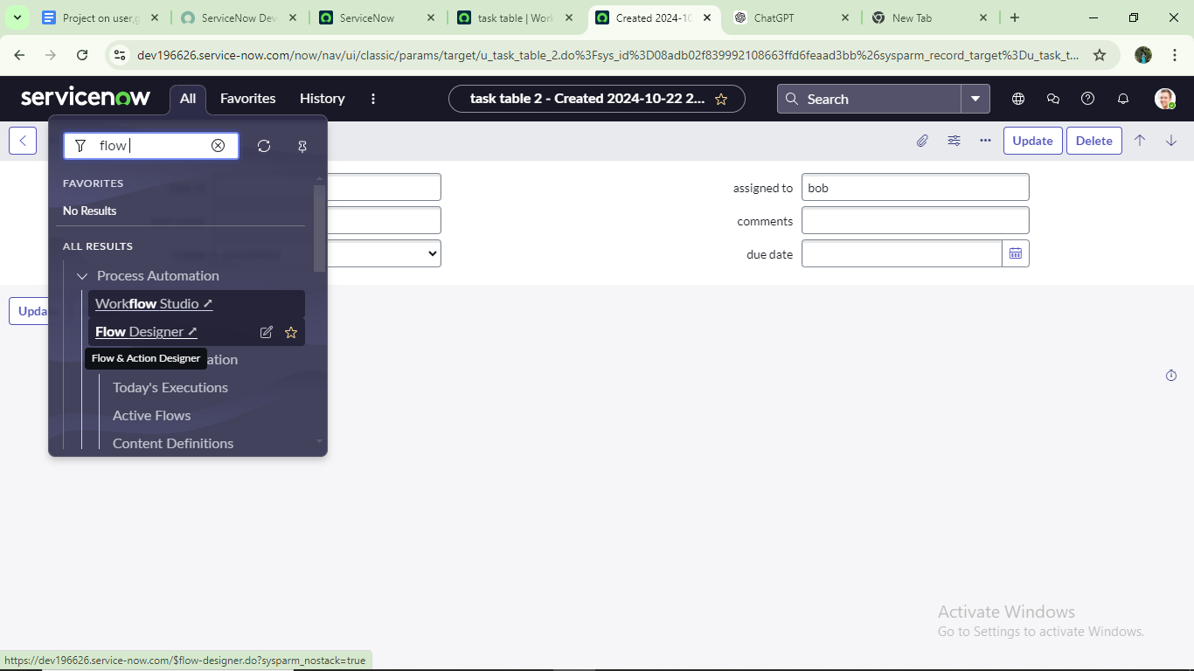

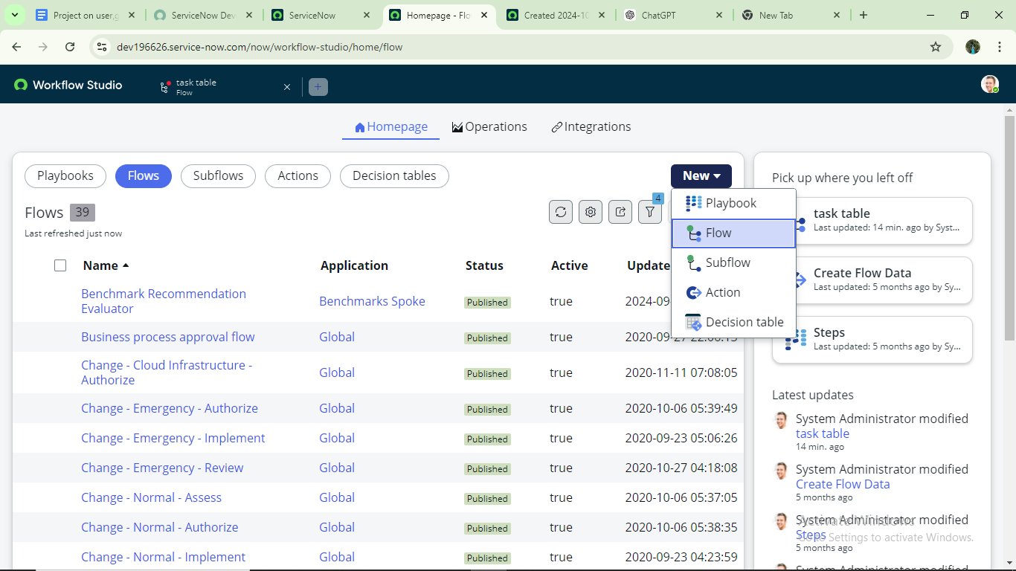

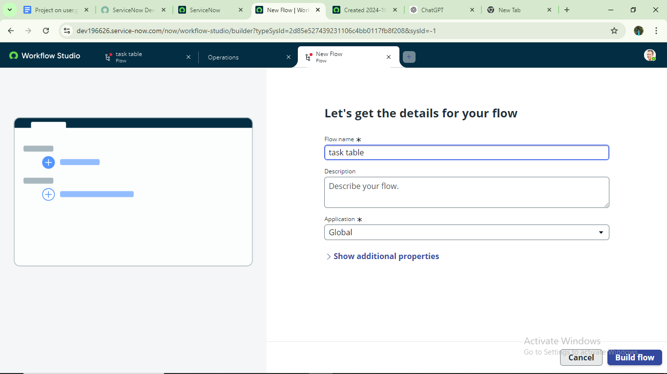

**next step:**

1. Click on Add a trigger
2. Select the trigger in that Search for “create record” and select that.
3. Give the table name as “ task table ”.
4. Give the Condition as Field : status Operator :is Value : in progress

Field : comments Operator :is Value : feedback

Field : assigned to Operator :is Value : bob

1. After that click on Done.

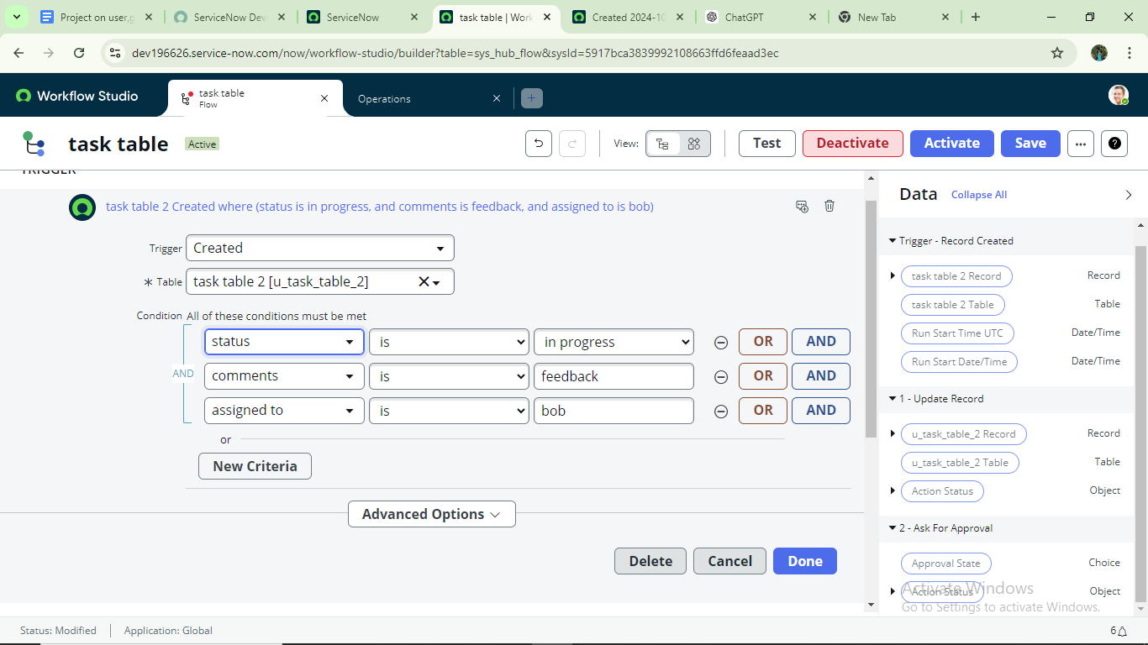

**Next step:**

1. Click on Add an action.
2. Select action in that ,search for “ update records”.
3. In Record field drag the fields from the data navigation from Right Side(Data pill)
4. Table will be auto assigned after that
5. Add fields as “status” and value as “completed”
6. Click on Done.

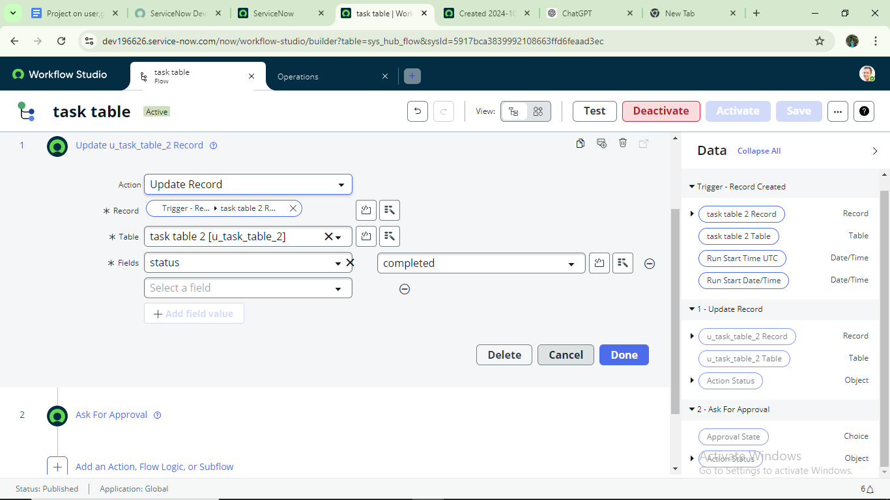

**Next step:**

1. Now under Actions.
2. Click on Add an action.
3. Select action in that ,search for “ ask for approval ”.
4. In Record field drag the fields from the data navigation from Right side
5. Table will be auto assigned after that
6. Give the approve field as “ status”
7. Give approver as alice p
8. Click on Done.

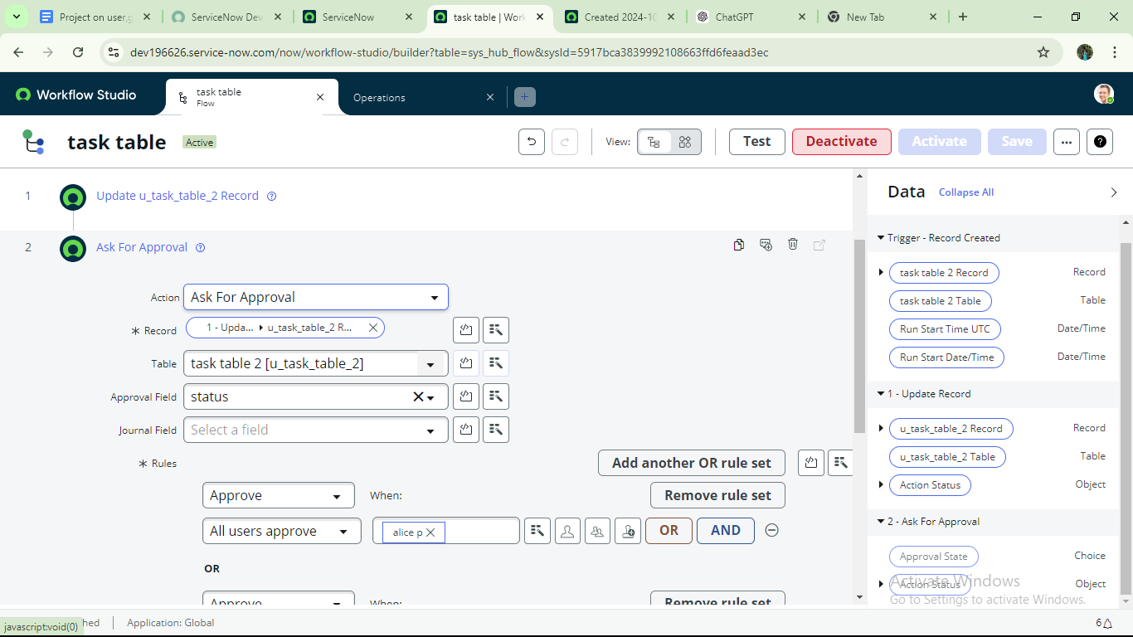

9.Go to application navigator search for task table.

10.It status field is updated to completed

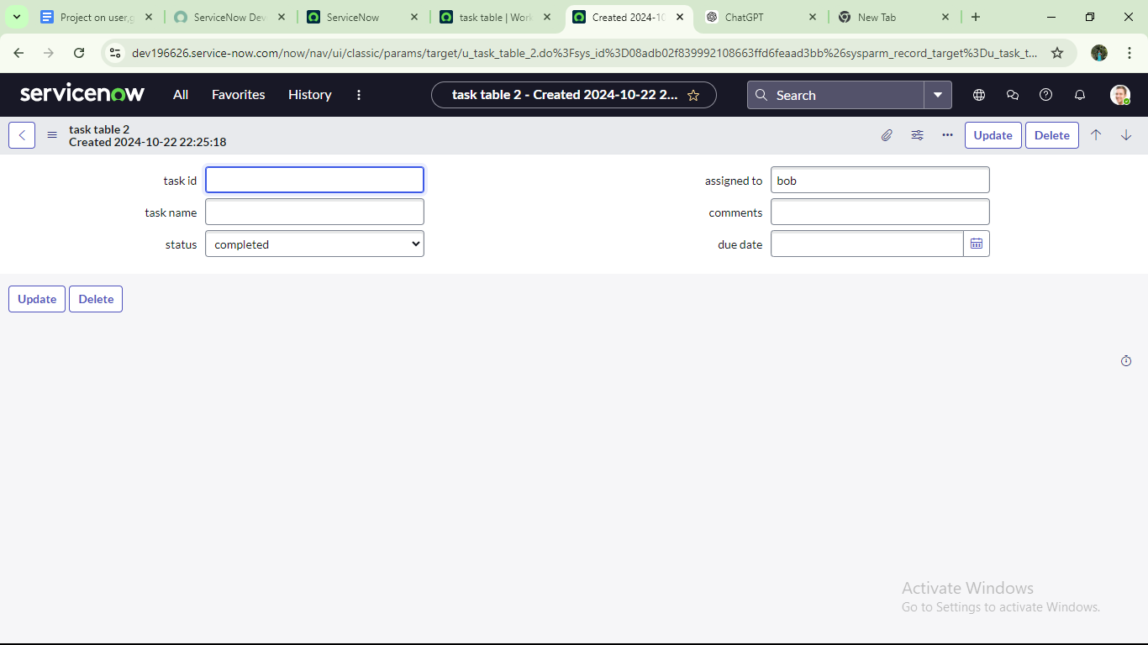

11.Go to application navigator and search for my approval

12.Click on my approval under the service desk.

13. Alice p got approval request then right click on requested then select approved

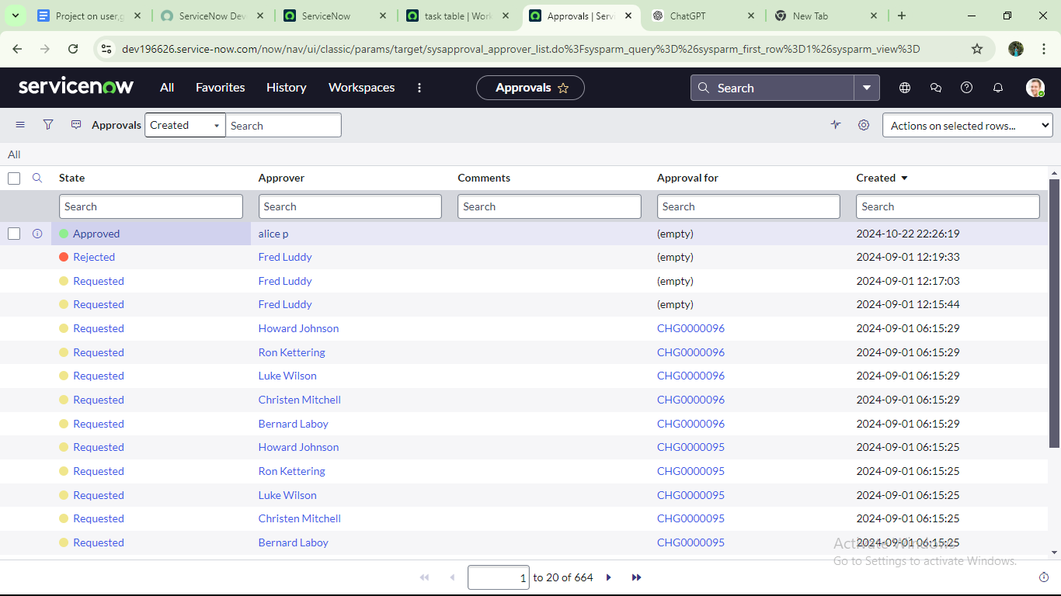

# Conclusion :

This scenario highlights a structured approach to project management, showcasing the roles of Alice and Bob within a defined workflow. With Alice's oversight and Bob's execution, the team effectively collaborates to ensure project success. The use of tables organizes key information, facilitating easy tracking of projects, tasks, and progress updates. Overall, this system promotes accountability, enhances communication, and leads to the successful completion of projects.