Veritly Market Intelligence Report
Telecom Customer Churn Analysis
Generated: 2026-01-28 05:27

Executive Summary
Analysis of 3,333 telecom customers reveals a churn rate of 14.49%, representing 483 customers lost.
Key findings indicate that international plan customers and those with high service call volumes are at elevated risk of churning.

Key Metrics
Metric | Value
Total Customers | 3,333
Churned Customers | 483
Churn Rate | 14.49%
Model Accuracy | 86.38%
High Risk Customers | 181

Segment Analysis

By International Plan
Segment | Customers | Churned | Churn Rate
Without International Plan | 3,010 | 346 | 11.5%
With International Plan | 323 | 137 | 42.41%

Analysis Visualisations

Churn By Segment
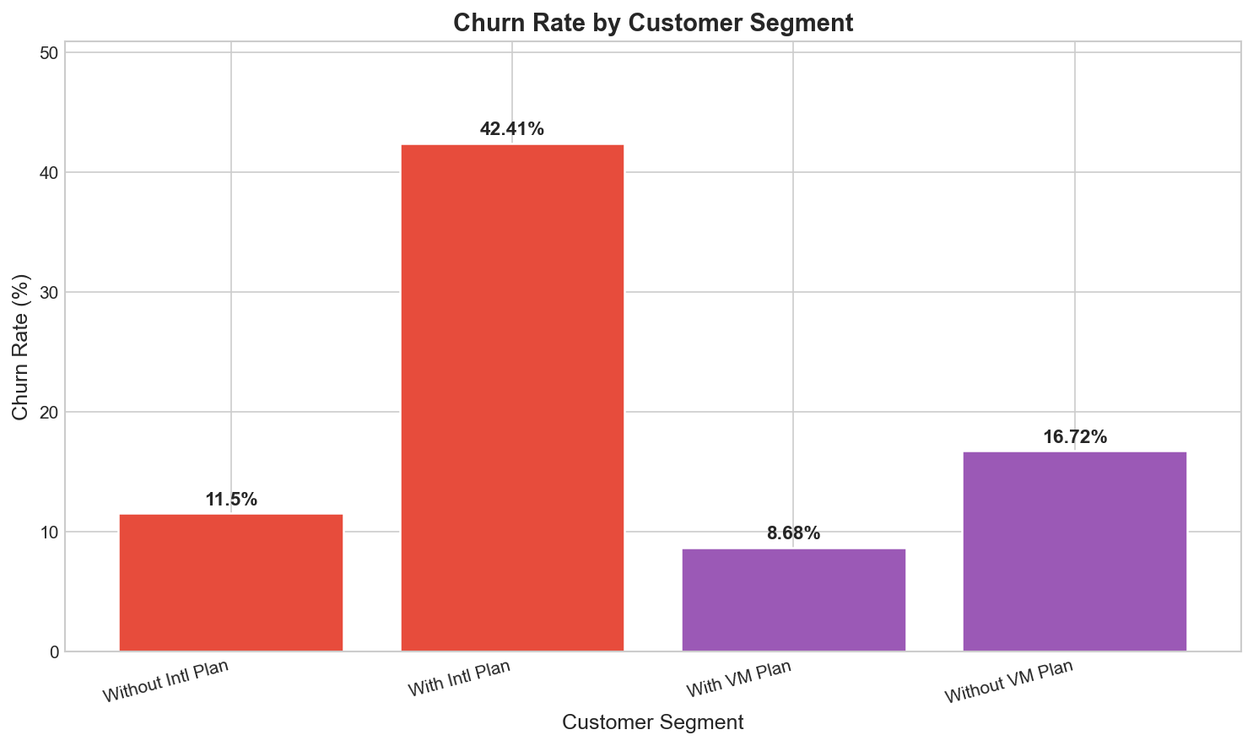

Service Calls Tipping Point
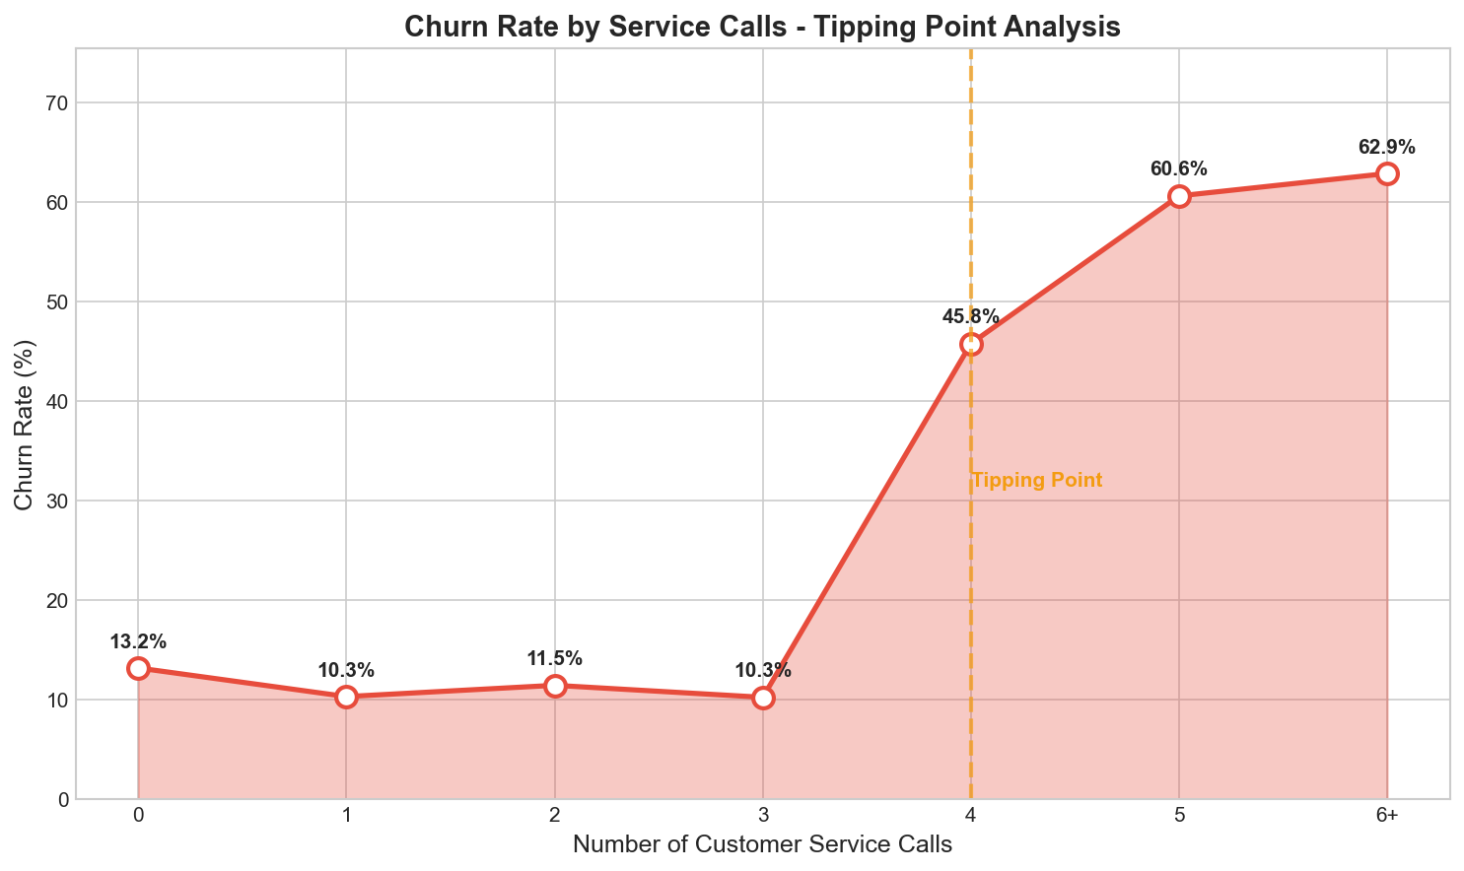

Risk Distribution
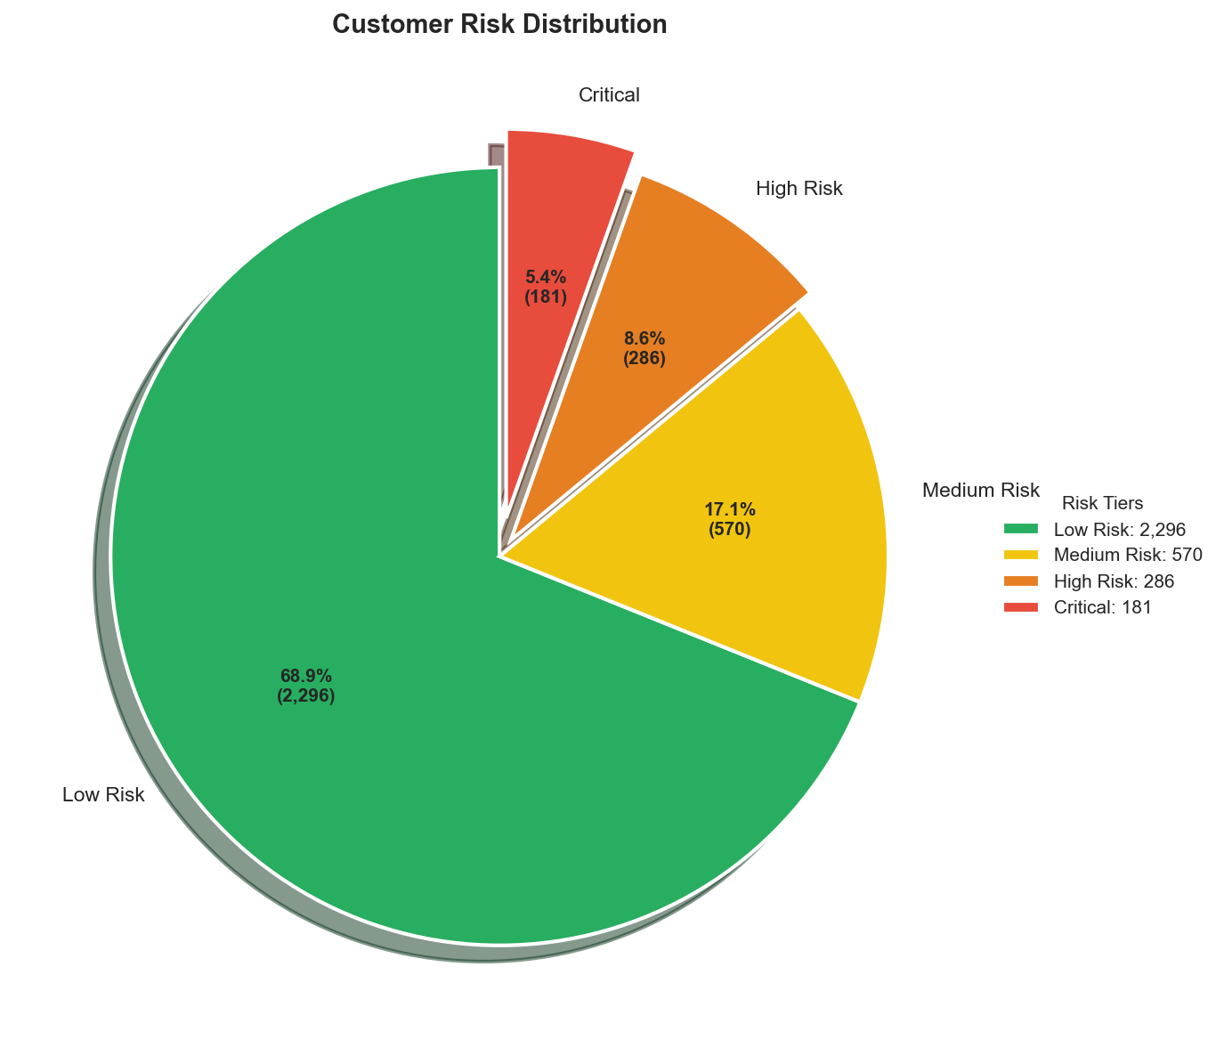

Top States Churn
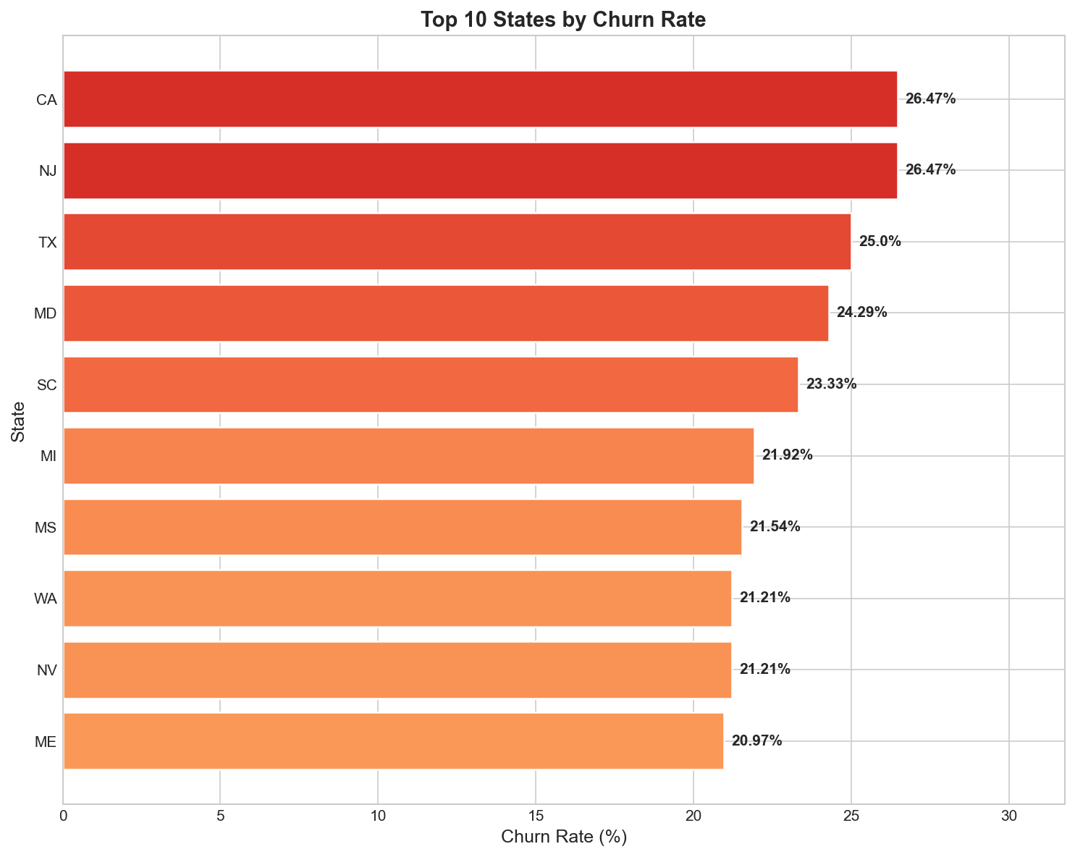

Feature Correlation
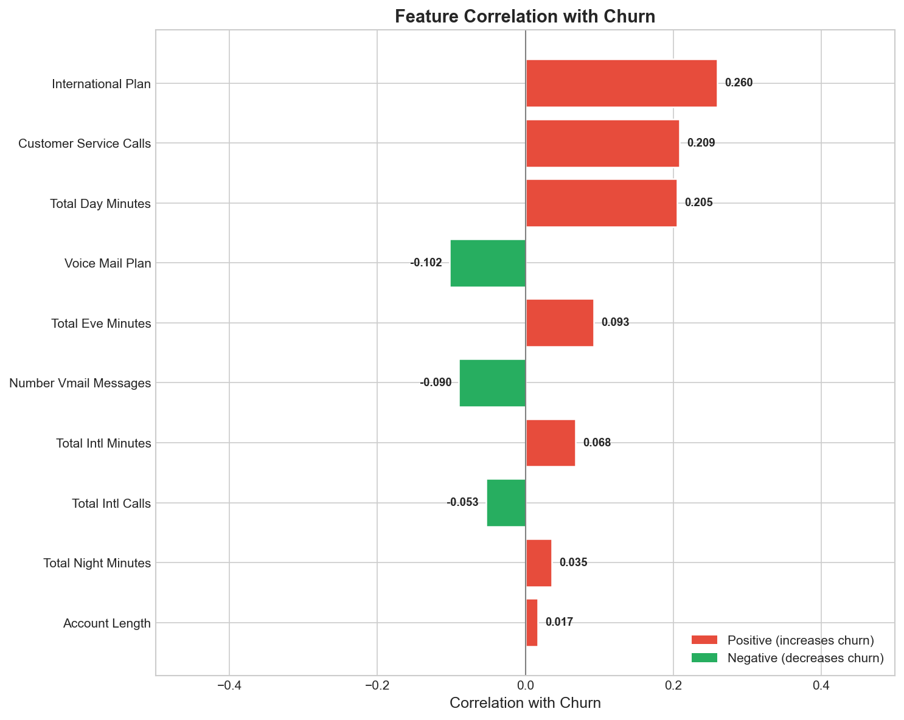

Risk Tier Distribution
Risk Tier | Count | Probability Range
Low | 2,296 | 0% - 15%
Medium | 570 | 15% - 30%
High | 286 | 30% - 50%
Critical | 181 | 50% - 100%

Generated by Veritly AI Market Intelligence Platform

