**Introduction**

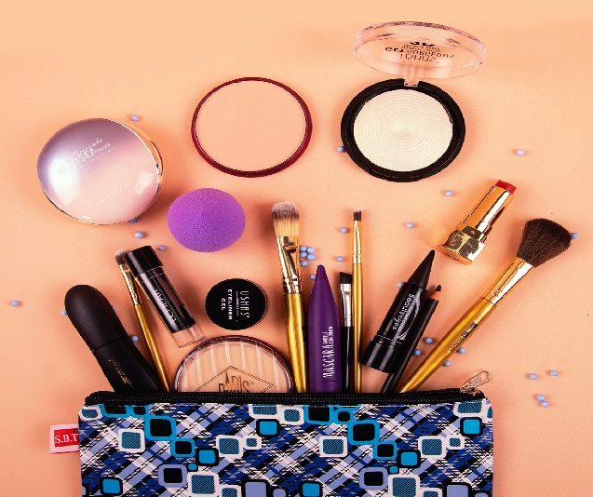

**Overview**

While most people think of the beauty business as cosmetics, it has grown in scope and now includes covers a wide range of products.  Beyond just cosmetics there is perfume, skin cleaners, a host of other skin care products, cosmeceuticals, etc.

Beyond the products themselves, the beauty business also includes the way in which the products are sold. In particular, price points and the places cosmetics are packaged and sold.

Price points have always varied, but packaging has become ever more important. Where products sell has gone from physical stores that were very location driven, to being sold over the Internet to people all over the world.

This guide is not the science of beauty, it is a business guide that includes information on the history and the current market (as of the date of this guide). There is a U.S. and European focus generally, but the modern industry is very global. This guide is not comprehensive or exhaustive, but rather meant as a starting point for research in this area.

## About Business Reference Services

Part of the [Science, Technology & Business Division](https://www.loc.gov/rr/business/busover.html) at the Library of Congress, Business Reference Services is the starting point for conducting research at the Library of Congress in the subject areas of business and economics. Here, reference specialists in specific subject areas of business assist patrons in formulating search strategies and gaining access to the information and materials contained in the Library's rich collections of business and economics materials.

Purpose

It helps your skin stay in good condition: You're shedding skin cells throughout the day, so it's important to keep your skin glowing and in good condition. An effective routine can help prevent acne, treat wrinkles, and help keep your skin looking its best.

***Cosmetics****are constituted mixtures of*[*chemical compounds*](https://en.wikipedia.org/wiki/Chemical_compound)*derived from either*[*natural sources*](https://en.wikipedia.org/wiki/Natural_product)*, or synthetically created ones.*[*[1]*](https://en.wikipedia.org/wiki/Cosmetics#cite_note-Ullmann-1)*Cosmetics have various purposes. Those designed for*[*personal care*](https://en.wikipedia.org/wiki/Personal_care)*and*[*skin care*](https://en.wikipedia.org/wiki/Skin_care)*can be used to*[*cleanse*](https://en.wikipedia.org/wiki/Cleaning)*or protect the body or skin. Cosmetics designed to enhance or alter one's appearance (makeup) can be used to conceal blemishes, enhance one's natural features (such as the*[*eyebrows*](https://en.wikipedia.org/wiki/Eyebrow)*and*[*eyelashes*](https://en.wikipedia.org/wiki/Eyelash)*), add color to a person's face, or change the appearance of the face entirely to resemble a different person, creature or object. Due to the harsh ingredients in makeup products, individuals with acne-prone skin are more likely to suffer from breakouts.*[*[2]*](https://en.wikipedia.org/wiki/Cosmetics#cite_note-2)*Cosmetics can also be designed to add fragrance to the body*.



*Due to the harsh ingredients in makeup products, individuals with acne-prone skin are more likely to suffer from breakouts.*[*[2]*](https://en.wikipedia.org/wiki/Cosmetics#cite_note-2)*Cosmetics can also be designed to add fragrance to the body*.

Literature Survey

In the [tertiary education](https://en.wikipedia.org/wiki/Tertiary_education) system of the United States, a **literature survey** is (typically) a [sophomore](https://en.wikipedia.org/wiki/Sophomore#Tertiary_education)-level class introducing students to major works of literature of a given culture, language, and period. Literature taught in those classes is often the canonical material of the culture, language, and period; similar classes are taught by history departments as well, with similar objectives: to teach what one manual called "the broad sweep of our civilization's accomplishments"

**The damaging effects of chemicals on living organisms of cosmetic products are hilarious.**

* Batch times. Problem:- When product demands grow, so too must the supply and capacity of the production facilities. ...
* Emulsification process. Problem:- ...
* Varying viscosity. Problem:- ...
* High energy consumption. Problem:- ...
* Maximizing quality.

**Solutions:**

* Manufacturing accountability drives quality and efficiency.
* From the beginning of research and development and ingredient selection to planning and preparation, brands need to accelerate the process and simplify production processes to ensure they remain effective in today's cosmetics world.
* Also, nowadays, some techniques are used for testing the unfavorable impacts of cosmetic products. However, such practices are hindered by factors like short testing windows of the lab and poor data translation from animal models.
* Even so, there still exist over 400 firms that manage to do experiments and tests on animals. The majority of these companies, if not all, lived before restrictions on animal tests came into effect.
* The damaging effects of chemicals on living organisms of cosmetic products are hilarious.
* When product demands grow, so too must the supply and capacity of the production facilities. There is the concern that to attain a faster speed to market. This will lead to compounded production processes and a great amount of resource investment. 2. Emulsification process
* There are several processing steps, In any given cosmetics production cycle time. The calculation of this cycle time starts with selecting and producing the raw materials, and yes, it is the most time-consuming process. The main raw materials are oil and water, which need to be heated up to 80ᴼC then cooled down to 25ᴼC. This cooling period makes up the longest part of the cosmetics production process, accounting for approximately 60% of the overall cycle time.

**Theortical Analysis**

**Block Diagram:**

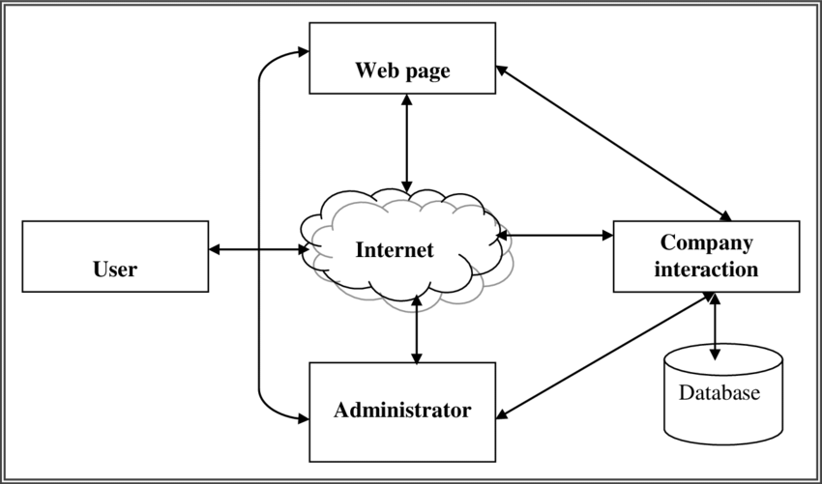

**Hardaware Reqiurements:**

* **MEMORY**
* **SECONDARY STORAGE**
* **DISPLAY ADAPTER**
* **PERPHERALS**

**Software Requirments:**

* **HTML**
* **CSS**
* **Java Script**

Result

**Ecommerce Result**

*Service Provider*

Ecommerce Result is a vendor-independent Ecommerce Technology Agency with offices in The Netherlands and Belgium. Our consultants and interim professionals have at least 10 years of relevant working experience in Ecommerce, Customer Data Management, Product Data Management and Marketing Automation Solutions.

First of all, we help our CDP customers with a proper Customer Data Strategy. Next to that we help them select the perfect solution and manage the implementation and activation of the Customer Data Platform.

Vendors we have worked with: Adobe, Agi lone, Blue conic, Blue Venn, Cust Obar, Exponea, Invicta, Lead Boxer, Lytics, PRDCT, Salesforce, Squeezely, Tealium.

### **Cosmotic Results:**

'I appreciate the seriousness and wholesomeness of this brand. I’ve used brands like Dr Hauschka and Weleda for years but am pleased to have found a more local/ UK alternative. I use the Makeup Melt, the Rejuvenate Day Cream and have had samples of the exfoliator and serum. I’m impressed by the high quality ingredients, lovely natural scents from essential oils and plastic-free packaging.'  
Thank you! Nathalie (Dorset/ Paris)

'Really good quality, lovely packaging & smells amazing. Speedy delivery.' Becky, England

'Always great and a pleasure to do business with this company. Cream is excellent. I have been using it for years. Thanks.' Jeffrey, USA

'Beautiful gift set! The presentation packaging is really lovely, and the gift box was packaged really securely for the post! I'm very pleased with the item, the shampoo smells delicious! Thank you!' Lydia, England

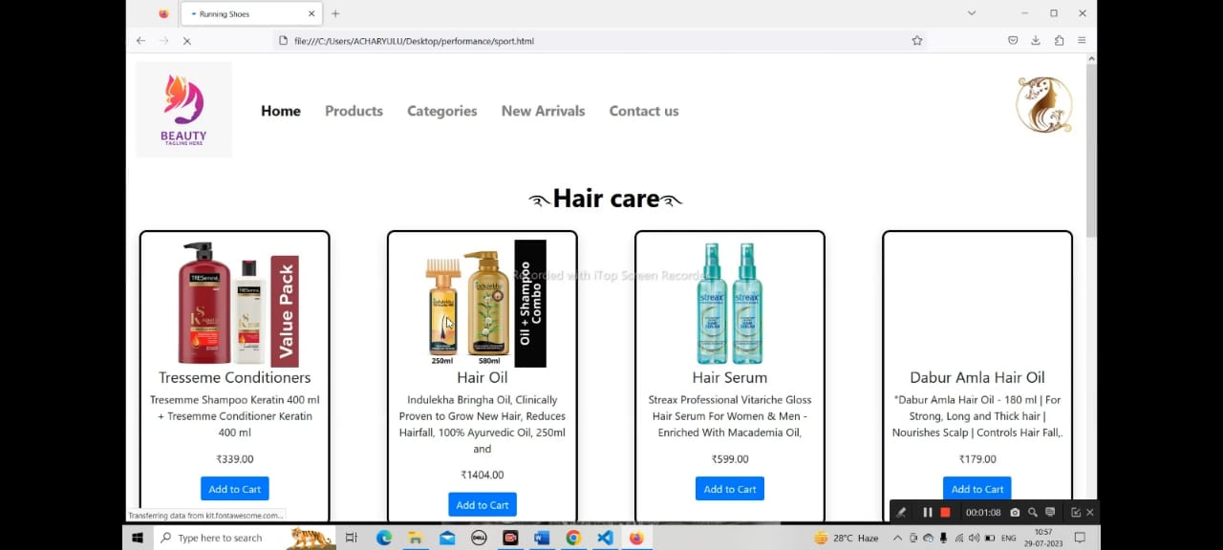

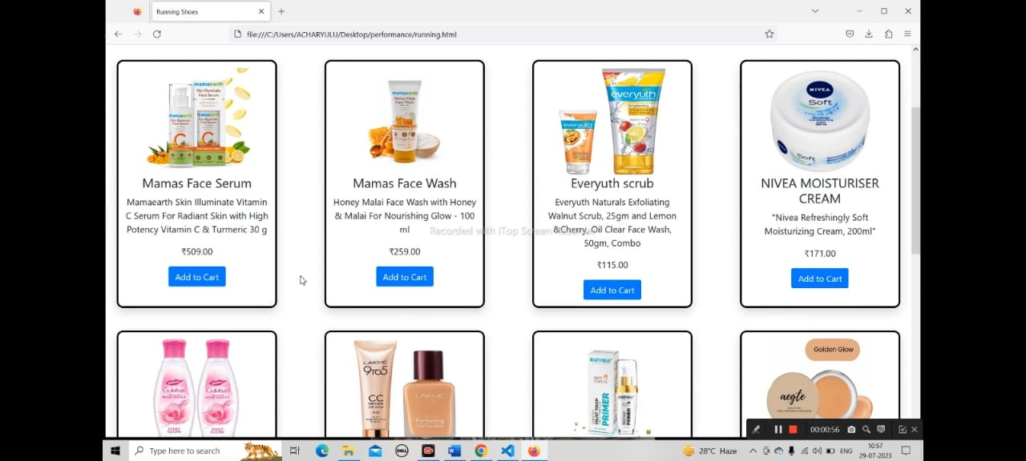



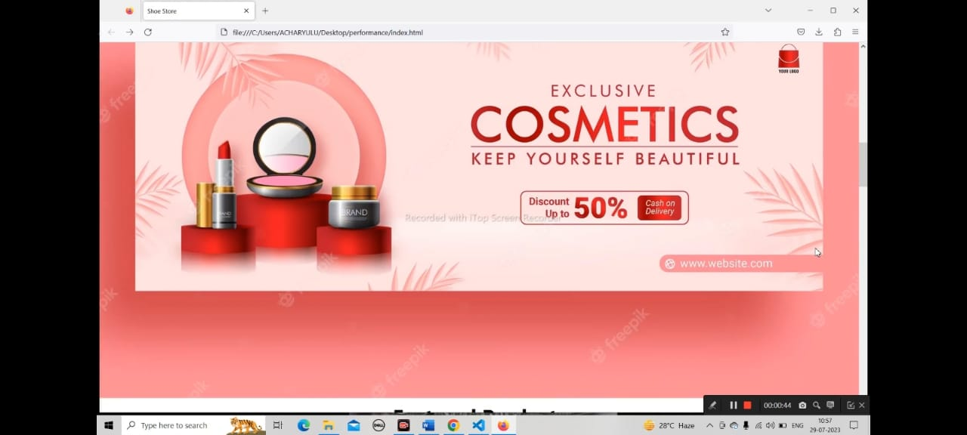

Advantages:

This article was made to help you know more about the benefits of e-business. The online marketplace is a good platform for you to expand your business. We are going to explain what kind of advantages there are by sharing what we know about online selling. In brief, these are the plus points we will talk about.  
  
1. Faster buying process  
2. Store and product listing creation  
3. Cost reduction  
4. Affordable advertising and marketing  
5. Flexibility for customers  
6. No reach limitations  
7. Product and price comparison  
8. Faster response to buyer/market demands  
9. Several payment modes  
10. Enables easy exports

Disadvantages:

* Potential security threats. When you're doing business online, there's always the potential for security threats. ...
* Competition. ...
* IT issues. ...
* Shipping logistics. ...
* Limited connection with customers.
* There are advantages and disadvantages of a business using e-commerce, so it’s important to know about the potential drawbacks as well. Running an e-commerce website can be particularly challenging for people who aren’t familiar with computers and technology. Here’s what you need to know about the potential downsides of e-commerce.

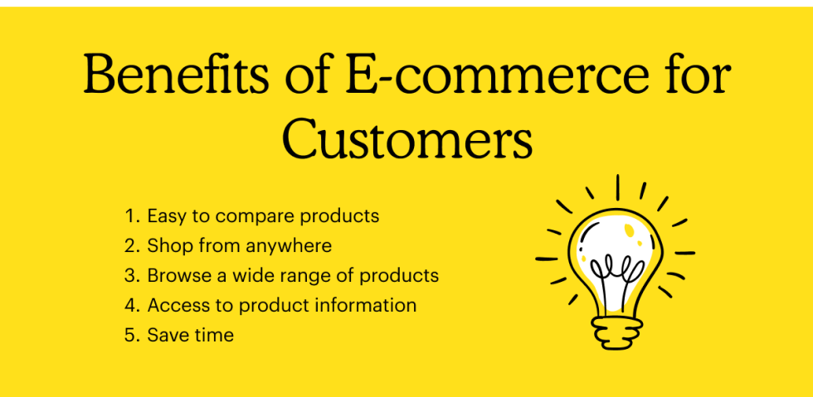

Applications

Ecommerce or electronic commerce actually means the use of an electronic medium for commercial transactions, but it is commonly used to refer to selling products and services over the internet to consumers or other businesses.

According to another definition, ecommerce refers to the sharing of business information, maintenance of business relationships and conducting business transactions with the help of computers that are connected to a telecommunication network, and without the use of paper documents.

We can classify Ecommerce by application into:

* **Electronic markets** – here the buyer is presented a range of products and services available in a market so that they can compare prices and make the purchase
* **Electronic Data Interchange** – this is a standardized system where computers communicate with one another without printed documents like order forms or invoices; it eliminates delays and errors otherwise seen when paper handling is involved
* **Internet Commerce** – the one we are most familiar with; the medium used to advertise, and sell innumerable products and services; the purchased goods are then shipped to the buyer.

Conclusion

   E-commerce still represents one of the business methods that take advantage if done the right way, even if the stock market and commodities fell, but E-Commerce still able to survive and receive high transaction. E-commerce has a tremendous opportunity in the course of or business in Malaysia. In addition, it is also to introducing new techniques and styles in a transaction. Use the extensive E-Commerce in the Internet world is actually much better to bring the goodness of the individual or the state.

    E-Commerce has undeniably become an important part of our society. The successful companies of the future will be those that take E-Commerce seriously, dedicating sufficient resources to its development. E-Commerce is not an IT issue but a whole business undertaking. Companies that use it as a reason for completely re-designing their business processes are likely to reap the greatest benefits. Moreover, E-Commerce is a helpful technology that gives the consumer access to business and companies all over the world.

he internet has opened so many opportunities for doing business online, and e-commerce is one of the most popular ones. Not only does it require low investment, it actually is a type of business that does not require a full-time commitment, especially if you are selling a limited number of products. You just make an online presence and promote the business here and there using both free and paid methods. However, as each business, it has its positive and negative sides. If you want to achieve success, you will have to create an organized strategy which is based on realistic goals and comprehensive analysis of the market.

**Future Scope**

Some Likely Future Trends of Ecommerce in India · **Increasing number of mobile shoppers thanks to the** high mobile penetration in India

India has shown rapid growth in the eCommerce sector. It is **now brimming with job opportunities and service providers**

The Scope of Ecommerce ·

1. **Omnichannel presence and support** ·

2. Customer experience ·

3. A high degree of individualization in all aspects ·

**Scope of E-Commerce- The Upcoming Trends**

* 1. Omnichannel presence and support Today, people carry out research, consideration, and purchase across multiple channels. ...
* 2. Customer experience Customer experience, both in-store and online, matters a lot for the success of your e-commerce business. ...
* 3. High levels of personalization ...
* 4. Mobile-friendliness ...
* 5. Image recognition turned product recognition ...