Understanding Algorithm Efficiency and Scalability: A Comparative Study of Quicksort and Hash Tables
Ranjith Kumar Bollam
University of the Cumberlands
MSCS 532 – Algorithms and Data Structures
March 22, 2026

Abstract
In this assignment, I analyzed and compared the efficiency and scalability of two important algorithmic techniques: Quicksort and Hash Tables with chaining. The goal of this study was to understand how algorithm design choices impact performance under different input conditions. Through implementation and testing, I observed that Randomized Quicksort provides consistent performance across datasets, while Deterministic Quicksort fails under certain conditions, such as sorted and repeated inputs. Additionally, hash tables with chaining demonstrated efficient performance for data storage and retrieval. The findings highlight the importance of selecting appropriate algorithms for real-world applications.
Introduction
Algorithm efficiency plays a critical role in computer science, especially when dealing with large datasets. Efficient algorithms reduce execution time and improve system performance. In this assignment, I focused on two key concepts: sorting algorithms and hashing techniques. Sorting is fundamental for organizing data, while hashing enables fast data retrieval. This project includes the implementation and analysis of Randomized Quicksort, Deterministic Quicksort, and a Hash Table using chaining. Each algorithm was tested under different conditions to evaluate its behavior and scalability.
Randomized Quicksort
Randomized Quicksort is a variation of the traditional Quicksort algorithm where the pivot element is selected randomly. This approach helps avoid worst-case scenarios that occur when the input data is already sorted or contains repeated values. The algorithm works by partitioning the array into three parts: elements less than the pivot, equal to the pivot, and greater than the pivot. From my implementation and testing, I observed that Randomized Quicksort consistently performed well across all datasets. Its average-case time complexity is O(n log n), making it suitable for large-scale applications. The randomness in pivot selection ensures that the algorithm does not degrade easily under unfavorable input conditions.
Deterministic Quicksort
Deterministic Quicksort uses a fixed strategy for selecting the pivot, typically the first element of the array. While this approach is simple to implement, it can lead to poor performance when the input data is already sorted or contains many identical elements.. During testing, I noticed that Deterministic Quicksort worked efficiently for random datasets but failed for sorted and repeated datasets. In such cases, the recursion depth increased significantly, leading to a RecursionError in Python. This behavior confirms the theoretical worst-case time complexity of O(n²).
This experiment clearly demonstrates that pivot selection plays a crucial role in the efficiency of Quicksort.
Hash Table with Chaining
A hash table is a data structure that stores key-value pairs and allows for fast insertion, deletion, and lookup operations. In this assignment, I implemented a hash table using chaining to handle collisions. Chaining involves storing multiple elements in the same index using a linked list. The hash function maps keys to indices in the table. When multiple keys map to the same index, they are stored in a list at that index. This approach ensures that collisions do not result in data loss. From testing, I observed that the hash table performed efficiently for insert and search operations. The average-case time complexity is O(1), provided that the load factor is maintained properly. The performance of the hash table is influenced by the load factor, which is the ratio of stored elements to the number of slots. As the load factor increases, the number of collisions also increases, which can degrade performance. Maintaining a low load factor through resizing helps ensure efficient operations. This makes hash tables highly efficient for real-world applications such as databases and caching systems.
Experimental Setup
To evaluate the performance of the algorithms, I tested them using different types of datasets:
- Random arrays
- Sorted arrays
- Reverse-sorted arrays
- Arrays with repeated elements
Each dataset was tested with different sizes (1000, 3000, and 5000 elements). The execution time for both Randomized and Deterministic Quicksort was measured using Python’s time module.
Results and Discussion
The results of the experiments showed clear differences in performance between the algorithms. Randomized Quicksort maintained stable performance across all datasets, while Deterministic Quicksort failed in worst-case scenarios. Specifically, it failed when the input data was already sorted or contained repeated values, resulting in recursion errors. The hash table implementation worked efficiently for all operations. Insert and search operations returned expected results, demonstrating the effectiveness of chaining as a collision resolution technique. These results highlight the importance of algorithm selection and design. Choosing the right algorithm can significantly impact system performance and scalability.
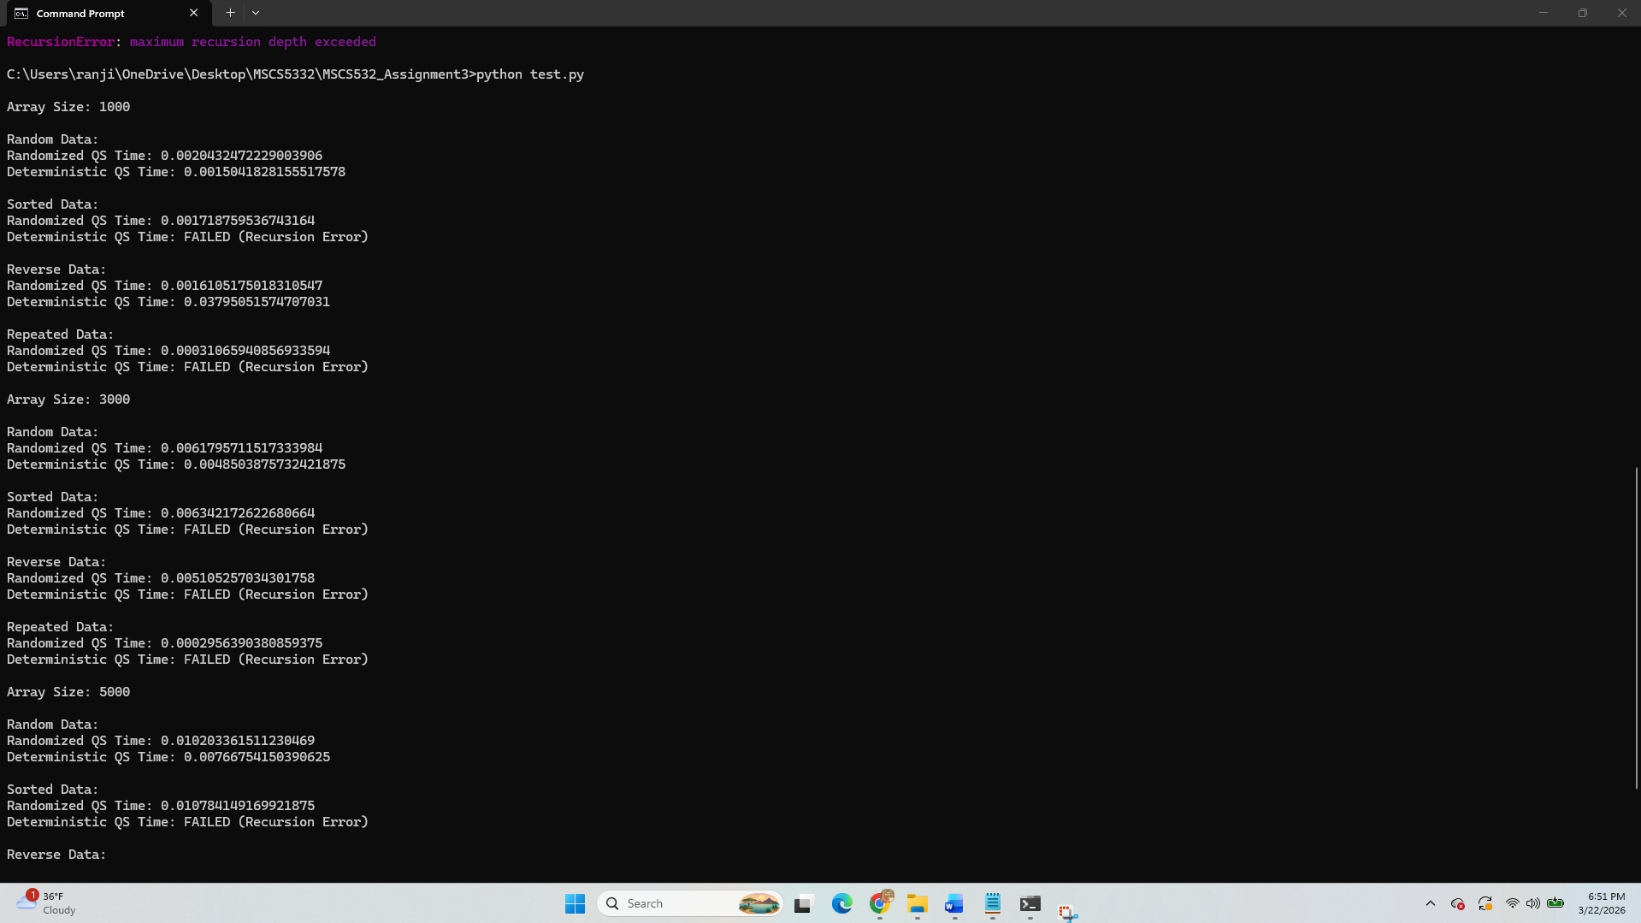

Conclusion
From this project, I observed that algorithm performance depends heavily on design decisions such as pivot selection and collision handling. Randomized Quicksort is more reliable than Deterministic Quicksort, especially for unpredictable datasets. Hash tables with chaining provide efficient data storage and retrieval, making them suitable for various applications.
Overall, this assignment helped me understand the practical implications of algorithm efficiency and scalability.
References
Cormen, T. H., Leiserson, C. E., Rivest, R. L., & Stein, C. (2009). Introduction to Algorithms (3rd ed.). MIT Press.
Goodrich, M. T., Tamassia, R., & Goldwasser, M. H. (2014). Data Structures and Algorithms in Python. Wiley.
Knuth, D. E. (1998). The Art of Computer Programming (Vol. 3). Addison-Wesley.

