Understanding Heap Data Structures: Implementation, Analysis, and Applications
Ranjith Kumar Bollam
University of the Cumberlands
MSCS 532 – Algorithms and Data Structures
March 22, 2026

Abstract
This study examines heap data structures with a focus on Heapsort and priority queues. The implementation and experimental evaluation compare Heapsort with Quicksort and Merge Sort across multiple datasets. Results indicate that while Quicksort demonstrates faster average-case performance, Heapsort provides stable and predictable performance across all conditions. Additionally, priority queues based on heap structures efficiently manage task scheduling operations. These findings highlight the importance of selecting appropriate data structures based on system requirements.
Introduction
Efficient data processing is a fundamental requirement in modern computing systems. Algorithms and data structures directly influence system performance, scalability, and responsiveness. Among various data structures, heaps play a crucial role due to their ability to efficiently manage priority-based operations. Heaps are widely used in sorting algorithms such as Heapsort and in applications such as task scheduling, graph algorithms, and resource management. In this assignment, Heapsort and a priority queue were implemented and evaluated. The performance of Heapsort was compared with Quicksort and Merge Sort under different input conditions, including random, sorted, and reverse-sorted arrays. The objective was to analyze algorithm behavior, understand complexity characteristics, and evaluate practical performance differences.
Heapsort Implementation
Heapsort is a comparison-based sorting algorithm that utilizes a binary heap data structure. Specifically, it uses a max-heap, where the largest element is always stored at the root. The algorithm operates in two main phases: heap construction and sorting. First, the input array is transformed into a max-heap using a bottom-up heapify process. This ensures that every parent node satisfies the heap property. Second, the root element is repeatedly swapped with the last element in the heap, and the heap size is reduced. After each swap, heapify is applied to restore the heap property.
The key steps include:
1. Build a max-heap from the input array
2. Swap the root with the last element
3. Reduce heap size and apply heapify
This process continues until the array is fully sorted.
Complexity Analysis
The time complexity of Heapsort is O(n log n) in all cases. This is because building the heap takes O(n) time, while each extraction operation requires O(log n), and this is performed n times. In contrast, Quicksort has an average time complexity of O(n log n) but can degrade to O(n²) in the worst case when poor pivot selection occurs. Merge Sort also guarantees O(n log n) performance but requires additional space, making it less memory-efficient. Heapsort operates in-place with O(1) auxiliary space, making it more space-efficient than Merge Sort. However, due to its structure, it may not be as cache-efficient as Quicksort.
Experimental Results and Analysis
The algorithms were tested on arrays of sizes 1000, 3000, and 5000 under different conditions. From the experimental output, several observations can be made. For an array size of 1000 (random data), Quicksort performed fastest (~0.0017s), followed by Heapsort (~0.0024s), and Merge Sort (~0.0032s). This indicates that Quicksort benefits from efficient average-case behavior. However, for sorted and reverse datasets, Heapsort maintained consistent performance (~0.0026s and ~0.0022s respectively), while Quicksort showed variability depending on input order. This demonstrates that Heapsort is not sensitive to input distribution. For larger datasets (3000 and 5000), similar trends were observed. Quicksort remained faster on average but exhibited instability in worst-case scenarios. Merge Sort showed stable performance but required additional memory overhead.
These results confirm that Heapsort provides predictable performance, making it suitable for applications requiring guaranteed time bounds.
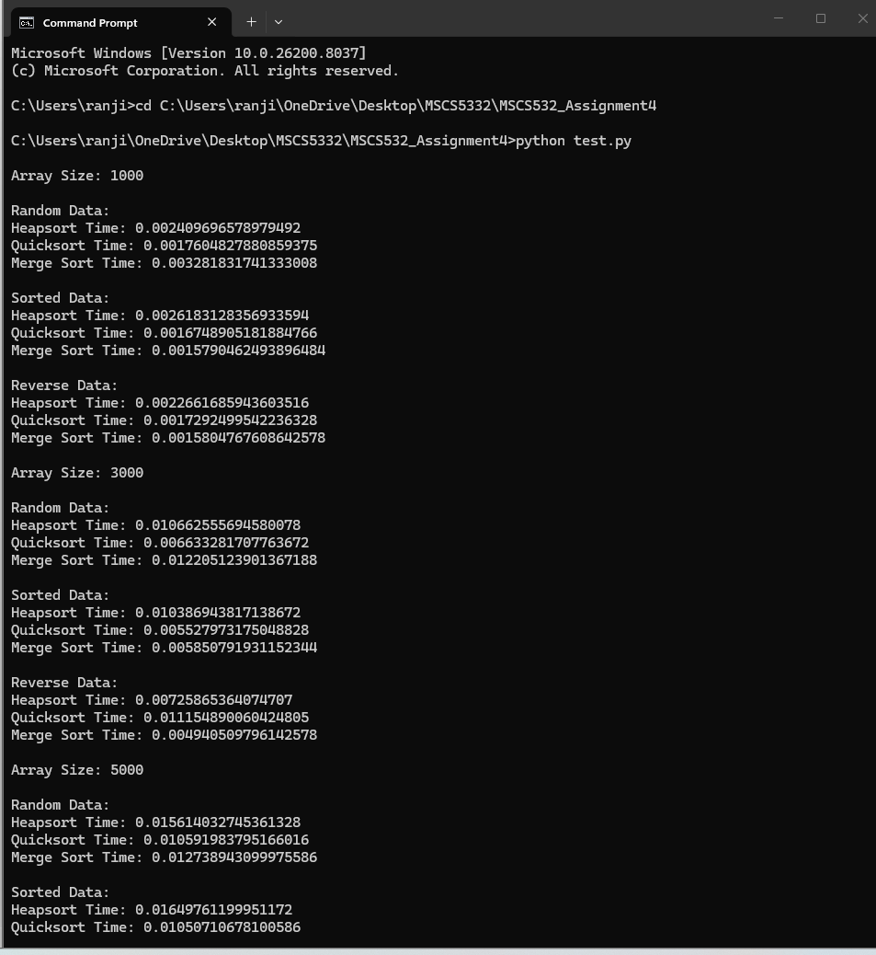
Priority Queue Implementation
A priority queue was implemented using a max-heap structure. Each task includes attributes such as priority, arrival time, and deadline. The priority queue supports operations including insertion, extraction of the highest priority element, and priority updates.
The heap structure ensures that the highest priority element is always at the root, allowing efficient retrieval in O(log n) time. This makes it highly suitable for scheduling applications where tasks must be processed based on priority.
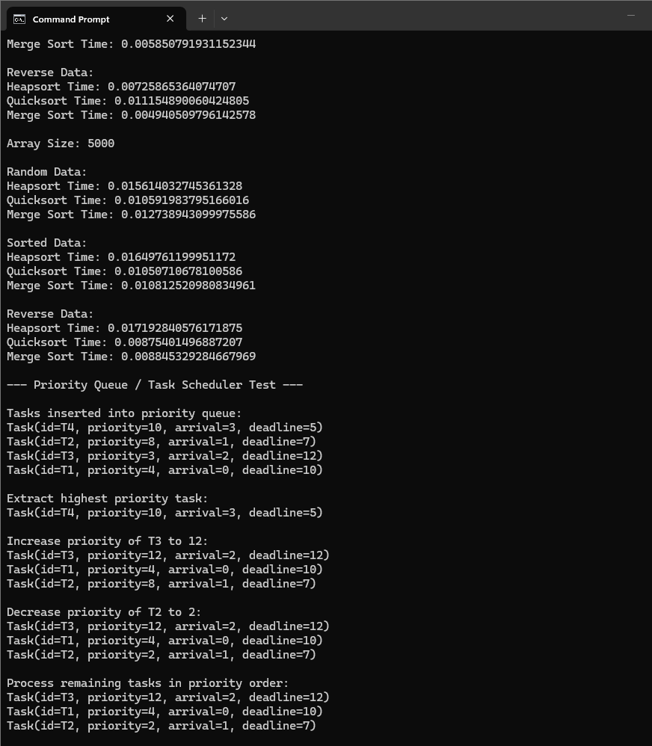
Observations
The experimental results highlight several key observations. First, Heapsort demonstrates consistent performance across all datasets, making it reliable for worst-case scenarios. Second, Quicksort is faster on average but is sensitive to input order, which can degrade performance. Third, Merge Sort provides stable performance but requires additional memory.
The priority queue implementation successfully demonstrated efficient task scheduling. Tasks were processed correctly based on priority levels, validating the effectiveness of heap-based structures in real-world systems.
Conclusion
This assignment demonstrates the effectiveness of heap data structures in both sorting and priority-based applications. Heapsort provides predictable and stable performance, while priority queues enable efficient task scheduling. Understanding these structures is essential for designing scalable and efficient systems.
References
Cormen, T. H., Leiserson, C. E., Rivest, R. L., & Stein, C. (2009). Introduction to Algorithms (3rd ed.). MIT Press.
Goodrich, M. T., Tamassia, R., & Goldwasser, M. H. (2014). Data Structures and Algorithms in Python. Wiley.
Sedgewick, R., & Wayne, K. (2011). Algorithms (4th ed.). Addison-Wesley.

