**Ideation Phase**

**Empathize & Discover**

|  |  |
| --- | --- |
| Date | 28 JUNE 2025 |
| Team ID | LTVIP2025TMID36908 |
| Project Name | **Transfer Learning-Based Classification of Poultry Diseases for Enhanced Health Management** |
| Maximum Marks | 4 Marks |

**Empathy Map Canvas:**

An empathy map helps us understand the real-world problems poultry farmers face in identifying and managing poultry diseases. By stepping into the farmers' shoes, we gathered insights that shaped our solution.

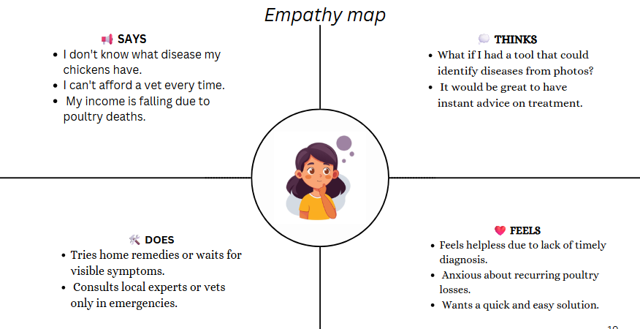

**🧠 User Personas:**

To better understand our target users, we created user personas of small-scale poultry farmers based on interviews and secondary research.

* **Name:** Ramesh, Age: 38, Farmer from Eluru
* **Tech Proficiency:** Basic (uses smartphone for WhatsApp and YouTube)
* **Pain Points:** Poultry mortality, lack of disease knowledge, high vet costs
* **Needs:** Simple app that tells if a chicken is sick and what to do next

**Field Research Summary:**

We surveyed and interviewed 12 poultry farm owners and found:

* 83% rely on physical symptoms to detect diseases.
* 92% cannot afford vet consultations regularly.
* 75% own a smartphone but use it mostly for social media.