Project Proposal (PRP)

Rev: A0-05

November 24th, 2016

Paloma

Tablet Remote Control

Development Proposal



**Revision History**

|  |  |  |  |
| --- | --- | --- | --- |
| **Date** | **Rev No.** | **Description** | **By** |
| 10/10/2016 | A0-01 | Initial draft | VVDN |
| 10/10/2016 | A0-02 | Block diagram is updated | VVDN |
| 10/12/2016 | A0-03 | Host processor is changed | VVDN |
| 10/13/2016 | A0-04 | NRE cost added | VVDN |
| 11/24/2016 | A0-05 | * Tablet width reduce from 24mm to 10mm * Wireless charger width reduces from 42mm to 32mm * 1K BOM cost added | VVDN |

Table of Contents

1 Executive Summary 5

2 Product Overview 5

2.1 Technical and Specification Requirements 6

3 Hardware Architecture 8

3.1 Tablet Remote Control Architecture 8

3.1.1 CPU 9

3.1.2 Memory 9

3.1.3 WiFi-BT RF Front End 10

3.1.4 Audio Output 10

3.1.5 Power 10

3.2 Wireless Charger Hardware Architecture 12

3.2.1 BLE SoC 13

3.2.2 Wireless Power Transmitter 13

3.2.3 Power Section 13

3.2.4 Boiler Interface Chip 13

3.2.5 Status Indicators 13

3.2.6 Boiler Connector 13

3.3 Mechanical Requirements 14

3.4 Preliminary BOM Analysis – 1K unit price 17

3.5 Preliminary BOM Analysis – 5K unit price 19

3.6 Design for Manufacturing 20

3.7 Environmental Requirements 20

4 Software Development 21

4.1 Key Software Features 21

5 Industrial Design and Development 21

5.1 Thermal analysis 21

6 Complete Scope of Project 24

7 Schedule, Tasks and Deliverables 25

7.1 Schedule 25

8 Commercial Terms 26

8.1 Fees 26

8.1.1 Non-Recurring Engineering Fees Milestones 26

8.1.2 Prototype Fees for 10 boards 26

8.1.3 Payment Milestones 26

8.1.4 Travel Costs 26

8.1.5 Certification Fee 26

9 About VVDN 26

9.1 Development Process 27

***List of Figures***

Figure 1: Product Overview 5

Figure 2: Tablet Remote Control Hardware Architecture 8

Figure 3: Wireless Charger Hardware Architecture 12

Figure 4: Tablet Mechanical Dimension 14

Figure 5: Wireless Charger Mechanical Dimensions 15

Figure 6: Wireless Charger Isometric View 16

Figure 7: Sample Thermal Profiling 21

Figure 8: Product development process at VVDN 26

***List of Tables***

Table 1:Tablet Remote Control Specification and Requirements 7

Table 2: Wireless Charger Specification and requirements 7

Table 3: BOM Cost for Tablet Remote Control 17

Table 4: BOM Cost for Wireless Charger 18

Table 5: BOM Cost for Tablet Remote Control 19

Table 6: BOM Cost for Wireless Charger 20

Table 7: Project Schedule 25

# Executive Summary

This proposal describes the product requirements, developments, objectives and deliverables along with schedule and commercial terms for the design and development of Tablet remote control and Wireless charger for Paloma Co. Ltd.

The technical basis for this proposal is based on the following inputs:

* Meetings directly between VVDN and Paloma
* Product requirement email from Paloma on 4th October 2016

# Product Overview

The tablet will allow the user to control the boiler using an app. The given control information by the user will be transmitted to the wireless charger via BLE. The wireless charger will be having the control system to control the boiler. The control signals will be transmitted through wires to the boiler to increase (or) decrease the temperature. When the tablet will be placed inside the charger, battery in the tablet will be charged wirelessly. The user can playback audio & video using the tablet and browse after connecting tablet to WiFi.

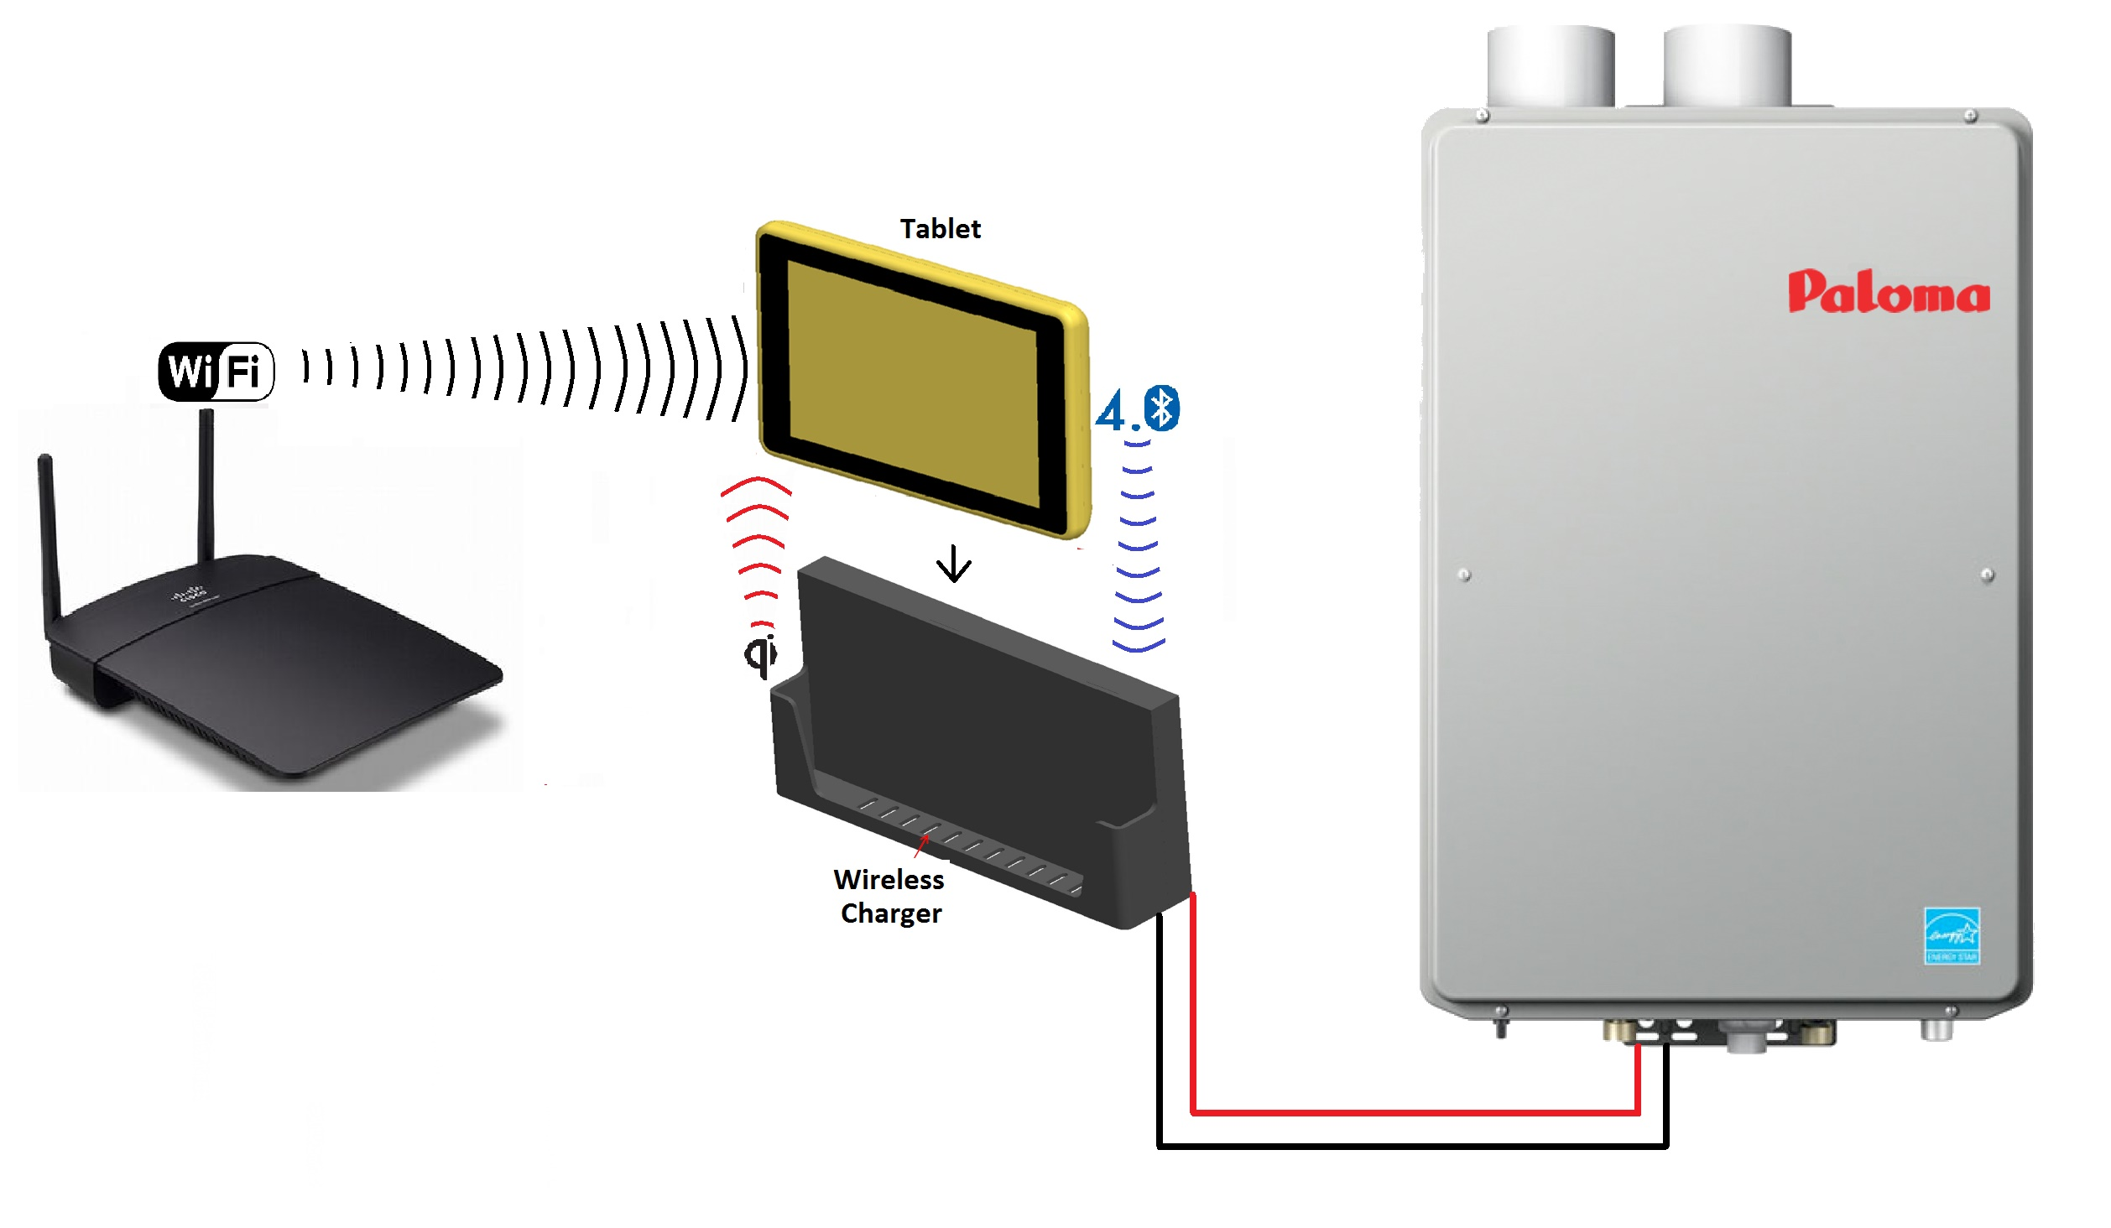

Figure 1: Product Overview

## Technical and Specification Requirements

The following table captures the key technical and functional requirements of the Tablet remote control.

|  |  |
| --- | --- |
| **Parameter** | **Requirements** |
| **Hardware Requirements** | |
| **CPU** | Allwinner R16 (or) equivalent |
| **RAM** | 1GB DDR3 SDRAM |
| **Internal Storage** | 4GB eMMC Flash |
| **Display type** | 7” TFT LED Display |
| **Display Resolution** | 1024x600 pixels |
| **Touch type** | Capacitive / Resistive |
| **Bluetooth** | Version 4.0 |
| **Speaker** | 1watt Mono Speaker |
| **Battery type** | Li-Ion |
| **Battery Capacity** | To be given |
| **Battery backup time at different conditions** | To be given |
| **Battery Charging duration** | 6 hours |
| **Charger method** | Qi Wireless Charging |
| **Software** | |
| **Operating System** | Android vers4.4 |
| **Bluetooth version** | 4.0 |
| **WLAN** | WiFi |
| **Browser App Support** | Yes |
| **Audio playback formats** | AAC LC, AAC+, eAAC+, AAC-ELD, AMR-NB, AMR-WB, FLAC, MP3, WMA |
| **Video playback formats** | H.264, H.265, MPEG-4, VP8 |
| **Photo Viewer formats** | JPEG, GIF, PNG, BMP |
| **Boiler Control App through BLE** | Yes |
| **Operating Condition** | |
| **Operating temperature** | 0degC to 50degC/humidity of 80%(or)less(with No condensation) |
| **Storage temperature** | -20degC to 60degC(with No condensation) |
| **Waterproof** | IPx7 (or) IPx8 |
| **Mechanical** | |
| **Dimension** | 195x128x10mm |

Table 1:Tablet Remote Control Specification and Requirements

The following table captures the key technical and functional requirements of the Wireless charger.

|  |  |
| --- | --- |
| **Parameter** | **Requirements** |
| **Hardware Requirements** | |
| **CPU** | Microcontroller / System On Chip with internal RAM and Flash |
| **Internal Memory** | 4MB NOR Flash |
| **Bluetooth** | Version 4.0 |
| **Communication interface with tablet** | BLE |
| **Wireless power transmitter** | Qi |
| **Wireless Power Output** | To be defined |
| **Boiler interface** | To be defined |
| **Power input** | 18V input |
| **Software Requirements** | |
| **Bluetooth version** | 4.0 |
| **Operating Conditions** | |
| **Operating temperature** | 0degC to 50degC/humidity of 80%(or)less(with No condensation) |
| **Storage temperature** | -20degC to 60degC(with No condensation) |
| **Waterproof** | IPx7 (or) IPx8 |
| **Mechanical Requirements** | |
| **Dimension** | 195x133x32mm |

Table 2: Wireless Charger Specification and requirements

**Technical Queries from VVDN to Customer:**

1. Battery backup time at various operating conditions
2. List of control to be done from Tablet to Boiler using App
3. Need the detailed information about the communication interface/circuitry between T6B70BFG(Toshiba) and boiler. If this information will be shared, VVDN will try to find suitable solution other than T6B70BFG(Toshiba). This is alsorequired to select the boiler connector.
4. Length(195mm) of the wireless charger is same as the tablet. Please give the correct dimension
5. Audio format supported by processor are “AAC+, eAAC, AMR-NB, AMR-WB, FLAC, MP3, WMA”

# Hardware Architecture

## Tablet Remote Control Architecture

Below is the proposed hardware architecture for Tablet Remote Control. The proposed solution includes all hardware feature requested.



Figure 2: Tablet Remote Control Hardware Architecture

### CPU

APQ8009 processor from Qualcomm will be used as CPU in this system to implement the system requirements.

**Features:**

* Quad Core 32-bit ARM Cortex A7
* Adreno 304 GPU
* Video playback support for H.264, H.265, MPEG-4, VP8
* Audio playback support for AAC+, eAAC, AMR-NB, AMR-WB, FLAC, MP3, WMA
* 512KB L2 Cache, 96kB Graphics SRAM
* Memory interfaces: Non-PoP LPDDR2, LPDDR3, eMMC v4.5
* I/O interfaces: TWI, SDIO, SPI, UART
* Display interfaces: MIPI supports upto 8Mega pixels
* Audio Interface: PDM
* Internal WiFi & Bluetooth MODEM

### Memory

LPDDR2 SDRAM is used for code execution and eMMC used for boot code & mass storage.

#### LPDDR3 SDRAM

An 1GB LPDDR2 SDRAM K3PE7E700D-XGC2 from Samsung will be used in this system to implement the requirements.

**Features:**

* Dual Channel 32-bit
* Speed support upto1066MHz
* Operating Voltage: 1.2V
* 0 degC to +95 degC
* Package: FBGA-14x14-220pins

#### eMMC Flash Memory

eMMC Flash EMMC04G-M627-B01 from Kingston tech will be used in this system to store boot code and kernel.

**Features:**

* 4Gbyte
* eMMC standard 5.1
* Operating Voltage: 1.35V/1.5V
* -40 degC to +85 degC
* Package: BGA-11.5x13x1mm-153pins

### WiFi-BT RF Front End

WCN3610/WCN3660 from Qualcomm will be used to process the Bluetooth and WiFi RF signals.

**Features:**

* WiFi – 2.4GHz band
* WiFi Host interface: SDIO
* Bluetooth Host interface: SSBI

### Audio Output

PDM Audio output from Host processor will be given to PMIC audio codec and the DAC output will be given to the Amplifier LM4902MM/NOPB from TI. The amplifier output will drive the1watt speaker from Veco.

### Power

#### Wireless Power Receiver

BQ51013BRHLR from TI will be used as Wireless power receiver in this system. 760308101303 from Wurth Electronik will be used as Wireless power receiver coil.

**Features:**

* Qi Certified
* Wireless Power Consortium (WPC) v1.1
* AC-DC Efficiency 93%
* Power Output: 5W
* Package: VQFN-4.5x3.5x1mm-20pins

#### Battery Charger

BQ24040DSQR from TI will be used as battery charger in this system.

**Features:**

* Output voltage: 4.2V
* Charge current upto 1A
* 0degC to 125degC
* Package: VSON-2x2x0.8mm-10pins

#### Fuel Gauge

BQ27411DRZ from TI will be used as fuel gauge in this system. This chip will be connected to Host processor via I2C interface.

**Features:**

* Li-Ion Fuel gauge
* I2C interface with 400KHz
* -40degC to +85degC
* Package: VSON-2.5x4x1mm-12pins

#### Li-Ion Battery

To be selected in detailed design stage after calculating the system power consumption.

#### Power Regulators

PM8208/PM8916-1 from Qualcomm will be used to give all the ON-Board power.

## Wireless Charger Hardware Architecture

Below is a block diagram for Wireless charger. The proposed solution includes all hardware feature requested.



Figure 3: Wireless Charger Hardware Architecture

### BLE SoC

SoCNRF51822-QFAB-R7from Nordic Semi will be used as heart of this system. This will be responsible for controlling the complete system.

**Features:**

* ARM® Cortex™-M0 32-bit processor
* 256KB Flash
* 32KB RAM
* 20KB of Ultralow-Leakage SRAM
* I2C, UART, SPI
* VFQFN-6x6x0.9mm-48pins

### Wireless Power Transmitter

BQ500212ARGZRfrom TI will be used as Wireless power transmitter in this system to implement the system requirements.

**Features:**

* WPC1.1 Compliant
* Qi Certified
* -40degC to 110degC
* Package: VFQFN-7x7x1mm-48pins

760308101103 from Wurth electronik will be used as Wireless transmitter coil. This may be changed during the detailed design, since it is depending on the power consumption of the system.

### Power Section

This system will be powered from 18V which will be given from boiler unit. DC-DC converters will be used to output on-board powers. Exact components will be selected during the detailed design of the system.

### Boiler Interface Chip

T6B70BFGfrom Toshiba will be used to communicate with the boiler. It’s operating voltage 4.5-5.5V. So this will be connected to SoC via a level translator.

### Status Indicators

* Red LED to indicate the On-Board power status
* Blinking Green LED to indicate the Wireless power status
* Green LED to indicate the System status

### Boiler Connector

To be selected, after getting the detailed information about the boiler interface.

## Mechanical Requirements

Customer and VVDN will collaborate closely in the design of the electronics and internal / external connections. The below figures depict the Mechanical structure of the Tablet and wireless charger.

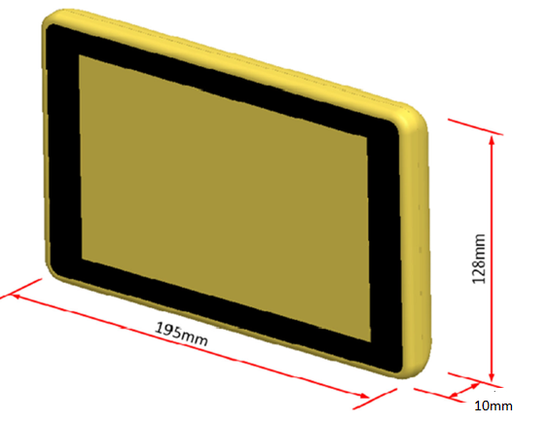

Figure 4: Tablet Mechanical Dimension

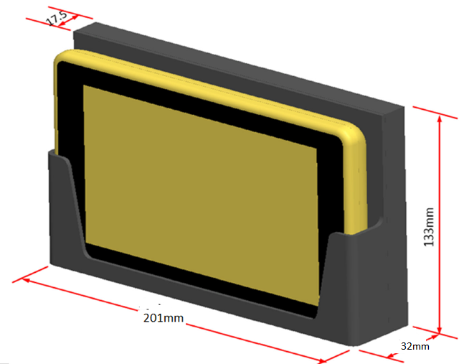

Figure 5: Wireless Charger Mechanical Dimensions

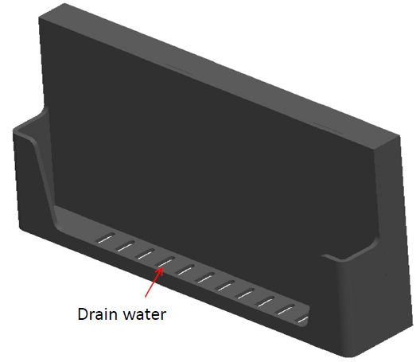

Figure 6: Wireless Charger Isometric View

**Note:** The enclosure should satisfy IPx7 (or) IPx8.

## Preliminary BOM Analysis – 1K unit price

Below table give the price for 1K unit Tablet Remote Control.

|  |  |  |  |  |  |
| --- | --- | --- | --- | --- | --- |
| **Si.No** | **Description** | **Mfg** | **Mfg Part No** | **Qty** | **Price in US$** |
| 1 | Processor | Qualcomm | APQ8009 | 1 | 9.5 |
| 2 | PMIC for Processor | Qualcomm | PM8208/PM8916-1 | 1 |
| 3 | WiFi - BT Module | Qualcomm | WCN3610/WCN3660B | 1 |
| 4 | 1GB LPDDR2 SDRAM | Samsung | K3PE7E700D-XGC2 | 1 | 3.75 |
| 5 | 7” TFT LED Display with 1024x600 pixels | FORMIKE | KWH070KQ36-F01 | 1 | 39 |
| 6 | Qi Wireless power receiver | TI | BQ51013BRHLR | 1 | 1.1 |
| 7 | Qi Wireless power receiver antenna | Wurth Electronik | 760308101303 | 1 | 6 |
| 8 | 2.4GHz Antenna | Taoglas | FXP73.07.0100A | 2 | 3 |
| 9 | 4GB eMMC Flash | Kingston Tech | EMMC04G-M627-B01 | 1 | 3 |
| 10 | Speaker, Monaural, 1W, IPx7 | Veco |  | 1 | 0.5 |
| 11 | Audio Amplifier | TI | LM4902MM/NOPB | 1 | 0.25 |
| 12 | Battery |  |  | 1 | 7 |
| 13 | Battery charger | TI | BQ24040DSQR | 1 | 0.35 |
| 14 | Fuel guage | TI | BQ27411DRZ | 1 | 0.8 |
| 15 | Others |  |  | 1 | 7 |
| 16 | Enclosure Fab Cost |  |  | 1 | 4 |
| 17 | PCB Fab Cost |  |  | 1 | 4 |
| 18 | Assembly Cost |  |  | 1 | 3 |
|  | Price for 1K unit | | |  | 92.25 |

Table : BOM Cost for Tablet Remote Control

Below table give the price for 1K unit for Wireless charger.

|  |  |  |  |  |  |
| --- | --- | --- | --- | --- | --- |
| **Si.No** | **Description** | **Mfg** | **Mfg Part No** | **Qty** | **Pricein US$** |
| 1 | BLE SoC | Nordic Semi | 2 | 1 | 1.7 |
| 2 | Qi Wireless power transmitter | TI | 2.1 | 1 | 1.8 |
| 3 | Water boiler interface chip | Toshiba | 5 | 1 | 4 |
| 4 | MOSFET | TI | 0.9 | 2 | 0.9 |
| 5 | BLE Antenna | Johanson Tech | 0.25 | 1 | 0.25 |
| 6 | Qi Wireless power antenna | Wurth Electronik | 6 | 1 | 5 |
| 7 | Others |  | 3.5 | 1 | 3 |
| 8 | Enclosure Fab Cost |  | 2.5 | 1 | 2 |
| 9 | PCB Fab Cost |  | 2.5 | 1 | 2 |
| 10 | Assembly Cost |  | 2.5 | 1 | 2 |
|  | Price for 1K unit | | |  | 27.25 |

Table : BOM Cost for Wireless Charger

## Preliminary BOM Analysis – 5K unit price

Below table give the price for 5K unit Tablet Remote Control.

|  |  |  |  |  |  |
| --- | --- | --- | --- | --- | --- |
| **Si.No** | **Description** | **Mfg** | **Mfg Part No** | **Qty** | **Price in US$** |
| 1 | Processor | Qualcomm | APQ8009 | 1 | 7.5 |
| 2 | PMIC for Processor | Qualcomm | PM8208/PM8916-1 | 1 |
| 3 | WiFi - BT Module | Qualcomm | WCN3610/WCN3660B | 1 |
| 4 | 1GB LPDDR2 SDRAM | Samsung | K3PE7E700D-XGC2 | 1 | 3.5 |
| 5 | 7” TFT LED Display with 1024x600 pixels | FORMIKE | KWH070KQ36-F01 | 1 | 35 |
| 6 | Qi Wireless power receiver | TI | BQ51013BRHLR | 1 | 1.1 |
| 7 | Qi Wireless power receiver antenna | Wurth Electronik | 760308101303 | 1 | 5 |
| 8 | 2.4GHz Antenna | Taoglas | FXP73.07.0100A | 2 | 2 |
| 9 | 4GB eMMC Flash | Kingston Tech | EMMC04G-M627-B01 | 1 | 2 |
| 10 | Speaker, Monaural, 1W, IPx7 | Veco |  | 1 | 0.5 |
| 11 | Audio Amplifier | TI | LM4902MM/NOPB | 1 | 0.25 |
| 12 | Battery |  |  | 1 | 5 |
| 13 | Battery charger | TI | BQ24040DSQR | 1 | 0.35 |
| 14 | Fuel guage | TI | BQ27411DRZ | 1 | 0.8 |
| 15 | Others |  |  | 1 | 5 |
| 16 | Enclosure Fab Cost |  |  | 1 | 3 |
| 17 | PCB Fab Cost |  |  | 1 | 3 |
| 18 | Assembly Cost |  |  | 1 | 3 |
|  | Price for 5K unit | | |  | 77 |

Table 5: BOM Cost for Tablet Remote Control

Below table give the price for 5K unit for Wireless charger.

|  |  |  |  |  |  |
| --- | --- | --- | --- | --- | --- |
| **Si.No** | **Description** | **Mfg** | **Mfg Part No** | **Qty** | **Pricein US$** |
| 1 | BLE SoC | Nordic Semi | NRF51822-QFAB-R7 | 1 | 1.7 |
| 2 | Qi Wireless power transmitter | TI | BQ500212ARGZR | 1 | 1.8 |
| 3 | Water boiler interface chip | Toshiba | T6B70BFG | 1 | 4 |
| 4 | MOSFET | TI | CSD97394Q4M | 2 | 0.9 |
| 5 | BLE Antenna | Johanson Tech | 2450AT42E0100E | 1 | 0.25 |
| 6 | Qi Wireless power antenna | Wurth Electronik | 760308101103 | 1 | 5 |
| 7 | Others |  |  | 1 | 3 |
| 8 | Enclosure Fab Cost |  |  | 1 | 2 |
| 9 | PCB Fab Cost |  |  | 1 | 2 |
| 10 | Assembly Cost |  |  | 1 | 2 |
|  | Price for 5K unit | | |  | 22.65 |

Table 6: BOM Cost for Wireless Charger

**Note:**

The above BOM and cost may be changed during the detailed design stage. Unit Price for 1K and 5K will vary.

## Design for Manufacturing

Design shall utilize design for manufacturing conceptsfor a reliable and cost effective manufacturing.

## Environmental Requirements

**Operating temperature:**Commercial grade components 0degC to 50degC/humidity of 80%(or)less(with No condensation)  
**Storage temperature:** -20degC to 60degC(with No condensation)

# Software Development

VVDN will develop all firmware required to implement the required features and specifications. All implemented firmware, middleware and software will be royalty free and free of licensing requirements.

## Key Software Features

* Driver Development and Integration
* Linux/Android OS Porting and Integration
* Boil Control Application
* Protocol Stack Porting and Development
* Testing and Validation
* Complete BSP development

# Industrial Design and Development

## Thermal analysis

After completion of PCB floor planning and major component placement, power plane cut, power drops, etc. the PCB file can be importedinto Icepak. After making thermal models of all components complete thermal analysis can be done by considering the PCB thermal properties, airflow, heat sink orientation, etc. The thermal profile from Icepak will help to verify operating junction temperature (Tj) and thereby ensure board reliability from a thermal perspective.

To achieve required thermal design the following typical thermal design steps shall be followed.

* Pre-layout thermal analysis
  + Analysis of power dissipation in each components and identify the “key” components which dissipate “greatest” power.
  + Create thermal model of the following items
    - Major power consuming components (with its thermal specification such as the thermal resistance from Jn to case/ Jn. to PCB/ Jn. to ambient, etc.)
    - PCB (with stack up and draft floor plan)
  + Perform thermal analysis with thermal simulation for the worst case deployment conditions (max. external ambient temperature) to check maximum Jn. temperature and PCB / Internal ambient temperature, etc.
  + Try variations (different floor plan/ PCB mounting options, thermal pad etc.) to achieve most optimum junction temperature for all components on board.
  + Based on this analysis, define thermal design guidelines for mechanical and PCB design
* Post Layout analysis (After PCB design & Mechanical design)
  + Update enclosure and PCB models based on final design files (PCB file can be imported to the thermal simulation tool like “icepak”)
  + Verify thermal behavior (mainly operating temperature of major components / PCB / Internal ambient while external ambient is the worst case.

VVDN uses“icepak” thermal simulation/ analysis tool and design engineers with experience and expertise in thermal designs of products specifically in harsh domains such as Automotive Car Black box Camera, Sub-sea cameras, industrial surveillance cameras, etc.

Sample thermal profile from Icepak simulation we did for a Car Black boxis shown below for reference.

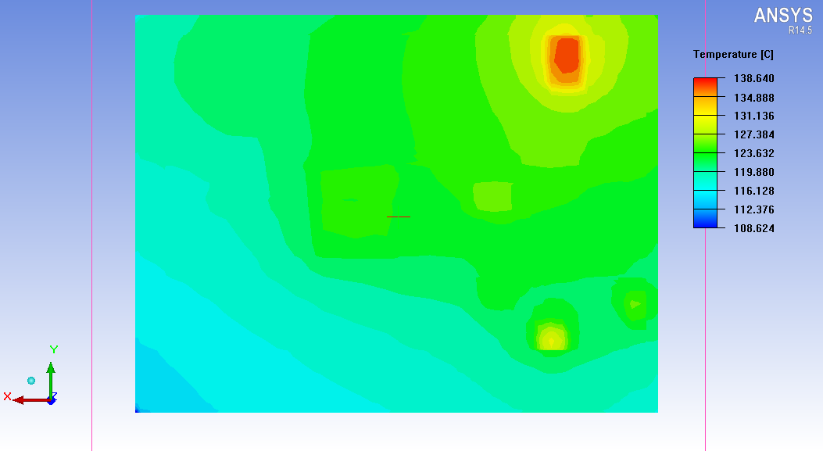

U101

U204

U205

U206

U201

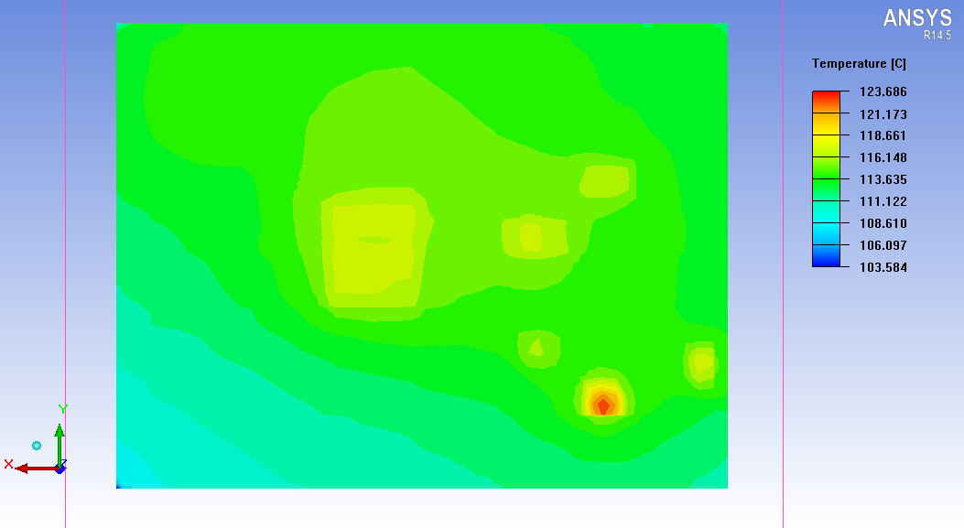

U204

U205

U206

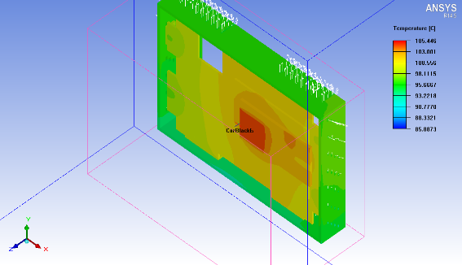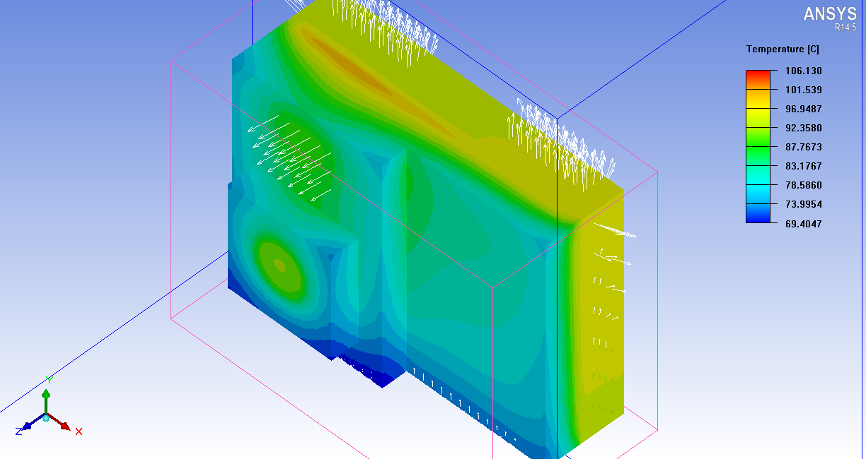

Figure 7: Sample Thermal Profiling

Proper care shall be taken care for product ruggedness as well as aesthetics and ergonomics. The design will be thoroughly discussed and reviewed with customer.

# Complete Scope of Project

The Scope of Work (SOW) for the project is described below.

* **Hardware Scope of Work**
  + Hardware Design Document (HDD)
  + Schematics development (Orcad CAD File)
  + Design, Development and Bring-up of board level solutions
  + PCB Layout (Allegro CAD File)
  + Thermal and Signal Integrity Analysis
  + DFM / DFA optimization
  + Gerber Generation (Artwork files for PCB Fab and Assembly)
  + Board Fab and Assembly for prototypes
  + Integration with Mechanical
  + Board Bring-up, Testing and Validation
  + DVT Report
  + Compliance and certifications
* **Mechanical Scope of Work**
  + Enclosure Development/Selection (CAD file)
  + Enclosure fabrication
  + Mechanical Integration
* **Software Scope of Work**
  + Software Design Document (SDD)
  + Development and Porting of OS(Linux & Android) device drivers and validation testing for all required interfaces
  + Test Plan and Validation Report
  + Complete Binaries and Source Code
* **Testing and Validation**
  + Test all the I/O interfaces
  + Hardware DVT
  + Product QA

**Assumptions**

* Allegro PCB EDA tools shall be used for this platform design

# Schedule, Tasks and Deliverables

## Schedule

|  |  |  |
| --- | --- | --- |
| **Phase** | **Service** | **Estimate(Weeks)** |
| Requirements | Requirement Analysis | T0 + 1 |
|  | Product Requirement Document (PRD)  Hardware Design Document (HDD)  Software Design Document (SDD) | T0 + 2 |
| HW Development | Schematics Capture Final bill of material and cost Generation | T0 + 3 |
| PCB Design - Components Placement and Stack up request  PCB Design - Signal Routing  PCB design - Clean-up and Gerber Generation | T0 + 5 |
| Mechanicals Development | Analysis of Mechanical Board dimension | T0 + 6 |
| System SW Development | Firmware Development, Application Stack Development | T0 + 7 |
| Prototyping(Rev A) | PCB Fab/ Assembly Board Bring Up Plan preparation  Software  Board bring up and validation  Software Testing and validation on actual platform | T0 + 10 |
| 10 Validated Boards | Testing and Bug fixing  Compliance and Certifications Started  Delivery of 10 Validated Boards | T0 + 12 |
| Pilot Production | Pilot Batch Production of 100 Devices | T0 + 18 |
| Mass Production Start | Mass Production Start | T0 + 20 |

Table 7: Project Schedule

# Commercial Terms

## Fees

The Total Fees cover all the SOW items described in proposal. Scope of Project.

### Non-Recurring Engineering Fees Milestones

VVDN would charge a total NRE Fee of 300K USD for complete Hardware Design, Software Design (Linux & Android), Design Validation & Acceptance.

### Prototype Fees for 10 boards

VVDN would charge this on actuals ( FAB, Assembly & Components ) + 10 % Markup.

### Payment Milestones

|  |  |  |
| --- | --- | --- |
| PM | Description | Payment |
| 1 | Execution of SOW | 25% of NRE |
| 2 | Completion of PCB Layout | 25% 0f NRE |
| 3 | Completion of in-lab Validation | 25% of NRE |
| 4 | Delivery of 10 prototypes to Paloma | 25% of NRE |

### Travel Costs

### Certification Fee

VVDN would charge the Certification Fee on actuals from the customer. VVDN would provide engineering help as part of contract but actual fee shall be paid by Paloma Co. Ltd to Certification Agency.

# About VVDN

Following is a brief introduction to the product development process at VVDN and a brief description about few exemplary sample projects executed by VVDN team in related domain is given in this section for reference.

## Development Process

At VVDN we follow “Requirement Driven Development” (internally named “RequireD”) methodology for all our projects. This methodology ensures the teams focus on the actual requirements of the solution at every stage of the project.

The Product development process at VVDN, in an abstract level, is shown in figure below. During requirement analysis phase a “Product Requirement Document” (PRD) is prepared and is reviewed and refined with the customer. Thereafter, this becomes the blue print for all subsequent phases.

For HW components, based on the PRD, “Hardware Design Description” (HDD) is prepared during High level design phase. HDD will have Block diagrams, Class A BOM, Power budgeting, PCB floor plan etc. A test plan document is also prepared in this phase. HDD and Test plan documents are reviewed and refined as applicable with customer team. HDD is transformed to Schematic / PCB designs during detailed design phase, followed by PCB fab/ assembly, board bring-up, SW integration and system level validation.

For SW projects, architectural design starts with Use case analysis. Use case model gives direction to evolve most suitable design architecture for the software solution. High level SDD (Software Design Description) is developed and reviewed/ refined with customer team in the high level design phase. This is followed by detailed design phase where each component of the SW solutions is described in detail in the SDD. SDD helps SW team to implement the logic most effective manner to executable code. The code is initially tested on reference platforms / simulation environments if final HW platform not available during implementation phase. Once final HW platform is ready, code is validated on the HW platform and released after validation.



Figure 8: Product development process at VVDN