**#1. Overview of Version Control System**

**Roll Number:CB.EN.P2EBS22005**

**Date of Submission:14-10-2022**

**Aim:**

To perform following activities using a Version Control System:

1. Create a Local Repository
2. Create a new file inside the repo and stage it. Classify the file as tracked/untracked/ignored file
3. Stage the created file and commit to the local repository
4. Create different version of the file and commit the changes
5. List the SHA code of objects: tree, blob, commits
6. Create a remote repository
7. Push the contents of local repository to remote repository
8. Clone the local repository and observe the changes between the source and cloned repository
9. Clone the remote repository into local machine
10. Change the file in local repo and update the file in remote repo
11. Change the file in remote repo and update the file in local repo

**Tools Required:**

Computer with version control system (GIT) and text editor installed.

1. **Create a Local Repository**



1. **Create a new file inside the repo and stage it. Classify the file as tracked/untracked/ignored file**

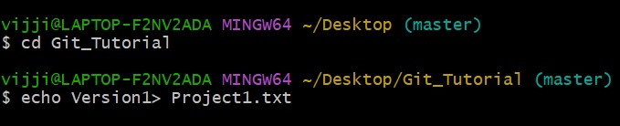

1. **Stage the created file and commit to the local repository**

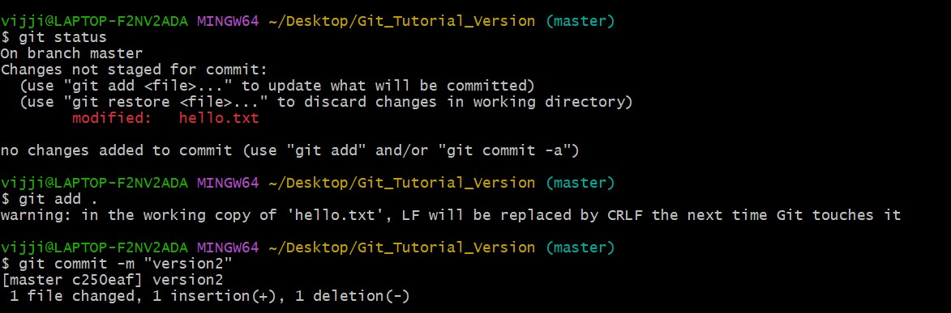

1. **Create different version of the file and commit the changes**

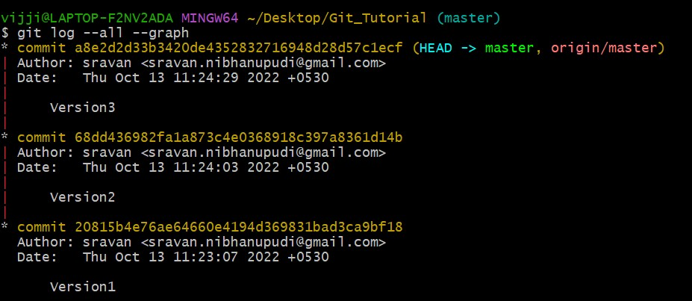

1. **List the SHA code of objects: tree, blob, commits**

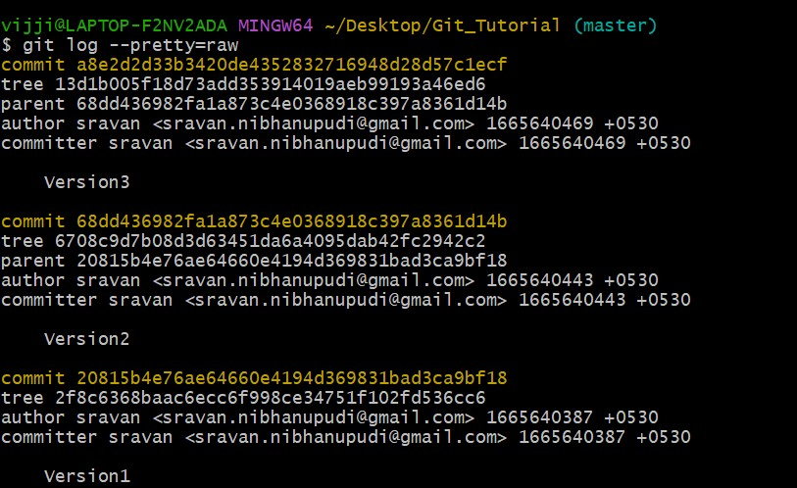

1. **Create a remote repository**



1. **Push the contents of local repository to remote repository**

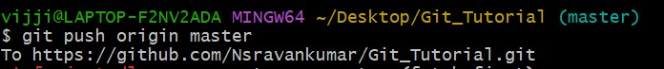

1. **Clone the local repository and observe the changes between the source and cloned repository**

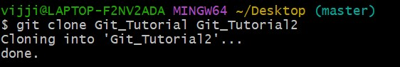

1. **Clone the remote repository into local machine**

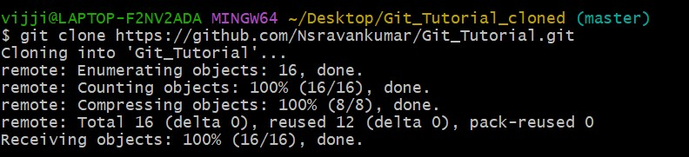

1. **Change the file in local repo and update the file in remote repo**

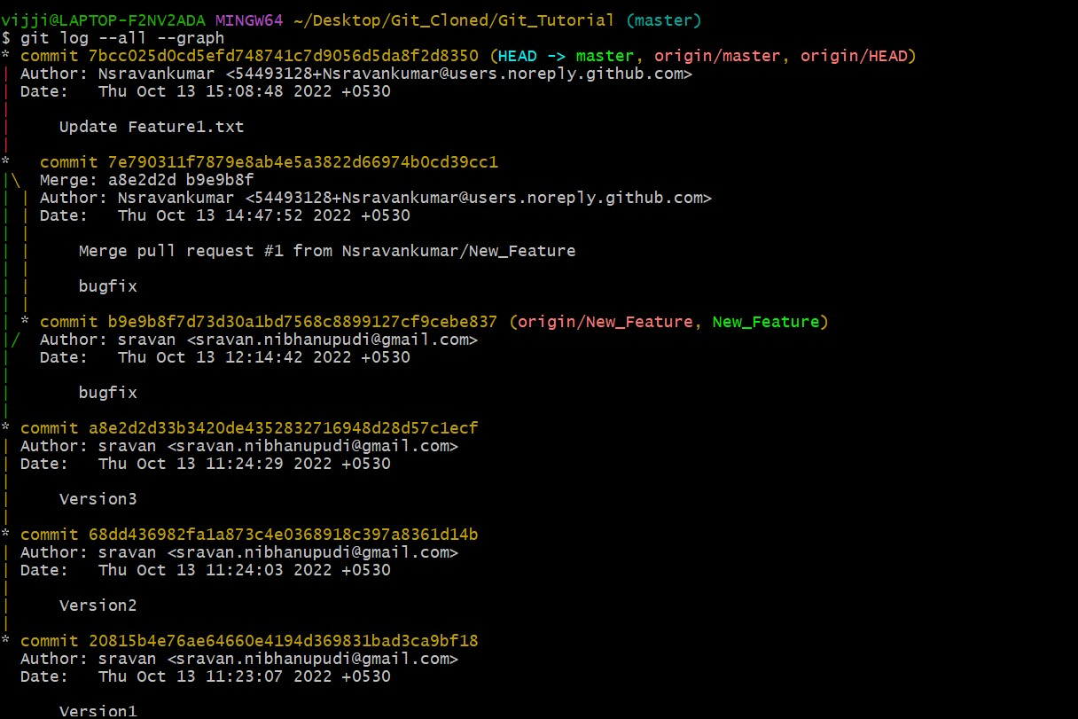

1. **Change the file in remote repo and update the file in local repo**



**Inference and Result:**

**Hence**