**#1. Overview of Version Control System**

**Roll Number: Akshaya KB, CB.EN.P2EBS22001**

**Date of Submission: 19-October-2022**

**Aim:**

To perform following activities using a Version Control System:

1. Create a Local Repository
2. Create a new file inside the repo and stage it. Classify the file as tracked/untracked/ignored file
3. Stage the created file and commit to the local repository
4. Create a different version of the file and commit the changes
5. List the SHA code of objects: tree, blob, commits
6. Create a remote repository
7. Push the contents of the local repository to the remote repository
8. Clone the local repository and observe the changes between the source and cloned repository
9. Clone the remote repository into local machine
10. Change the file in the local repo and update the file in the remote repo
11. Change the file in the remote repo and update the file in the local repo

**Tools Required:**

Computer with a version control system (GIT) and text editor installed.

1. **Create a Local Repository**

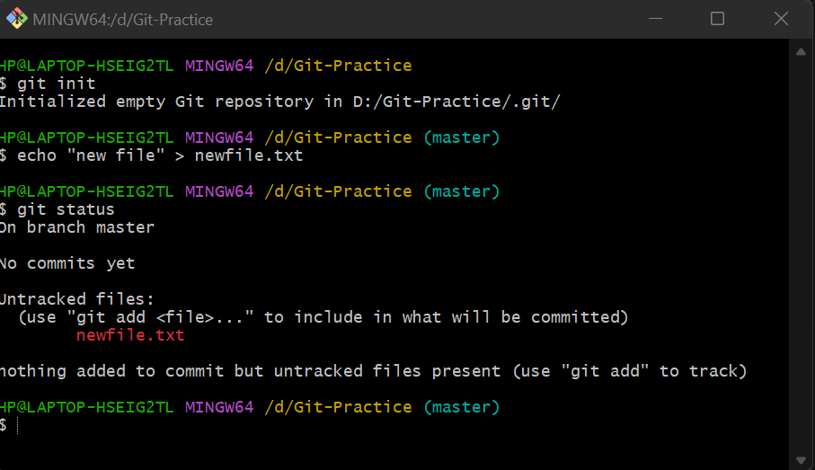

1. **Create a new file inside the repo and stage it. Classify the file as tracked/untracked/ignored file**

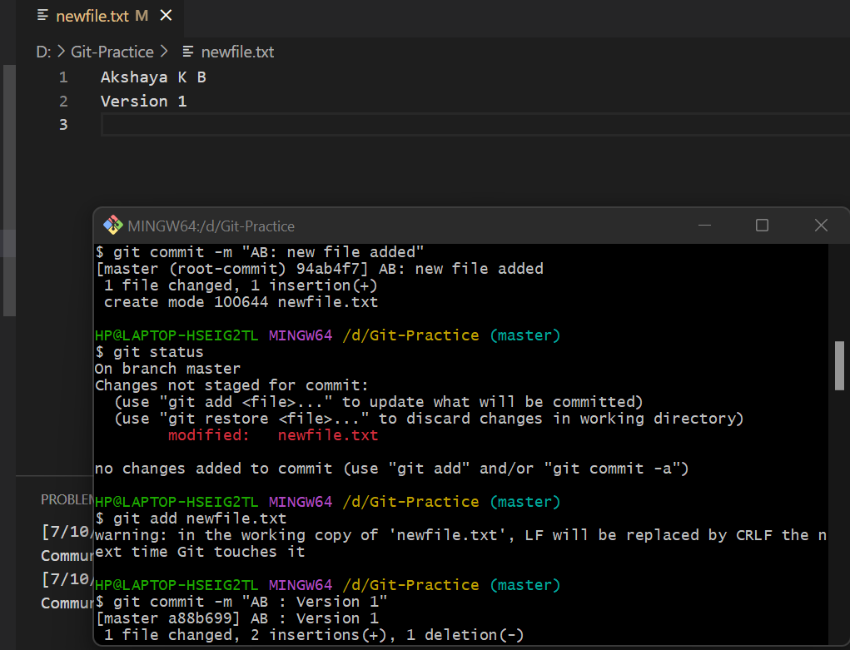

1. **Stage the created file and commit it to the local repository**



1. **Create a different version of the file and commit the changes**

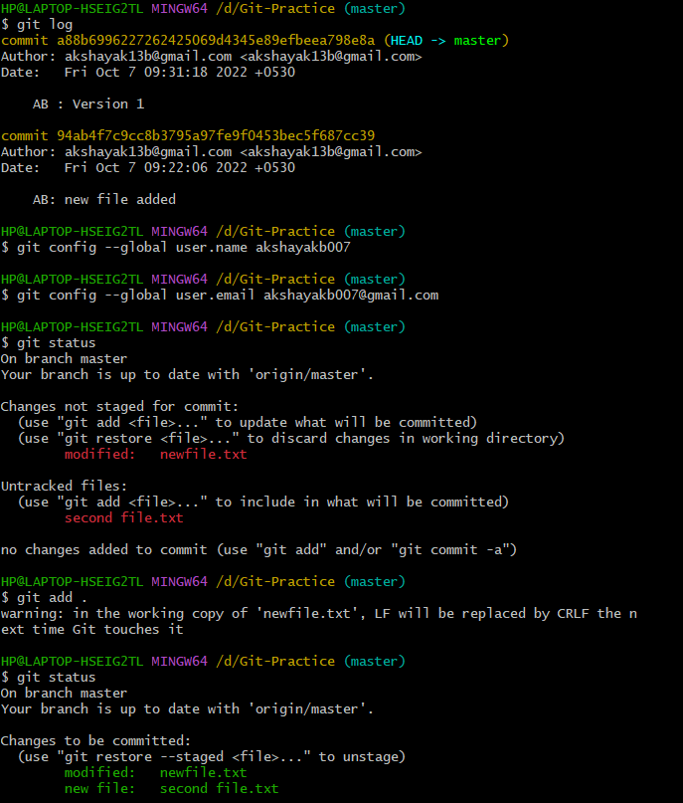

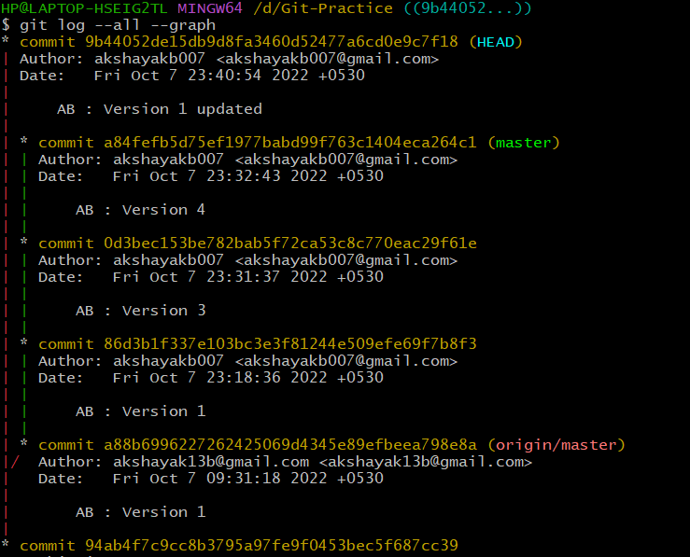

1. **List the SHA code of objects: tree, blob, commits**

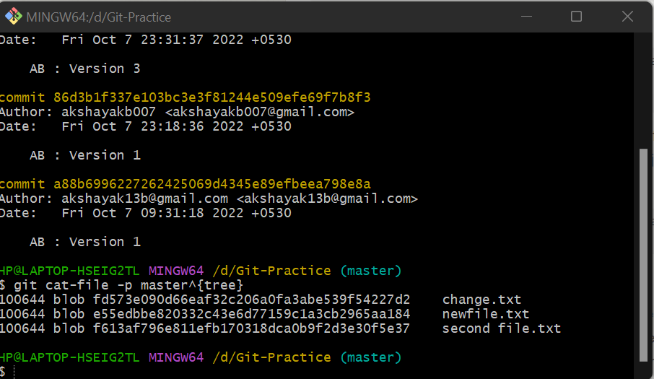

1. **Create a remote repository**

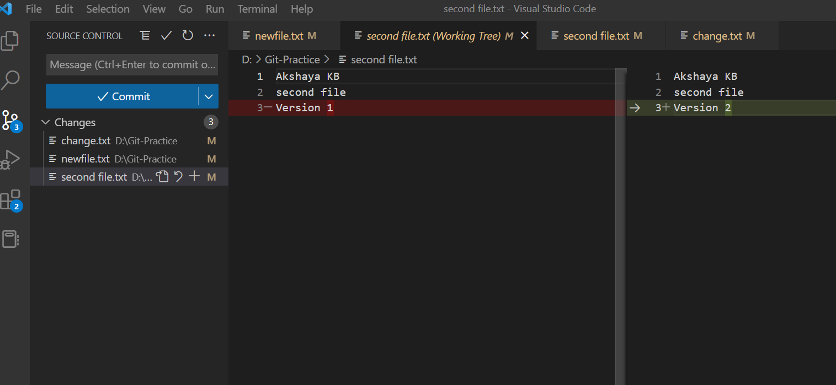

1. **Push the contents of the local repository to remote repository**

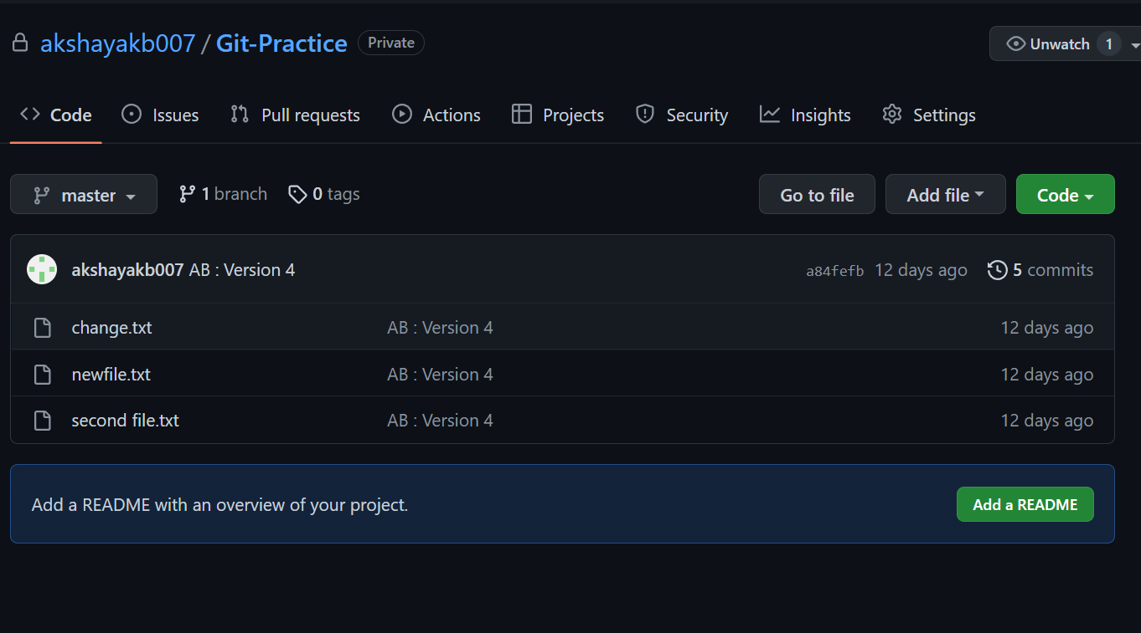

1. **Clone the local repository and observe the changes between the source and cloned repository**
2. **Clone the remote repository into local machine**

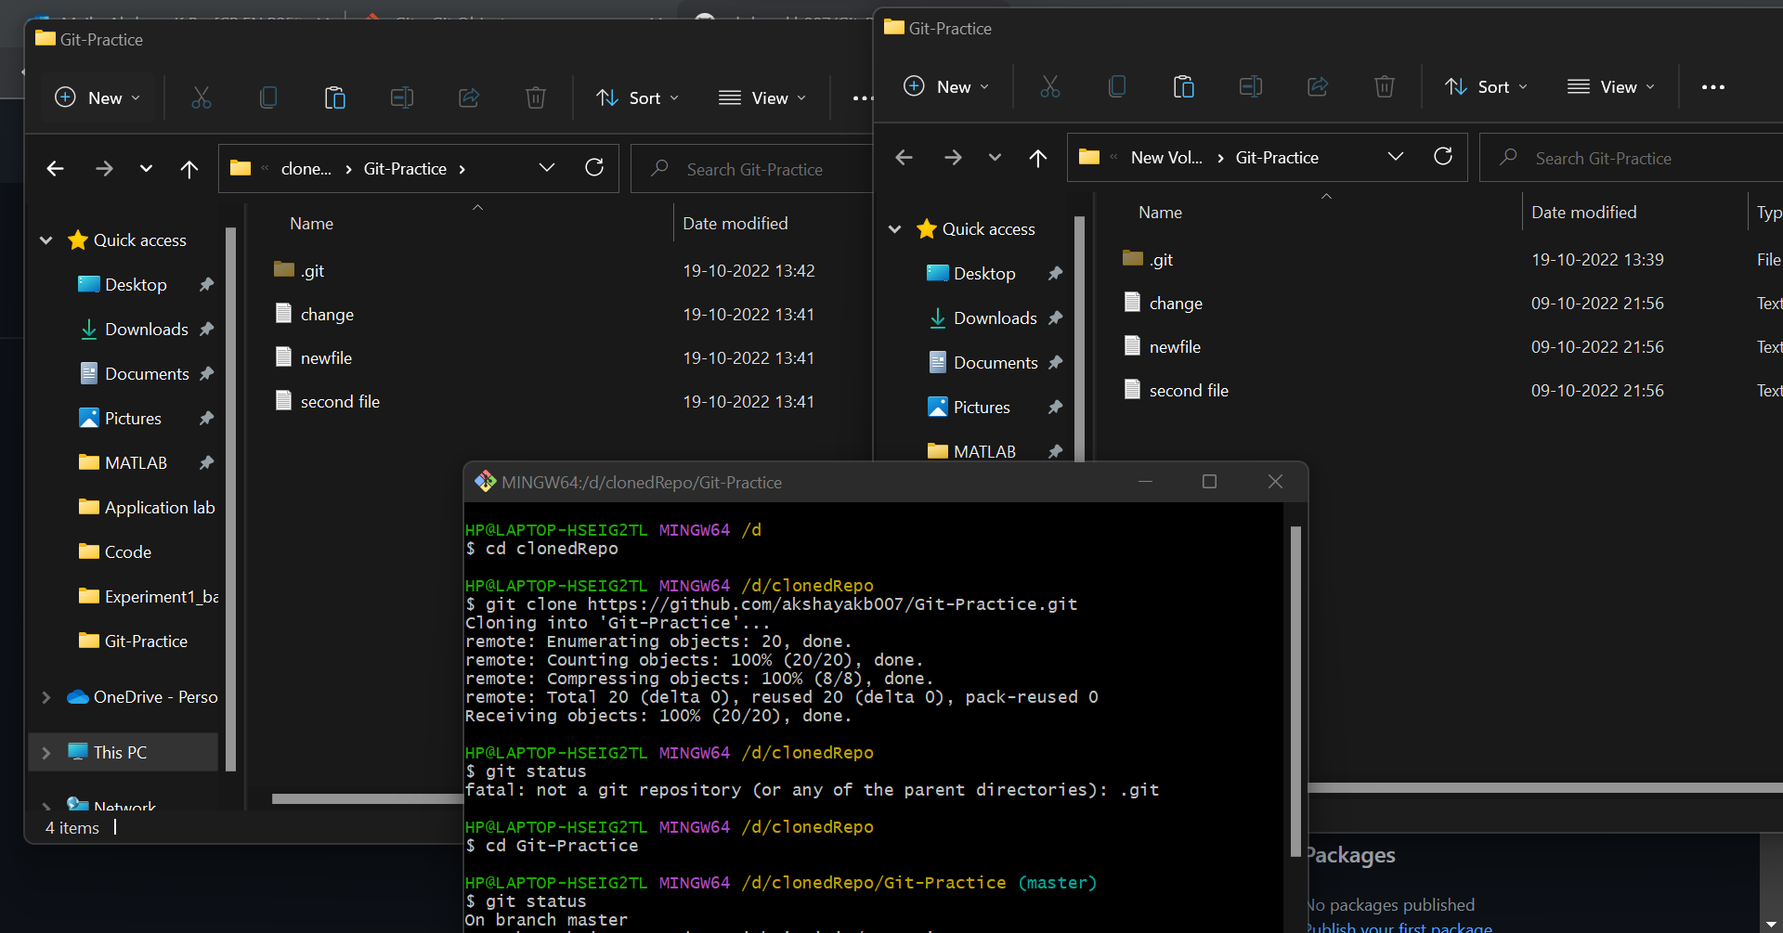

1. **Change the file in local repo and update the file in remote repo**

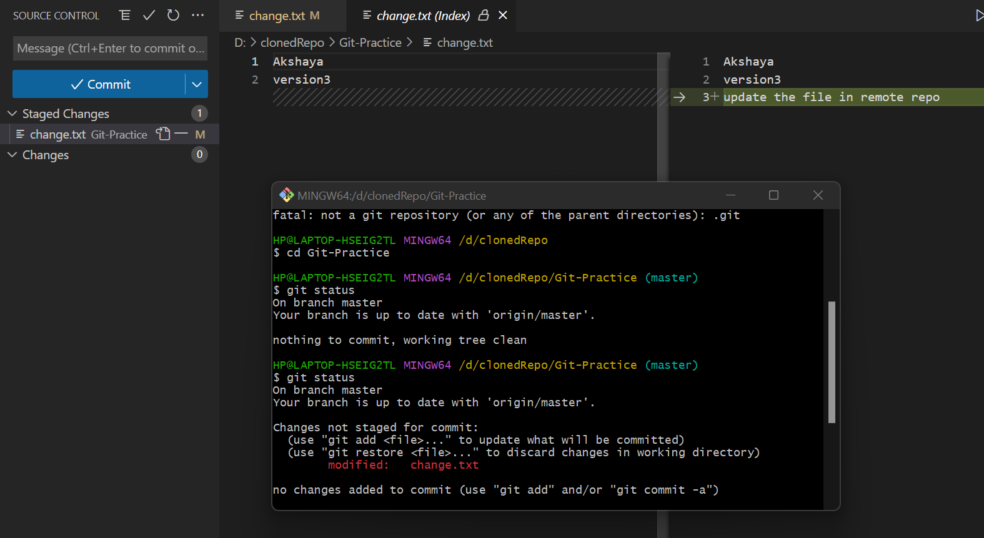

1. **Change the file in remote repo and update the file in local repo**

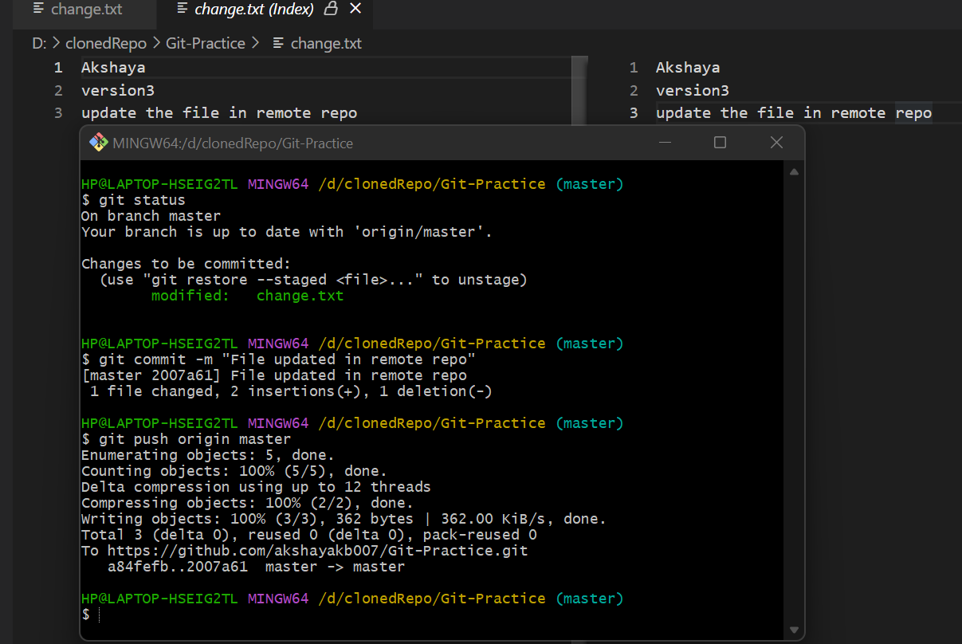

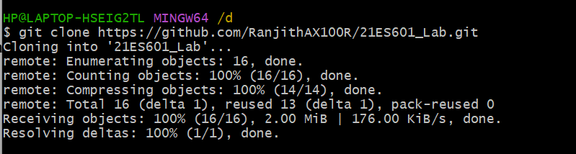

**Inference and Result:**

Practiced version control using git and created local and remote repository