**#8. Code Testing using Python**

**Roll Number: CB.EN.P2EBS22001**

**Date of Submission: 13-01-2022**

**Aim:**

Automate unit testing for finding factorial of numbers 1 to 10 using assert function in python

**Tools Required:**

PyCharm and python compiler

**Experiment:**

Code

Main.py:

import unittest  
import math  
  
from my_sum import fact  
  
  
class TestSum(unittest.TestCase):  
 def test_list_int(self):  
 for i in range(0,11):  
 result = fact(i)  
 self.assertEqual(result,math.factorial(i))  
 print("Factorial of", i, "is", result)  
  
  
if __name__ == '__main__':  
 unittest.main()

* **__init__.py:**

import math  
  
  
def fact(i):  
 if i<11:  
 return math.factorial(i)  
 else:  
 print('Value greater than 10')

**Inference and Result:**

The python code for finding factorial of 1-10 number is automated using *unittest* and *assertion* functions.

**Positive Test case**:

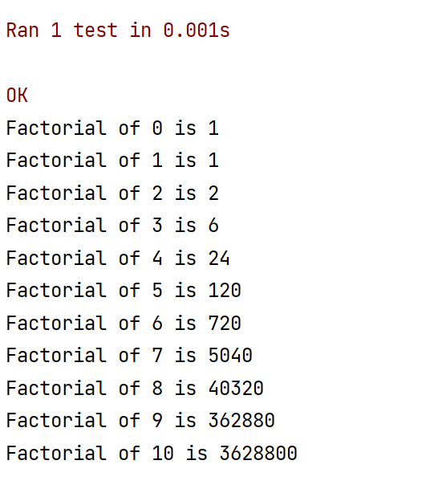

**Negative Test Case**:

