**#2. Array Operations**

**Roll Number:CB.EN.P2EBS22005**

**Date of Submission:29-10-2022**

**Aim:**

To perform following array operations using C Programming:

1. Create a 3-dimensional matrix of dimension 3x3x3. The entries inside the matrix can be as shown below,
$$\left[\begin{matrix}0 & 1 & 2 \\ 3 & 4 & 5 \\ 6 & 7 & 8\end{matrix}\right]\left[\begin{matrix}0 & 2 & 4 \\ 6 & 8 & 10 \\ 12 & 14 & 16\end{matrix}\right]\left[\begin{matrix}0 & 4 & 8 \\ 12 & 16 & 20 \\ 24 & 28 & 32\end{matrix}\right]$$

2. Perform matrix multiplication of two 3x3 matrix. Matrix data shall be acquired from the user. User defined function can be used for matrix multiplication operation.

**Tools Required:**

Text editor with C Compiler.

**Experiment:**

1. Create a 3-dimensional matrix of dimension 3x3x3. The entries inside the matrix can be as shown below,

**Code:** #include<stdio.h>

int main()

{

int a[3][3][3],i,j,k;

printf("enter the elements of the matrices\n\n");

for(k=0;k<3;k++)

{

for (i=0;i<3;i++)

{

for(j=0;j<3;j++)

{

scanf("%d",&a[k][i][j]);

a[1][i][j]=a[k][i][j]*2;

a[2][i][j]=a[k][i][j]*4;

}

}

for(k=0;k<3;k++)

{

for (i=0;i<3;i++)

{

for(j=0;j<3;j++)

{

printf("%d",a[k][i][j]);

printf(" ");

}

printf("\n\n");

}

printf(" ");

printf("\n\n");

}

}

}

Result: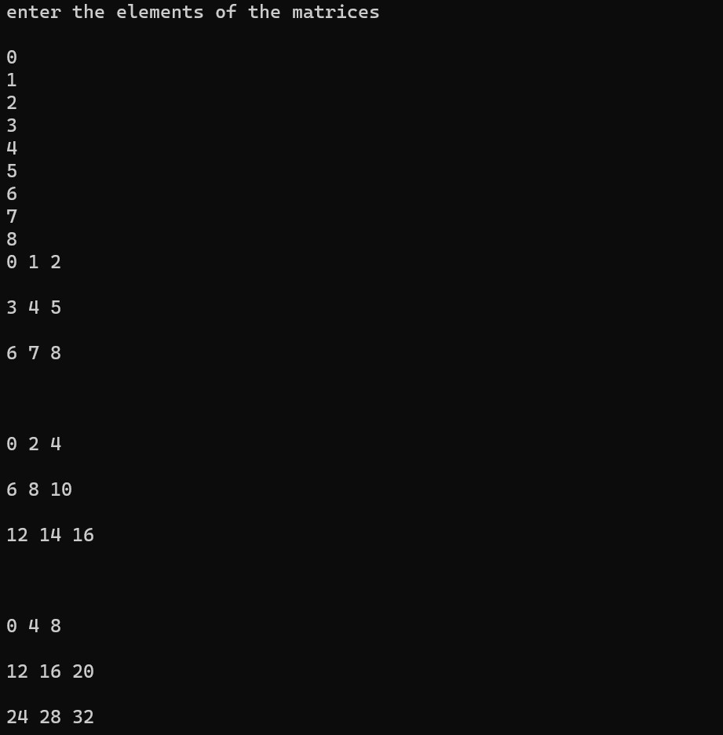

**Code:** #include<stdio.h>

void multiply(int a[10][10],int b[10][10],int ,int ,int );

void main()

{

int a[10][10],b[10][10],mul[10][10];

int i,j,k,m,n,p;

printf("Enter the number of rows and columns for 1st matrix\n");

scanf("%d%d",&m,&n);

printf("Enter the elements of the 1st matrix\n");

for(i=0;i<m;i++)

{

for(j=0;j<n;j++)

{

scanf("%d",&a[i][j]);

}

}

printf("Enter the number of columns for 2nd matrix\n");

scanf("%d",&p);

printf("Enter the elements of the 2nd matrix\n");

for(i=0;i<n;i++)

{

for(j=0;j<p;j++)

{

scanf("%d",&b[i][j]);

}

}

multiply(a,b,m,n,p );

}

void multiply(int a[10][10],int b[10][10],int m,int n,int p)

{

int mul[10][10],i,j,k;

for(i=0;i<m;i++)

{

for(j=0;j<p;j++)

{

mul[i][j]=0;

for(k=0;k<n;k++)

{

mul[i][j]=mul[i][j]+a[i][k]*b[k][j];

}

}

}

printf("The resultant matrix \n");

for(i=0;i<m;i++)

{

for(j=0;j<p;j++)

{

printf("%d\t",mul[i][j]);

}

printf("\n");

}

}

Result: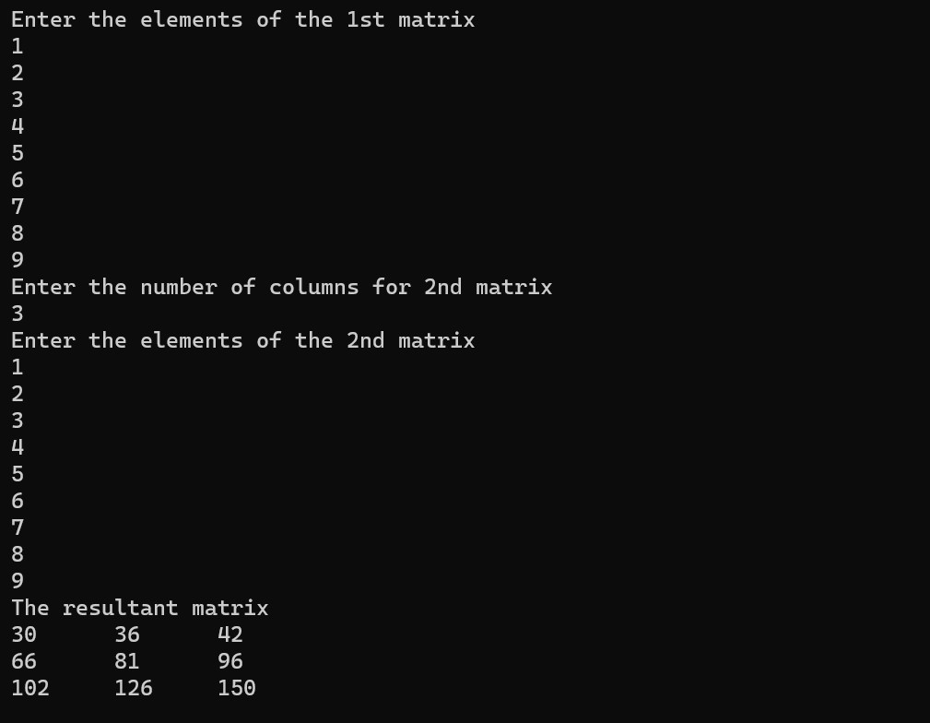

**Inference and Result:**

Hence, we have practiced how to call functions from the main and to take values from user into arrays to do multiplication of matrices.