**#7. Code Documentation**

**Roll Number: CB.EN.P2EBS22002**

**Date of Submission: 12-01-2023**

**Aim:**

To perform code documentation using doxygen GUI frontend tool.

**Tools Required:**

Doxygen

**Experiment:**

**Code (Queue):**

**#include <stdio.h>**

**#include <stdlib.h>**

**typedef struct queue {**

**int size;**

**int rear;**

**int front;**

**int *array;**

**}Q1;**

**Q1* create(unsigned int size)**

**{**

**Q1 *memory;**

**memory= (struct queue*)malloc(sizeof(struct queue));**

**memory->array=(int*)malloc(size*sizeof(int));**

**memory->size=size-1;**

**memory->front=-1;**

**memory->rear=-1;**

**return memory;**

**}**

**int isfull(Q1 *q1){**

**if(q1->rear==q1->size){**

**return printf("Queue is Full");**

**}**

**else**

**{**

**return 1;**

**}**

**}**

**int isempty(Q1 *q1)**

**{**

**if(q1->front==-1&&q1->rear==-1)**

**{**

**printf("The queue is empty");**

**}**

**else**

**{**

**printf("The queue is not empty");**

**}**

**}**

**void enqueue(Q1 *q1){**

**int number;**

**if(isfull(q1)==1){**

**if(q1->front==-1)**

**{**

**q1->front=0;**

**}**

**printf("enter the number to be added to the queue:");**

**scanf("%d",&number);**

**q1->array[++q1->rear]=number;**

**}**

**}**

**void dequeue(Q1 *q1)**

**{**

**if(!q1->array[q1->rear])**

**{**

**printf("The queue is already empty");**

**q1->front=-1;**

**q1->rear=-1;**

**}**

**else**

**{**

**q1->array[q1->front]=NULL;**

**q1->front++;**

**}**

**}**

**void peek(Q1 *q1)**

**{**

**printf("The latest entry element is : %d",q1->array[q1->rear]);**

**}**

**void view(Q1 *q1)**

**{**

**int i,value;**

**value=(q1->front!=-1)?q1->front:0;**

**for(i=value;i<=q1->size;i++)**

**{**

**printf("\n---------\n");**

**printf("|\t");**

**if(!q1->array[i])**

**printf("\t");**

**if(q1->array[i])**

**printf("%d\t",q1->array[i]);**

**printf("|\n");**

**printf("---------\n");**

**}**

**}**

**int main()**

**{**

**int n;**

**Q1 *q1;**

**int Input;**

**printf("enter the size of the queue");**

**scanf("%d",&n);**

**q1=create(n);**

**while(1)**

**{**

**printf("\n1)Enqueue\n2)Dequeue\n3)isFull()\n4)isEmpty()\n5)peek()\n6)view()\n7)exit\n");**

**scanf("%d",&Input);**

**switch(Input){**

**case 1:enqueue(q1);**

**break;**

**case 2:dequeue(q1);**

**break;**

**case 3:isfull(q1);**

**break;**

**case 4:isempty(q1);**

**break;**

**break;**

**case 5:peek(q1);**

**break;**

**case 6:view(q1);**

**break;**

**case 7: exit(0);**

**default: printf("Enter a valid number");**

**}**

**}**

**return 0;**

**}**

Result

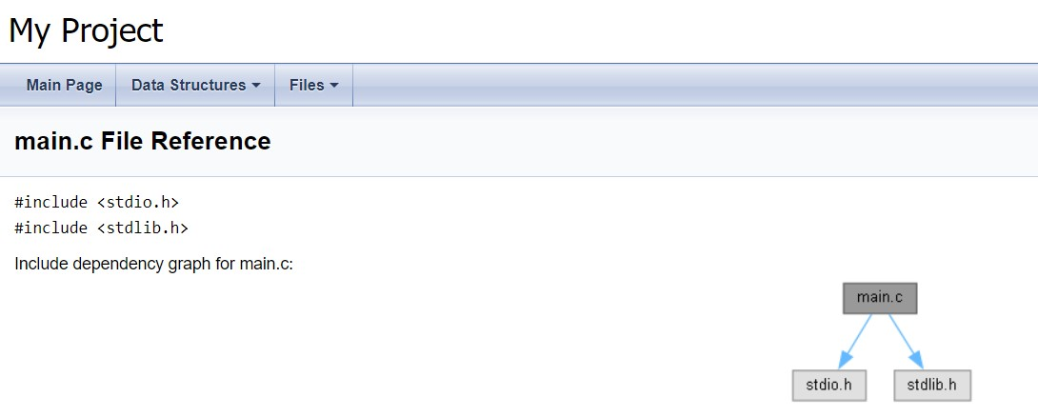

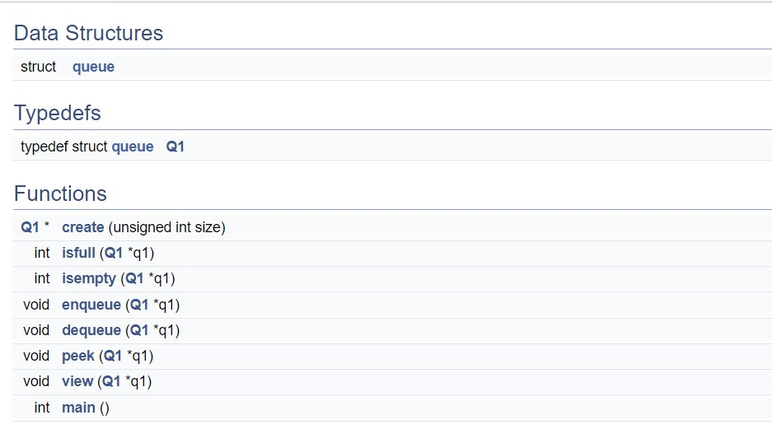

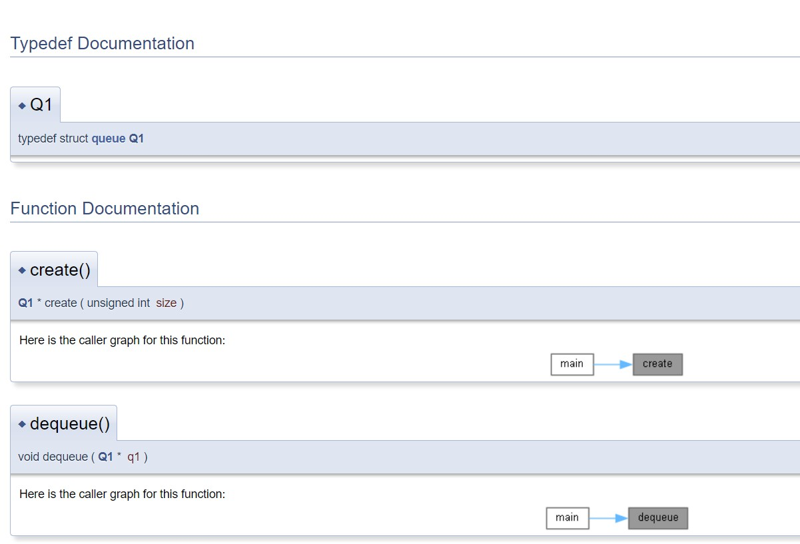

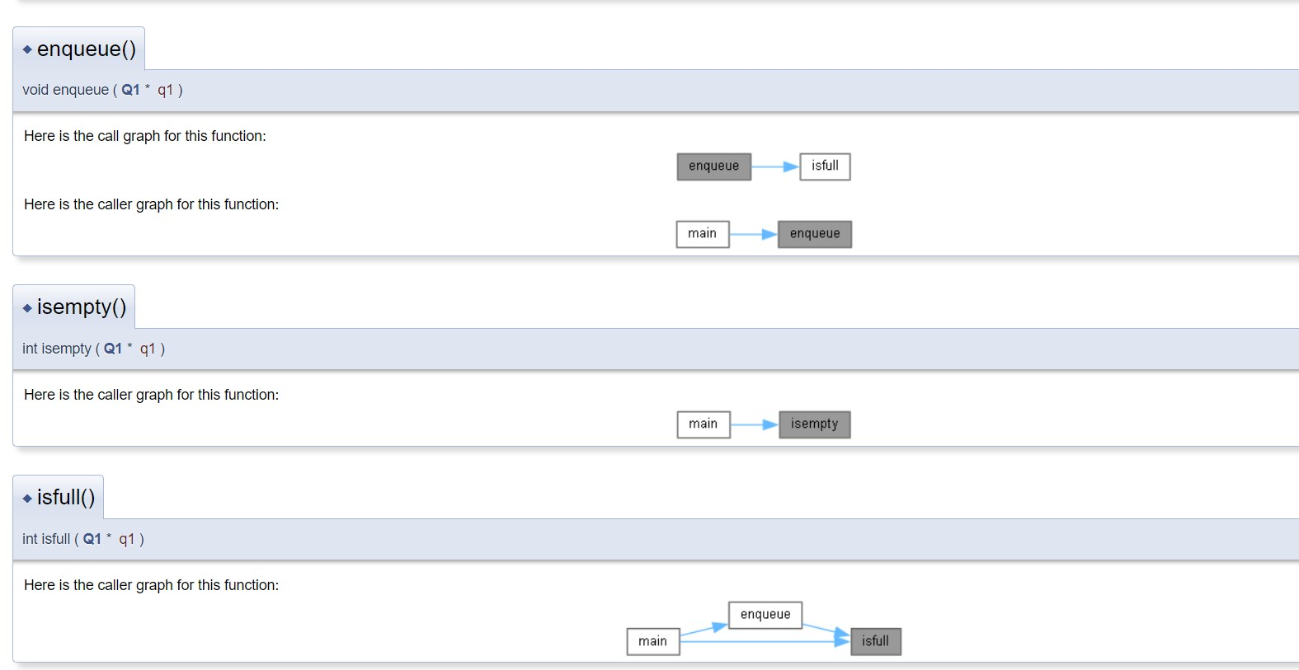

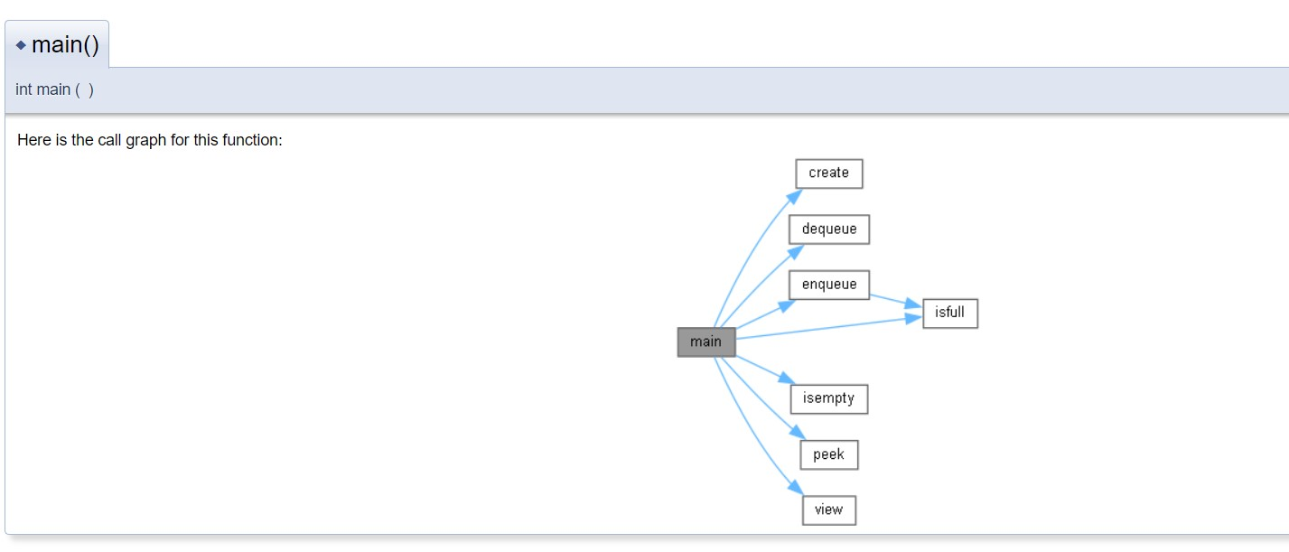

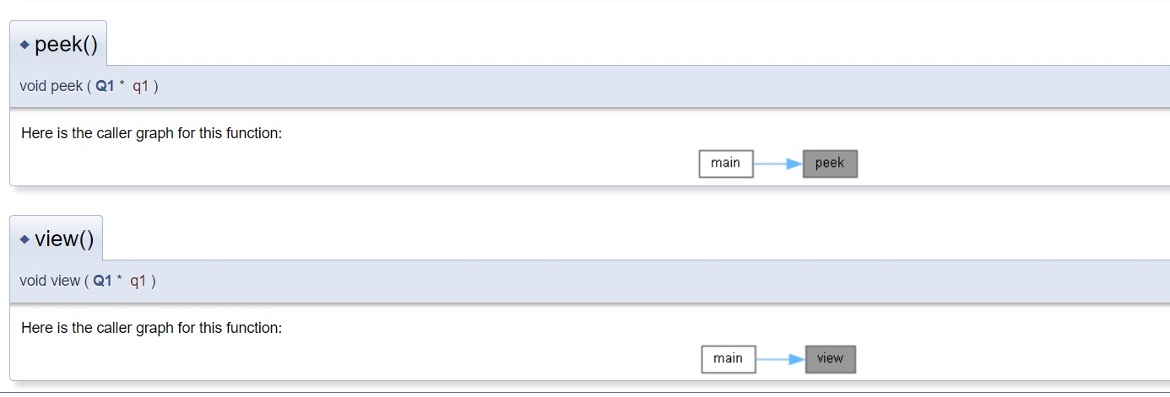

**Inference and Result:**

As a result, I have become familiar with the doxgen tool and have used it to build html and xml pages for the Queue program's source documentation.