**#7. Code Documentation**

**Roll Number:CB.EN.P2EBS22003**

**Date of Submission:08-01-2023**

**Aim:**

To perform code documentation using doxygen GUI frontend tool.

**Tools Required:**

Doxygen

**Experiment:**

1. Count of elements

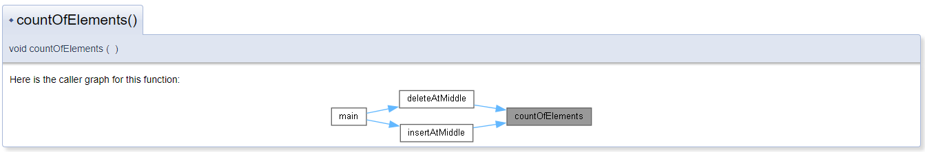

1. Delete at Beginning:

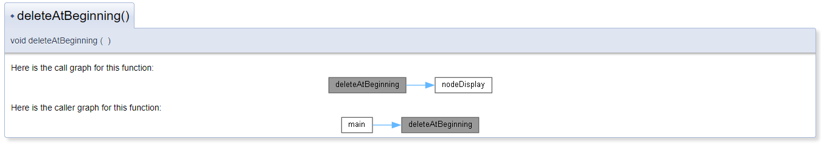

1. DeleteAtEnd:

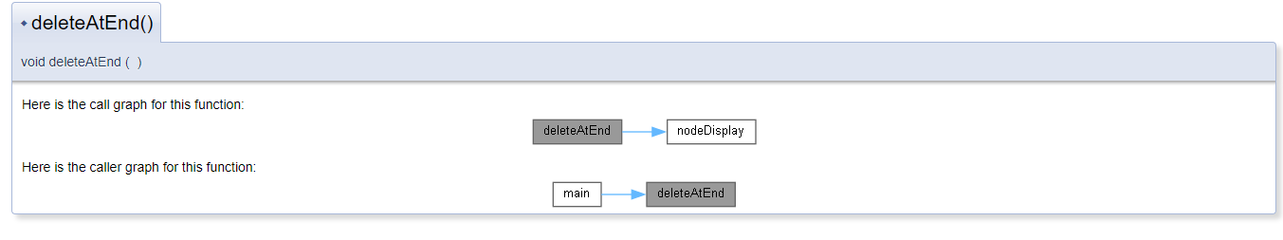

1. Delete At Middle

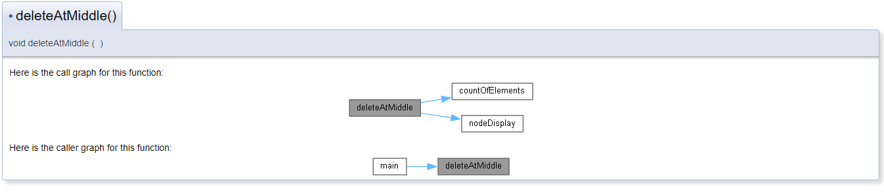

1. InsertAtBeginning()

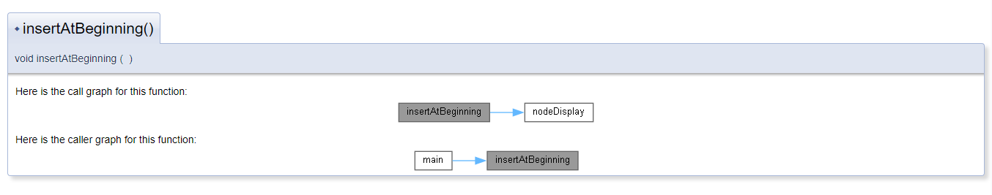

6.) InsertAtEnd()

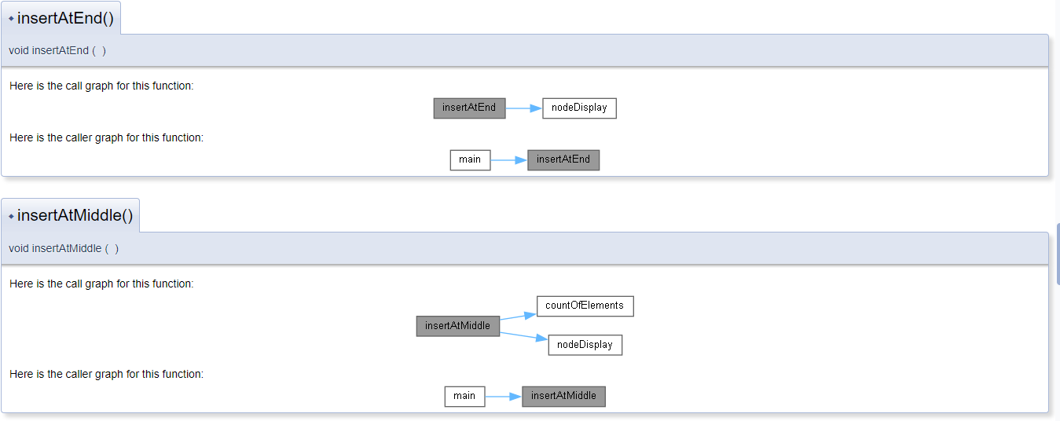

Main:

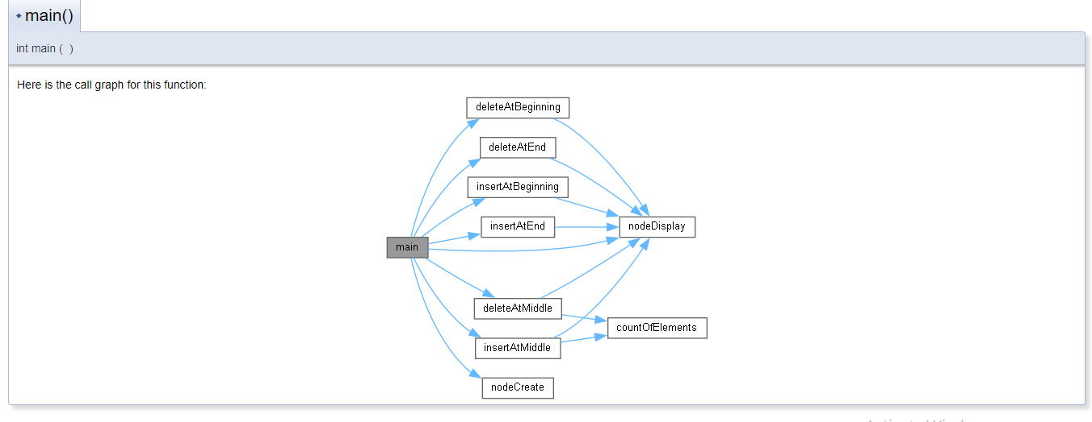

NodeDisplay:

