#2. Array Operations
Roll Number:CB.EN.P2EBS22005
Date of Submission:29-10-2022
Aim:
To perform following array operations using C Programming:
- Create a 3-dimensional matrix of dimension 3x3x3. The entries inside the matrix can be as shown below,
$$\left[\begin{matrix}0 & 1 & 2 \\ 3 & 4 & 5 \\ 6 & 7 & 8\end{matrix}\right]\left[\begin{matrix}0 & 2 & 4 \\ 6 & 8 & 10 \\ 12 & 14 & 16\end{matrix}\right]\left[\begin{matrix}0 & 4 & 8 \\ 12 & 16 & 20 \\ 24 & 28 & 32\end{matrix}\right]$$
- Perform matrix multiplication of two 3x3 matrix. Matrix data shall be acquired from the user. User defined function can be used for matrix multiplication operation.
Tools Required:
Text editor with C Compiler.
Experiment:
- Create a 3-dimensional matrix of dimension 3x3x3. The entries inside the matrix can be as shown below,
Code: #include<stdio.h>
int main()
{
int a[3][3][3],i,j,k;
printf("enter the elements of the matrices\n\n");
for(k=0;k<3;k++)
{
for (i=0;i<3;i++)
{
for(j=0;j<3;j++)
{
scanf("%d",&a[k][i][j]);
a[1][i][j]=a[k][i][j]*2;
a[2][i][j]=a[k][i][j]*4;
}
}
for(k=0;k<3;k++)
{
for (i=0;i<3;i++)
{
for(j=0;j<3;j++)
{
printf("%d",a[k][i][j]);
printf(" ");
}
printf("\n\n");
}
printf(" ");
printf("\n\n");
}
}
}
Result: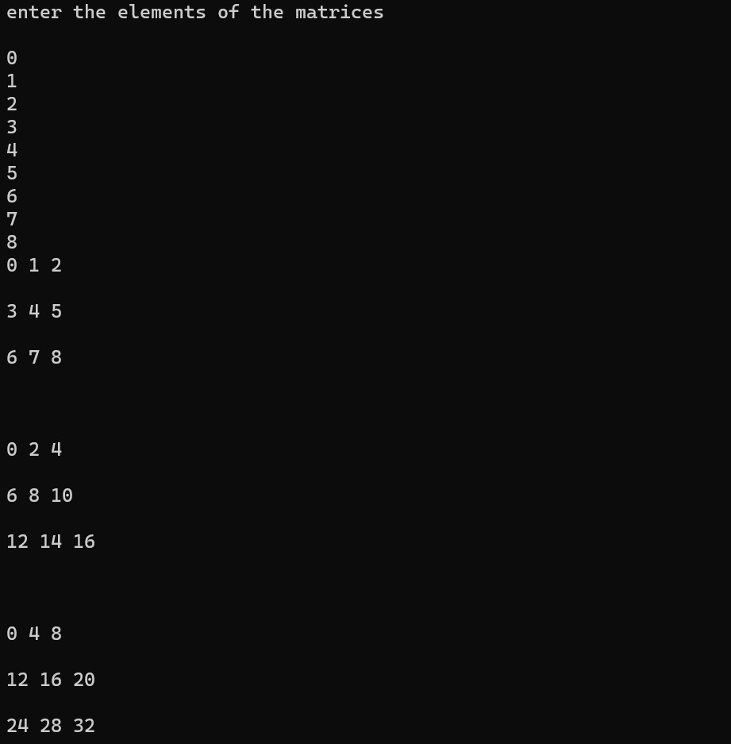

Code: #include<stdio.h>
void multiply(int a[10][10],int b[10][10],int ,int ,int );

void main()
{
int a[10][10],b[10][10],mul[10][10];
int i,j,k,m,n,p;
printf("Enter the number of rows and columns for 1st matrix\n");
scanf("%d%d",&m,&n);
printf("Enter the elements of the 1st matrix\n");
for(i=0;i<m;i++)
{
for(j=0;j<n;j++)
{
scanf("%d",&a[i][j]);
}
}

printf("Enter the number of columns for 2nd matrix\n");
scanf("%d",&p);
printf("Enter the elements of the 2nd matrix\n");
for(i=0;i<n;i++)
{
for(j=0;j<p;j++)
{
scanf("%d",&b[i][j]);
}
}
multiply(a,b,m,n,p );
}

void multiply(int a[10][10],int b[10][10],int m,int n,int p)
{
int mul[10][10],i,j,k;
for(i=0;i<m;i++)
{
for(j=0;j<p;j++)
{
mul[i][j]=0;
for(k=0;k<n;k++)
{
mul[i][j]=mul[i][j]+a[i][k]*b[k][j];
}
}
}
printf("The resultant matrix \n");
for(i=0;i<m;i++)
{
for(j=0;j<p;j++)
{
printf("%d\t",mul[i][j]);
}
printf("\n");
}
}

Result: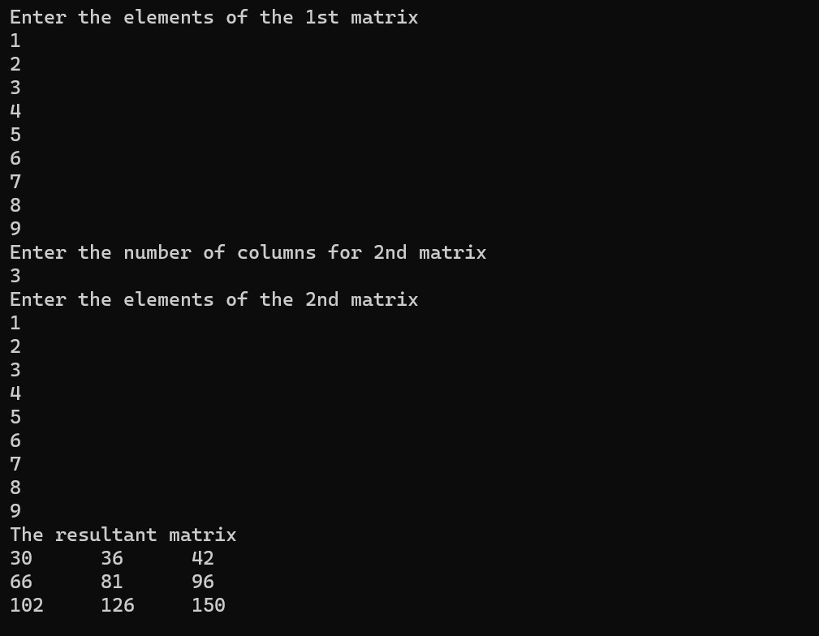

Inference and Result:

Hence, we have practiced how to call functions from the main and to take values from user into arrays to do multiplication of matrices.

