#5. Linked List
Roll Number:
Date of Submission:
Aim:
To perform following operations in a Linked List using C Programming:
- Creation of linked list
- Addition of nodes in the list (start, end and middle)
- Deletion of nodes in the list (start, end and middle)
- Print the entire list after each of the above operation

Tools Required:
Text editor with C Compiler.
Experiment:

Code:
// Online C compiler to run C program online
#include <stdio.h>
#include<stdlib.h>
typedef struct node{
int data;
struct node* next;
}N;

N *head=NULL,*newNode,*temp;
N* nodeCreate(){
int choice=1;
while(choice){
newNode=(struct node*)malloc(sizeof(struct node));
printf("Enter the data:");
scanf("%d",&newNode->data);
if(head==NULL){
head=newNode;
temp=newNode;
}
else{
temp->next=newNode;
temp=newNode;
}

printf("DO YOU WISH TO ENTER THE ELEMENTS(1 or 0):");
scanf("%d",&choice);
while(choice!=1&&choice!=0){
printf("Enter 1 or 0\n");
printf("DO YOU WISH TO ENTER THE ELEMENTS(1 or 0):");
scanf("%d",&choice);
}
}

}

nodeDisplay(){
temp=head;
printf("The elements in list are:");
while(temp!=0){
printf("%d",temp->data);
if(temp->next!=NULL)
printf("->");
temp=temp->next;
}
printf("\n");
}

void insertAtbegining(){
temp=head;
newNode=(struct node*)malloc(sizeof(struct node));
printf("\nEnter the element needs to be enetered at begin:");
scanf("%d",&newNode->data );
newNode->next=temp;
head=newNode;
}

void insertAtEnd(){
temp=head;
while(temp->next!=0){
temp=temp->next;
}
newNode=(struct node*)malloc(sizeof(struct node));
printf("\nEnter the element which needs to be enetered at the end:");
scanf("%d",&newNode->data);
newNode->next=0;
temp->next=newNode;
}

void insertAtMiddle(){
int ch,count,i=0;
count=countOfElements();
printf("\nThere are %d elements in the linked list where do you want to enter a new element:",count);
scanf("%d",&ch);
if(count>=ch){
newNode=(struct node*)malloc(sizeof(struct node));
temp=head;
while(i<ch){
temp=temp->next;
i++;
}
printf("Enter a element which needs to entered at %d the position:",ch);
scanf("%d",&newNode->data);
newNode->next=temp->next;
temp->next=newNode;
}
else{
printf("Enter a valid number");
}
}

int countOfElements(){
temp=head;
int count=0;
while(temp!=0){
temp=temp->next;
count++;
}
return count;
}

void deleteAtbegining(){
temp=head;
head=head->next;
free(temp);
}

void deleteAtEnd(){
N* prevNode;
temp=head;
while(temp->next!=0){
prevNode=temp;
temp=temp->next;
}
if(temp==head){
head=NULL;
}
else
prevNode->next=NULL;
free(temp);
}

void deleteAtRandom(){
int ch,i=0,count;
N* prevNode;
printf("where do you want to remove an element:");
scanf("%d",&ch);
count=countOfElements();
if(count>=ch){
temp=head;
while(i<ch){
prevNode=temp;
temp=temp->next;
i++;
}
prevNode->next=temp->next;
free(temp);
}
else{
printf("Enter a valid number");
}
}

int main() {
int choice;
printf("Create a Node\n");
nodeCreate();
nodeDisplay();
while(1){
printf("\n1-Insert Node at beginning\n2-Insert Node at End\n3-Insert Node at middle\n4-Delete at beginning\n5-Delete at end\n6-Delete Node at Middle\n7-Exit\nEnter your choice:");
scanf("%d",&choice);
switch(choice){
case 1: insertAtbegining();
nodeDisplay();
break;
case 2:insertAtEnd();
nodeDisplay();
break;
case 3: insertAtMiddle();
nodeDisplay();
break;
case 4: deleteAtbegining();
nodeDisplay();
break;
case 5: deleteAtEnd();
nodeDisplay();
break;
case 6: deleteAtRandom();
nodeDisplay();
break;
case 7: exit;
break;
default: printf("Enter a valid number");
return 0;
}
if(choice==7)
break;
}
}

Result:
- Creation of linked list
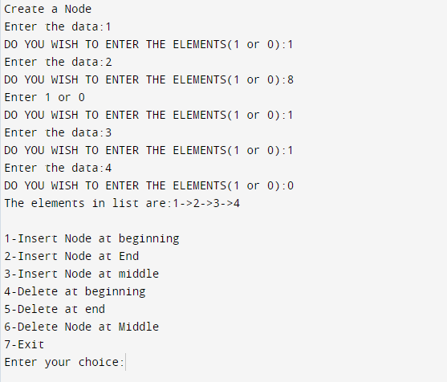
- Addition of nodes in the list (start, end and middle) 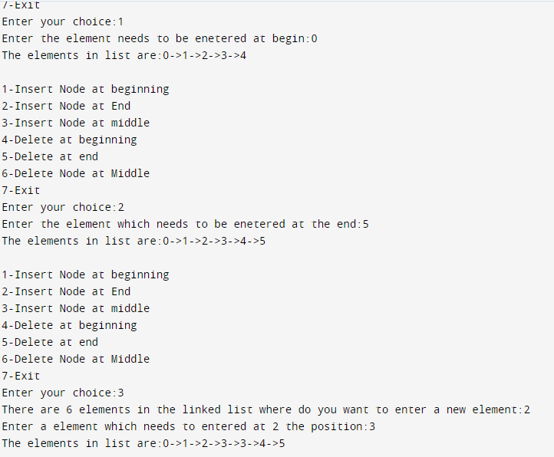

- Deletion of nodes in the list (start, end and middle) 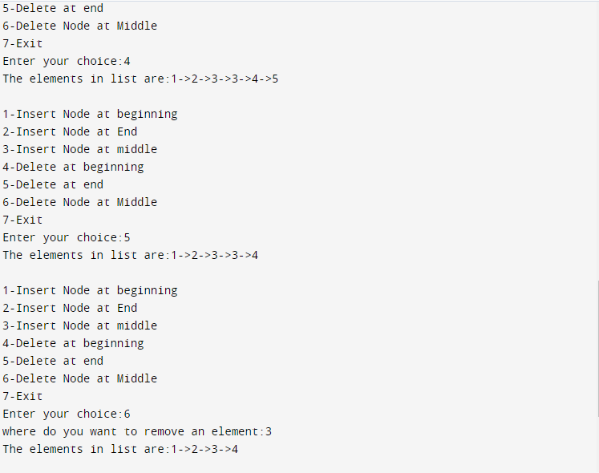

Inference and Result:
Thus, singly linked list has been implemented and various operations like insertion at beginning, end, middle has been implemented and same has been implemented for deletion also.

