**#7. Code Documentation**

**Roll Number:CB.EN.P2EBS22005**

**Date of Submission:08-01-2023**

**Aim:**

To perform code documentation using doxygen GUI frontend tool.

**Tools Required:**

Doxygen

**Experiment: Doxygen implemented on circular linked list**

1. Start of the program

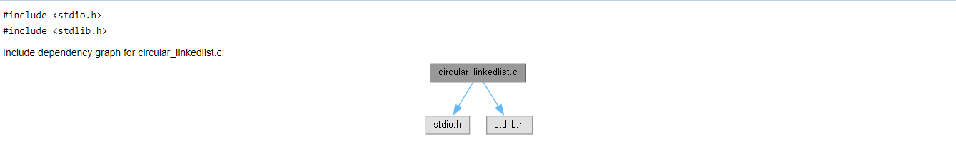

1. Delete first element

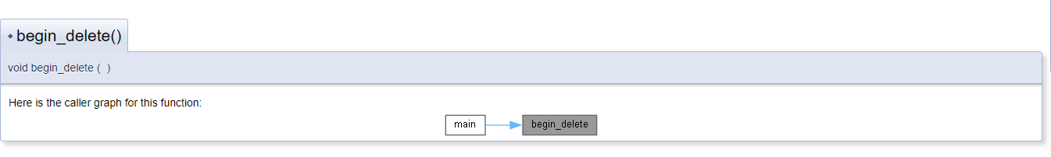

1. Insert at begining

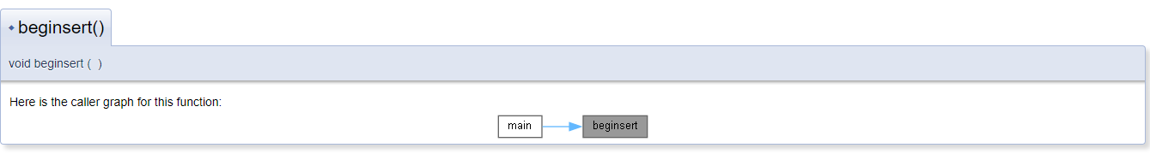

1. Display

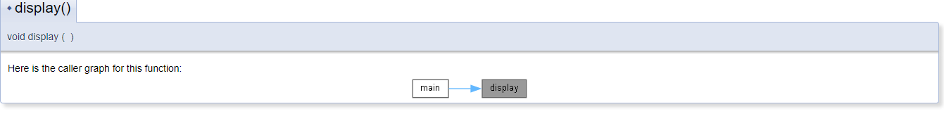

1. Delete last element

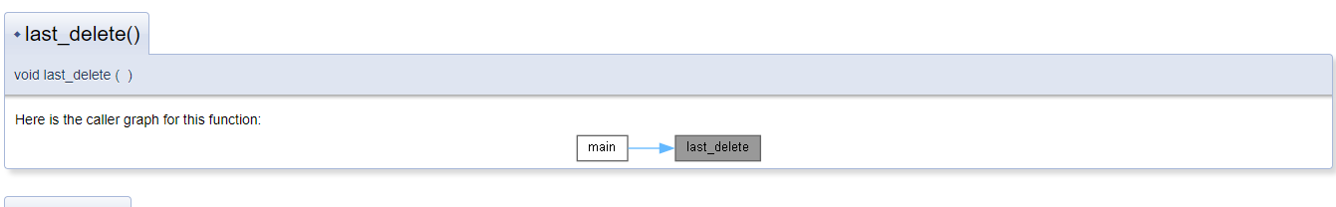

1. Insert at last

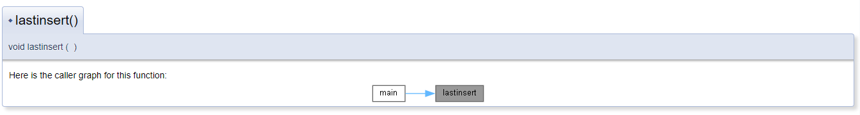

1. Main function

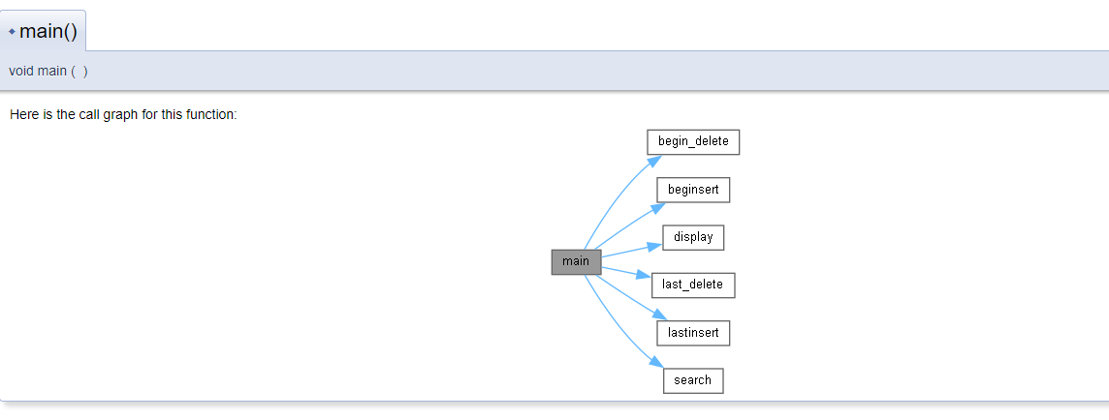

1. Search for an element

