BSE

Ranjith G

15 May 2019

library(Quandl)

## Warning: package 'Quandl' was built under R version 3.5.3

## Loading required package: xts

## Warning: package 'xts' was built under R version 3.5.3

## Loading required package: zoo

## Warning: package 'zoo' was built under R version 3.5.2

##   
## Attaching package: 'zoo'

## The following objects are masked from 'package:base':  
##   
## as.Date, as.Date.numeric

library(tidyverse)

## Warning: package 'tidyverse' was built under R version 3.5.3

## -- Attaching packages ---------------------------------------------------------- tidyverse 1.2.1 --

## v ggplot2 3.1.0 v purrr 0.2.5  
## v tibble 1.4.2 v dplyr 0.7.8  
## v tidyr 0.8.2 v stringr 1.3.1  
## v readr 1.3.1 v forcats 0.4.0

## Warning: package 'ggplot2' was built under R version 3.5.2

## Warning: package 'tidyr' was built under R version 3.5.2

## Warning: package 'readr' was built under R version 3.5.2

## Warning: package 'purrr' was built under R version 3.5.2

## Warning: package 'dplyr' was built under R version 3.5.2

## Warning: package 'forcats' was built under R version 3.5.2

## -- Conflicts ------------------------------------------------------------- tidyverse_conflicts() --  
## x dplyr::filter() masks stats::filter()  
## x dplyr::first() masks xts::first()  
## x dplyr::lag() masks stats::lag()  
## x dplyr::last() masks xts::last()

library(tidyquant)

## Warning: package 'tidyquant' was built under R version 3.5.3

## Loading required package: lubridate

## Warning: package 'lubridate' was built under R version 3.5.3

##   
## Attaching package: 'lubridate'

## The following object is masked from 'package:base':  
##   
## date

## Loading required package: PerformanceAnalytics

## Warning: package 'PerformanceAnalytics' was built under R version 3.5.3

##   
## Attaching package: 'PerformanceAnalytics'

## The following object is masked from 'package:graphics':  
##   
## legend

## Loading required package: quantmod

## Warning: package 'quantmod' was built under R version 3.5.3

## Loading required package: TTR

## Warning: package 'TTR' was built under R version 3.5.3

## Version 0.4-0 included new data defaults. See ?getSymbols.

library(tidyselect)

## Warning: package 'tidyselect' was built under R version 3.5.2

Quandl.api_key("eFNsb_JDyNQsTKnXc5JN")

BSE_1999<-Quandl("BSE/SENSEX",collapse="daily",  
 start_date="1999-05-05",end_date="1999-11-03",type="raw")  
BSE_1999[2:4]<-NULL  
BSE100_1999<-Quandl("BSE/BSE100",collapse="daily",  
 start_date="1999-05-05",end_date="1999-11-03",type="raw")  
BSE100_1999[2:4]<-NULL  
BSEAUTO_1999<-Quandl("BSE/SI1900",collapse="daily",  
 start_date="1999-05-05",end_date="1999-11-03",type="raw")  
BSEAUTO_1999[2:4]<-NULL

BSE<-cbind(BSE_1999,Stock="")  
BSE$Stock<-paste(BSE$Stock,"BSE",sep="")  
  
BSE100<-cbind(BSE100_1999,Stock="")  
BSE100$Stock<-paste(BSE$Stock,"BSE100",sep="")  
  
BSEAUTO<-cbind(BSEAUTO_1999,Stock="")  
BSEAUTO$Stock<-paste(BSE$Stock,"BSEAUTO",sep="")

Master_Data<-rbind(BSE,BSE100,BSEAUTO)  
  
  
Master_Data$Date<-as.character(Master_Data$Date)  
list<-strsplit(Master_Data$Date,"-")  
  
library(plyr)

## -------------------------------------------------------------------------

## You have loaded plyr after dplyr - this is likely to cause problems.  
## If you need functions from both plyr and dplyr, please load plyr first, then dplyr:  
## library(plyr); library(dplyr)

## -------------------------------------------------------------------------

##   
## Attaching package: 'plyr'

## The following object is masked from 'package:lubridate':  
##   
## here

## The following objects are masked from 'package:dplyr':  
##   
## arrange, count, desc, failwith, id, mutate, rename, summarise,  
## summarize

## The following object is masked from 'package:purrr':  
##   
## compact

Master_Date1<-ldply(list)  
colnames(Master_Date1)<-c("Year","Month","Day")  
Master_Data<-cbind(Master_Data,Master_Date1)  
names(Master_Data)

## [1] "Date" "Close" "Stock" "Year" "Month" "Day"

Master_Data$Date<-as.Date(Master_Data$Date)

P<- ggplot(Master_Data,aes(factor(Stock),Close,color=Stock,frame=Month)) +  
 geom_jitter(aes(size = Close, colour=Stock, alpha=.02)) +  
 ylim(0,5000)+  
 labs(title = "BSE Stock Prices", x = "BSE", y= "Close Price") +  
 theme(panel.border = element_blank(),  
 panel.grid.major = element_line(colour = "grey61", size = 0.5, linetype = "dotted"),  
 panel.grid.minor = element_blank(),  
 axis.line=element_line(colour="black"),  
 plot.title = element_text(hjust = 0.5,size=18,colour="indianred4"))+  
 theme(legend.position="none")  
P

## Warning: Removed 4 rows containing missing values (geom_point).

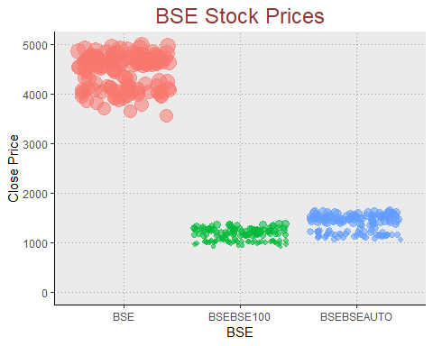

Master_Data<-Master_Data%>%  
 tibble::as.tibble()%>%  
 group_by(Stock)  
Master_Data %>%  
 ggplot(aes(x = Date, y = Close, color = Stock)) +  
 geom_point() +  
 labs(title = "Daily Close Price", x = "Month",y="Close Price") +  
 facet_wrap(~ Stock, ncol = 3, scale = "free_y") +  
 scale_fill_tq(fill="green4",theme="light") +  
 theme_tq() +  
 theme(panel.border = element_blank(),  
 panel.grid.major = element_line(colour = "grey61", size = 0.5, linetype = "dotted"),  
 panel.grid.minor = element_blank(),  
 axis.line=element_line(colour="black"),  
 plot.title = element_text(hjust = 0.5,size=18,colour="indianred4"))+  
 theme(legend.position="none")

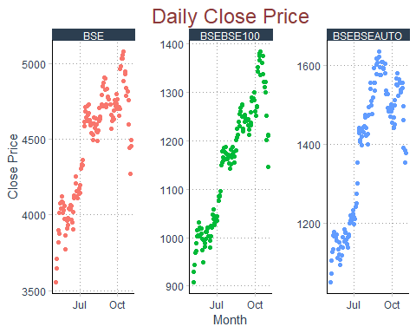

#Chart  
  
BSE_1999x<-Quandl("BSE/SENSEX",collapse="daily",  
 start_date="1999-05-05",end_date="1999-11-03",type="xts")  
  
BSE100_1999x<-Quandl("BSE/BSE100",collapse="daily",  
 start_date="1999-05-05",end_date="1999-11-03",type="xts")  
  
BSEAUTO_1999x<-Quandl("BSE/SI1900",collapse="daily",  
 start_date="1999-05-05",end_date="1999-11-03",type="xts")

chartSeries(BSE_1999x)

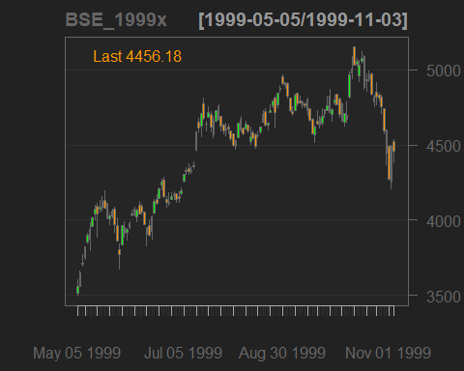

hist(BSE_1999x$Close, breaks=10, col='blue')

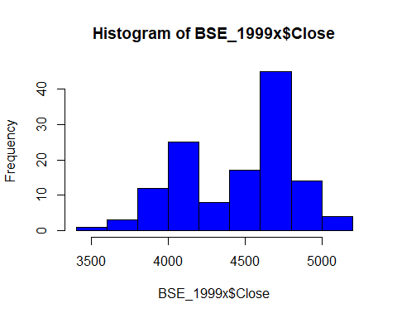

chartSeries(BSE100_1999x, theme="white", TA="addVo();addBBands();addRSI()")

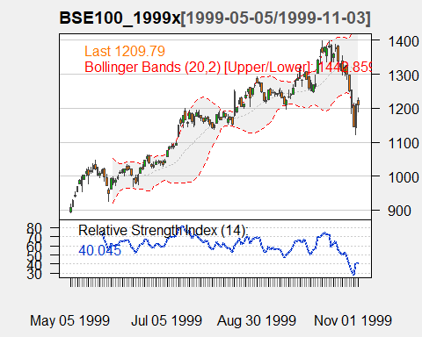

# Moving Average

BSE_mm <- subset( BSE_1999x, index(BSE_1999x) >= "1999-06-05")  
  
BSE_mm3 <- rollmean(BSE_mm[,4], 6, fill = list(NA, NULL, NA), align = "right")  
BSE_mm6 <- rollmean(BSE_mm[,4], 10, fill = list(NA, NULL, NA), align = "right")  
  
BSE_mm$mm3 <- coredata(BSE_mm3)  
BSE_mm$mm6 <- coredata(BSE_mm6)  
ggplot(BSE_mm, aes(x = index(BSE_mm))) +  
 geom_line(aes(y = BSE_mm[,4], color = "BSE")) + ggtitle("BSE MOVING AVERAGE") +  
 geom_line(aes(y = BSE_mm$mm3, color = "MM6")) +  
 geom_line(aes(y = BSE_mm$mm6, color = "MM10")) + xlab("Date") + ylab("Price") +  
 theme(plot.title = element_text(hjust = 0.5), panel.border = element_blank()) +  
 scale_x_date(date_labels = "%b %y", date_breaks = "4 months") +  
 scale_colour_manual("Series", values=c("BSE"="gray40", "MM6"="firebrick4", "MM10"="darkcyan"))

## Don't know how to automatically pick scale for object of type xts/zoo. Defaulting to continuous.

## Warning: Removed 5 rows containing missing values (geom_path).

## Warning: Removed 9 rows containing missing values (geom_path).

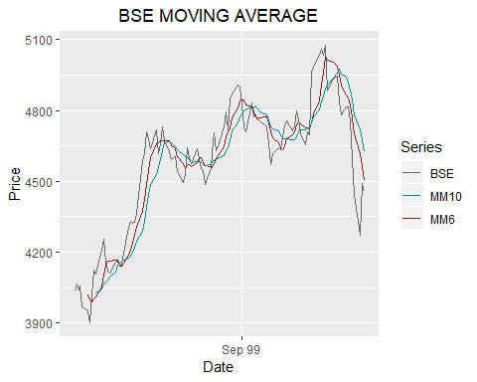

BSE_ret <- diff(log(BSE_1999x[,4]))  
BSE_ret <- BSE_ret[-1,]  
  
  
summary(BSE_ret)

## Index Close   
## Min. :1999-05-06 Min. :-0.039894   
## 1st Qu.:1999-06-20 1st Qu.:-0.009398   
## Median :1999-08-03 Median : 0.001136   
## Mean :1999-08-03 Mean : 0.001761   
## 3rd Qu.:1999-09-17 3rd Qu.: 0.011277   
## Max. :1999-11-03 Max. : 0.054958

ggplot(BSE_ret, aes(x = index(BSE_ret), y = BSE_ret)) +  
 geom_line(color = "deepskyblue4") +  
 ggtitle("BSE returns series") +  
 xlab("Date") + ylab("Return") +  
 theme(plot.title = element_text(hjust = 0.5)) + scale_x_date(date_labels = "%b %y", date_breaks = "3 months")

## Don't know how to automatically pick scale for object of type xts/zoo. Defaulting to continuous.

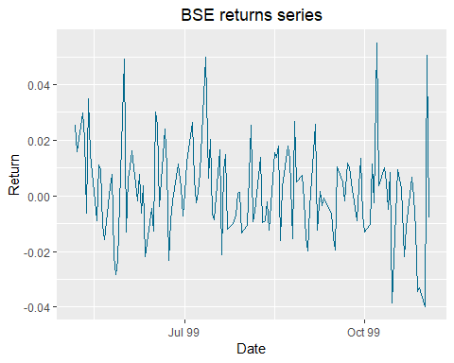

summary(BSE_1999x)

## Index Open High Low   
## Min. :1999-05-05 Min. :3517 Min. :3606 Min. :3495   
## 1st Qu.:1999-06-18 1st Qu.:4130 1st Qu.:4167 1st Qu.:4083   
## Median :1999-08-03 Median :4604 Median :4637 Median :4563   
## Mean :1999-08-03 Mean :4473 Mean :4514 Mean :4418   
## 3rd Qu.:1999-09-17 3rd Qu.:4763 3rd Qu.:4792 3rd Qu.:4696   
## Max. :1999-11-03 Max. :5151 Max. :5151 Max. :5041   
## Close   
## Min. :3557   
## 1st Qu.:4120   
## Median :4595   
## Mean :4460   
## 3rd Qu.:4730   
## Max. :5075

closing_price <- as.xts(data.frame(BSEr = BSE_1999x[, "Close"],BSE100r = BSE100_1999x[, "Close"],   
 BSEAUTOr = BSEAUTO_1999x[, "Close"]))  
head(closing_price)

## Close Close.1 Close.2  
## 1999-05-05 3557.07 908.47 1052.13  
## 1999-05-06 3648.86 929.13 1072.35  
## 1999-05-07 3707.75 944.48 1105.44  
## 1999-05-10 3820.25 968.68 1128.60  
## 1999-05-11 3900.49 988.87 1170.82  
## 1999-05-12 3876.89 972.56 1135.28

plot(as.zoo(closing_price), screens = 1, lty = 1:3, xlab = "Date", ylab = "Closing Price")  
legend("topleft", c("BSEr", "BSE100r", "BSEAUTOr"), lty = 1:3, cex = 0.5)

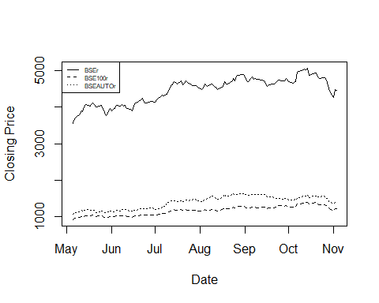

returns <- apply(closing_price, 1, function(x) {x / closing_price[1,]}) %>%   
 t %>% as.xts  
summary(returns)

## Index Close Close.1   
## Min. :1999-05-05 00:00:00 Min. :1.000 Min. :1.000   
## 1st Qu.:1999-06-18 00:00:00 1st Qu.:1.158 1st Qu.:1.130   
## Median :1999-08-03 00:00:00 Median :1.292 Median :1.288   
## Mean :1999-08-03 02:25:06 Mean :1.254 Mean :1.270   
## 3rd Qu.:1999-09-17 00:00:00 3rd Qu.:1.330 3rd Qu.:1.375   
## Max. :1999-11-03 00:00:00 Max. :1.427 Max. :1.522   
## Close.2   
## Min. :1.000   
## 1st Qu.:1.126   
## Median :1.371   
## Mean :1.314   
## 3rd Qu.:1.459   
## Max. :1.552

plot(as.zoo(returns), screens = 1, lty = 1:3, xlab = "Date", ylab = "Return")  
legend("topleft", c("BSEr", "BSE100r", "BSEAUTOr"), lty = 1:3, cex = 0.5)

