API Documentation

Transaction Management Service

Authentication
All APIs require an API Key to be passed in the request header:
X-API-KEY: my-secret-key

Endpoints

1. Upload Transactions
Description: Uploads transactions from datasource.txt and saves them into the database.
Endpoint: POST /api/batch/upload
Headers:
- X-API-KEY: my-secret-key
Response:
{
"message": "Data successfully uploaded to database."
}

2. Get All Transactions (Paginated)
Endpoint: GET /api/batch/getAll
Query Parameters:
- pageNo: (integer) page number (starting from 0)
- pageSize: (integer) number of items per page
Example Request: GET http://localhost:8080/api/batch/getAll?pageNo=1&pageSize=2
Headers:
- X-API-KEY: my-secret-key
Sample Response:
{
"content": [...],
"pageable": {...},
"totalElements": 188,
"totalPages": 94,
...
}

3. Search Transactions by Description
Endpoint: GET /api/batch/search
Query Parameters:
- description: (string) text to search in description field
Example Request: GET http://localhost:8080/api/batch/search?description=FUND TRANSFER
Headers:
- X-API-KEY: my-secret-key
Response:
[
{"transactionId": ..., "description": "ATM WITHDRAWAL", ...},
...
]

4. Update Transaction
Description: Updates a transaction.
Endpoint: PUT /api/batch/{customerId}
Headers:
- X-API-KEY: my-secret-key
- Content-Type: application/json
Request Body:
{
"transactionId": 191,
"customer": {"id": 222, "accountNumber": "8872838283"},
"trxAmount": 123.0,
...
}
Response:
{
"transactionId": 191,
"version": 1,
...
}

Design Pattern Used
- MVC Design Pattern
- Singleton Pattern (used by Spring Beans)
- Repository Pattern.(used in CRUD layer

Sample Configuration
application.properties
# Data file location
data.file.path=classpath:data.txt
# Oracle DB
spring.datasource.url=jdbc:oracle:thin:@localhost:1521:ORCL
spring.datasource.username=your_user
spring.datasource.password=your_password
spring.jpa.hibernate.ddl-auto=update
spring.jpa.show-sql=true
# API Key
api.key.header=X-API-KEY
api.key.value=my-secret-key

data.file.path=classpath:data.txt

Class Diagram
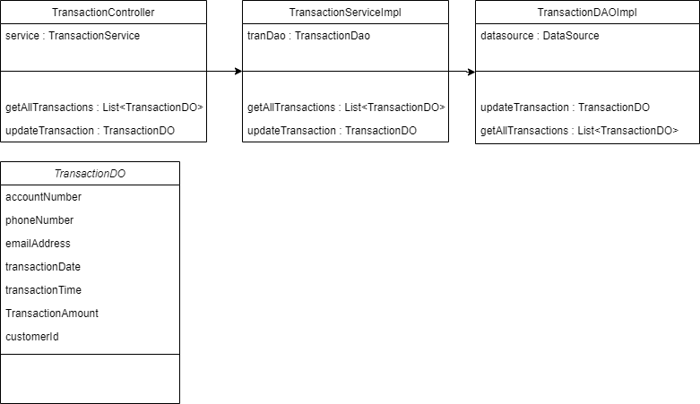

ER Diagram

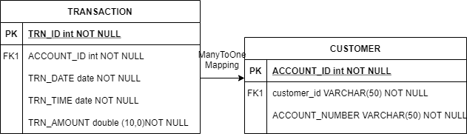

ER Diagram



