**Finance**

**KPI’S**

1.total loan applications

select count( distinct id) as total_loan_applications

from finance_loan;



2.MTD Loan Applications

select count( distinct id) as MTDtotal_loan_applications

from finance_loan

where month(issue_date)=12 and YEAR(issue_date)=2021;



3.PMTD Loan Applications

select count( distinct id) as PMTMtotal_loan_applications

from finance_loan

where month(issue_date)=11 and YEAR(issue_date)=2021;



**--Total money issued**

4.Total

select SUM(loan_amount) as Total_fund_issued

from finance_loan;



5.MTDmoneyissued

select SUM(loan_amount) as MTDTotal_fund_issued

from finance_loan

where month(issue_date)=12 and YEAR(issue_date)=2021;



6.P MTDmoneyissued

select SUM(loan_amount) as PMTDTotal_fund_issued

from finance_loan

where month(issue_date)=11 and YEAR(issue_date)=2021;



**-Total** **amount** **recieved**

7**.**Total amout recicevd

select SUM(total_payment) as Recievd_amount

from finance_loan;



8. Month to date Money Recived

select SUM(total_payment) as MTDRecievd_amount

from finance_loan

where month(issue_date)=12 and YEAR(issue_date)=2021;



9.Previous Month to date Money Recived

select SUM(total_payment) as PMTDRecievd_amount

from finance_loan

where month(issue_date)=11 and YEAR(issue_date)=2021;



**-Average** **interest** **rate**

10.Avg int_rate

select cast(AVG(int_rate)*100 as decimal(10,2)) as Avg_intetrest_rate

from finance_loan;



11.MTD int_rate

select cast(AVG(int_rate)*100 as decimal(10,2)) as MTMAvg_intetrest_rate

from finance_loan

where MONTH(issue_date)=12 and YEAR(issue_date)=2021;



12.PMTD int_rate

select cast(AVG(int_rate)*100 as decimal(10,2)) as PMTDAvg_intetrest_rate

from finance_loan

where MONTH(issue_date)=11 and YEAR(issue_date)=2021;



**-Average** **DTI** **rate**

13.Avg DTI_rate

select cast(AVG(dti)*100 as decimal(10,2)) as Avg_dti_rate

from finance_loan;



14.MTD DTI_rate

select cast(AVG(dti)*100 as decimal(10,2)) as MTMAvg_dti_rate

from finance_loan

where MONTH(issue_date)=12 and YEAR(issue_date)=2021;



15.PMTD DTI_rate

select cast(AVG(dti)*100 as decimal(10,2)) as PMTMAvg_dti_rate

from finance_loan

where MONTH(issue_date)=11 and YEAR(issue_date)=2021;



**Good Vs Bad Loan**

--Goodloan

select * from finance_loan;

/*select COUNT(id ) as Good_Loan_applications

from finance_loan

where loan_status like 'Fully%' or loan_status like 'Current%' ;*/ --its one way to find total good loan

1. Good_Loan_Percentage

select

(COUNT(case when loan_status = 'Fully Paid' or loan_status = 'Current' then id end) *100)

/COUNT(id) as Good_Loan_Percentage

from finance_loan;



2. Total_Good_Loan

select

count (case

when loan_status = 'Fully Paid' or loan_status = 'Current' then id

end)as Total_Good_Loan

from finance_loan;



3.Good_Loan_Amount

select SUM

(case

when loan_status = 'Fully Paid' or loan_status = 'Current' then loan_amount

end) as Good_Loan_Amount

from finance_loan;



4. Good_Loan_Amount payment

select SUM

(case

when loan_status = 'Fully Paid' or loan_status = 'Current' then total_payment

end) as Good_Loan_Amount

from finance_loan



--bad Loan

5. Total_bad_Loan

select

count (case

when loan_status = 'Charged Off' then id

end)as Total_bad_Loan

from finance_loan;



6. bad_Loan_Percentage

select

(COUNT(case when loan_status = 'Charged Off' then id end) *100)

/COUNT(id) as bad_Loan_Percentage

from finance_loan;



7. bad_loan_Amount

select SUM(loan_amount) as bad_loan_Amount

from finance_loan

where loan_status = 'Charged Off';



8. bad_loan_Amount

select SUM(total_payment) as bad_loan_Amount

from finance_loan

where loan_status = 'Charged Off';



9. loan_status

select

loan_status,

COUNT(id) as Total_application,

SUM(loan_amount) as Total_amount,

SUM(total_payment) as Total_Payment,

AVG(int_rate *100) as Avg_intrest_rate,

AVG(dti *100) as Avg_DTI

from finance_loan

group by loan_status;

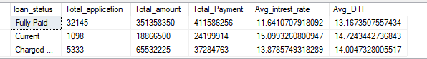

select

loan_status,

SUM(loan_amount) as Total_amount,

SUM(total_payment) as Total_Payment

from finance_loan

where MONTH(issue_date)=12

group by loan_status;

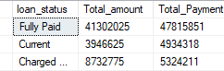

**Charts**

select * from finance_loan;

--charts

--Monthly trend by issue date

select

MONTH(issue_date) as Month_index,

DATENAME(MONTH,issue_date) as Months,

COUNT(id) as Total_Applications,

SUM(loan_amount) as Total_Lended,

sUM(total_payment) as Total_Recievd,

sUM(total_payment) - SUM(loan_amount) as profit_margin

from finance_loan

group by MONTH(issue_date),DATENAME(MONTH,issue_date)

order by MONTH(issue_date);

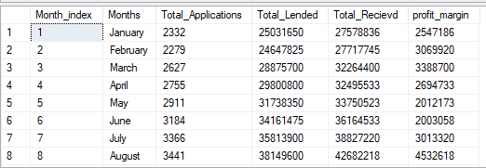

--regional analysis

select

address_state,

COUNT(id) as Total_Applications,

SUM(loan_amount) as Total_Lended,

sUM(total_payment) as Total_Recievd

from finance_loan

group by address_state

order by address_state;

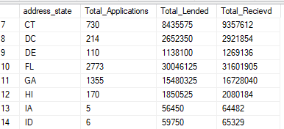

--term analysis

select

term,

COUNT(id) as Total_Applications,

SUM(loan_amount) as Total_Lended,

sUM(total_payment) as Total_Recievd

from finance_loan

group by term

order by term;

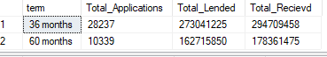

--employee_length

select

emp_title,

COUNT(id) as Total_Applications,

SUM(loan_amount) as Total_Lended,

sUM(total_payment) as Total_Recievd

from finance_loan

group by emp_title

order by emp_title;

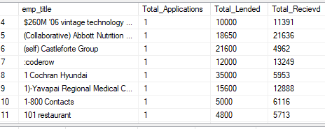

--purpose

select

purpose,

COUNT(id) as Total_Applications,

SUM(loan_amount) as Total_Lended,

sUM(total_payment) as Total_Recievd

from finance_loan

group by purpose

order by purpose;

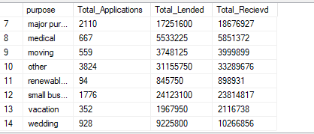

--home ownership

select

home_ownership,

COUNT(id) as Total_Applications,

SUM(loan_amount) as Total_Lended,

sUM(total_payment) as Total_Recievd

from finance_loan

group by home_ownership

order by home_ownership;

