GUVI : TASK-1

Difference between HTTP1.1 vs HTTP2

The Hypertext Transfer Protocol, or HTTP, is an application protocol that has been standard for communication on the World Wide Web since its invention in 1989. From the release of HTTP/1.1 in 1997 until recently, there have been few revisions to the protocol. But in 2015, a reimagined version called HTTP/2 came into use, which offered several methods to decrease latency, especially when dealing with mobile platforms and server-intensive graphics and videos.

These are the high-level differences between HTTP1 and HTTP2:
- HTTP2 is binary, instead of textual
- HTTP2 is fully multiplexed, instead of ordered and blocking
- HTTP2 can, therefore, use one connection for parallelism
- HTP2 uses header compression to reduce overhead
- HTTP2 allows servers to “push” responses proactively into client caches

when web browser loads a web page using HTTP/1.1 it can requests resource (like an image, JavaScript file, etc) one at a time, per connection to the server. It looks like this:

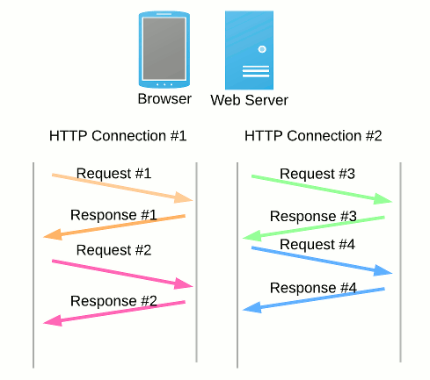

HTTP/2 works by making a single connection to the server, and then "multiplexing" multiple requests over that connection to receive multiple responses at the same time. It looks like this:
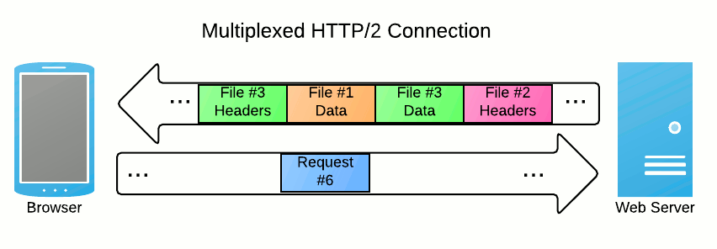

HTTP Version history:

In 1989, while he was working at CERN, Tim Berners-Lee wrote a proposal to build a hypertext system over the Internet. Initially calling it the Mesh, it was later renamed to World Wide Web during its implementation in 1990. Built over the existing TCP and IP protocols, it consisted of 4 building blocks:
- A textual format to represent hypertext documents, the HyperText Markup Language (HTML).
- A simple protocol to exchange these documents, the HypertText Transfer Protocol (HTTP).
- A client to display (and accidentally edit) these documents, the first Web browser called WorldWideWeb.
- A server to give access to the document, an early version of httpd.
These four building blocks were completed by the end of 1990, and the first servers were already running outside of CERN by early 1991. On August 6th 1991, Tim Berners-Lee's post on the public alt.hypertext newsgroup is now considered as the official start of the World Wide Web as a public project.
The HTTP protocol used in those early phases was very simple, later dubbed HTTP/0.9, and sometimes as the one-line protocol.

Year | HTTP Version
1991 | 0.9
1996 | 1.0
1997 | 1.1
2015 | 2.0
Draft (2020) | 3.0

Difference between browser Js and Node Js:

1 | Javascript is a programming language that is used for writing scripts on the website. | NodeJS is a Javascript runtime environment.
2 | Javascript can only be run in the browsers. | NodeJS code can be run outside the browser.
3 | It is basically used on the client-side. | It is mostly used on the server-side.
4 | Javascript is capable enough to add HTML and play with the DOM. | Nodejs does not have capability to add HTML tags.
5 | Javascript can run in any browser engine as like JS core in safari and Spidermonkey in Firefox. | Nodejs can only run in V8 engine of google chrome.
6 | Javascript is used in frontend development. | Nodejs is used in server-side development.
7 | Some of the javascript frameworks are RamdaJS, TypedJS, etc. | Some of the Nodejs modules are Lodash, express etc. These modules are to be imported from npm.
8 | It is the upgraded version of ECMA script that uses Chrome’s V8 engine written in C++. | Nodejs is written in C, C++ and Javascript.

What happens when you type a URL in the address bar in the browser?

- You enter a URL into a web browser
- The browser looks up the IP address for the domain name via DNS
- The browser sends a HTTP request to the server
- The server sends back a HTTP response
- The browser begins rendering the HTML
- The browser sends requests for additional objects embedded in HTML (images, css, JavaScript) and repeats steps 3-5.
- Once the page is loaded, the browser sends further async requests as needed.
That’s really it. Here’s a description in words for this site.

Reference :
1.https://www.digitalocean.com/community/tutorials/http-1-1-vs-http-2-what-s-the-difference
2.https://moz.com/blog/http2-a-fast-secure-bedrock-for-the-future-of-seo
3.https://developer.mozilla.org/en-US/docs/Web/HTTP/Basics_of_HTTP/Evolution_of_HTTP
4.https://www.geeksforgeeks.org/difference-between-node-js-and-javascript/
5.https://wsvincent.com/what-happens-when-url/

