**Topic: JENKINS (DAY-1)**

Date: 05-10-2023

**Step 1:** Launch Linux Instance,

**Step 2:** Connect putty

**Step 3:** login as ec2-user and change to root user by using ‘sudo su’

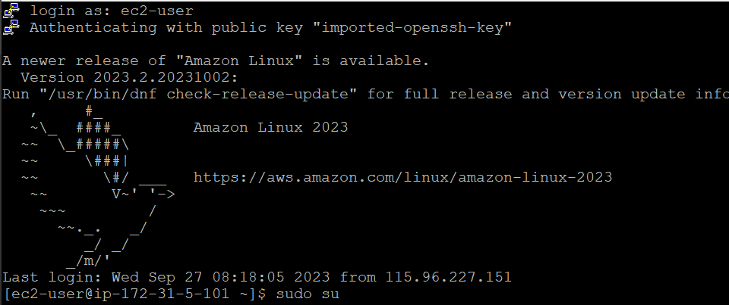

**Step 4:** browse ‘download Jenkins in amazon Linux ‘(or) given below the link

[Jenkins on AWS](https://www.jenkins.io/doc/tutorials/tutorial-for-installing-jenkins-on-AWS/)

**Step 5:** Ensure that your software packages are up to date on your instance by using the following command to perform a quick software update:



**Step 6:** Add the Jenkins repo using the following command:

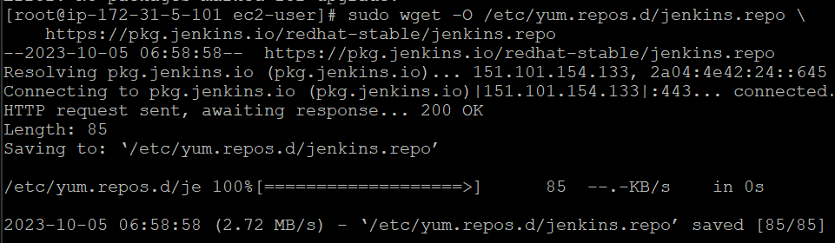

**Step 7:** Import a key file from Jenkins-CI to enable installation from the package:



**Step 8:** Install Java (Amazon Linux 2023):

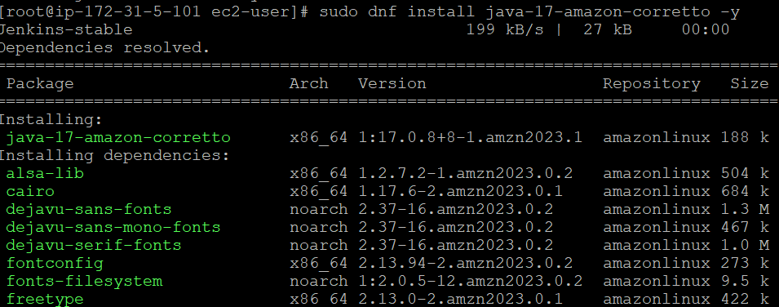

**Step 9:** Install Jenkins:

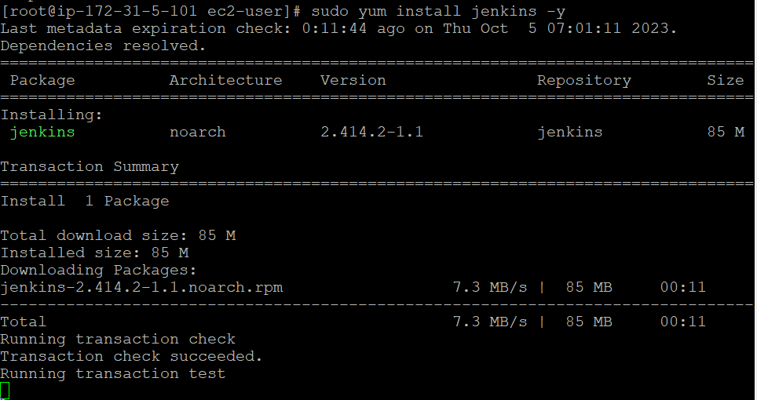

**Step 10:** Enable the Jenkins service to start at boot:

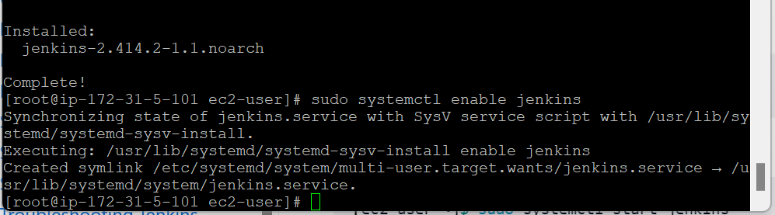

**Step 12:** Start Jenkins as a service:



**Step 13:** as well install git also in the putty:

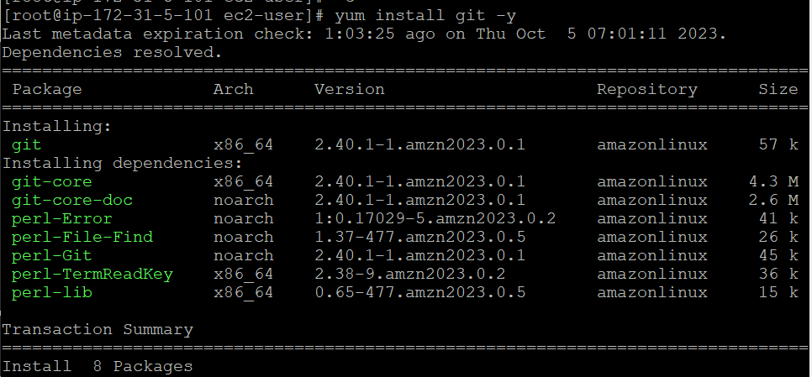

**Step 14:** copy IP-address : 8080

8080🡪 Jenkins port number



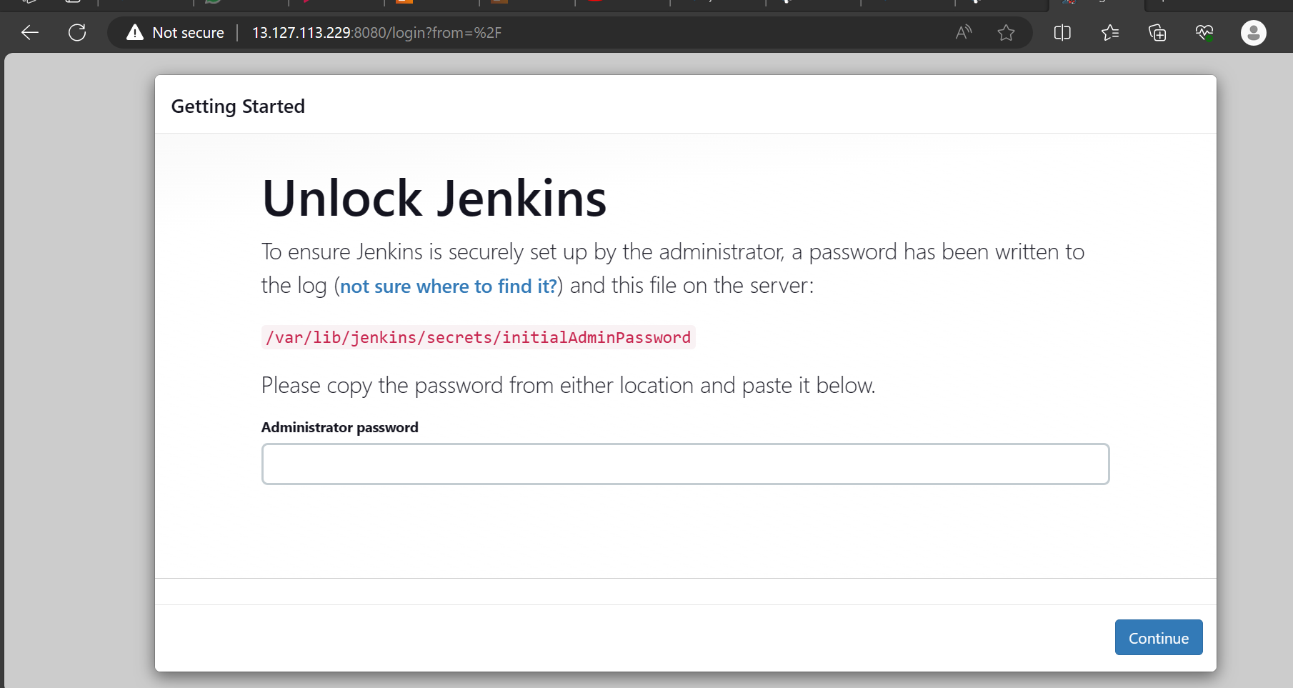

**Step 15:** get password,





**Step 16:** paste the password and continue:

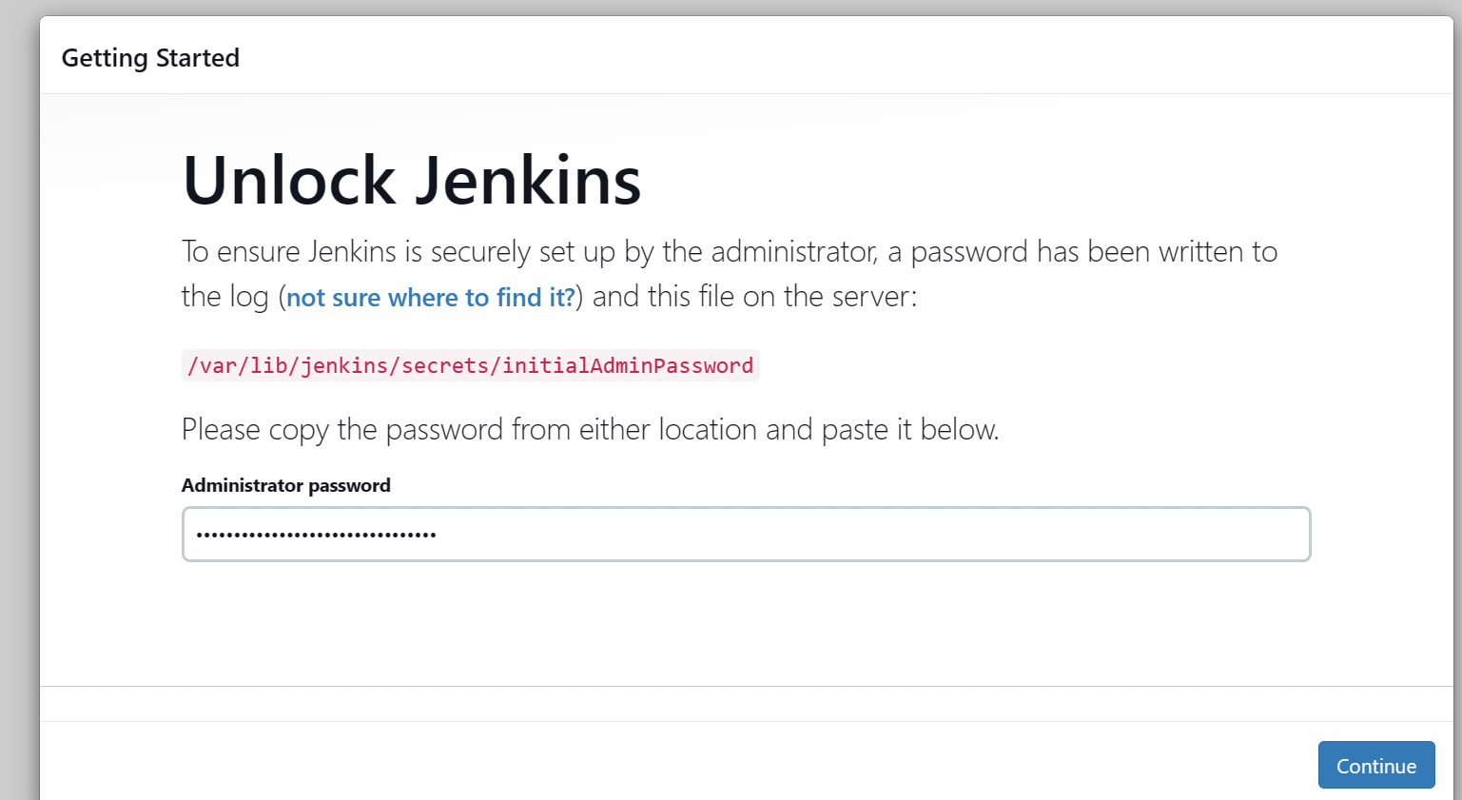

**Step 17:** select the installation of plugins:

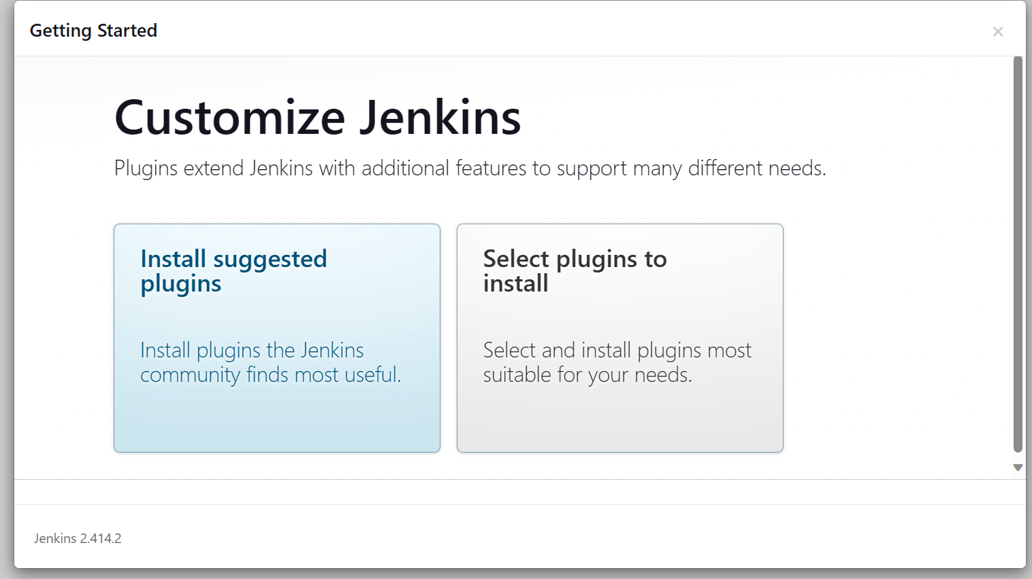

**Step 18:** after click install suggested plugins, here the plugins are installing,

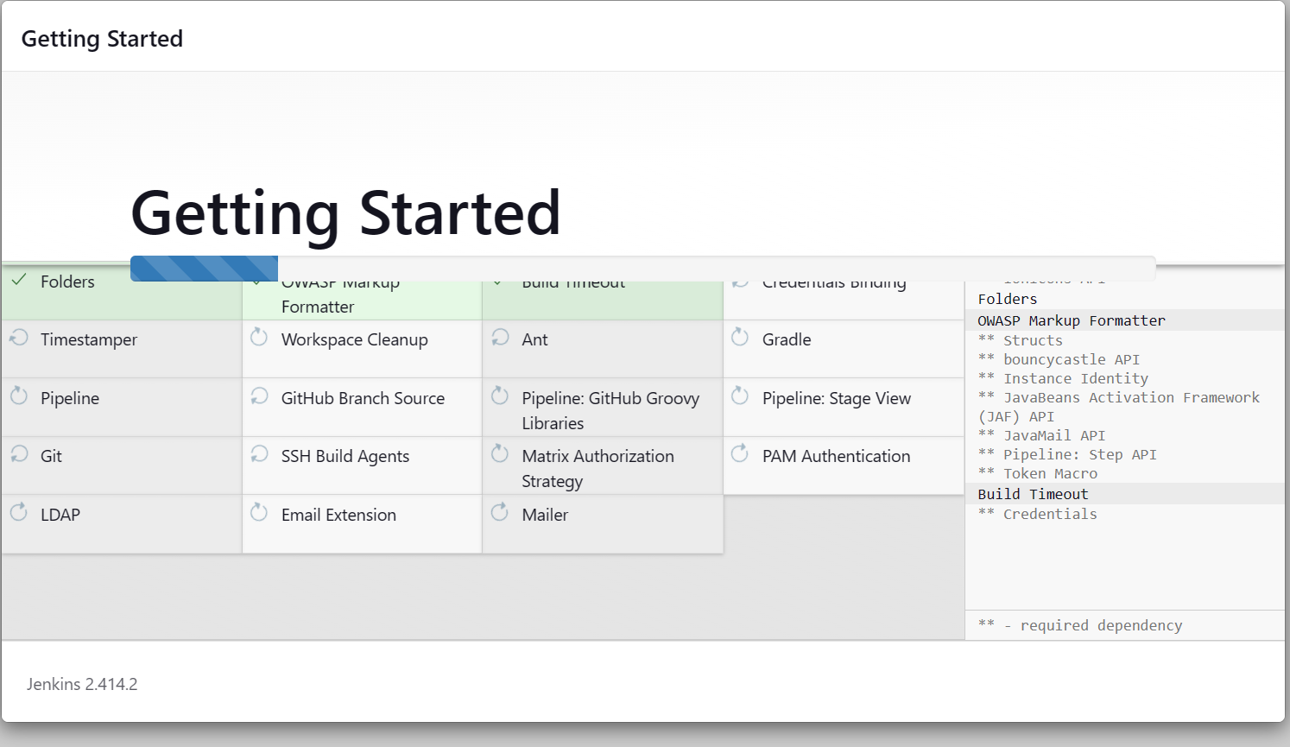

**Step 19:** After installation the plugins, give the user details click continue button, and it move to below screen, click save and finish button.

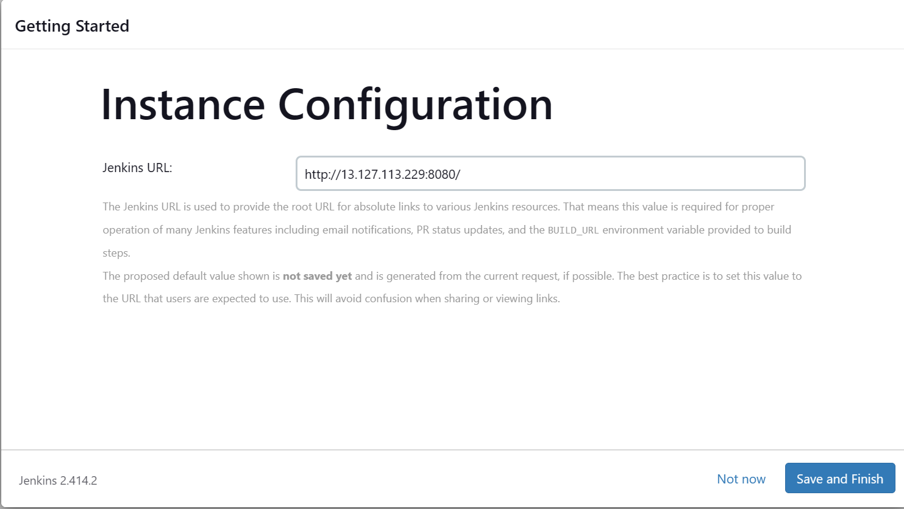

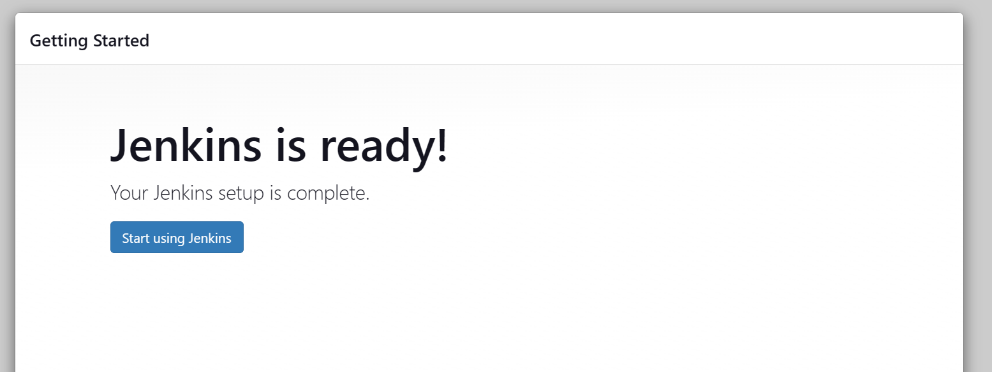

**Step 20:** now the Jenkins repo is open, and click new item to write the stages:

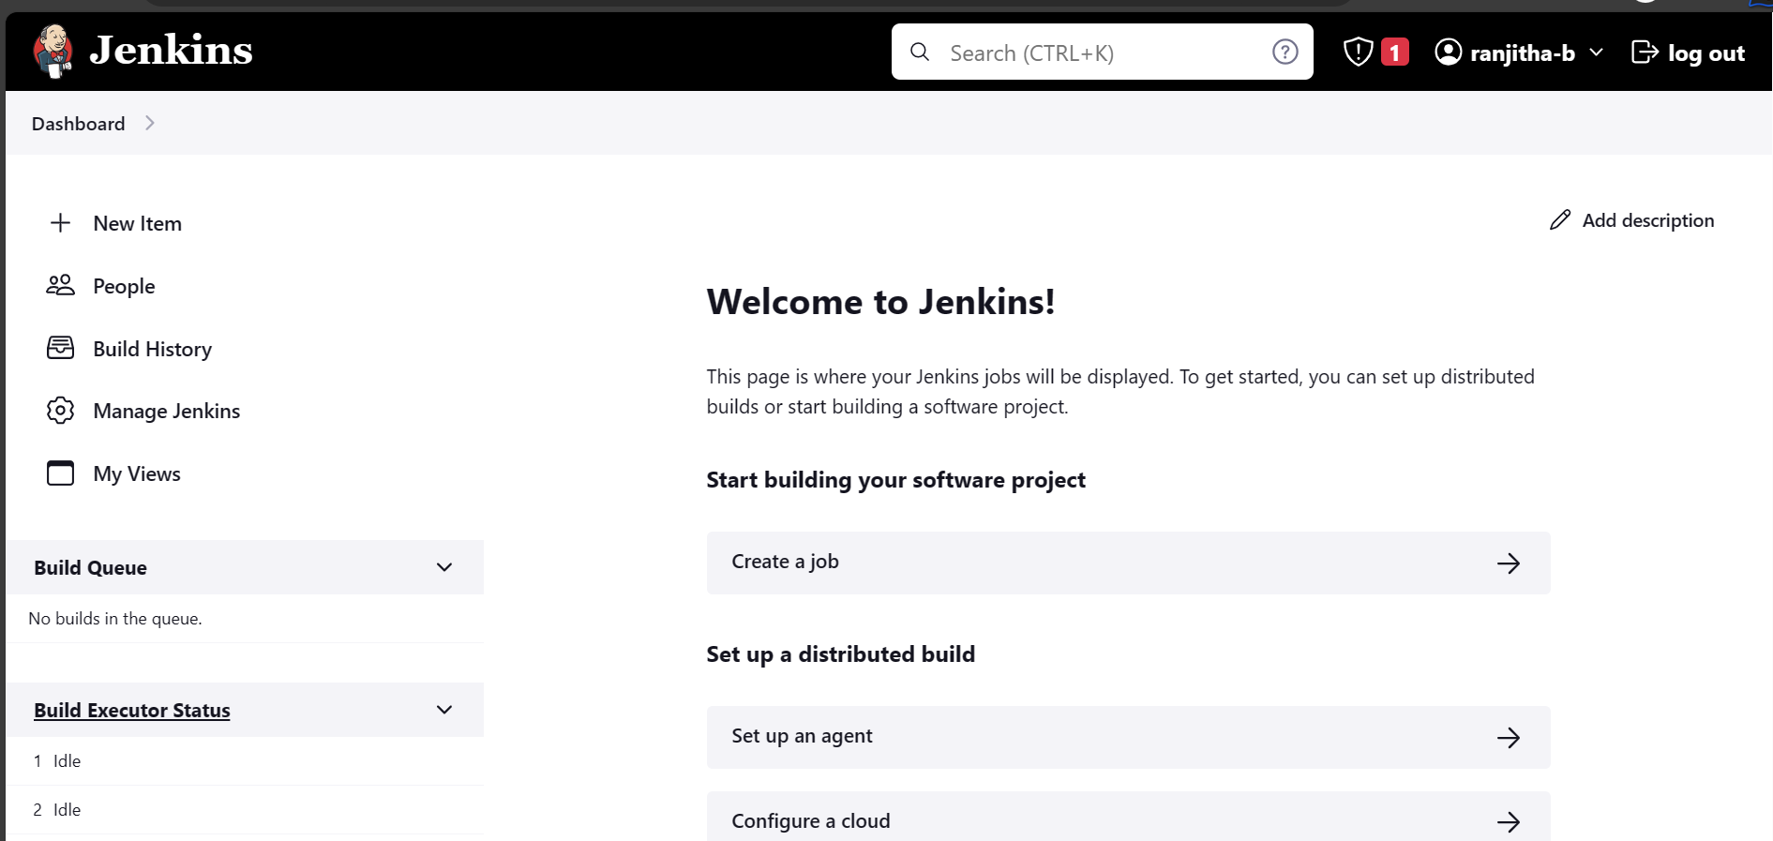

**Step 21:** enter the job name and select pipeline, click ok button:

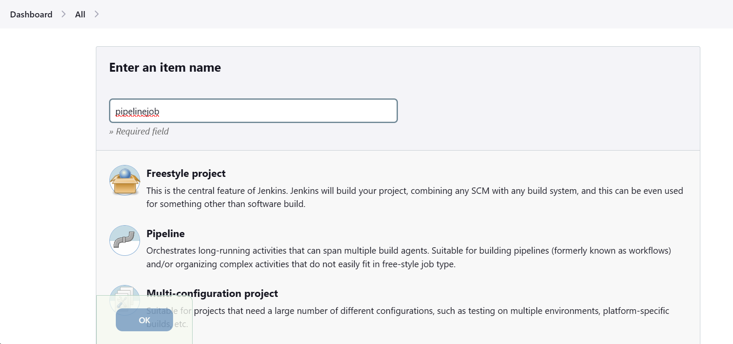

**Step 22:** select pipeline button🡪 click Hello world🡪 change the code what you want

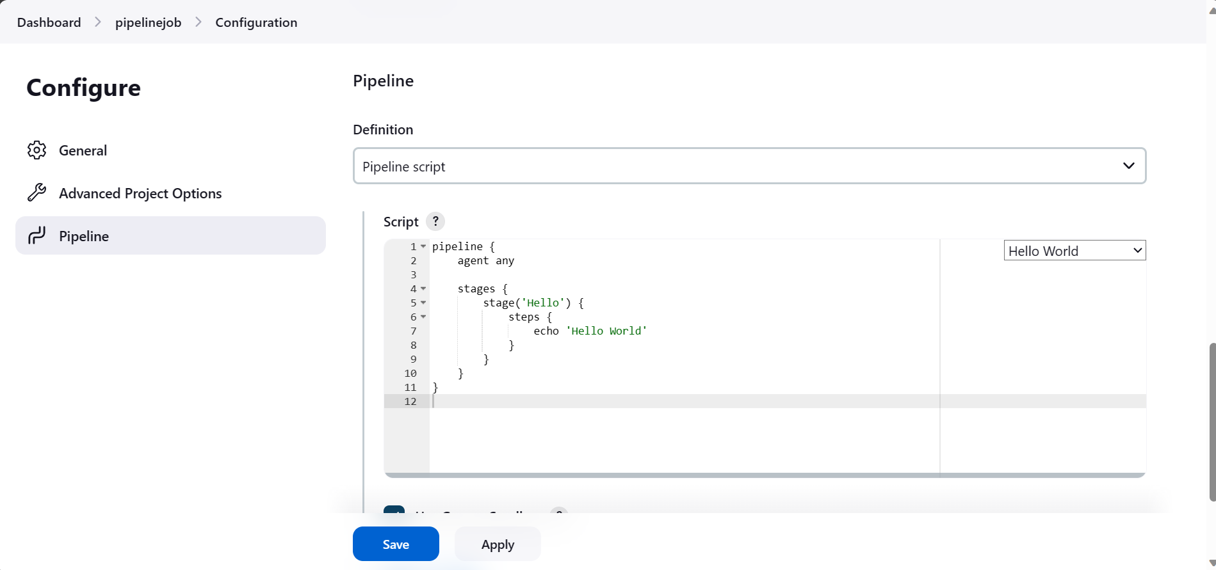

**Step 23:** here if don’t know about the script for git we can use pipeline syntax button,

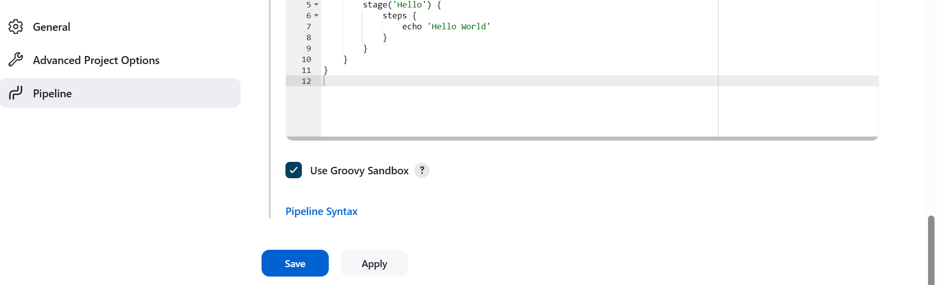



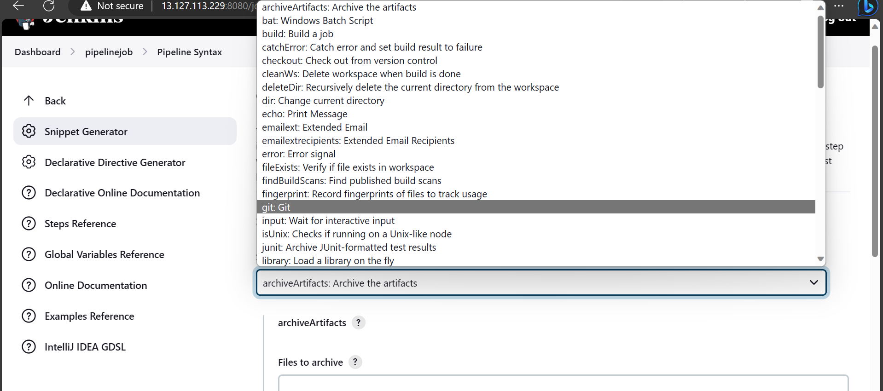



**Step 24:** enter the repositor URL (git la irukura repository <code> URL ah inga kutukanum apothan git la irukura repository Jenkins ku move agum like clone mathiri) & give branch name, credentials (repository public ah iruntha ‘None’ / repository private ah iruntha username, password kutukanum)

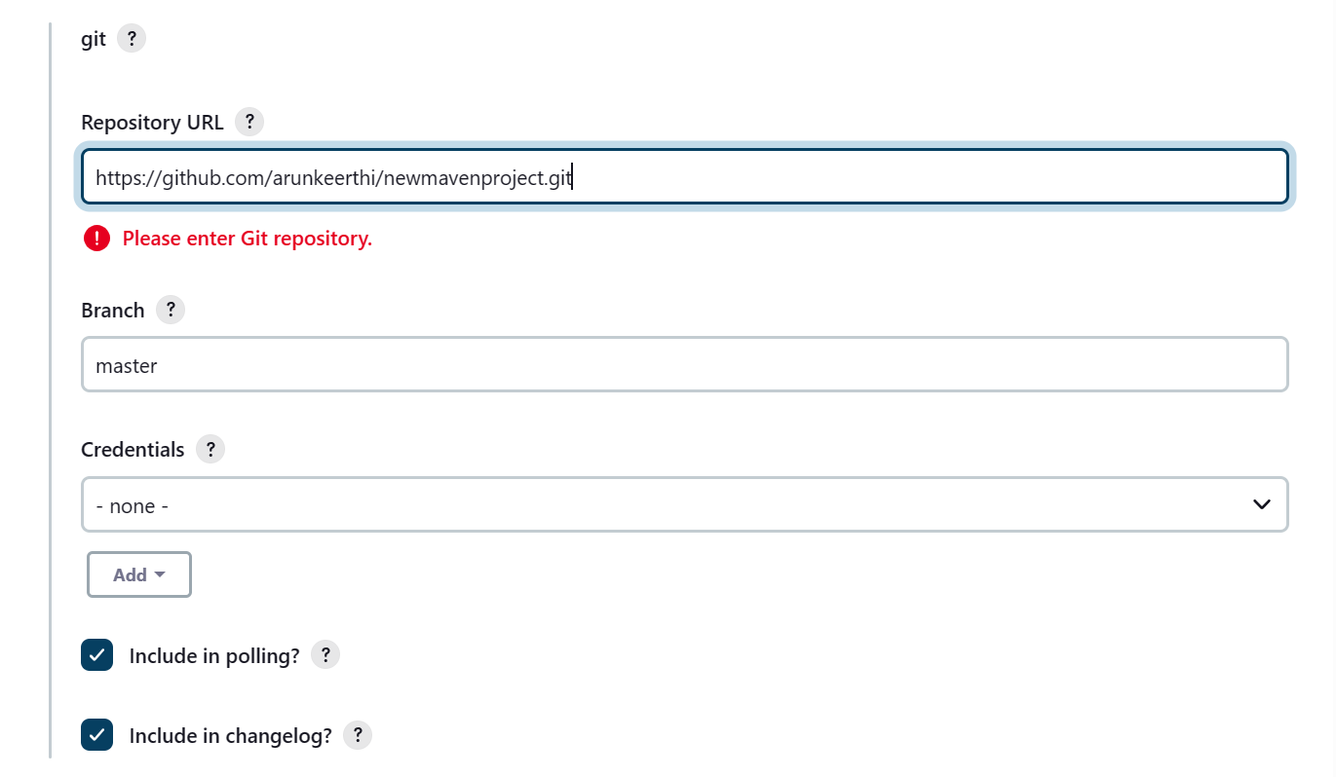

**Step 25:** click generate pipeline script & copy that URL script paste to script stage program:

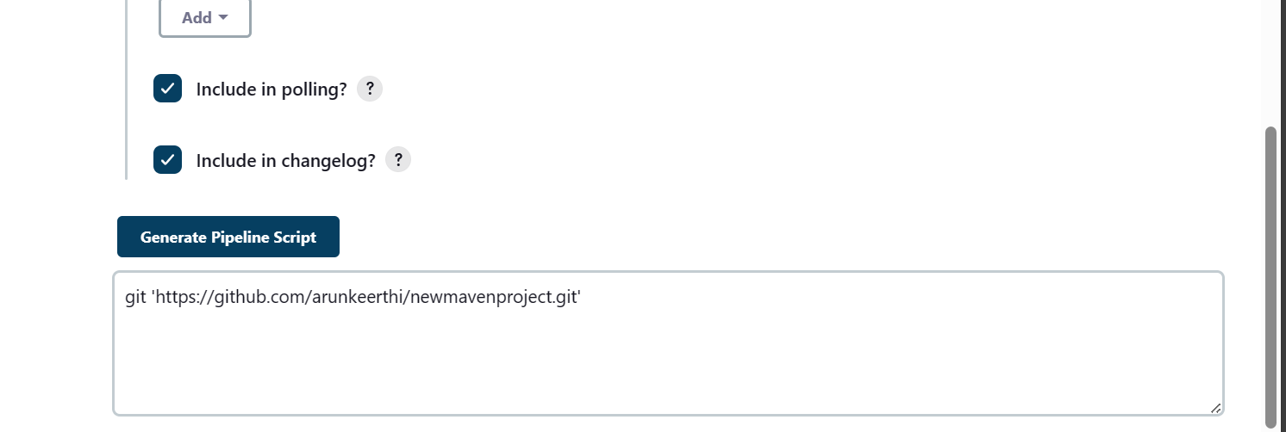



**Step 26:** paste to stage script pipeline & click save button for save the stage changes:

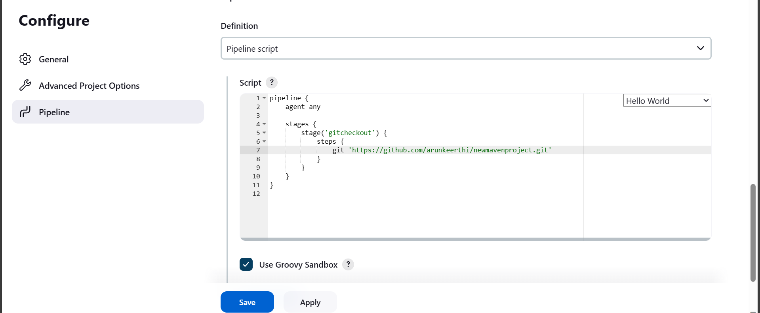



**Step 27:** click build now button & check the output on the screen;

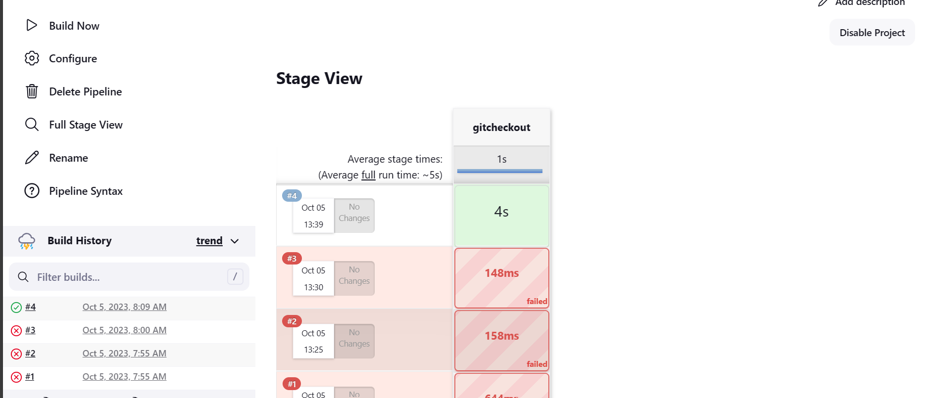



**Step 28:** check the output in console output page:

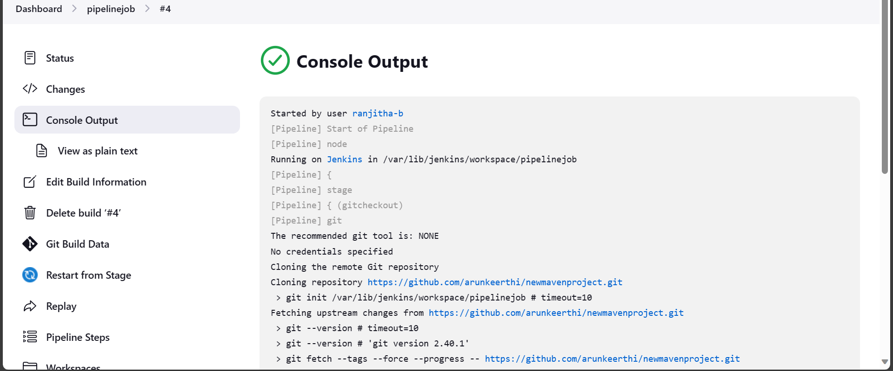

**Step 29:** when you see the folder of the repository in Jenkins copy that URL and paste to putty

And the files and folder are listed below:

