**Hystrix Example for real impatient**

Hystrix configuration is done in four major steps.

1. Add Hystrix starter and dashboard dependencies.

|  |
| --- |
| <dependency>      <groupId>org.springframework.cloud</groupId>      <artifactId>spring-cloud-starter-hystrix</artifactId>  </dependency>  <dependency>      <groupId>org.springframework.cloud</groupId>      <artifactId>spring-cloud-starter-hystrix-dashboard</artifactId>  </dependency> |

1. Add @EnableCircuitBreaker annotation
2. Add @EnableHystrixDashboard annotation
3. Add annotation @HystrixCommand(fallbackMethod = "myFallbackMethod")

Table of Contents

[What is Circuit Breaker Pattern?](https://howtodoinjava.com/spring-cloud/spring-hystrix-circuit-breaker-tutorial/#what-is-circuit-breaker)

[Hystrix Circuit Breaker Example](https://howtodoinjava.com/spring-cloud/spring-hystrix-circuit-breaker-tutorial/#hystrix-example)

[Create Student Microservice](https://howtodoinjava.com/spring-cloud/spring-hystrix-circuit-breaker-tutorial/#student-microservice)

[Create School Microservice - Hystrix Enabled](https://howtodoinjava.com/spring-cloud/spring-hystrix-circuit-breaker-tutorial/#school-microservice)

[Test Hystrix Circuit Breaker](https://howtodoinjava.com/spring-cloud/spring-hystrix-circuit-breaker-tutorial/#demo)

[Hystrix Dashboard](https://howtodoinjava.com/spring-cloud/spring-hystrix-circuit-breaker-tutorial/#hystrix-dashboard)

[Summary](https://howtodoinjava.com/spring-cloud/spring-hystrix-circuit-breaker-tutorial/#summary)

**Whay is Circuit Breaker Pattern?**

If we design our systems on microservice based architecture, we will generally develop many Microservices and those will interact with each other heavily in achieving certain business goals. Now, all of us can assume that this will give expected result if all the services are up and running and response time of each service is satisfactory.

Now what will happen if any service, of the current Eco system, has some issue and stopped servicing the requests. It will result in timeouts/exception and the whole Eco system will get unstable due to this single point of failure.

Here circuit breaker pattern comes handy and it redirects traffic to a fall back path once it sees any such scenario. Also it monitors the defective service closely and restore the traffic once the service came back to normalcy.

So circuit breaker is a kind of a wrapper of the method which is doing the service call and it monitors the service health and once it gets some issue, the circuit breaker trips and all further calls goto the circuit breaker fall back and finally restores automatically once the service came back !! That’s cool right?

[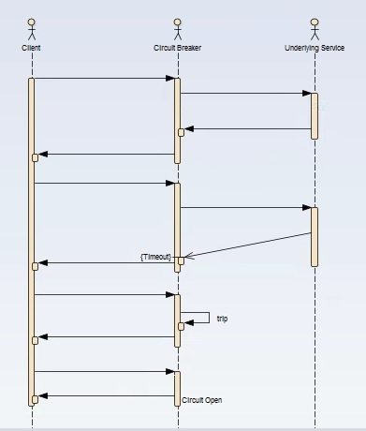](https://howtodoinjava.com/wp-content/uploads/2017/07/CB_Sequence.jpg)Circuit Breaker Sequence of Invocation

**Hystrix Circuit Breaker Example**

To demo circuit breaker, we will create following two microservices where first is dependent on another.

* **Student Microservice** – Which will give some basic functionality on Student entity. It will be a REST based service. We will call this service from School Service to understand Circuit Breaker. It will run on port 8098 in localhost.
* **School Microservice** – Again a simple REST based microservice where we will implement circuit breaker using Hystrix. Student Service will be invoked from here and we will test the fall back path once student service will be unavailable. It will run on port 9098 in localhost.

**Tech Stack and Demo Runtime**

* Java 1.8
* Eclipse as IDE
* Maven as build tool
* Spring cloud Hystrix as circuit breaker framework
* Spring boot
* Spring Rest

**Create Student Service**

Follow these steps to create and run Student Service – a simple REST service providing some basic functionality of Student entity.

**Create spring boot project**

Create a Spring boot project from [Spring Boot initializer portal](https://start.spring.io/) with three dependencies i.e. Web, Rest Repositories and Actuator. Give other maven GAV coordinates and download the project.

[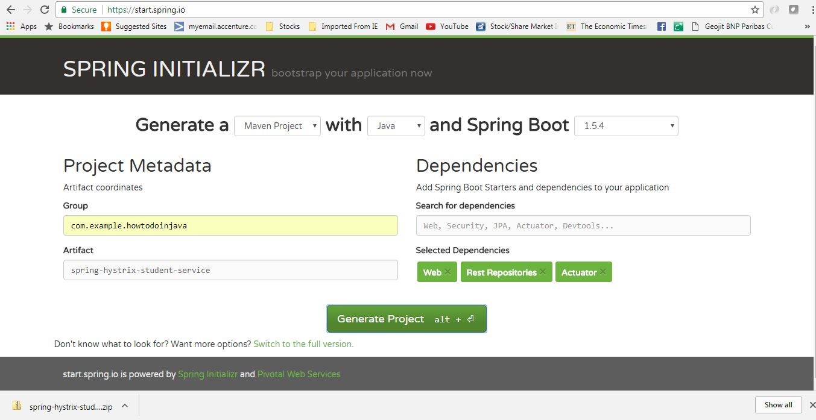](https://howtodoinjava.com/wp-content/uploads/2017/07/studentservciegeneration.jpg)Student Service Generation

Unzip and import the project into Eclipse as existing maven project. In this step, all necessary dependencies will be downloaded from maven repository.

**Server Port Settings**

Open application.properties and add port information.

|  |
| --- |
| server.port = 8098 |

This will enable this application run on default port 8098. We can easily override this by supplying -Dserver.port = XXXX argument at the time of starting the server.

**Create REST APIs**

Now add one REST controller class called StudentServiceController and expose one rest endpoint for getting all the student details for a particular school. Here we are exposing /getStudentDetailsForSchool/{schoolname} endpoint to serve the business purpose. For simplicity, we are hard coding the student details.

**StudentServiceController.java**

|  |
| --- |
| package com.example.howtodoinjava.springhystrixstudentservice.controller;    import java.util.ArrayList;  import java.util.HashMap;  import java.util.List;  import java.util.Map;  import org.springframework.web.bind.annotation.PathVariable;  import org.springframework.web.bind.annotation.RequestMapping;  import org.springframework.web.bind.annotation.RequestMethod;  import org.springframework.web.bind.annotation.RestController;  import com.example.howtodoinjava.springhystrixstudentservice.domain.Student;    @RestController  public class StudentServiceController {        private static Map<String, List<Student>> schooDB = new HashMap<String, List<Student>>();        static {          schooDB = new HashMap<String, List<Student>>();            List<Student> lst = new ArrayList<Student>();          Student std = new Student("Sajal", "Class IV");          lst.add(std);          std = new Student("Lokesh", "Class V");          lst.add(std);            schooDB.put("abcschool", lst);            lst = new ArrayList<Student>();          std = new Student("Kajal", "Class III");          lst.add(std);          std = new Student("Sukesh", "Class VI");          lst.add(std);            schooDB.put("xyzschool", lst);        }        @RequestMapping(value = "/getStudentDetailsForSchool/{schoolname}", method = RequestMethod.GET)      public List<Student> getStudents(@PathVariable String schoolname) {          System.out.println("Getting Student details for " + schoolname);            List<Student> studentList = schooDB.get(schoolname);          if (studentList == null) {              studentList = new ArrayList<Student>();              Student std = new Student("Not Found", "N/A");              studentList.add(std);          }          return studentList;      }  } |

**Student.java**

|  |
| --- |
| package com.example.howtodoinjava.springhystrixstudentservice.domain;    public class Student {        private String name;      private String className;        public Student(String name, String className) {          super();          this.name = name;          this.className = className;      }        public String getName() {          return name;      }        public void setName(String name) {          this.name = name;      }        public String getClassName() {          return className;      }        public void setClassName(String className) {          this.className = className;      }  } |

**Build and Test Student Service**

Now do a final build using mvn clean install and run the server using command java -jar target\spring-hystrix-student-service-0.0.1-SNAPSHOT.jar. This will start the student service in default port 8098.

Open browser and type http://localhost:8098/getStudentDetailsForSchool/abcschool.

It should show the below output in browser –

[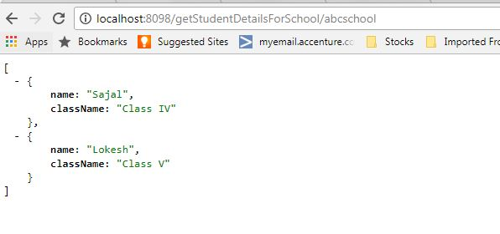](https://howtodoinjava.com/wp-content/uploads/2017/07/studentserviceresponse.jpg)Student Service Response

**Create School Service – Hystrix Enabled**

Similar to Student service, create another microservice for School. It will internally invoke already developed Student Service.

**Generate spring boot project**

Create a Spring boot project from [Spring Boot initializer portal](https://start.spring.io/) with those dependencies mainly.

* **Web** – REST Endpoints
* **Actuator** – providing basic management URL
* **Hystrix** – Enable Circuit Breaker
* **Hystrix Dashboard** – Enable one Dashboard screen related to the Circuit Breaker monitoring

Give other maven GAV coordinates and download the project.

[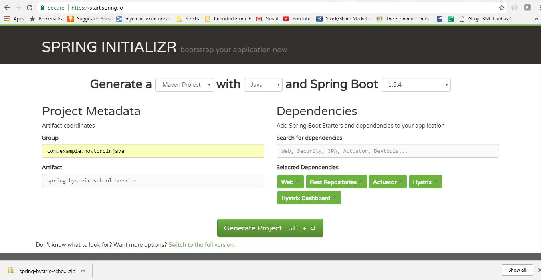](https://howtodoinjava.com/wp-content/uploads/2017/07/schoolservicegeneration.jpg)School Service Project

Unzip and import the project into Eclipse as *existing maven project*. In this step, all necessary dependencies will be downloaded from maven repository.

**Server Port Settings**

Open application.properties and add port information.

|  |
| --- |
| server.port = 9098 |

This will enable this application run on default port 9098. We can easily override this by supplying -Dserver.port = XXXX argument at the time of starting the server.

**Enable Hystrix Settings**

Open SpringHystrixSchoolServiceApplication i.e the generated class with @SpringBootApplication and add @EnableHystrixDashboard and @EnableCircuitBreaker annotations.

This will **enable Hystrix circuit breaker** in the application and also will add one useful dashboard running on localhost provided by Hystrix.

|  |
| --- |
| package com.example.howtodoinjava.springhystrixschoolservice;    import org.springframework.boot.SpringApplication;  import org.springframework.boot.autoconfigure.SpringBootApplication;  import org.springframework.cloud.client.circuitbreaker.EnableCircuitBreaker;  import org.springframework.cloud.netflix.hystrix.dashboard.EnableHystrixDashboard;    @SpringBootApplication  @EnableHystrixDashboard  @EnableCircuitBreaker  public class SpringHystrixSchoolServiceApplication {        public static void main(String[] args) {          SpringApplication.run(SpringHystrixSchoolServiceApplication.class, args);      }  } |

**Add REST controller**

Add SchoolServiceController Rest Controller where we will expose /getSchoolDetails/{schoolname} endpoint which will simply return school details along with its student details. For Student Details it will call the already developed Student service endpoint. We will create a Delegate layer StudentServiceDelegate.java to call the Student Service. This simple Code will look like

**SchoolServiceController.java**

|  |
| --- |
| package com.example.howtodoinjava.springhystrixschoolservice.controller;    import org.springframework.beans.factory.annotation.Autowired;  import org.springframework.web.bind.annotation.PathVariable;  import org.springframework.web.bind.annotation.RequestMapping;  import org.springframework.web.bind.annotation.RequestMethod;  import org.springframework.web.bind.annotation.RestController;  import com.example.howtodoinjava.springhystrixschoolservice.delegate.StudentServiceDelegate;    @RestController  public class SchoolServiceController {        @Autowired      StudentServiceDelegate studentServiceDelegate;        @RequestMapping(value = "/getSchoolDetails/{schoolname}", method = RequestMethod.GET)      public String getStudents(@PathVariable String schoolname) {          System.out.println("Going to call student service to get data!");          return studentServiceDelegate.callStudentServiceAndGetData(schoolname);      }  } |

**StudentServiceDelegate**

We will do the following things here to enable Hystrix circuit breaker.

* Invoke Student Service through spring framework provided RestTemplate
* Add Hystrix Command to enable fallback method – @HystrixCommand(fallbackMethod = "callStudentServiceAndGetData_Fallback") – this means that we will have to add another method callStudentServiceAndGetData_Fallback with same signature, which will be invoked when actual Student service will be down.
* Add fallback method – callStudentServiceAndGetData_Fallback which will simply return some default value.

|  |
| --- |
| package com.example.howtodoinjava.springhystrixschoolservice.delegate;    import java.util.Date;  import org.springframework.beans.factory.annotation.Autowired;  import org.springframework.context.annotation.Bean;  import org.springframework.core.ParameterizedTypeReference;  import org.springframework.http.HttpMethod;  import org.springframework.stereotype.Service;  import org.springframework.web.client.RestTemplate;  import com.netflix.hystrix.contrib.javanica.annotation.HystrixCommand;    @Service  public class StudentServiceDelegate {        @Autowired      RestTemplate restTemplate;        @HystrixCommand(fallbackMethod = "callStudentServiceAndGetData_Fallback")      public String callStudentServiceAndGetData(String schoolname) {            System.out.println("Getting School details for " + schoolname);            String response = restTemplate                  .exchange("<http://localhost:8098/getStudentDetailsForSchool/>{schoolname}"                  , HttpMethod.GET                  , null                  , new ParameterizedTypeReference<String>() {              }, schoolname).getBody();            System.out.println("Response Received as " + response + " -  " + new Date());            return "NORMAL FLOW !!! - School Name -  " + schoolname + " :::  " +                      " Student Details " + response + " -  " + new Date();      }        @SuppressWarnings("unused")      private String callStudentServiceAndGetData_Fallback(String schoolname) {            System.out.println("Student Service is down!!! fallback route enabled...");            return "CIRCUIT BREAKER ENABLED!!! No Response From Student Service at this moment. " +                      " Service will be back shortly - " + new Date();      }        @Bean      public RestTemplate restTemplate() {          return new RestTemplate();      }  } |

**Build and Test of School Service**

Now do a final build using mvn clean install and run the server using command java -jar target\spring-hystrix-school-service-0.0.1-SNAPSHOT.jar. This will start the school service in default port **9098**.

Start the student service as described above and then test school service by opening browser and type http://localhost:9098/getSchoolDetails/abcschool. It should show the below output in browser :

[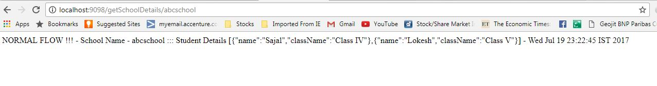](https://howtodoinjava.com/wp-content/uploads/2017/07/schoolserviceresponse.jpg)School Service Response

**Test Hystrix Circuit Breaker – Demo**

Opening browser and type http://localhost:9098/getSchoolDetails/abcschool.

It should show the below output in browser –

[](https://howtodoinjava.com/wp-content/uploads/2017/07/schoolserviceresponse.jpg)School Service Response

Now we already know that School service is calling student service internally, and it is getting student details from that service. So if both the services are running, school service is displaying the data returned by student service as we have seen in the school service browser output above. This is **CIRCUIT CLOSED State**.

Now let us *stop the student service* by just pressing CTRL + C in the student service server console (stop the server) and test the school service again from browser. This time it will return the fall back method response. Here Hystrix comes into picture, it monitors Student service in frequent interval and as it is down, Hystrix component has opened the Circuit and fallback path enabled.

Here is the fall back output in the browser.

[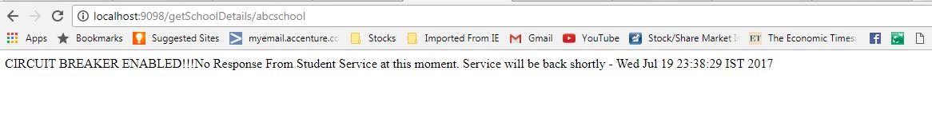](https://howtodoinjava.com/wp-content/uploads/2017/07/schoolserviceresponse_fallback.jpg)School Service Response Fallback path

Again start the Student service, wait for few moments and go back to school service and it will again start responding in normal flow.

**Hystrix Dashboard**

As we have added hystrix dashboard dependency, hystrix has provided one nice Dashboard and a Hystrix Stream in the bellow URLS:

* [**http://localhost:9098/hystrix.stream**](http://localhost:9098/hystrix.stream) – It’s a continuous stream that Hystrix generates. It is just a health check result along with all the service calls that are being monitored by Hystrix. Sample output will look like in browser –

[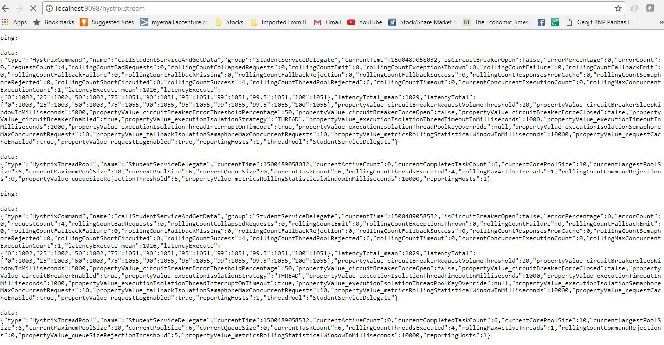](https://howtodoinjava.com/wp-content/uploads/2017/07/HystrixStream.jpg)Hystrix Stream output

* [**http://localhost:9098/hystrix**](http://localhost:9098/hystrix) – This is visual dashboard initial state.

[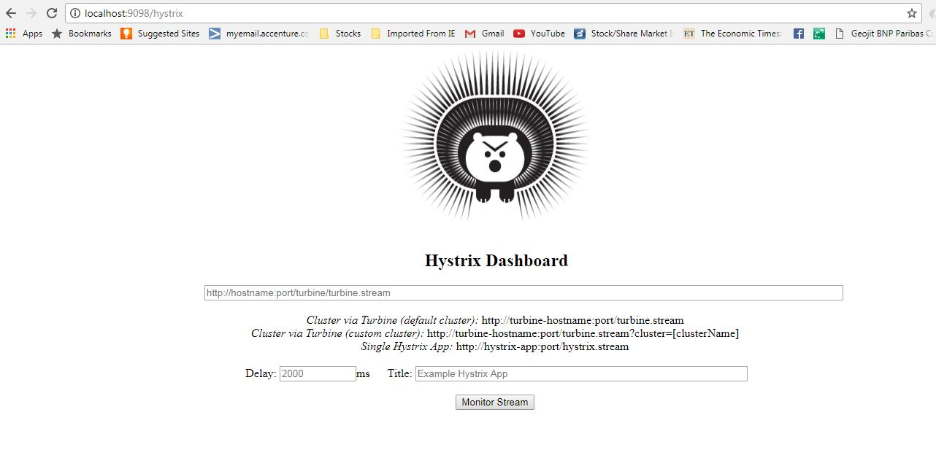](https://howtodoinjava.com/wp-content/uploads/2017/07/Hystrix_initial.jpg)Hystrix Initial Dashboard

* Now add <http://localhost:9098/hystrix.stream> in dashboard to get a meaningful dynamic visual representation of the circuit being monitored by the Hystrix component. Visual Dashboard after providing the Stream input in the home page –

[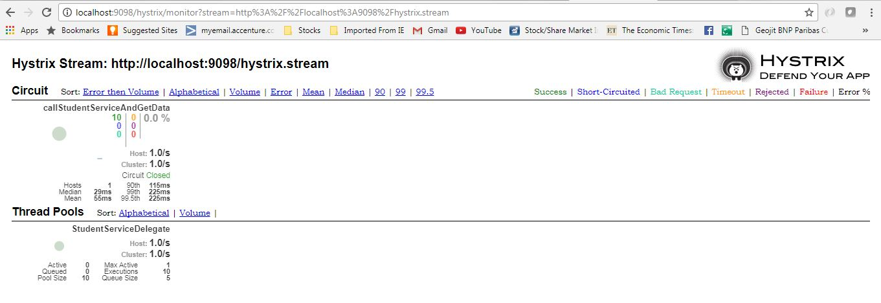](https://howtodoinjava.com/wp-content/uploads/2017/07/HystrixDashboard.jpg)

<https://howtodoinjava.com/spring-cloud/spring-hystrix-circuit-breaker-tutorial/>