Here we are creating REST SERVICES for Cone.

If we take r=1 and h=1 as default, then this is the result screen shot:

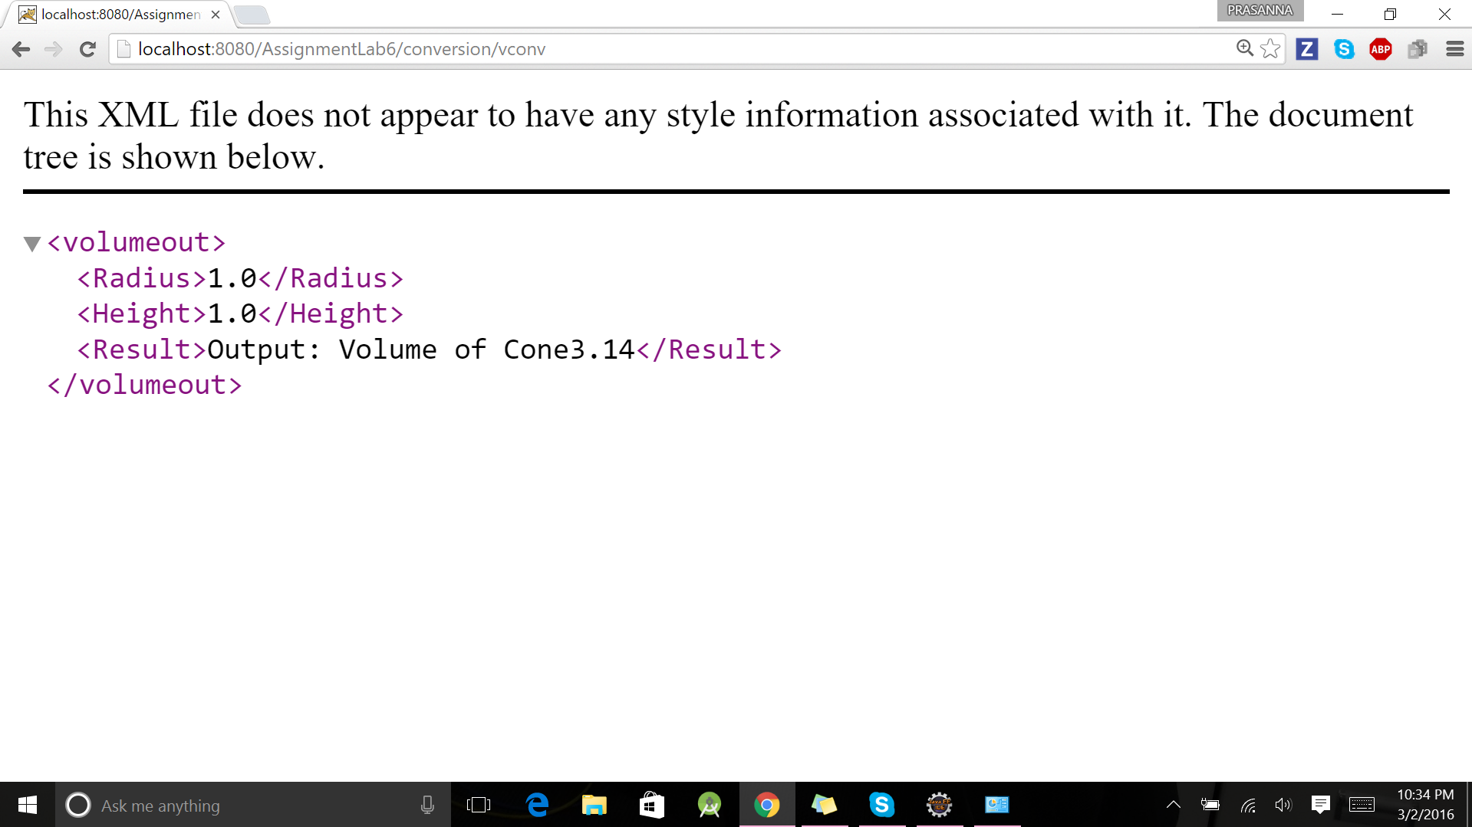

If r=3 and h=4 then the result is :

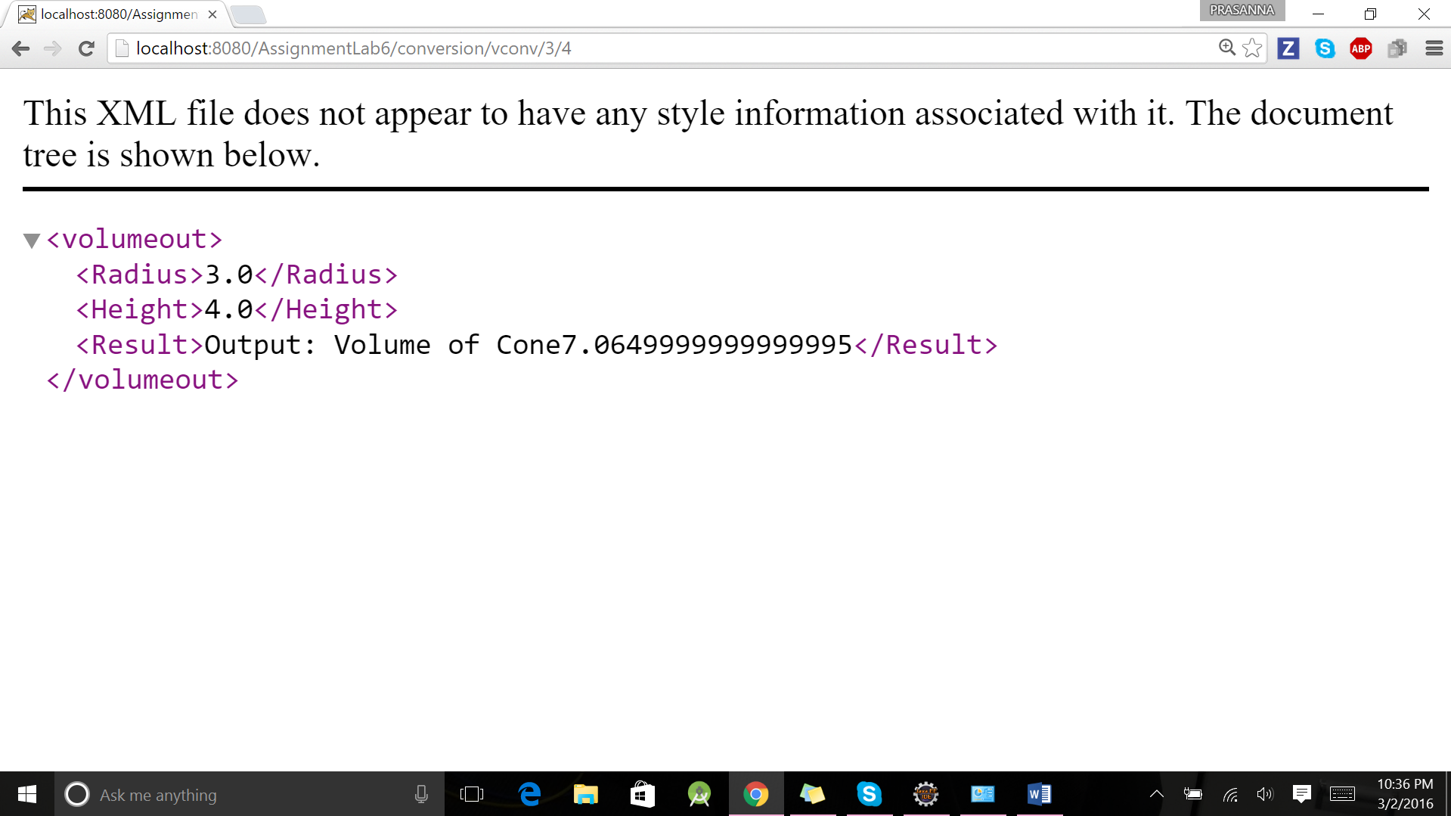

If we consider surface area , and by default r=1 and h=1:Then the result can be seen as below:

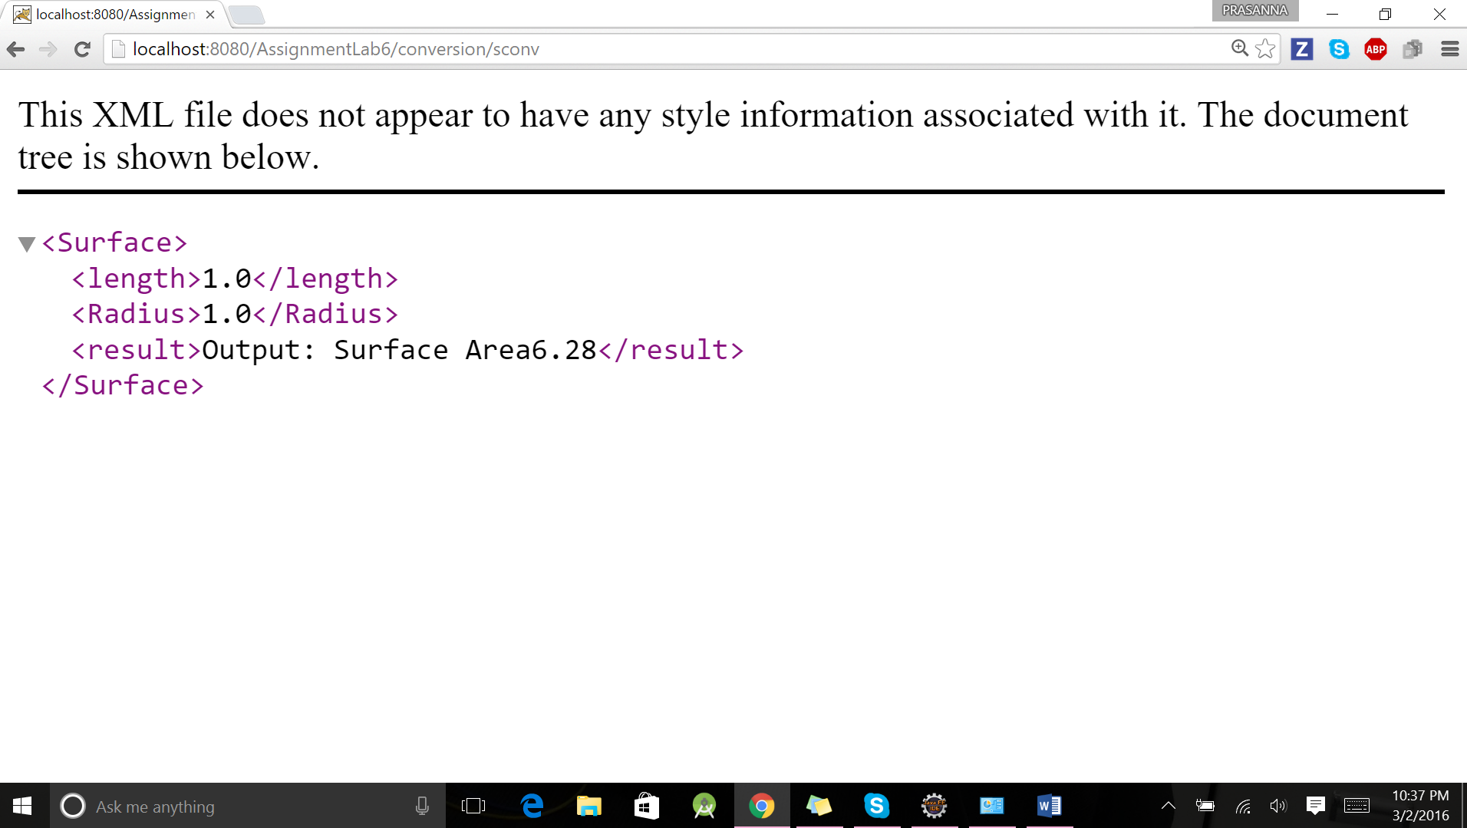

If in the above case r=3 and h=4.The result will be here :

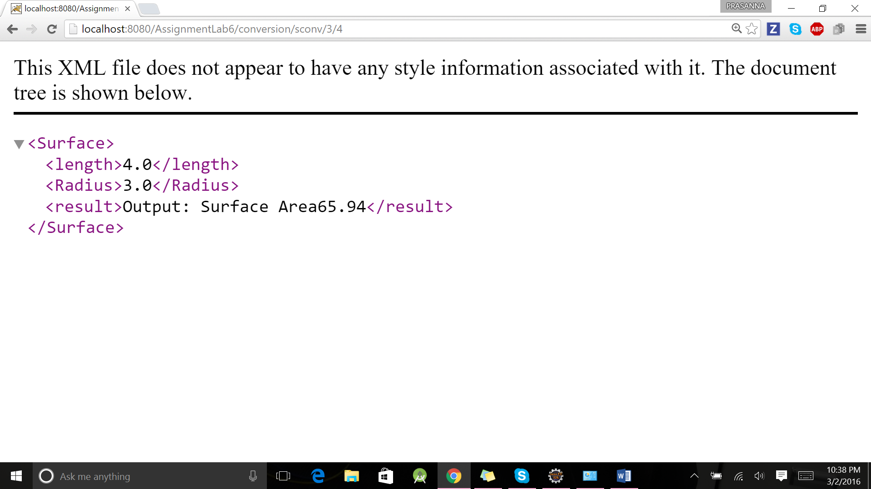

This is the success test case for surface area of the cone:

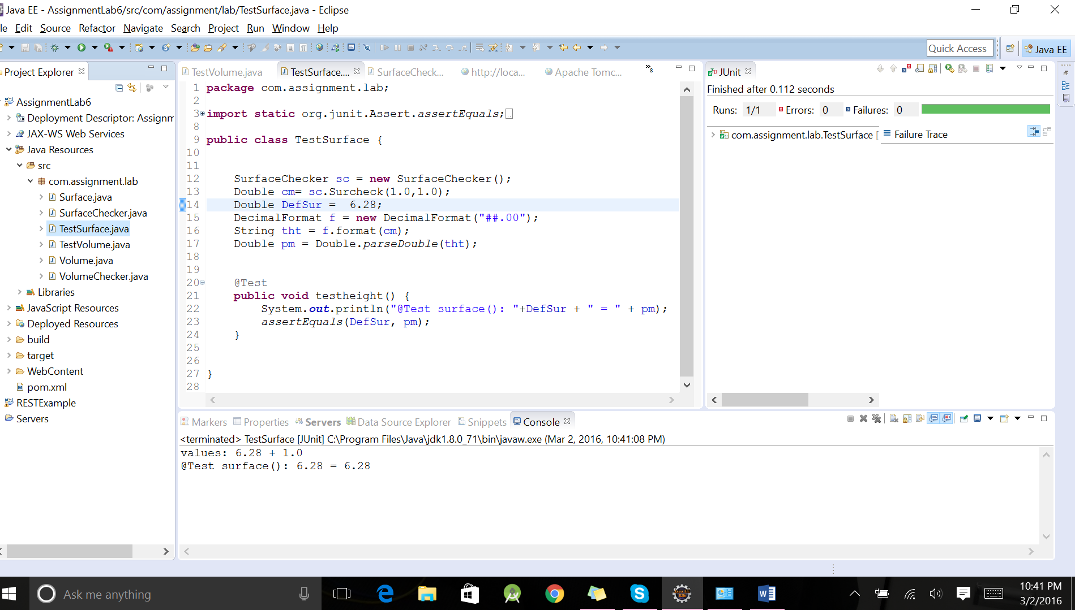

This is the failure test case for surface area of the case.

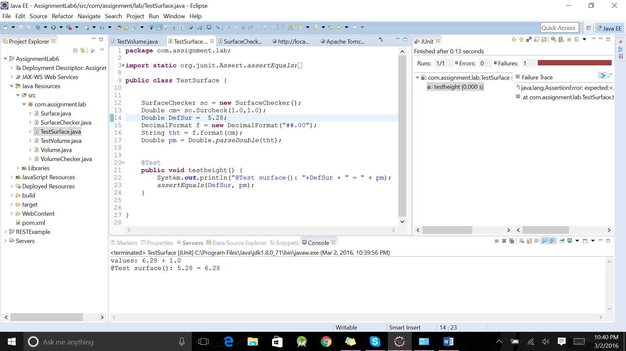

This is the success test case for volume of the cone:

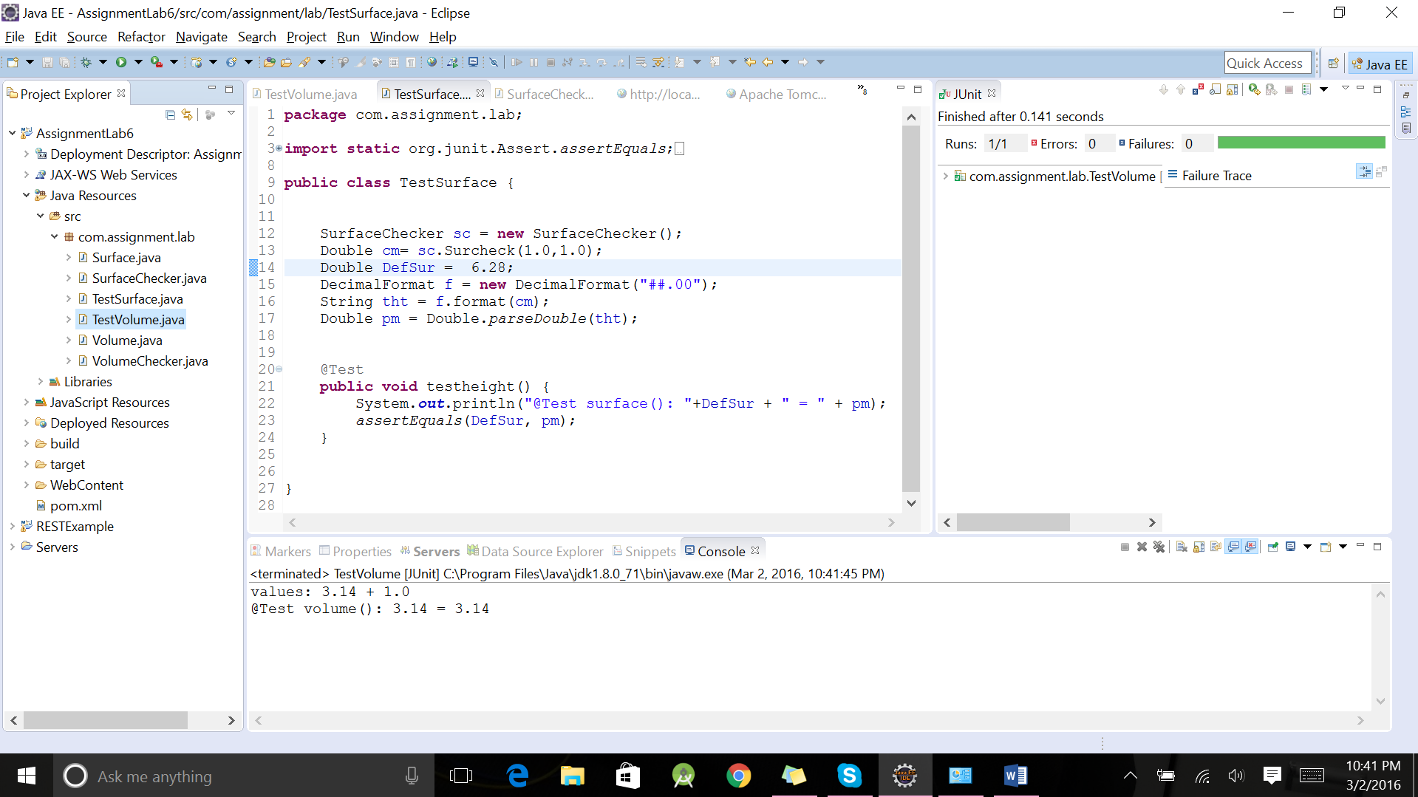

This is the failure test for the volume of the cone:

