IT STAFFING INVOICE
MANAGEMENT SYSTEM
Solution Architecture & Business Workflow
Technical handoff document

1. Purpose and scope
This document describes the proposed architecture and operational workflow for an IT staffing invoice management application. The system supports the staffing company’s billing lifecycle: maintaining clients and consultant assignments, capturing approved billable time, calculating invoices from contractual rates, producing invoice PDFs, and tracking payments.
The solution is designed as a layered application with an Angular 14 user interface, ASP.NET Core 8 Web API, Entity Framework Core, and SQL Server.

2. Technology stack
Layer | Technology / responsibility
Frontend | Angular 14, TypeScript, HTML/SCSS
API | C# / ASP.NET Core 8 Web API
Persistence | Entity Framework Core 8
Database | Microsoft SQL Server
API documentation | Swagger / OpenAPI
PDF output | QuestPDF
Logging | Serilog structured logging
Validation and errors | Request validation, business-rule checks, global exception middleware
Testing | xUnit unit tests; integration tests recommended for next phase

3. High-level solution architecture
The browser communicates with the API over HTTPS using REST/JSON. The API routes requests through cross-cutting middleware and application services. Services enforce billing rules and use EF Core to persist data in SQL Server. PDF generation uses saved invoice data and line-item snapshots.
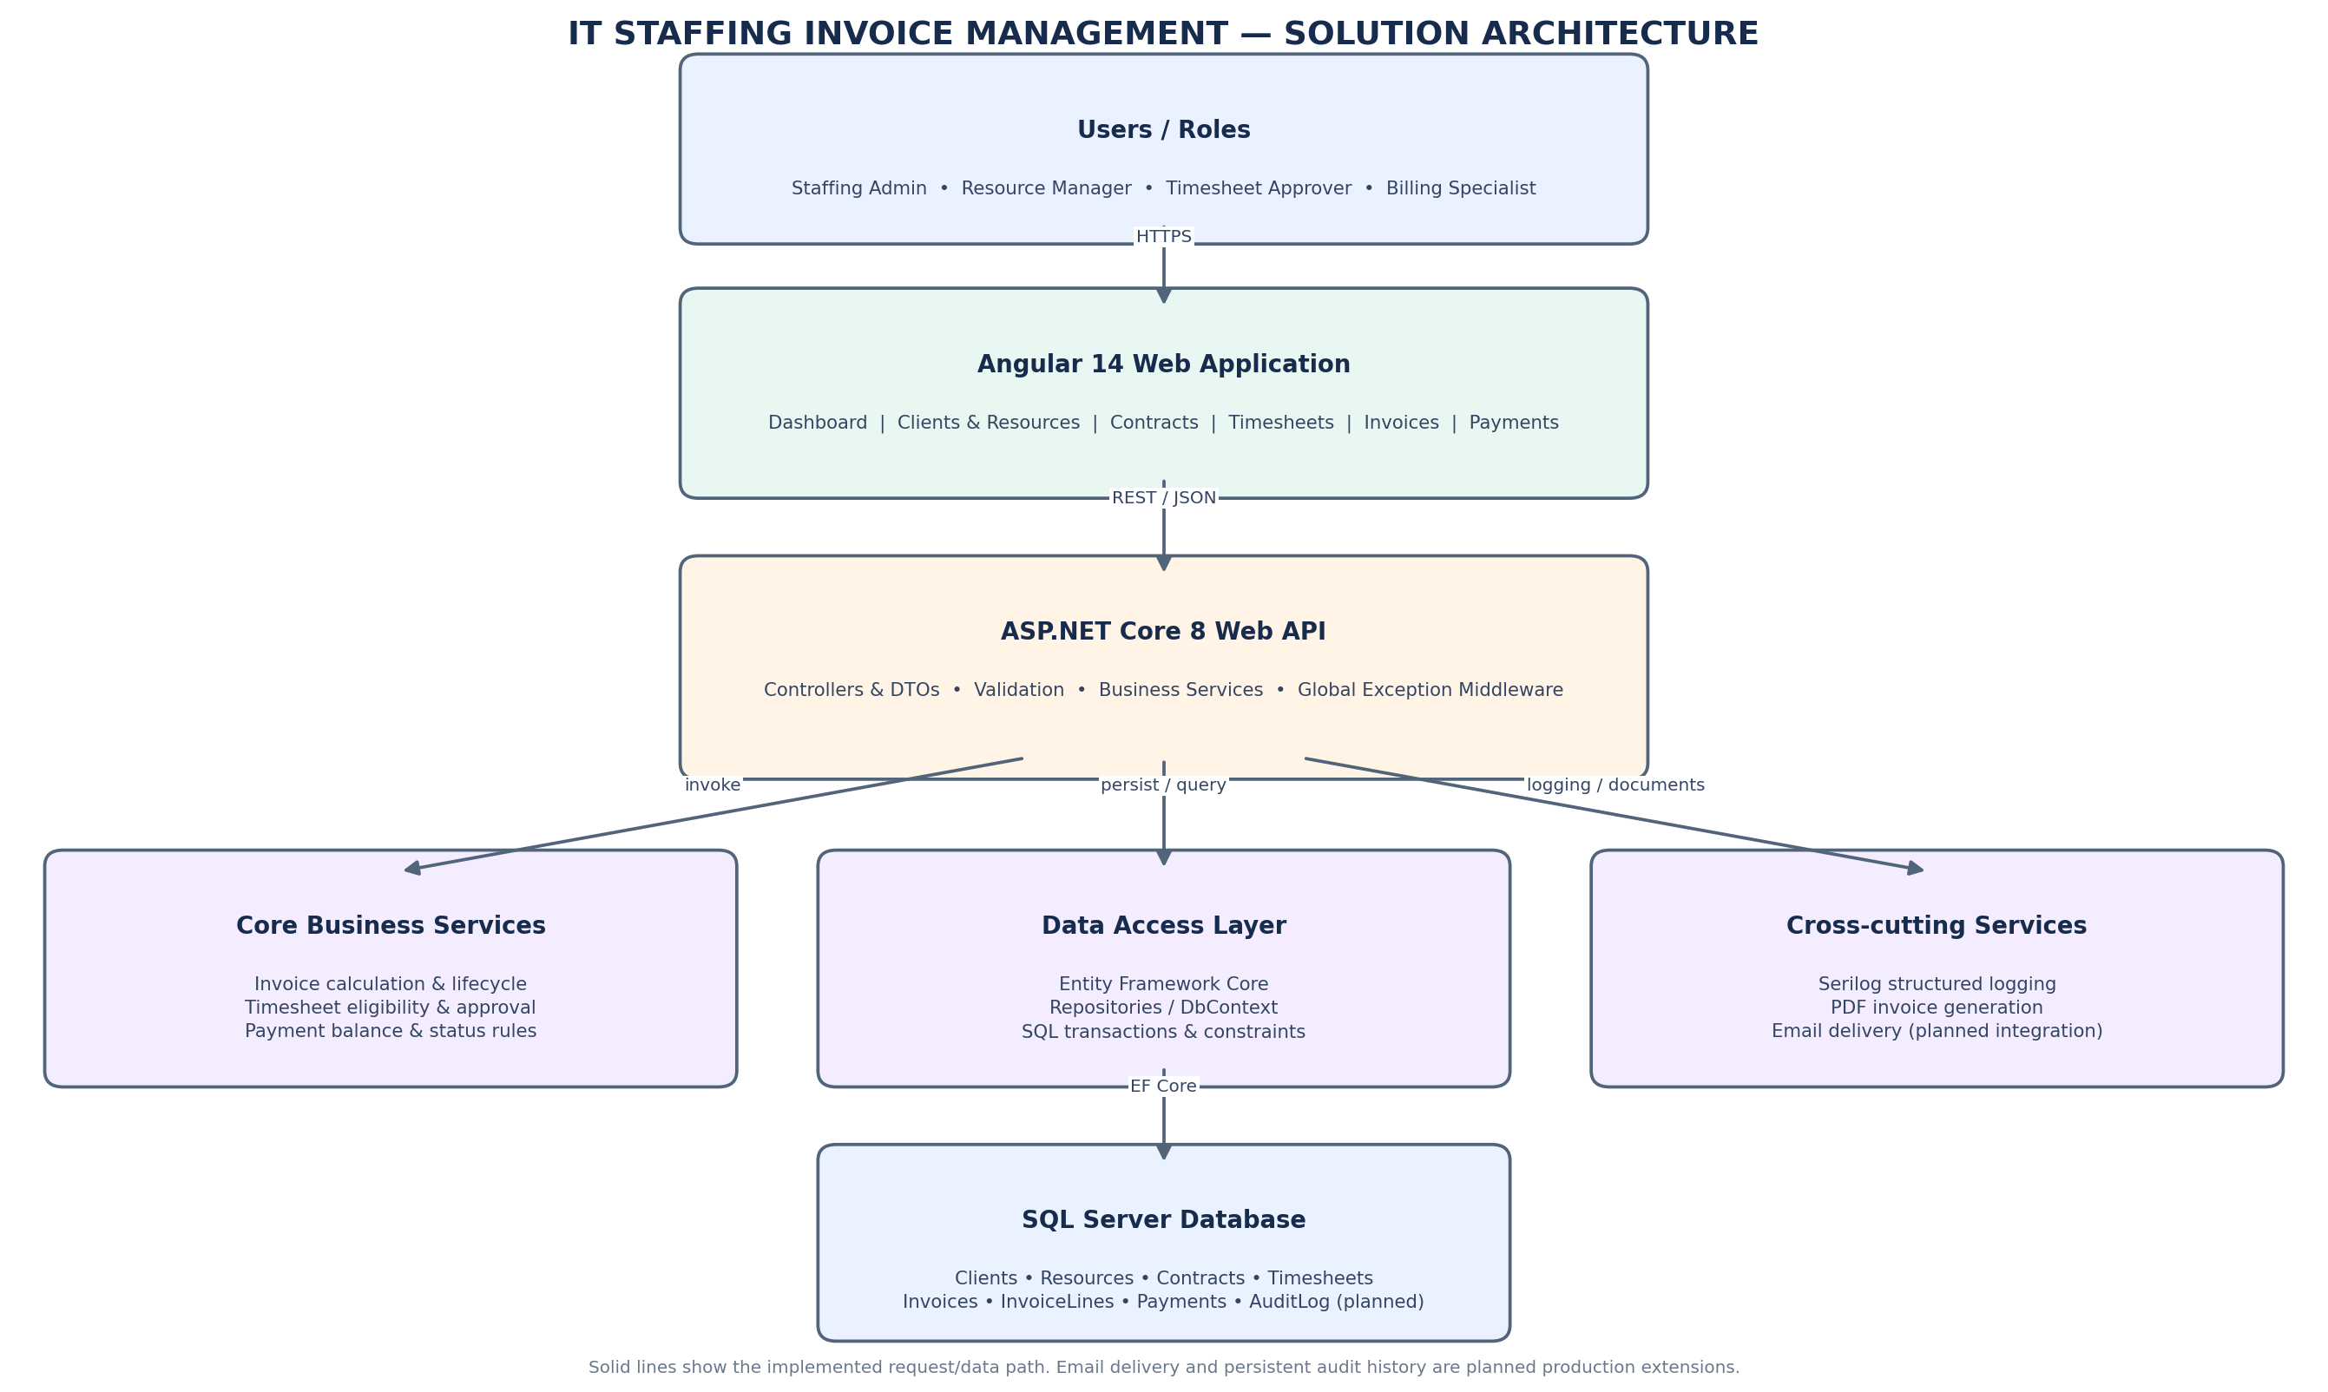
Note: Email delivery and persistent audit history are identified as production extensions; they are not represented as completed capabilities in the current starter.

4. Component responsibilities

Angular 14 UI
Provides dashboard metrics, client and resource views, invoice generation, invoice listing, approval actions, and PDF download. Client-side validation improves usability; the API remains the authority for business rules.

ASP.NET Core API
Exposes versionable HTTP endpoints, validates request shape, invokes business services, and returns consistent status codes and response contracts.

Application services
Encapsulate invoice calculation, timesheet eligibility, invoice state transitions, and payment rules. Business logic is kept out of controllers.

EF Core / SQL Server
Persists client, resource, contract, timesheet, invoice, invoice-line, and payment records. Explicit decimal precision is configured for financial and hours fields.

PDF service
Creates a downloadable PDF from persisted invoice details. Invoice lines preserve the resource, hours, rate, and amount used at invoice time.

Cross-cutting concerns
Structured logging and global exception handling provide operational visibility and consistent API errors. Authentication, authorization, durable audit events, and retry policies are production hardening items.

5. End-to-end invoice workflow
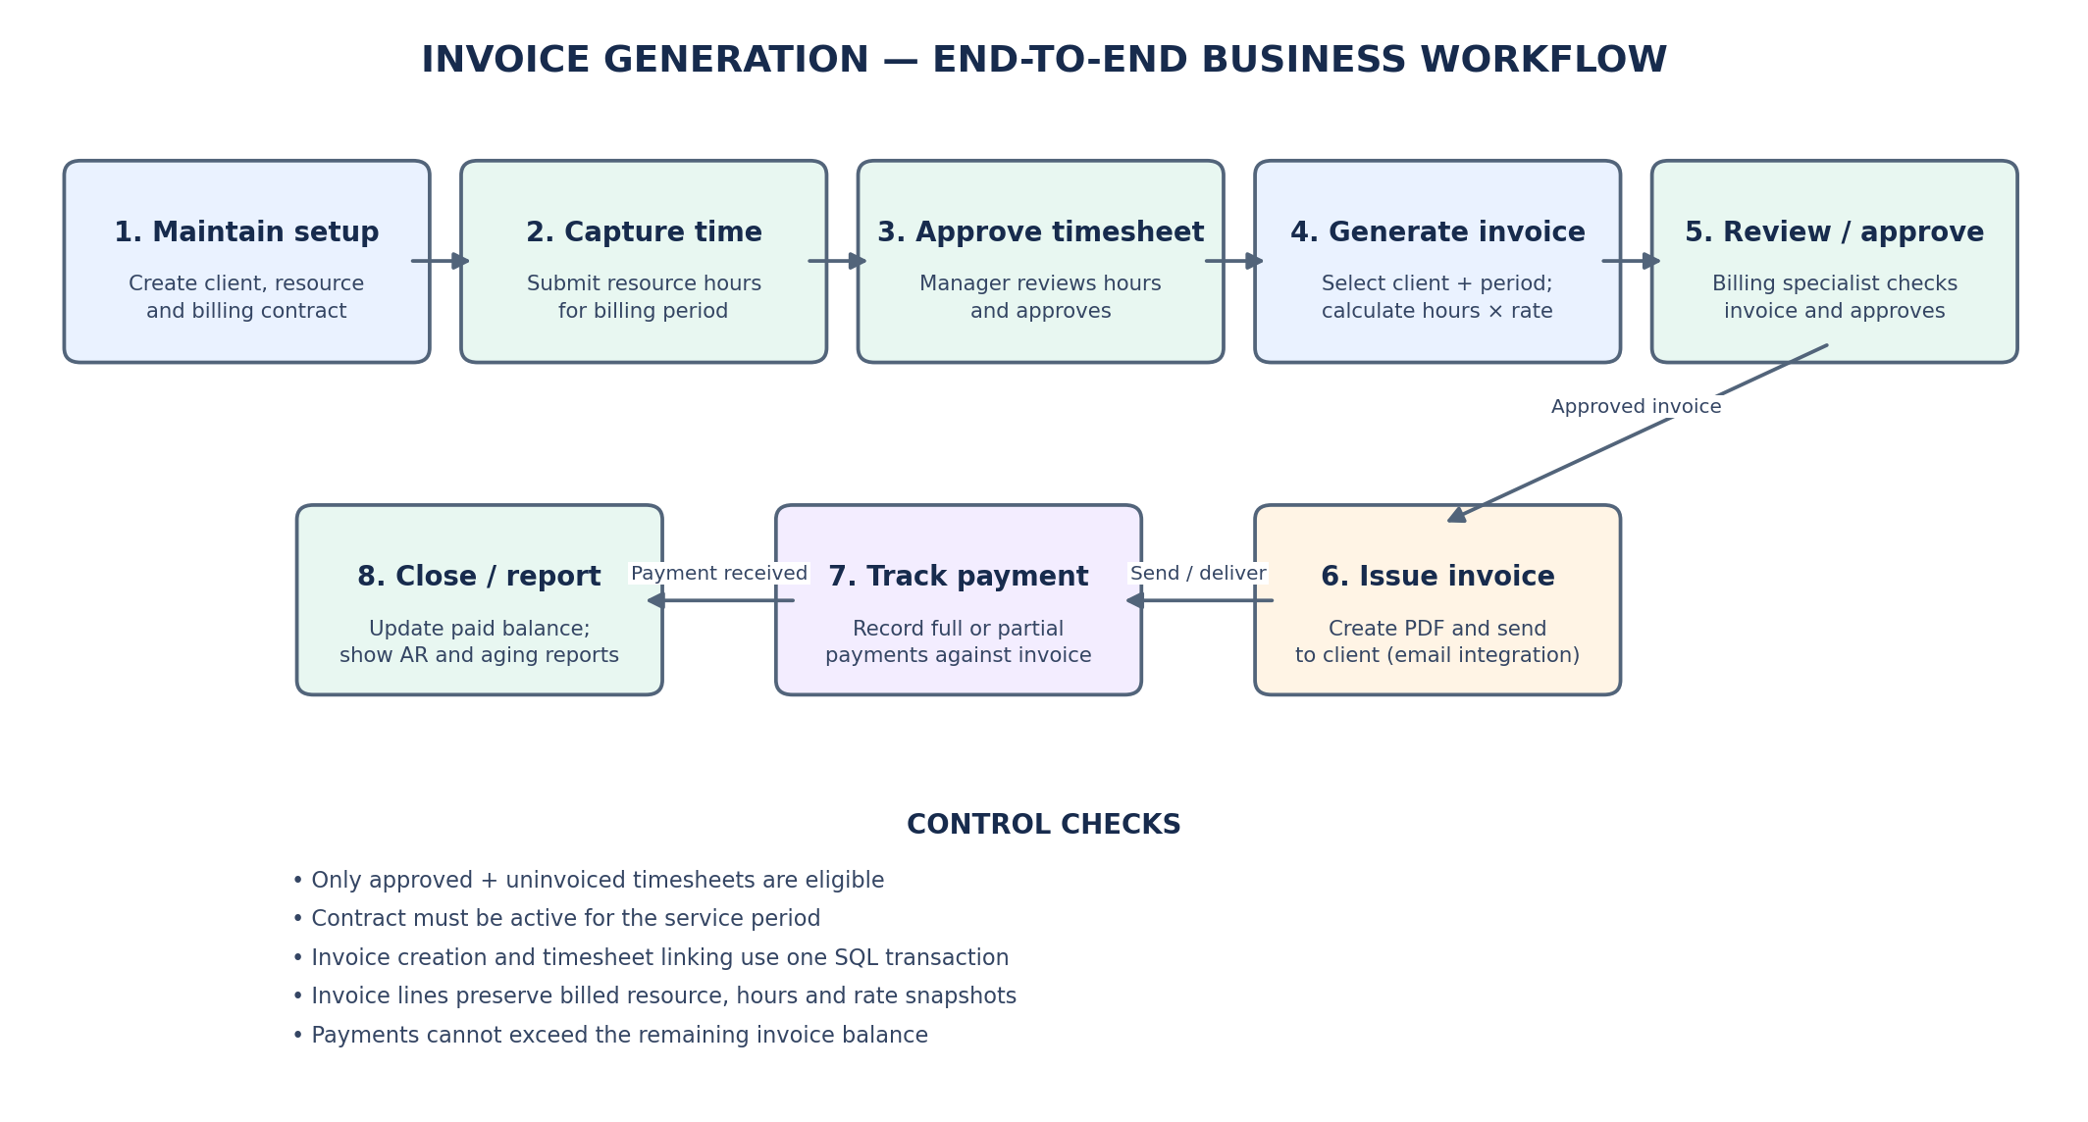
Operational sequence:
- Create the client, including billing email, billing address, and payment terms.
- Create the consultant/resource and associate the resource with the client.
- Create a contract with hourly rate, currency, and effective dates.
- Enter the resource timesheet for the applicable billing period.
- Have an authorized manager review and approve the timesheet.
- Billing specialist selects the client and service period to generate an invoice.
- The API selects only approved, uninvoiced timesheets for that client and period.
- The API verifies that a valid contract rate covers each service period.
- The service calculates line amounts, subtotal, tax, and invoice total using decimal arithmetic.
- The invoice and its lines are saved, and selected timesheets are linked to the invoice in a SQL transaction.
- Billing specialist reviews and approves the draft invoice, then downloads the PDF.
- After invoice delivery, record full or partial payments and update the outstanding balance.

6. Core data model
Entity | Purpose | Important relationships
Client | Customer billing profile | One client has many resources and invoices
Resource | Consultant supplied to a client | Belongs to a client; has contracts and timesheets
Contract | Effective-dated commercial terms | Belongs to a resource; defines rate and currency
Timesheet | Submitted and approved service hours | Belongs to a resource; may be linked to one invoice
Invoice | Invoice header and financial totals | Belongs to a client; has invoice lines and payments
InvoiceLine | Historical billed line snapshot | Belongs to invoice; references source timesheet
Payment | Full or partial remittance | Belongs to invoice
AuditLog | Who changed what and when | Recommended production addition

7. API surface (starter implementation)
Endpoint | Purpose
GET /api/clients | List clients
POST /api/clients | Create client
GET /api/resources | List resources
POST /api/resources | Create resource
POST /api/contracts | Create contract
GET /api/timesheets | List timesheets
POST /api/timesheets | Create timesheet
POST /api/timesheets/{id}/approve | Approve timesheet
GET /api/invoices | List invoices
POST /api/invoices | Generate invoice from approved timesheets
GET /api/invoices/{id} | Get invoice detail
POST /api/invoices/{id}/approve | Approve draft invoice
GET /api/invoices/{id}/pdf | Download invoice PDF
POST /api/invoices/{id}/payments | Record payment

8. Key business controls
- Do not invoice pending, rejected, or previously invoiced timesheets.
- Validate client/resource association and contract effective dates before calculating charges.
- Use decimal data types and explicit precision for currency and hours; never use float/double for monetary calculations.
- Create invoice and mark source timesheets invoiced atomically in one database transaction.
- Preserve invoice line snapshots so later contract/resource edits do not rewrite historical billing.
- Reject non-positive payments and payments greater than the current outstanding balance.
- Keep a clear invoice state model and restrict state transitions to authorized roles.
- Use unique invoice numbers and add database-level concurrency/idempotency protection before concurrent production use.

9. Security, reliability, and production readiness
- Integrate Microsoft Entra ID or another OIDC identity provider; do not expose invoice mutation endpoints anonymously.
- Enforce role-based permissions for resource maintenance, timesheet approval, invoice approval, and payment entry.
- Add tenant/client data access boundaries where the business serves multiple legal entities or customers.
- Persist audit events for sensitive financial changes, including before/after values, actor, timestamp, and correlation ID.
- Add idempotency keys and concurrency tokens to prevent duplicate invoice creation or payment recording under retries.
- Configure secret storage, TLS, database backups, retention, monitoring, and alerting.
- Integrate email delivery with retry/backoff, delivery status, and a durable outbound message history.
- Add SQL Server integration tests, API authorization tests, PDF output tests, and CI build/test gates.

10. Assumptions and items requiring business confirmation
- Initial billing model is hourly time-and-materials; fixed-fee, milestone, and expense billing are out of initial scope.
- Overtime is included in submitted hours in the current starter calculation. Production policy should define separate overtime multipliers and approval rules.
- Tax is represented as a configurable invoice percentage in the starter. Real tax treatment must be determined by jurisdiction and company policy.
- Currency is initially USD; multi-currency conversion and exchange-rate sourcing require a defined accounting policy.
- Invoice email sending, reminders, credit notes, void/reissue workflow, and accounting-system integration are planned enhancements.

11. Suggested technical-team walkthrough
- Start with the architecture diagram and explain the separation between UI, API, business services, data access, and database.
- Walk through client/resource/contract setup and explain effective-dated billing rates.
- Create and approve a timesheet, then generate an invoice from approved unbilled time.
- Show the invoice line snapshot, totals, generated PDF, approval action, and payment balance.
- Explain transaction boundaries, decimal precision, validation, exception handling, structured logs, and the next production hardening steps.

Prepared as a technical handoff companion to the StaffingInvoiceManagement Visual Studio solution.

