TIMESHEET TRACKER

Solution Architecture & Workflow
Angular 14 | ASP.NET Core Web API | C# | Entity Framework Core | SQL Server

Purpose
This document describes the proposed full-stack architecture, major components, data flow, and employee-to-manager timesheet workflow. It is intended as an architecture handoff for the technical team.

1. High-level solution architecture
The solution uses a separate Angular 14 single-page application for presentation and an ASP.NET Core Web API for business operations. The backend owns authorization, validation, business rules, and persistence.
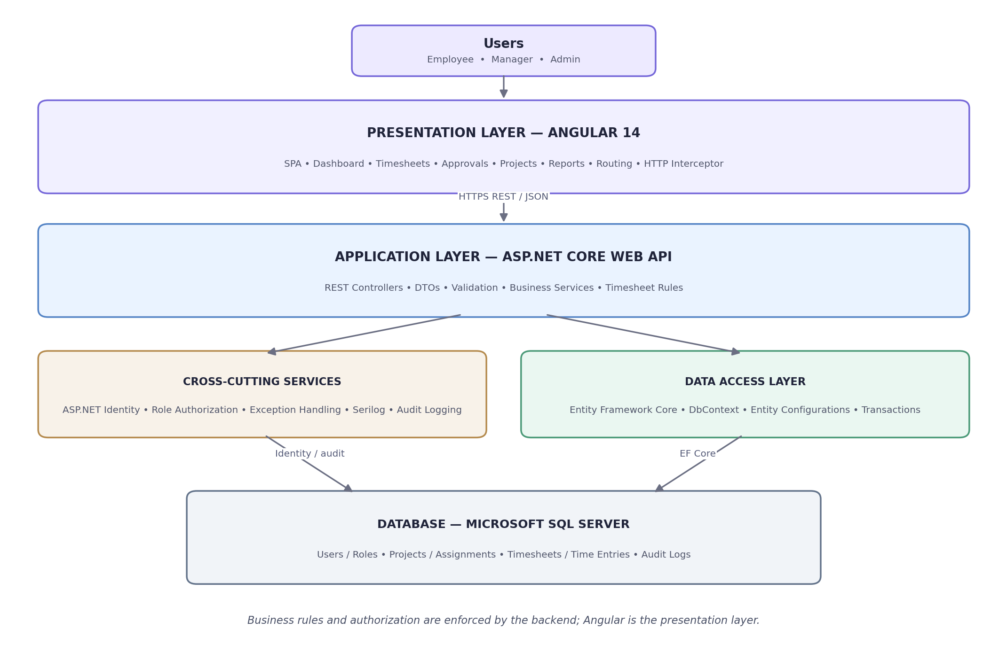
Request flow: Angular components call API services; the HTTP interceptor sends authentication cookies; API controllers validate requests and delegate to business services; Entity Framework Core persists data in SQL Server.

2. Technology stack
Layer | Technology / responsibility
Frontend | Angular 14.2, TypeScript 4.8, RxJS, Angular Router, Reactive Forms
Backend | C#, ASP.NET Core Web API, REST endpoints
Authentication | ASP.NET Core Identity with secure HttpOnly cookies
Data access | Entity Framework Core, DbContext, entity configurations
Database | Microsoft SQL Server
Cross-cutting | Role authorization, exception handling, Serilog, audit logging

3. End-to-end timesheet workflow
The employee creates a weekly timesheet, records daily time against assigned projects, and submits it. A manager reviews the submission and either approves it or rejects it with a comment. Rejected timesheets return to the employee for correction and resubmission.
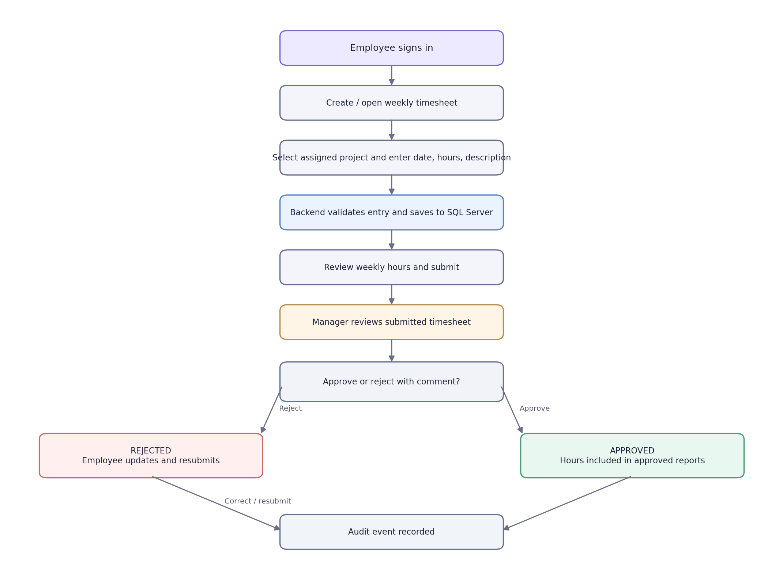

4. Timesheet status lifecycle
Draft — Employee can add or update entries. Only eligible draft or rejected timesheets are editable.
Submitted — Employee has submitted the timesheet; it is awaiting manager review.
Approved — Manager approved the timesheet. Approved hours become available to reporting.
Rejected — Manager returned the timesheet with a required comment. Employee corrects and resubmits.

5. Component responsibilities
Component | Responsibility
Angular components | Render screens and collect user input.
Angular services | Encapsulate API calls and map responses to frontend models.
HTTP interceptor | Send credentials with same-origin API requests.
API controllers | Expose REST endpoints and translate HTTP requests into service calls.
DTOs and validation | Define request/response contracts and validate incoming data.
Business services | Enforce timesheet rules and coordinate workflow transitions.
ASP.NET Core Identity | Authenticate users and manage roles.
Entity Framework Core | Query and persist application entities.
SQL Server | Persist users, roles, projects, assignments, timesheets, entries, and audit records.
Logging and exception handling | Capture diagnostics and return consistent API errors.

6. Core data entities and relationships
ApplicationUser 1-to-many Timesheet; Timesheet 1-to-many TimeEntry; Project 1-to-many TimeEntry; ApplicationUser and Project are linked through ProjectAssignment; ApplicationUser 1-to-many AuditLog.
Entity | Representative fields | Purpose
ApplicationUser | Id, FullName, Email, IsActive | User identity and profile
Project | Id, ProjectCode, Name, IsActive | Work allocation target
ProjectAssignment | Id, UserId, ProjectId | Projects an employee may charge time to
Timesheet | Id, EmployeeId, WeekStartDate, Status, RowVersion | One employee's weekly submission
TimeEntry | Id, TimesheetId, ProjectId, WorkDate, Hours, Description | Daily time record
AuditLog | Id, UserId, Action, CreatedDateTime | Traceability of key actions

7. API surface
Method | Endpoint | Purpose
POST | /api/auth/login | Authenticate and issue Identity cookie
GET | /api/auth/me | Return current authenticated user
POST | /api/auth/logout | Sign out
GET | /api/timesheets | List timesheets
POST | /api/timesheets | Create or retrieve weekly timesheet
GET | /api/timesheets/{id} | Get timesheet and entries
GET | /api/timesheets/projects | Get assigned projects
POST | /api/timesheets/{id}/entries | Add a time entry
POST | /api/timesheets/{id}/submit | Submit for approval
POST | /api/timesheets/{id}/review | Approve or reject

8. Security, validation and reliability
- Enforce role-based authorization on every protected backend endpoint; frontend route protection is supplementary only.
- Restrict employees to their own timesheets and managers to their explicitly assigned teams.
- Validate project assignment, active project status, date range, hours, description, and timesheet status on the server.
- Enforce one timesheet per employee per week with a database unique constraint.
- Use transactions for multi-step operations and audit records where atomicity is required.
- Use optimistic concurrency to prevent lost updates.
- Add antiforgery protection for cookie-authenticated state-changing API requests.
- Use HTTPS, secure HttpOnly cookies, centralized exception handling, structured logging, and audit trails.

9. Implementation phases
- Foundation: database model, Identity, roles, API conventions, logging.
- Employee experience: Angular shell, dashboard, weekly timesheet and time entry screens.
- Workflow: submission, manager queue, approval and rejection.
- Administration: employee, manager, project, and assignment management.
- Reporting: approved hours by employee/project, date filters, CSV/Excel export.
- Hardening: automated tests, authorization review, antiforgery, concurrency, CI/CD, deployment.

10. Implementation status and assumptions
This is the target architecture and workflow specification. The current starter solution provides the Angular 14 frontend foundation and a subset of API endpoints. Full manager-to-team authorization, administration screens, fully live dashboard metrics, comprehensive automated tests, and production security hardening remain implementation tasks. Verify all diagrams and endpoint contracts against the exact source revision before treating this as an approved production design.

Recommended ownership boundary
Angular owns presentation, navigation, client-side usability, and immediate form feedback. ASP.NET Core owns authentication, authorization, business rules, validation, workflow transitions, and data integrity. SQL Server is the system of record.

