WEEK_1-DESIGN_PATTERNS
Exercise 1: Implementing the Singleton Pattern
Scenario:
You need to ensure that a logging utility class in your application has only one instance throughout the application lifecycle to ensure consistent logging.

Steps:
1. Create a new Java project named SingletonPatternExample.
2. Define a Singleton Class:
- Create a class named Logger that has a private static instance of itself.
- Ensure the constructor of Logger is private.
- Provide a public static method to get the instance of the Logger class.
3. Implement the Singleton Pattern:
- Write code to ensure that the Logger class follows the Singleton design pattern.
4. Test the Singleton Implementation:
- Create a test class to verify that only one instance of Logger is created and used across the application.

Solution Code:
Logger.java
class Logger {
private static Logger instance;
private Logger() {
System.out.println("Logger Instance Created");
}
public static Logger getInstance() {
if (instance == null) {
instance = new Logger();
}
return instance;
}
public void log(String message) {
System.out.println("LOG: " + message);
}
}
SingletonTest.java
public class SingletonTest {
public static void main(String[] args) {
Logger logger1 = Logger.getInstance();
logger1.log("First Message");
Logger logger2 = Logger.getInstance();
logger2.log("Second Message");
if (logger1 == logger2) {
System.out.println("Only One Logger Instance Exists");
} else {
System.out.println("Multiple Instances Exist");
}
}
}
Output:
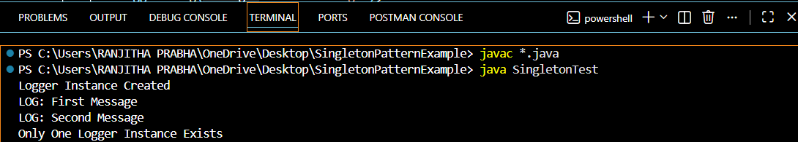

Exercise 2: Implementing the Factory Method Pattern

Scenario:

You are developing a document management system that needs to create different types of documents (e.g., Word, PDF, Excel). Use the Factory Method Pattern to achieve this.

Steps:
1. Create an interface named Document.
2. Implement different document types such as WordDocument, PdfDocument, and ExcelDocument.
3. Create an abstract class DocumentFactory with a factory method createDocument().
4. Create concrete factory classes:
- WordDocumentFactory
- PdfDocumentFactory
- ExcelDocumentFactory
5. Test the Factory Method Pattern by creating different document types using their respective factories.

Solution Code:
Document.java
interface Document {
void open();
}
WordDocument.java
class WordDocument implements Document {

@Override
public void open() {
System.out.println("Opening Word Document");
}
}
PdfDocument.java
class PdfDocument implements Document {

@Override
public void open() {
System.out.println("Opening PDF Document");
}
}
ExcelDocument.java
class ExcelDocument implements Document {

@Override
public void open() {
System.out.println("Opening Excel Document");
}
}
DocumentFactory.java
abstract class DocumentFactory {
public abstract Document createDocument();
}
WordDocumentFactory.java
class WordDocumentFactory extends DocumentFactory {

@Override
public Document createDocument() {
return new WordDocument();
}
}
PdfDocumentFactory.java
class PdfDocumentFactory extends DocumentFactory {

@Override
public Document createDocument() {
return new PdfDocument();
}
}
ExcelDocumentFactory.java
class ExcelDocumentFactory extends DocumentFactory {

@Override
public Document createDocument() {
return new ExcelDocument();
}
}
FactoryMethodTest.java
public class FactoryMethodTest {

public static void main(String[] args) {

DocumentFactory wordFactory = new WordDocumentFactory();
Document word = wordFactory.createDocument();
word.open();

DocumentFactory pdfFactory = new PdfDocumentFactory();
Document pdf = pdfFactory.createDocument();
pdf.open();

DocumentFactory excelFactory = new ExcelDocumentFactory();
Document excel = excelFactory.createDocument();
excel.open();
}
}

Output:
