INTERNET PROGRAMMING LAB RECORD
PROGRAM 11
HOME FINDER – ONLINE REAL ESTATE PLATFORM
Name: P. Ranjithkumar
Register Number: 192411119
Course code:CSA4304

AIM
To design a simple, responsive Home Finder website that helps users browse residential and commercial properties, filter listings by location and property type, and view basic property details using HTML, CSS, and JavaScript.

TOOL REQUIRED
HTML5, CSS3, JavaScript, and a web browser such as Google Chrome or Microsoft Edge.

ALGORITHM
- Start the program.
- Create the webpage structure using HTML.
- Add property cards containing name, location, type, and price.
- Style the webpage and property cards using CSS.
- Use JavaScript to filter properties by location and type.
- Display a message when a user selects View Details.
- Open index.html in a browser and test the filters.
- Stop the program.

PROGRAM

1. index.html
<!DOCTYPE html>
<html lang="en">
<head>
<meta charset="UTF-8">
<meta name="viewport" content="width=device-width, initial-scale=1.0">
<title>Home Finder</title>
<link rel="stylesheet" href="style.css">
</head>
<body>
<header>
<h1>Home Finder</h1>
<p>Find a place that feels like home</p>
</header>
<main>
<h2>Available Properties</h2>
<div class="filters">
<input id="location" type="text" placeholder="Search by location">
<select id="type">
<option value="all">All Property Types</option>
<option value="Apartment">Apartment</option>
<option value="House">House</option>
<option value="Commercial">Commercial</option>
</select>
<button onclick="searchProperties()">Search</button>
</div>
<section class="property-grid">
<article class="property" data-location="chennai" data-type="Apartment">
<div class="property-image">🏢</div>
<h3>Modern City Apartment</h3><p>Location: Chennai</p>
<p>Type: Apartment</p><p class="price">₹45,00,000</p>
<button onclick="viewDetails('Modern City Apartment')">View Details</button>
</article>
<article class="property" data-location="bangalore" data-type="House">
<div class="property-image">🏡</div>
<h3>Family Garden House</h3><p>Location: Bangalore</p>
<p>Type: House</p><p class="price">₹78,00,000</p>
<button onclick="viewDetails('Family Garden House')">View Details</button>
</article>
<article class="property" data-location="hyderabad" data-type="Commercial">
<div class="property-image">🏬</div>
<h3>Business Office Space</h3><p>Location: Hyderabad</p>
<p>Type: Commercial</p><p class="price">₹60,00,000</p>
<button onclick="viewDetails('Business Office Space')">View Details</button>
</article>
<article class="property" data-location="chennai" data-type="House">
<div class="property-image">🏠</div>
<h3>Suburban Family Home</h3><p>Location: Chennai</p>
<p>Type: House</p><p class="price">₹55,00,000</p>
<button onclick="viewDetails('Suburban Family Home')">View Details</button>
</article>
</section>
<p id="message" aria-live="polite"></p>
</main>
<footer><p>© 2026 Home Finder</p></footer>
<script src="script.js"></script>
</body>
</html>

2. style.css
* { box-sizing: border-box; }
body { margin: 0; font-family: Arial, sans-serif; color: #24313b; background: #f3f7f6; }
header { text-align: center; color: white; background: #176b61; padding: 24px 12px; }
header h1 { margin: 0; }
main { max-width: 1050px; margin: 24px auto; padding: 0 16px; }
.filters { display: flex; flex-wrap: wrap; gap: 10px; margin-bottom: 22px; }
input, select, button { padding: 10px; border: 1px solid #b7c9c5; border-radius: 5px; }
input { flex: 1; min-width: 180px; }
button { color: white; background: #176b61; border: none; cursor: pointer; }
button:hover { background: #104d46; }
.property-grid { display: grid; grid-template-columns: repeat(3, 1fr); gap: 16px; }
.property { background: white; padding: 16px; border-radius: 9px; box-shadow: 0 2px 8px #dce5e2; }
.property-image { padding: 20px; text-align: center; font-size: 48px; background: #e1f0ec; border-radius: 7px; }
.price { font-weight: bold; color: #176b61; }
footer { text-align: center; padding: 14px; background: #e1ebe8; }
@media (max-width: 750px) { .property-grid { grid-template-columns: repeat(2, 1fr); } }
@media (max-width: 480px) { .property-grid { grid-template-columns: 1fr; } }

3. script.js
function searchProperties() {
const location = document.getElementById("location").value.trim().toLowerCase();
const type = document.getElementById("type").value;
const properties = document.querySelectorAll(".property");
let count = 0;
properties.forEach(function(property) {
const locationMatches = location === "" || property.dataset.location.includes(location);
const typeMatches = type === "all" || property.dataset.type === type;
if (locationMatches && typeMatches) {
property.style.display = "block";
count++;
} else {
property.style.display = "none";
}
});
document.getElementById("message").textContent = count + " property/properties found.";
}
function viewDetails(name) {
document.getElementById("message").textContent =
"You selected: " + name + ". Contact the property agent for more information.";
}

OUTPUT
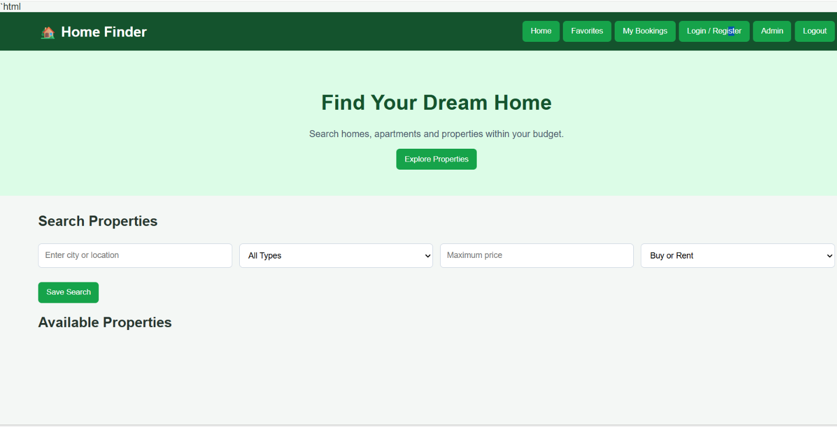

RESULT
Thus, a responsive Home Finder online real estate webpage was created using HTML, CSS, and JavaScript. It supports property listings, location and property-type filtering, and a basic property details message. This is a frontend demonstration and does not connect to a real database, Google Maps, user login, or property transaction service.

