INTERNET PROGRAMMING LAB
EXPERIMENT – 6
ONLINE CAKE ORDERING SYSTEM
Name | P. Ranjithkumar
Register Number | 192411119
Course code | CSA4304

AIM
To create a simple Online Cake Ordering System using HTML, CSS, and JavaScript that displays cakes, allows users to select a cake and quantity, and calculates the total price.

TOOL REQUIRED
1. Visual Studio Code or any text editor
2. Web browser such as Google Chrome or Microsoft Edge
3. HTML, CSS, and JavaScript

ALGORITHM
1. Start the program.
2. Create an HTML page with cake choices, quantity input, and an order button.
3. Use CSS to style the page and cake cards.
4. Store cake names and prices in JavaScript.
5. Read the selected cake and quantity when the user clicks the order button.
6. Calculate the total price and display the order summary.
7. Stop the program.

PROGRAM

File 1: index.html
<!DOCTYPE html>
<html lang="en">
<head>
<meta charset="UTF-8">
<meta name="viewport" content="width=device-width, initial-scale=1.0">
<title>Online Cake Ordering</title>
<link rel="stylesheet" href="style.css">
</head>
<body>
<div class="container">
<h1>Sweet Treats Cake Shop</h1>
<p>Choose your favourite cake</p>
<div class="cake-list">
<label for="cake">Select Cake:</label>
<select id="cake">
<option value="500">Chocolate Cake - ₹500</option>
<option value="650">Black Forest Cake - ₹650</option>
<option value="700">Red Velvet Cake - ₹700</option>
<option value="400">Vanilla Cake - ₹400</option>
</select>
<label for="quantity">Quantity:</label>
<input type="number" id="quantity" min="1" value="1">
<button onclick="placeOrder()">Place Order</button>
</div>
<div id="summary"></div>
</div>
<script src="script.js"></script>
</body>
</html>

File 2: style.css
body {
font-family: Arial, sans-serif;
background: #fff0f5;
margin: 0;
padding: 20px;
}
.container {
max-width: 650px;
margin: 30px auto;
padding: 25px;
background: white;
border-radius: 10px;
text-align: center;
box-shadow: 0 3px 12px #e5cbd5;
}
h1 { color: #a52a5a; }
.cake-list {
display: flex;
flex-direction: column;
gap: 12px;
max-width: 400px;
margin: 20px auto;
text-align: left;
}
input, select, button {
padding: 11px;
font-size: 15px;
border: 1px solid #ccc;
border-radius: 5px;
}
button {
background: #c04475;
color: white;
border: none;
cursor: pointer;
}
button:hover { background: #9f2e5c; }
#summary {
margin-top: 20px;
font-weight: bold;
color: #176b3a;
}
@media (max-width: 600px) {
.container { padding: 15px; margin: 10px auto; }
input, select, button { width: 100%; box-sizing: border-box; }
}

File 3: script.js
function placeOrder() {
const cakeSelect = document.getElementById("cake");
const quantityInput = document.getElementById("quantity");
const summary = document.getElementById("summary");
const price = Number(cakeSelect.value);
const quantity = Number(quantityInput.value);
const cakeName = cakeSelect.options[cakeSelect.selectedIndex].text.split(" - ")[0];
if (!Number.isInteger(quantity) || quantity < 1) {
summary.textContent = "Please enter a quantity of at least 1.";
return;
}
const total = price * quantity;
summary.innerHTML =
"Order placed successfully!<br>" +
"Cake: " + cakeName + "<br>" +
"Quantity: " + quantity + "<br>" +
"Total Price: ₹" + total;
}

OUTPUT
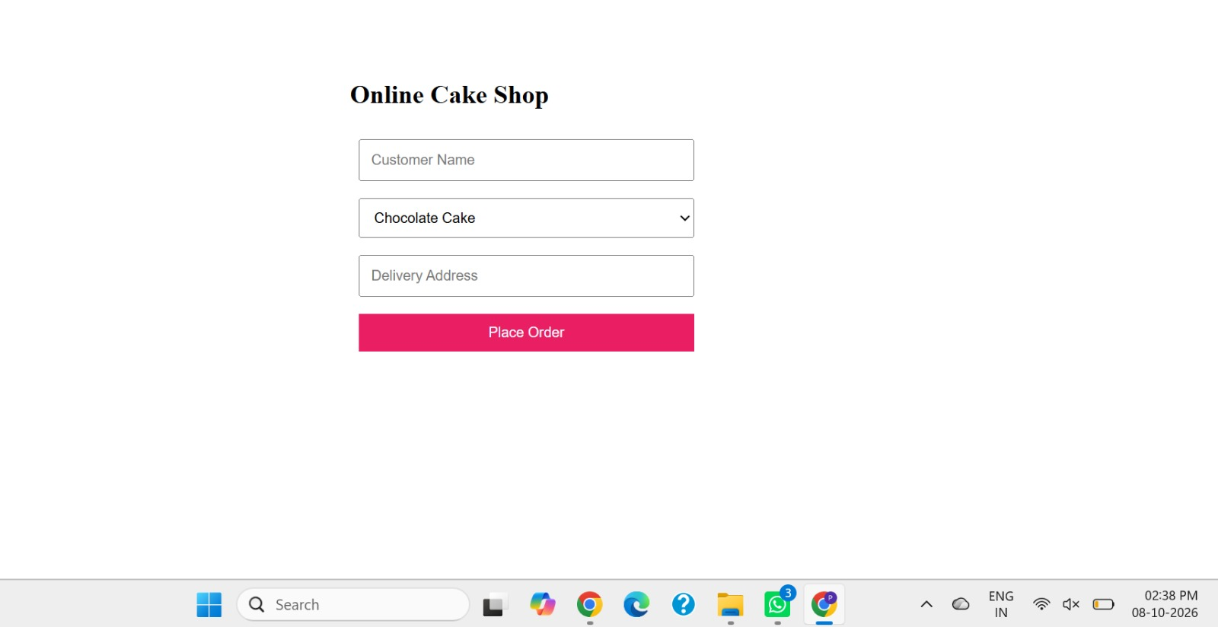

RESULT
Thus, a simple Online Cake Ordering System was created successfully using HTML, CSS, and JavaScript. It allows users to select a cake, enter the quantity, and view the total price. This is a front-end demonstration and does not process real payments or store orders on a server.

