INTERNET PROGRAMMING LAB
Name: P.Ranjithkumar
Reg:192411119
Course code:CSA4304

Experiment: BlossomGifts – Online Gift Shopping System
1. AIM
To design and develop a simple BlossomGifts online shopping webpage using HTML, CSS, and JavaScript to display gift products, search and filter items, and add selected products to a shopping cart.
2. TOOL
- Visual Studio Code
- Web Browser
- HTML
- CSS
- JavaScript
3. ALGORITHM
1. Start the program.
2. Create the webpage using HTML.
3. Apply styles to the page using CSS.
4. Display gift products with their names, categories, prices, and descriptions.
5. Allow users to search for gifts by name or category.
6. Use JavaScript to filter and display matching products.
7. Allow users to add products to the shopping cart.
8. Update the cart item count and total price dynamically.
9. Display a message when an item is added to the cart.
10. Stop the program.
4. PROGRAM
File 1: index.html
<!DOCTYPE html>
<html lang="en">
<head>
<meta charset="UTF-8">
<meta name="viewport" content="width=device-width, initial-scale=1.0">
<title>BlossomGifts - Online Gift Shop</title>
<link rel="stylesheet" href="style.css">
</head>
<body>
<header>
<h1>🌸 BlossomGifts</h1>
<p>Thoughtful gifts for every special moment</p>
<div class="cart">🛒 Cart: <span id="cart-count">0</span> |
Total: ₹<span id="cart-total">0</span></div>
</header>
<nav>
<a href="#home">Home</a>
<a href="#products">Shop Gifts</a>
<a href="#about">About</a>
</nav>
<main>
<section id="home" class="welcome">
<h2>Make Someone's Day Special!</h2>
<p>Flowers, gift baskets, and personalized gifts for every occasion.</p>
</section>
<section id="products">
<h2>Explore Our Gifts</h2>
<div class="filters">
<input type="text" id="search" placeholder="Search gifts..."
oninput="filterProducts()">
<select id="category" onchange="filterProducts()">
<option value="all">All Categories</option>
<option value="Flowers">Flowers</option>
<option value="Gift Baskets">Gift Baskets</option>
<option value="Personalized">Personalized Gifts</option>
</select>
</div>
<p id="message" aria-live="polite"></p>
<div id="product-list" class="product-grid">
<article class="product" data-name="Rose Bouquet" data-category="Flowers" data-price="599">
<div class="emoji">💐</div>
<h3>Rose Bouquet</h3>
<p>Fresh roses for birthdays and anniversaries.</p>
<p class="price">₹599</p>
<button onclick="addToCart('Rose Bouquet', 599)">Add to Cart</button>
</article>
<article class="product" data-name="Sunflower Bunch" data-category="Flowers" data-price="449">
<div class="emoji">🌻</div>
<h3>Sunflower Bunch</h3>
<p>Bright sunflowers to share happiness.</p>
<p class="price">₹449</p>
<button onclick="addToCart('Sunflower Bunch', 449)">Add to Cart</button>
</article>
<article class="product" data-name="Sweet Gift Basket" data-category="Gift Baskets" data-price="799">
<div class="emoji">🎁</div>
<h3>Sweet Gift Basket</h3>
<p>A delightful basket of treats and surprises.</p>
<p class="price">₹799</p>
<button onclick="addToCart('Sweet Gift Basket', 799)">Add to Cart</button>
</article>
<article class="product" data-name="Chocolate Hamper" data-category="Gift Baskets" data-price="699">
<div class="emoji">🍫</div>
<h3>Chocolate Hamper</h3>
<p>A chocolate collection for every celebration.</p>
<p class="price">₹699</p>
<button onclick="addToCart('Chocolate Hamper', 699)">Add to Cart</button>
</article>
<article class="product" data-name="Personalized Mug" data-category="Personalized" data-price="299">
<div class="emoji">☕</div>
<h3>Personalized Mug</h3>
<p>A memorable mug for someone special.</p>
<p class="price">₹299</p>
<button onclick="addToCart('Personalized Mug', 299)">Add to Cart</button>
</article>
<article class="product" data-name="Photo Frame" data-category="Personalized" data-price="399">
<div class="emoji">🖼️</div>
<h3>Photo Frame</h3>
<p>Keep your favourite memories close.</p>
<p class="price">₹399</p>
<button onclick="addToCart('Photo Frame', 399)">Add to Cart</button>
</article>
</div>
</section>
<section id="about" class="about">
<h2>About BlossomGifts</h2>
<p>We make gifting simple with thoughtful products for birthdays, anniversaries,
celebrations, and everyday surprises.</p>
</section>
</main>
<footer>
<p>&copy; 2026 BlossomGifts | Made with care 🌷</p>
</footer>
<script src="script.js"></script>
</body>
</html>

File 2: style.css
* {
box-sizing: border-box;
}
body {
margin: 0;
font-family: Arial, sans-serif;
background: #fff7fa;
color: #333;
}
header {
background: #b83264;
color: white;
text-align: center;
padding: 22px 12px;
}
header h1 {
margin: 0;
}
.cart {
margin-top: 10px;
font-weight: bold;
}
nav {
background: #7d2045;
text-align: center;
padding: 12px;
}
nav a {
color: white;
text-decoration: none;
margin: 0 16px;
}
main {
max-width: 1050px;
margin: auto;
padding: 20px;
}
.welcome, .about {
background: #ffe2ec;
text-align: center;
padding: 24px;
border-radius: 10px;
margin-bottom: 24px;
}
h2 {
color: #9f2855;
}
.filters {
display: flex;
gap: 10px;
flex-wrap: wrap;
margin-bottom: 15px;
}
input, select {
padding: 11px;
border: 1px solid #d9a2b7;
border-radius: 6px;
font-size: 15px;
}
input {
flex: 1;
min-width: 200px;
}
.product-grid {
display: grid;
grid-template-columns: repeat(auto-fit, minmax(220px, 1fr));
gap: 18px;
}
.product {
background: white;
padding: 18px;
text-align: center;
border: 1px solid #f0c7d6;
border-radius: 10px;
box-shadow: 0 2px 7px #ead2dc;
}
.emoji {
font-size: 45px;
}
.product h3 {
color: #8d244c;
}
.price {
font-size: 18px;
font-weight: bold;
color: #b83264;
}
button {
background: #b83264;
color: white;
border: none;
padding: 10px 15px;
border-radius: 6px;
cursor: pointer;
}
button:hover {
background: #7d2045;
}
#message {
color: #287341;
font-weight: bold;
}
footer {
background: #7d2045;
color: white;
text-align: center;
padding: 14px;
margin-top: 20px;
}

File 3: script.js
function filterProducts() {
const searchText = document.getElementById("search").value.toLowerCase();
const selectedCategory = document.getElementById("category").value;
const products = document.getElementsByClassName("product");
let visibleCount = 0;
for (let i = 0; i < products.length; i++) {
const name = products[i].dataset.name.toLowerCase();
const category = products[i].dataset.category;
const matchesSearch = name.includes(searchText);
const matchesCategory =
selectedCategory === "all" || category === selectedCategory;
if (matchesSearch && matchesCategory) {
products[i].style.display = "block";
visibleCount++;
} else {
products[i].style.display = "none";
}
}
document.getElementById("message").textContent =
visibleCount === 0 ? "No gifts found. Try another search." : "";
}
let cartCount = 0;
let cartTotal = 0;
function addToCart(productName, price) {
cartCount++;
cartTotal += price;
document.getElementById("cart-count").textContent = cartCount;
document.getElementById("cart-total").textContent = cartTotal;
document.getElementById("message").textContent =
productName + " added to your cart!";
}
5. OUTPUT
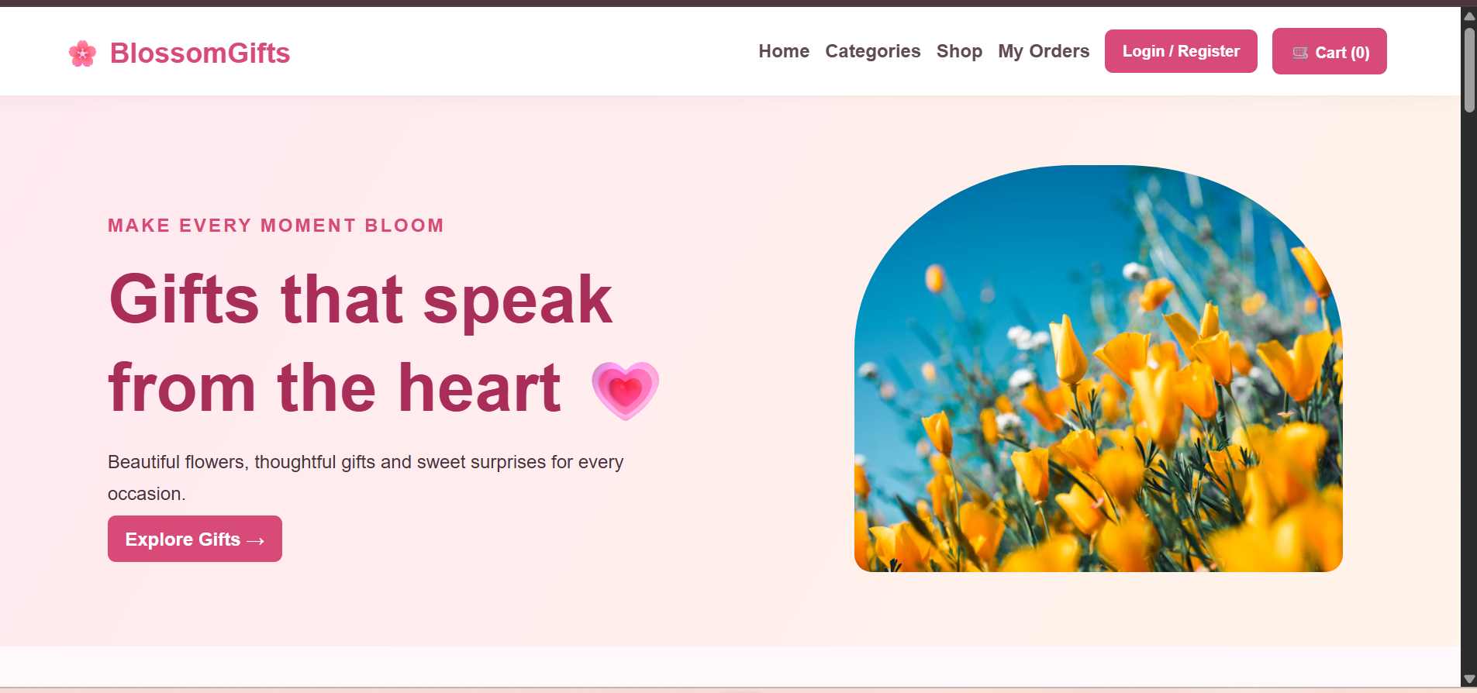
6. RESULT
The BlossomGifts online gift shopping webpage was created successfully using HTML, CSS, and JavaScript. It displays gift products, supports searching and category filtering, and updates the shopping cart count and total price dynamically.

