INTERNET PROGRAMMING LAB
Name: P.Ranjithkumar
Reg: 192411119
Course code: CSA4304

Experiment: ReNewMarket – Second-Hand Goods Marketplace
1. AIM
To design and develop a simple ReNewMarket online marketplace webpage using HTML, CSS, and JavaScript to display second-hand products, search and filter listings, and allow users to add items to a favorites list.
2. TOOL
- Visual Studio Code
- Web Browser
- HTML
- CSS
- JavaScript
3. ALGORITHM
1. Start the program.
2. Create the webpage structure using HTML.
3. Apply styling using CSS.
4. Display second-hand products with names, categories, conditions, descriptions, and prices.
5. Provide a search box and category filter for buyers.
6. Use JavaScript to search listings and filter products by category.
7. Allow users to mark products as favorites.
8. Display a message when a product is added to favorites.
9. Allow the administrator to view basic product listing information in the sample interface.
10. Stop the program.
4. PROGRAM
File 1: index.html
<!DOCTYPE html>
<html lang="en">
<head>
<meta charset="UTF-8">
<meta name="viewport" content="width=device-width, initial-scale=1.0">
<title>ReNewMarket - Second-Hand Marketplace</title>
<link rel="stylesheet" href="style.css">
</head>
<body>
<header>
<h1>♻ ReNewMarket</h1>
<p>Give pre-loved items a new home</p>
<div class="account">Welcome, Shopper! | Favorites: <span id="favorite-count">0</span></div>
</header>

<nav>
<a href="#home">Home</a>
<a href="#listings">Browse Items</a>
<a href="#about">About Us</a>
</nav>

<main>
<section id="home" class="welcome">
<h2>Buy Better. Reuse More.</h2>
<p>Discover affordable second-hand electronics, furniture, clothing, and collectibles.</p>
</section>

<section id="listings">
<h2>Available Listings</h2>
<div class="filters">
<input type="text" id="search" placeholder="Search items..." oninput="filterItems()">
<select id="category" onchange="filterItems()">
<option value="all">All Categories</option>
<option value="Electronics">Electronics</option>
<option value="Furniture">Furniture</option>
<option value="Clothing">Clothing</option>
<option value="Collectibles">Collectibles</option>
</select>
</div>
<p id="message" aria-live="polite"></p>

<div id="item-list" class="item-grid">
<article class="item" data-name="Wireless Headphones" data-category="Electronics">
<div class="emoji">🎧</div>
<h3>Wireless Headphones</h3>
<p>Good working condition with clear sound.</p>
<p class="condition">Condition: Good</p>
<p class="price">₹1,200</p>
<button onclick="addFavorite('Wireless Headphones')">♡ Add to Favorites</button>
</article>

<article class="item" data-name="Study Table" data-category="Furniture">
<div class="emoji">🪑</div>
<h3>Study Table</h3>
<p>Strong wooden table suitable for study or work.</p>
<p class="condition">Condition: Used - Good</p>
<p class="price">₹1,800</p>
<button onclick="addFavorite('Study Table')">♡ Add to Favorites</button>
</article>

<article class="item" data-name="Denim Jacket" data-category="Clothing">
<div class="emoji">🧥</div>
<h3>Denim Jacket</h3>
<p>Pre-loved jacket in a classic style.</p>
<p class="condition">Condition: Very Good</p>
<p class="price">₹650</p>
<button onclick="addFavorite('Denim Jacket')">♡ Add to Favorites</button>
</article>

<article class="item" data-name="Vintage Camera" data-category="Collectibles">
<div class="emoji">📷</div>
<h3>Vintage Camera</h3>
<p>A collectible camera for photography enthusiasts.</p>
<p class="condition">Condition: Used</p>
<p class="price">₹2,500</p>
<button onclick="addFavorite('Vintage Camera')">♡ Add to Favorites</button>
</article>

<article class="item" data-name="Bluetooth Speaker" data-category="Electronics">
<div class="emoji">🔊</div>
<h3>Bluetooth Speaker</h3>
<p>Portable speaker suitable for everyday listening.</p>
<p class="condition">Condition: Good</p>
<p class="price">₹900</p>
<button onclick="addFavorite('Bluetooth Speaker')">♡ Add to Favorites</button>
</article>

<article class="item" data-name="Bookshelf" data-category="Furniture">
<div class="emoji">📚</div>
<h3>Bookshelf</h3>
<p>Compact shelf for books and home storage.</p>
<p class="condition">Condition: Used - Good</p>
<p class="price">₹1,000</p>
<button onclick="addFavorite('Bookshelf')">♡ Add to Favorites</button>
</article>
</div>
</section>

<section id="about" class="about">
<h2>About ReNewMarket</h2>
<p>ReNewMarket helps people reuse quality pre-loved items, save money, and reduce waste.</p>
</section>
</main>

<footer>
<p>&copy; 2026 ReNewMarket | Reuse, renew, repeat.</p>
</footer>
<script src="script.js"></script>
</body>
</html>

File 2: style.css
* {
box-sizing: border-box;
}
body {
margin: 0;
font-family: Arial, sans-serif;
background: #f4f8f5;
color: #28332c;
}
header {
background: #26734d;
color: white;
text-align: center;
padding: 22px 12px;
}
header h1 {
margin: 0;
}
.account {
margin-top: 10px;
font-weight: bold;
}
nav {
background: #174b33;
text-align: center;
padding: 12px;
}
nav a {
color: white;
text-decoration: none;
margin: 0 16px;
}
main {
max-width: 1050px;
margin: auto;
padding: 20px;
}
.welcome, .about {
background: #dcefe3;
text-align: center;
padding: 24px;
border-radius: 10px;
margin-bottom: 24px;
}
h2 {
color: #216442;
}
.filters {
display: flex;
gap: 10px;
flex-wrap: wrap;
margin-bottom: 15px;
}
input, select {
padding: 11px;
border: 1px solid #a8cbb5;
border-radius: 6px;
font-size: 15px;
}
input {
flex: 1;
min-width: 200px;
}
.item-grid {
display: grid;
grid-template-columns: repeat(auto-fit, minmax(220px, 1fr));
gap: 18px;
}
.item {
background: white;
padding: 18px;
text-align: center;
border: 1px solid #c9dfd0;
border-radius: 10px;
box-shadow: 0 2px 7px #d8e5dc;
}
.emoji {
font-size: 45px;
}
.item h3 {
color: #216442;
}
.condition {
color: #56675c;
font-size: 14px;
}
.price {
font-size: 18px;
font-weight: bold;
color: #26734d;
}
button {
background: #26734d;
color: white;
border: none;
padding: 10px 13px;
border-radius: 6px;
cursor: pointer;
}
button:hover {
background: #174b33;
}
#message {
color: #216442;
font-weight: bold;
}
footer {
background: #174b33;
color: white;
text-align: center;
padding: 14px;
margin-top: 20px;
}

File 3: script.js
function filterItems() {
const searchText = document.getElementById("search").value.toLowerCase();
const selectedCategory = document.getElementById("category").value;
const items = document.getElementsByClassName("item");
let visibleCount = 0;

for (let i = 0; i < items.length; i++) {
const name = items[i].dataset.name.toLowerCase();
const category = items[i].dataset.category;
const matchesSearch = name.includes(searchText);
const matchesCategory =
selectedCategory === "all" || category === selectedCategory;

if (matchesSearch && matchesCategory) {
items[i].style.display = "block";
visibleCount++;
} else {
items[i].style.display = "none";
}
}

document.getElementById("message").textContent =
visibleCount === 0 ? "No items found. Try another search." : "";
}

let favoriteCount = 0;
const favorites = [];

function addFavorite(itemName) {
if (favorites.includes(itemName)) {
document.getElementById("message").textContent =
itemName + " is already in your favorites.";
return;
}

favorites.push(itemName);
favoriteCount++;
document.getElementById("favorite-count").textContent = favoriteCount;
document.getElementById("message").textContent =
itemName + " added to your favorites!";
}
5. OUTPUT
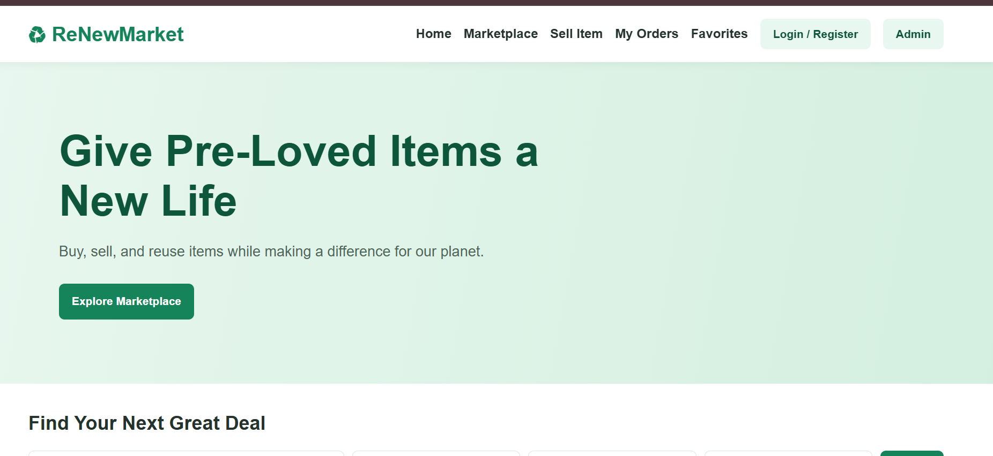
6. RESULT
The ReNewMarket second-hand marketplace webpage was created successfully using HTML, CSS, and JavaScript. It displays product listings, supports searching and category filtering, and allows users to add items to favorites dynamically. This is a front-end demonstration; real login, payment, order management, and database features would require a backend.

