INTERNET PROGRAMMING LAB EXPERIMENTS
Name: P.Ranjithkumar
Reg: 192411119
Course code:CSA4304

Experiment: EasyToll – Online Toll Payment System
1. AIM
To design and develop a simple EasyToll online toll payment webpage using HTML, CSS, and JavaScript to display toll services, manage a sample eWallet balance, purchase toll eTickets, and view toll pass information.
2. TOOL
- Visual Studio Code
- Web Browser
- HTML
- CSS
- JavaScript
3. ALGORITHM
1. Start the program.
2. Create the webpage structure using HTML.
3. Apply styles using CSS.
4. Display the EasyToll dashboard with wallet balance, toll pass, and eTicket options.
5. Allow the user to enter an amount and add it to the sample eWallet.
6. Allow the user to buy a toll eTicket by selecting a toll route.
7. Update the wallet balance and display a confirmation message.
8. Display sample toll pass details and a QR-code placeholder.
9. Use JavaScript to handle user actions and update the webpage dynamically.
10. Stop the program.
4. PROGRAM
File 1: index.html
<!DOCTYPE html>
<html lang="en">
<head>
<meta charset="UTF-8">
<meta name="viewport" content="width=device-width, initial-scale=1.0">
<title>EasyToll - Online Toll Payment</title>
<link rel="stylesheet" href="style.css">
</head>
<body>
<header>
<h1>🚘 EasyToll</h1>
<p>Pay in advance. Travel without waiting.</p>
</header>

<nav>
<a href="#dashboard">Dashboard</a>
<a href="#wallet">eWallet</a>
<a href="#tickets">Toll eTicket</a>
<a href="#pass">Toll Pass</a>
</nav>

<main>
<section id="dashboard" class="welcome">
<h2>Welcome to EasyToll</h2>
<p>Manage toll payments before your journey and reduce waiting time at toll gates.</p>
<div class="summary">
<div class="summary-card">
<span>Wallet Balance</span>
<strong>₹<span id="balance">500</span></strong>
</div>
<div class="summary-card">
<span>Toll Pass</span>
<strong id="pass-status">Active</strong>
</div>
<div class="summary-card">
<span>Tickets Purchased</span>
<strong id="ticket-count">0</strong>
</div>
</div>
</section>

<section id="wallet" class="panel">
<h2>eWallet</h2>
<p>Add money to your EasyToll wallet for future toll payments.</p>
<label for="amount">Amount (₹)</label>
<input type="number" id="amount" min="1" placeholder="Enter amount">
<button onclick="addMoney()">Add Money</button>
</section>

<section id="tickets" class="panel">
<h2>Buy Toll eTicket</h2>
<p>Select a sample toll route and pay in advance.</p>
<label for="route">Select Toll Gate</label>
<select id="route">
<option value="120">Chennai Bypass Toll - ₹120</option>
<option value="80">Sriperumbudur Toll - ₹80</option>
<option value="150">Vellore Highway Toll - ₹150</option>
</select>
<button onclick="buyTicket()">Buy eTicket</button>
<p id="ticket-message" class="message" aria-live="polite"></p>
</section>

<section id="pass" class="panel">
<h2>Toll Pass</h2>
<p><strong>Pass ID:</strong> ET-2026-1024</p>
<p><strong>Vehicle Number:</strong> TN-00-AB-1234 (sample)</p>
<p><strong>Status:</strong> <span id="pass-detail">Active</span></p>
<button onclick="applyPass()">Apply / Renew Toll Pass</button>
<div class="qr">
<div class="qr-code" aria-label="QR code placeholder">▦ ▪ ▦<br>▪ ▦ ▪<br>▦ ▪ ▦</div>
<p>Sample QR Code Placeholder</p>
</div>
<p id="pass-message" class="message" aria-live="polite"></p>
</section>

<section class="panel">
<h2>Recent Transactions</h2>
<ul id="transactions">
<li>Opening wallet balance: ₹500</li>
</ul>
</section>
</main>

<footer>
<p>&copy; 2026 EasyToll | Plan ahead. Travel smoothly.</p>
</footer>
<script src="script.js"></script>
</body>
</html>

File 2: style.css
* {
box-sizing: border-box;
}
body {
margin: 0;
font-family: Arial, sans-serif;
color: #24313b;
background: #f1f6fb;
}
header {
background: #145b8c;
color: white;
text-align: center;
padding: 22px 12px;
}
header h1 {
margin: 0;
}
nav {
background: #0d3f63;
padding: 13px;
text-align: center;
}
nav a {
color: white;
text-decoration: none;
margin: 0 14px;
}
main {
max-width: 1000px;
margin: auto;
padding: 20px;
}
.welcome, .panel {
background: white;
padding: 22px;
margin-bottom: 20px;
border-radius: 10px;
box-shadow: 0 2px 8px #d5e0e8;
}
.welcome {
background: #dceefa;
text-align: center;
}
h2 {
color: #145b8c;
}
.summary {
display: flex;
gap: 12px;
justify-content: center;
flex-wrap: wrap;
margin-top: 20px;
}
.summary-card {
background: white;
padding: 15px 24px;
border-radius: 8px;
min-width: 150px;
}
.summary-card span {
display: block;
margin-bottom: 8px;
}
.summary-card strong {
font-size: 22px;
color: #145b8c;
}
label {
display: block;
margin: 12px 0 6px;
}
input, select {
width: 100%;
max-width: 420px;
padding: 11px;
border: 1px solid #b7cbd9;
border-radius: 6px;
font-size: 15px;
}
button {
display: inline-block;
margin-top: 12px;
padding: 11px 16px;
border: none;
border-radius: 6px;
background: #1674ad;
color: white;
cursor: pointer;
}
button:hover {
background: #0d3f63;
}
.message {
color: #17683a;
font-weight: bold;
}
.qr {
margin-top: 15px;
text-align: center;
max-width: 220px;
padding: 12px;
background: #f5f8fa;
border: 1px dashed #9db3c3;
border-radius: 8px;
}
.qr-code {
display: inline-block;
padding: 10px;
background: white;
color: black;
font-size: 22px;
line-height: 1.1;
border: 2px solid black;
letter-spacing: 4px;
}
footer {
background: #0d3f63;
color: white;
text-align: center;
padding: 14px;
}

File 3: script.js
let walletBalance = 500;
let ticketCount = 0;

function updateBalance() {
document.getElementById("balance").textContent = walletBalance;
}

function addMoney() {
const amountInput = document.getElementById("amount");
const amount = Number(amountInput.value);

if (!Number.isFinite(amount) || amount <= 0) {
alert("Please enter a valid amount greater than zero.");
return;
}

walletBalance += amount;
updateBalance();
addTransaction("Money added to wallet: ₹" + amount);
amountInput.value = "";
alert("Money added successfully!");
}

function buyTicket() {
const routeSelect = document.getElementById("route");
const cost = Number(routeSelect.value);
const routeName = routeSelect.options[routeSelect.selectedIndex].text;

if (walletBalance < cost) {
document.getElementById("ticket-message").textContent =
"Insufficient wallet balance. Please add money first.";
return;
}

walletBalance -= cost;
ticketCount++;
updateBalance();
document.getElementById("ticket-count").textContent = ticketCount;
document.getElementById("ticket-message").textContent =
"eTicket purchased successfully for " + routeName + ".";
addTransaction("Toll eTicket purchased: " + routeName);
}

function applyPass() {
document.getElementById("pass-status").textContent = "Application Submitted";
document.getElementById("pass-detail").textContent = "Pending Approval";
document.getElementById("pass-message").textContent =
"Your sample toll pass request has been submitted for approval.";
}

function addTransaction(details) {
const list = document.getElementById("transactions");
const item = document.createElement("li");
item.textContent = details;
list.prepend(item);
}

5. OUTPUT
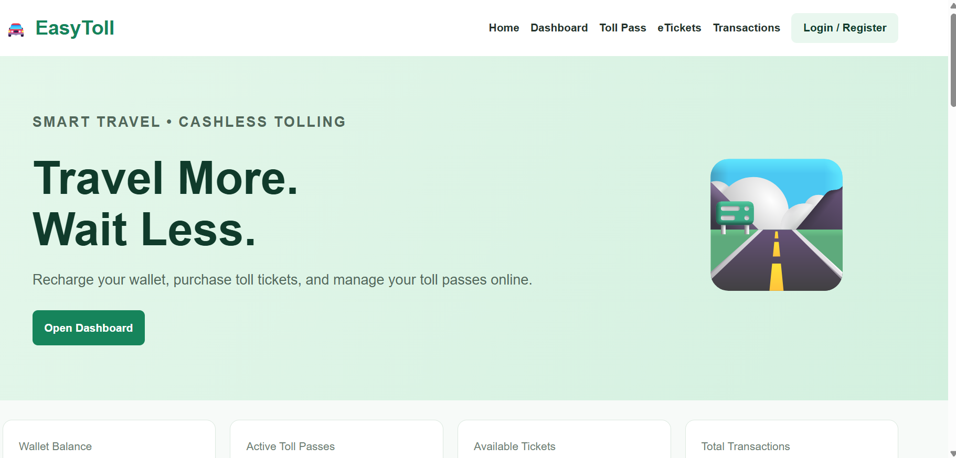
6. RESULT
The EasyToll online toll payment webpage was created successfully using HTML, CSS, and JavaScript. It demonstrates adding money to a sample wallet, purchasing toll eTickets, displaying toll pass details, and maintaining a transaction list. This is a front-end demonstration only; real login, secure payments, QR validation, toll-gate scanning, and database storage require a backend and payment-service integration.

