INTERNET PROGRAMMING LAB
EXPERIMENT – 9
TECHSAVVY ONLINE SHOPPING PLATFORM
Name | P. Ranjithkumar
Register Number | 192411119
Course code | CSA4304

AIM
To design a simple TechSavvy Online Shopping Platform using HTML, CSS, and JavaScript. The page displays electronic products, allows users to search for products, add items to a cart, and view the cart total.

TOOL REQUIRED
1. Visual Studio Code or any text editor
2. Web browser such as Google Chrome
3. HTML, CSS, and JavaScript

ALGORITHM
1. Start the program.
2. Create an HTML page with product cards, a search box, and a shopping cart section.
3. Use CSS to style the page and make it responsive.
4. Store sample product names and prices in JavaScript.
5. Display products and filter them based on the search text.
6. When Add to Cart is clicked, add the selected product to the cart.
7. Calculate and display the total price of the cart.
8. Stop the program.

PROGRAM

File 1: index.html
<!DOCTYPE html>
<html lang="en">
<head>
<meta charset="UTF-8">
<meta name="viewport" content="width=device-width, initial-scale=1.0">
<title>TechSavvy Online Shopping</title>
<link rel="stylesheet" href="style.css">
</head>
<body>
<header>
<h1>TechSavvy</h1>
<p>Your Online Electronics Store</p>
</header>
<main class="container">
<input type="text" id="search" placeholder="Search products..." oninput="displayProducts()">
<h2>Products</h2>
<div id="products" class="products"></div>
<section class="cart">
<h2>Shopping Cart</h2>
<ul id="cartItems"></ul>
<p id="total">Total: ₹0</p>
</section>
</main>
<script src="script.js"></script>
</body>
</html>

File 2: style.css
body {
margin: 0;
font-family: Arial, sans-serif;
background: #f2f5f9;
color: #222;
}
header {
background: #163b65;
color: white;
text-align: center;
padding: 18px;
}
header h1 { margin: 0; }
.container { max-width: 1000px; margin: 20px auto; padding: 15px; }
#search {
width: 100%; box-sizing: border-box; padding: 12px;
border: 1px solid #bbb; border-radius: 5px; font-size: 16px;
}
.products {
display: grid;
grid-template-columns: repeat(auto-fit, minmax(190px, 1fr));
gap: 15px;
}
.product, .cart {
background: white; padding: 16px; border-radius: 8px;
box-shadow: 0 2px 8px #d8dee6;
}
.product h3 { color: #163b65; }
.price { color: #167642; font-weight: bold; }
button {
background: #1769aa; color: white; border: none;
border-radius: 5px; padding: 10px 12px; cursor: pointer;
}
button:hover { background: #0d4f85; }
.cart { margin-top: 25px; }
@media (max-width: 600px) {
.container { padding: 10px; }
.products { grid-template-columns: 1fr; }
}

File 3: script.js
const products = [
{ id: 1, name: "Smartphone", price: 15000 },
{ id: 2, name: "Laptop", price: 45000 },
{ id: 3, name: "Tablet", price: 18000 },
{ id: 4, name: "Headphones", price: 2000 },
{ id: 5, name: "Smart Watch", price: 3500 }
];
const cart = [];
function displayProducts() {
const search = document.getElementById("search").value.toLowerCase();
const list = document.getElementById("products");
const filtered = products.filter(p => p.name.toLowerCase().includes(search));
if (filtered.length === 0) {
list.innerHTML = "<p>No products found.</p>";
return;
}
list.innerHTML = filtered.map(p => `
<div class="product">
<h3>${p.name}</h3>
<p class="price">Price: ₹${p.price}</p>
<button onclick="addToCart(${p.id})">Add to Cart</button>
</div>
`).join("");
}
function addToCart(id) {
const product = products.find(p => p.id === id);
cart.push(product);
displayCart();
}
function displayCart() {
const items = document.getElementById("cartItems");
const total = document.getElementById("total");
items.innerHTML = cart.map(p => `<li>${p.name} - ₹${p.price}</li>`).join("");
const sum = cart.reduce((amount, p) => amount + p.price, 0);
total.textContent = "Total: ₹" + sum;
}
displayProducts();

OUTPUT
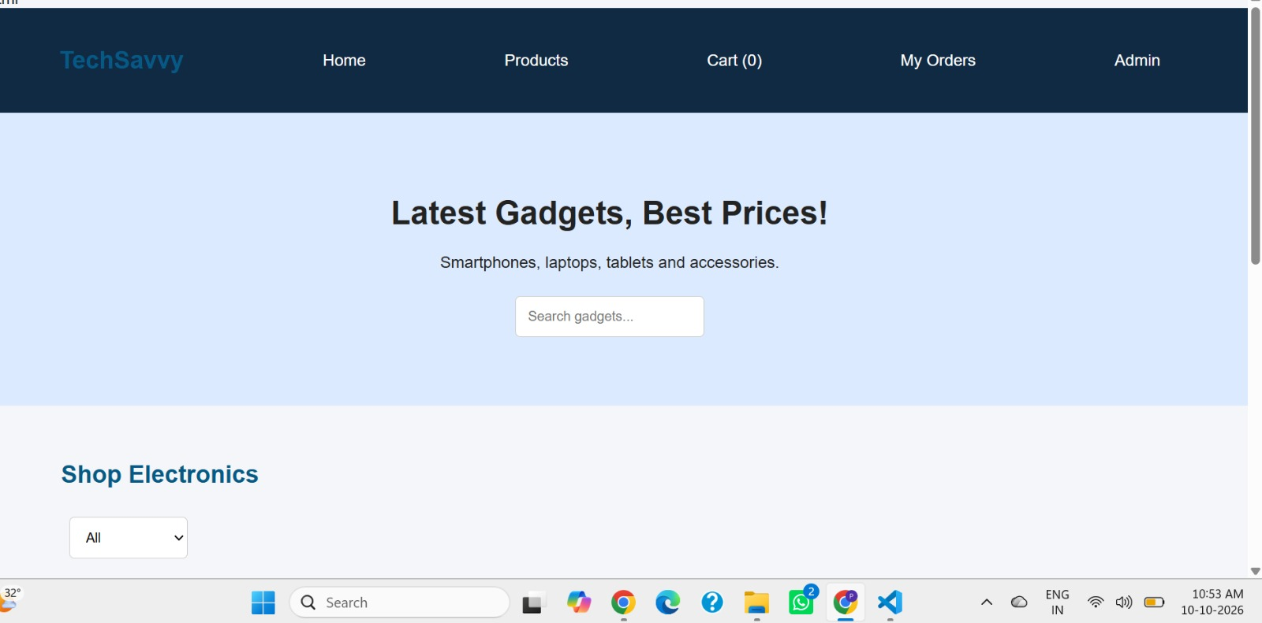

RESULT
Thus, the TechSavvy Online Shopping Platform was created using HTML, CSS, and JavaScript. It supports searching sample electronic products, adding products to a cart, and calculating the cart total. This front-end demonstration does not include user login, online payment, or database storage.

