INTERNET PROGRAMMING LAB
Name: P. Ranjithkumar
Reg: 192411119
Course code: CSA4304
Experiment: Online Bus Ticket Booking System

1. AIM
To design and develop a simple Online Bus Ticket Booking System using HTML, CSS, and JavaScript to search buses by route and display available bus details.

2. TOOL
- Visual Studio Code
- Web Browser
- HTML
- CSS
- JavaScript

3. ALGORITHM
- Start the program.
- Create the bus booking webpage using HTML.
- Apply styles using CSS.
- Display the available buses and route details.
- Allow users to enter a source and destination.
- Use JavaScript to filter buses according to the entered route.
- Display matching buses or a no-results message.
- Stop the program.

4. PROGRAM
File 1: index.html
<!DOCTYPE html>
<html>
<head>
<title>Bus Ticket Booking</title>
<link rel="stylesheet" href="style.css">
</head>
<body>
<h1>Online Bus Ticket Booking</h1>
<input type="text" id="source" placeholder="Enter source">
<input type="text" id="destination" placeholder="Enter destination">
<button onclick="searchBuses()">Search Buses</button>
<div id="buses">
<div class="bus" data-source="chennai" data-destination="bangalore">
<h3>Express Travels</h3>
<p>Chennai to Bangalore</p>
<p>Fare: Rs. 650</p>
</div>
<div class="bus" data-source="chennai" data-destination="hyderabad">
<h3>Green Line Travels</h3>
<p>Chennai to Hyderabad</p>
<p>Fare: Rs. 900</p>
</div>
<div class="bus" data-source="bangalore" data-destination="hyderabad">
<h3>City Bus Service</h3>
<p>Bangalore to Hyderabad</p>
<p>Fare: Rs. 750</p>
</div>
</div>
<p id="message"></p>
<script src="script.js"></script>
</body>
</html>
File 2: style.css
body {
font-family: Arial, sans-serif;
text-align: center;
background-color: #f2f2f2;
padding: 20px;
}
h1 {
color: darkblue;
}
input {
padding: 10px;
margin: 5px;
width: 180px;
}
button {
padding: 10px 15px;
background-color: darkblue;
color: white;
border: none;
cursor: pointer;
}
.bus {
background-color: white;
border: 1px solid gray;
border-radius: 6px;
padding: 12px;
margin: 15px auto;
max-width: 350px;
}
#message {
color: red;
}
File 3: script.js
function searchBuses() {
let source = document.getElementById("source").value.toLowerCase().trim();
let destination = document.getElementById("destination").value.toLowerCase().trim();
let buses = document.getElementsByClassName("bus");
let found = 0;
for (let i = 0; i < buses.length; i++) {
let busSource = buses[i].getAttribute("data-source");
let busDestination = buses[i].getAttribute("data-destination");
if (busSource.includes(source) && busDestination.includes(destination)) {
buses[i].style.display = "block";
found++;
} else {
buses[i].style.display = "none";
}
}
if (found === 0) {
document.getElementById("message").innerText = "No buses found.";
} else {
document.getElementById("message").innerText = found + " bus(es) found.";
}
}

OUTPUT
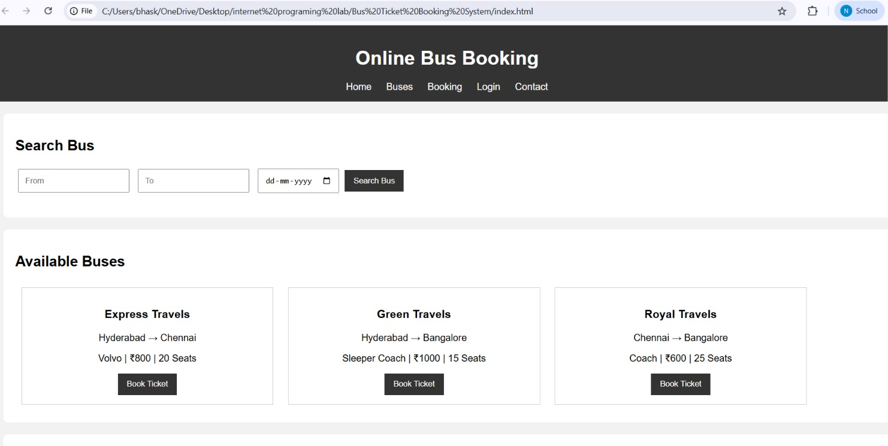

6. RESULT
The Online Bus Ticket Booking System webpage was created successfully using HTML, CSS, and JavaScript. Users can search buses by source and destination and view available bus details and fares.

