INTERNET PROGRAMMING LAB EXPERIMENTS
Name: P.Ranjithkumar
Reg: 192411119
Course code: CSA4304

Experiment: ComplainEase – Online Complaint Management System
1. AIM
To design and develop a simple ComplainEase complaint management webpage using HTML, CSS, and JavaScript to submit complaints, select complaint categories, view complaint status, and display a sample complaint dashboard.
2. TOOL
- Visual Studio Code
- Web Browser
- HTML
- CSS
- JavaScript
3. ALGORITHM
1. Start the program.
2. Create the webpage structure using HTML.
3. Apply styles to the webpage using CSS.
4. Create a complaint form with name, category, location, and description fields.
5. Allow users to submit a complaint.
6. Use JavaScript to validate the form and generate a sample complaint ID.
7. Display submitted complaints in the complaint history table.
8. Allow users to search complaints and view their current status.
9. Display sample officer and administrator contact information.
10. Stop the program.
4. PROGRAM
File 1: index.html
<!DOCTYPE html>
<html lang="en">
<head>
<meta charset="UTF-8">
<meta name="viewport" content="width=device-width, initial-scale=1.0">
<title>ComplainEase - Complaint Management</title>
<link rel="stylesheet" href="style.css">
</head>
<body>
<header>
<h1>📢 ComplainEase</h1>
<p>Raise your voice. Track your complaint. Get a resolution.</p>
</header>

<nav>
<a href="#home">Home</a>
<a href="#submit">Post Complaint</a>
<a href="#status">Complaint Status</a>
<a href="#contact">Contact</a>
</nav>

<main>
<section id="home" class="welcome">
<h2>Welcome to ComplainEase</h2>
<p>Submit a complaint and follow its progress through a simple dashboard.</p>
<div class="stats">
<div><strong id="total-count">0</strong><span>Complaints Submitted</span></div>
<div><strong id="pending-count">0</strong><span>Pending Complaints</span></div>
<div><strong>24/7</strong><span>Online Access</span></div>
</div>
</section>

<section id="submit" class="panel">
<h2>Post a Complaint</h2>
<form id="complaint-form">
<label for="user-name">Your Name</label>
<input type="text" id="user-name" required placeholder="Enter your name">

<label for="category">Complaint Category</label>
<select id="category" required>
<option value="">Select a category</option>
<option>Road Maintenance</option>
<option>Water Supply</option>
<option>Electricity</option>
<option>Waste Management</option>
<option>Public Safety</option>
<option>Other</option>
</select>

<label for="location">Complaint Location</label>
<input type="text" id="location" required placeholder="Enter area or address">

<label for="description">Complaint Description</label>
<textarea id="description" rows="4" required
placeholder="Describe the issue clearly"></textarea>

<button type="submit">Submit Complaint</button>
</form>
<p id="submit-message" class="message" aria-live="polite"></p>
</section>

<section id="status" class="panel">
<h2>Track Complaint Status</h2>
<input type="text" id="status-search" placeholder="Search by complaint ID or category"
oninput="searchComplaints()">
<div class="table-wrap">
<table>
<thead>
<tr>
<th>Complaint ID</th>
<th>Category</th>
<th>Location</th>
<th>Status</th>
</tr>
</thead>
<tbody id="complaint-table">
<tr id="empty-row"><td colspan="4">No complaints submitted yet.</td></tr>
</tbody>
</table>
</div>
</section>

<section id="contact" class="panel">
<h2>Admin Contact Details</h2>
<p><strong>Support Team:</strong> ComplainEase Help Desk</p>
<p><strong>Email:</strong> support@example.com (sample contact)</p>
<p><strong>Office Hours:</strong> Monday to Friday, 9:00 AM – 5:00 PM</p>
<p class="note">The contact details above are placeholders for this demonstration.</p>
</section>
</main>

<footer>
<p>&copy; 2026 ComplainEase | Transparent complaint handling</p>
</footer>
<script src="script.js"></script>
</body>
</html>

File 2: style.css
* {
box-sizing: border-box;
}
body {
margin: 0;
font-family: Arial, sans-serif;
background: #f4f7fb;
color: #263238;
}
header {
background: #285b8f;
color: white;
text-align: center;
padding: 22px 12px;
}
header h1 {
margin: 0;
}
nav {
background: #193e63;
text-align: center;
padding: 13px;
}
nav a {
color: white;
text-decoration: none;
margin: 0 14px;
}
main {
max-width: 1000px;
margin: auto;
padding: 20px;
}
.welcome, .panel {
background: white;
padding: 22px;
margin-bottom: 20px;
border-radius: 10px;
box-shadow: 0 2px 8px #dce4ed;
}
.welcome {
background: #e2effb;
text-align: center;
}
h2 {
color: #285b8f;
}
.stats {
display: flex;
gap: 12px;
justify-content: center;
flex-wrap: wrap;
margin-top: 20px;
}
.stats div {
background: white;
padding: 14px 20px;
border-radius: 8px;
min-width: 150px;
}
.stats strong, .stats span {
display: block;
}
.stats strong {
font-size: 22px;
color: #285b8f;
margin-bottom: 6px;
}
label {
display: block;
margin: 12px 0 6px;
font-weight: bold;
}
input, select, textarea {
width: 100%;
padding: 11px;
border: 1px solid #bdcbd8;
border-radius: 6px;
font-size: 15px;
font-family: Arial, sans-serif;
}
button {
margin-top: 14px;
padding: 11px 16px;
border: none;
border-radius: 6px;
background: #285b8f;
color: white;
cursor: pointer;
}
button:hover {
background: #193e63;
}
.message {
color: #17683a;
font-weight: bold;
}
.table-wrap {
overflow-x: auto;
}
table {
width: 100%;
border-collapse: collapse;
margin-top: 15px;
background: white;
}
th, td {
border: 1px solid #d5dee7;
padding: 11px;
text-align: left;
}
th {
background: #285b8f;
color: white;
}
.status-pending {
color: #9a6500;
font-weight: bold;
}
.note {
color: #687782;
font-size: 13px;
}
footer {
background: #193e63;
color: white;
text-align: center;
padding: 14px;
}

File 3: script.js
const complaints = [];
let nextComplaintNumber = 1001;

document.getElementById("complaint-form").addEventListener("submit", function(event) {
event.preventDefault();

const name = document.getElementById("user-name").value.trim();
const category = document.getElementById("category").value;
const location = document.getElementById("location").value.trim();
const description = document.getElementById("description").value.trim();

if (!name || !category || !location || !description) {
document.getElementById("submit-message").textContent =
"Please complete all fields.";
return;
}

const complaint = {
id: "CE" + nextComplaintNumber++,
name: name,
category: category,
location: location,
description: description,
status: "Pending"
};

complaints.push(complaint);
renderComplaints();
updateCounts();

document.getElementById("submit-message").textContent =
"Complaint submitted successfully. Your complaint ID is " + complaint.id + ".";
document.getElementById("complaint-form").reset();
});

function renderComplaints() {
const table = document.getElementById("complaint-table");
const searchText = document.getElementById("status-search").value.toLowerCase();
table.innerHTML = "";

const filtered = complaints.filter(function(complaint) {
return complaint.id.toLowerCase().includes(searchText) ||
complaint.category.toLowerCase().includes(searchText) ||
complaint.location.toLowerCase().includes(searchText);
});

if (filtered.length === 0) {
const row = table.insertRow();
const cell = row.insertCell();
cell.colSpan = 4;
cell.textContent = complaints.length === 0
? "No complaints submitted yet."
: "No matching complaints found.";
return;
}

filtered.forEach(function(complaint) {
const row = table.insertRow();
row.insertCell().textContent = complaint.id;
row.insertCell().textContent = complaint.category;
row.insertCell().textContent = complaint.location;

const statusCell = row.insertCell();
statusCell.textContent = complaint.status;
statusCell.className = "status-pending";
});
}

function searchComplaints() {
renderComplaints();
}

function updateCounts() {
document.getElementById("total-count").textContent = complaints.length;
document.getElementById("pending-count").textContent =
complaints.filter(function(item) {
return item.status === "Pending";
}).length;
}
5. OUTPUT
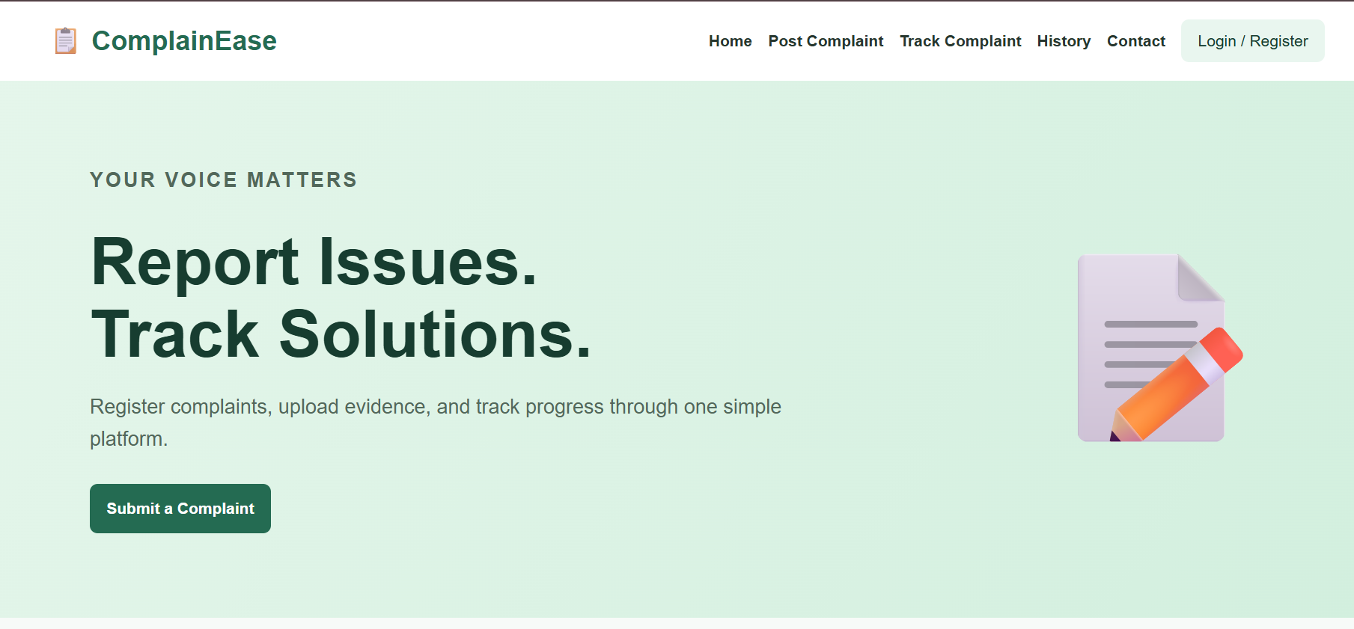
6. RESULT
The ComplainEase complaint management webpage was created successfully using HTML, CSS, and JavaScript. It allows users to submit complaints, generate sample complaint IDs, search complaint records, and view their status. This is a front-end demonstration; real user accounts, officer registration, administrator controls, Google Maps integration, file uploads, email/SMS notifications, and persistent storage require backend services and suitable integrations.

