INTERNET PROGRAMMING LAB EXPERIMENTS
Name: P.Ranjithkumar
Reg: 192411119
Course code: CSA4304

Experiment: VetCure – Online Veterinary Consultation System
1. AIM
To design and develop a simple VetCure online veterinary consultation webpage using HTML, CSS, and JavaScript to submit animal health complaints, choose a consultation method, view doctor details, and track the status of submitted requests.
2. TOOL
- Visual Studio Code
- Web Browser
- HTML
- CSS
- JavaScript
3. ALGORITHM
1. Start the program.
2. Create the webpage structure using HTML.
3. Apply styles using CSS.
4. Create a form for the farmer to enter details about the animal and its symptoms.
5. Allow the farmer to choose text, audio, image, or video as the complaint type.
6. Use JavaScript to validate the form and generate a sample complaint ID.
7. Display the submitted complaint in the complaint status table.
8. Display sample doctor details and basic animal-care information.
9. Allow users to search complaint records and submit feedback.
10. Stop the program.
4. PROGRAM
File 1: index.html
<!DOCTYPE html>
<html lang="en">
<head>
<meta charset="UTF-8">
<meta name="viewport" content="width=device-width, initial-scale=1.0">
<title>VetCure - Online Veterinary Consultation</title>
<link rel="stylesheet" href="style.css">
</head>
<body>
<header>
<h1>🐾 VetCure</h1>
<p>Better care for every animal</p>
</header>

<nav>
<a href="#home">Home</a>
<a href="#complaint">Post Complaint</a>
<a href="#status">My Complaint Status</a>
<a href="#doctors">View Doctors</a>
<a href="#news">Animal Care</a>
</nav>

<main>
<section id="home" class="welcome">
<h2>Welcome to VetCure</h2>
<p>Share your animal's symptoms and request help from a veterinary doctor.</p>
<div class="notice">
This is a lab demonstration. For urgent animal illness or distress, contact a veterinarian directly.
</div>
</section>

<section id="complaint" class="panel">
<h2>Submit Animal Health Complaint</h2>
<form id="complaint-form">
<label for="farmer-name">Farmer Name</label>
<input id="farmer-name" type="text" required placeholder="Enter your name">

<label for="animal">Animal Type / Name</label>
<input id="animal" type="text" required placeholder="e.g. Cow, Dog, Goat">

<label for="location">Location / Area</label>
<input id="location" type="text" required placeholder="Enter your area">

<label for="symptoms">Signs and Symptoms</label>
<textarea id="symptoms" rows="4" required
placeholder="Describe the animal's symptoms"></textarea>

<label for="media-type">How would you like to share details?</label>
<select id="media-type" required>
<option value="">Select a method</option>
<option>Text description</option>
<option>Image (sample selection only)</option>
<option>Audio (sample selection only)</option>
<option>Video (sample selection only)</option>
</select>

<label for="attachment">Select supporting file (optional)</label>
<input id="attachment" type="file" accept="image/*,audio/*,video/*">
<p class="small">This demo selects a file locally; it does not upload it to a server.</p>

<button type="submit">Submit Complaint</button>
</form>
<p id="submit-message" class="message" aria-live="polite"></p>
</section>

<section id="status" class="panel">
<h2>My Complaint Status</h2>
<input id="search" type="text" placeholder="Search by complaint ID or animal"
oninput="searchComplaints()">
<div class="table-wrap">
<table>
<thead>
<tr><th>Complaint ID</th><th>Animal</th><th>Location</th><th>Status</th></tr>
</thead>
<tbody id="complaint-table">
<tr><td colspan="4">No complaints submitted yet.</td></tr>
</tbody>
</table>
</div>
</section>

<section id="doctors" class="panel">
<h2>Available Doctors</h2>
<div class="doctor-card">
<h3>Government Veterinary Hospital</h3>
<p>Subscription: Free (sample listing)</p>
<p>Services: General veterinary consultation</p>
</div>
<div class="doctor-card">
<h3>Private Veterinary Clinic</h3>
<p>Subscription: Fee may apply (sample listing)</p>
<p>Services: Appointment-based consultation</p>
</div>
<p class="small">These are sample listings, not verified clinic details.</p>
</section>

<section id="news" class="panel">
<h2>Animal Care Information</h2>
<article class="care-item">
<h3>Observe changes early</h3>
<p>Record changes in appetite, activity, breathing, movement, or behaviour and share them with a veterinarian.</p>
</article>
<article class="care-item">
<h3>Keep a health record</h3>
<p>Note the date symptoms began and any relevant vaccination or treatment history.</p>
</article>
</section>

<section class="panel">
<h2>Post Feedback</h2>
<label for="feedback">Your feedback</label>
<textarea id="feedback" rows="3" placeholder="Share your experience"></textarea>
<button onclick="submitFeedback()">Submit Feedback</button>
<p id="feedback-message" class="message" aria-live="polite"></p>
</section>
</main>

<footer>
<p>&copy; 2026 VetCure | Caring for animals together</p>
</footer>
<script src="script.js"></script>
</body>
</html>

File 2: style.css
* {
box-sizing: border-box;
}
body {
margin: 0;
font-family: Arial, sans-serif;
background: #f3f8f6;
color: #283832;
}
header {
background: #26745a;
color: white;
text-align: center;
padding: 22px 12px;
}
header h1 {
margin: 0;
}
nav {
background: #174c3a;
text-align: center;
padding: 13px;
}
nav a {
color: white;
text-decoration: none;
margin: 0 12px;
}
main {
max-width: 1000px;
margin: auto;
padding: 20px;
}
.welcome, .panel {
background: white;
padding: 22px;
margin-bottom: 20px;
border-radius: 10px;
box-shadow: 0 2px 8px #dce8e2;
}
.welcome {
background: #e0f1e9;
text-align: center;
}
h2 {
color: #26745a;
}
.notice {
margin-top: 12px;
padding: 10px;
background: #fff2d8;
border-radius: 6px;
}
label {
display: block;
margin: 12px 0 6px;
font-weight: bold;
}
input, select, textarea {
width: 100%;
padding: 11px;
border: 1px solid #b9d0c5;
border-radius: 6px;
font-size: 15px;
font-family: Arial, sans-serif;
}
button {
margin-top: 14px;
padding: 11px 16px;
border: none;
border-radius: 6px;
background: #26745a;
color: white;
cursor: pointer;
}
button:hover {
background: #174c3a;
}
.message {
color: #17683a;
font-weight: bold;
}
.small {
color: #687a72;
font-size: 13px;
}
.table-wrap {
overflow-x: auto;
}
table {
width: 100%;
border-collapse: collapse;
margin-top: 15px;
}
th, td {
border: 1px solid #d5e2db;
padding: 11px;
text-align: left;
}
th {
background: #26745a;
color: white;
}
.doctor-card, .care-item {
padding: 14px;
margin: 12px 0;
border: 1px solid #d2e4da;
border-radius: 8px;
background: #fbfdfb;
}
footer {
background: #174c3a;
color: white;
text-align: center;
padding: 14px;
}

File 3: script.js
const complaints = [];
let nextComplaintNumber = 1001;

document.getElementById("complaint-form").addEventListener("submit", function(event) {
event.preventDefault();

const farmer = document.getElementById("farmer-name").value.trim();
const animal = document.getElementById("animal").value.trim();
const location = document.getElementById("location").value.trim();
const symptoms = document.getElementById("symptoms").value.trim();
const mediaType = document.getElementById("media-type").value;

if (!farmer || !animal || !location || !symptoms || !mediaType) {
document.getElementById("submit-message").textContent =
"Please complete all required fields.";
return;
}

const complaint = {
id: "VC" + nextComplaintNumber++,
farmer: farmer,
animal: animal,
location: location,
symptoms: symptoms,
mediaType: mediaType,
status: "Submitted"
};

complaints.push(complaint);
renderComplaints();

document.getElementById("submit-message").textContent =
"Complaint submitted. Your sample complaint ID is " + complaint.id + ".";
document.getElementById("complaint-form").reset();
});

function renderComplaints() {
const table = document.getElementById("complaint-table");
const searchText = document.getElementById("search").value.toLowerCase();
table.innerHTML = "";

const filtered = complaints.filter(function(item) {
return item.id.toLowerCase().includes(searchText) ||
item.animal.toLowerCase().includes(searchText) ||
item.location.toLowerCase().includes(searchText);
});

if (filtered.length === 0) {
const row = table.insertRow();
const cell = row.insertCell();
cell.colSpan = 4;
cell.textContent = complaints.length === 0
? "No complaints submitted yet."
: "No matching complaints found.";
return;
}

filtered.forEach(function(item) {
const row = table.insertRow();
row.insertCell().textContent = item.id;
row.insertCell().textContent = item.animal;
row.insertCell().textContent = item.location;
row.insertCell().textContent = item.status;
});
}

function searchComplaints() {
renderComplaints();
}

function submitFeedback() {
const feedback = document.getElementById("feedback").value.trim();
const message = document.getElementById("feedback-message");

if (!feedback) {
message.textContent = "Please enter feedback before submitting.";
return;
}

message.textContent = "Thank you for your feedback!";
document.getElementById("feedback").value = "";
}
5. OUTPUT
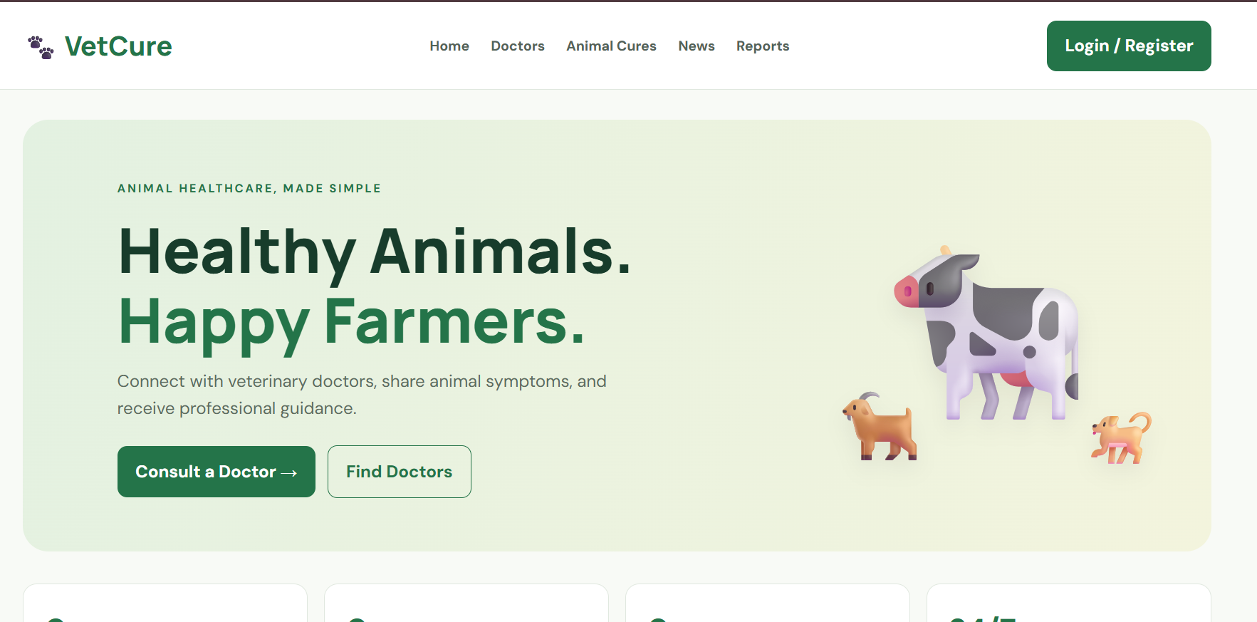
6. RESULT
The VetCure online veterinary consultation webpage was created successfully using HTML, CSS, and JavaScript. It demonstrates complaint submission, sample complaint ID generation, complaint searching, doctor listings, animal-care information, and feedback submission. This is a front-end demonstration; real registration, subscriptions, video/audio/image uploads, doctor responses, payments, database storage, and area-wise disease analysis require backend services and appropriate integrations.

